1. Provide screen shot verifying the Advertising period

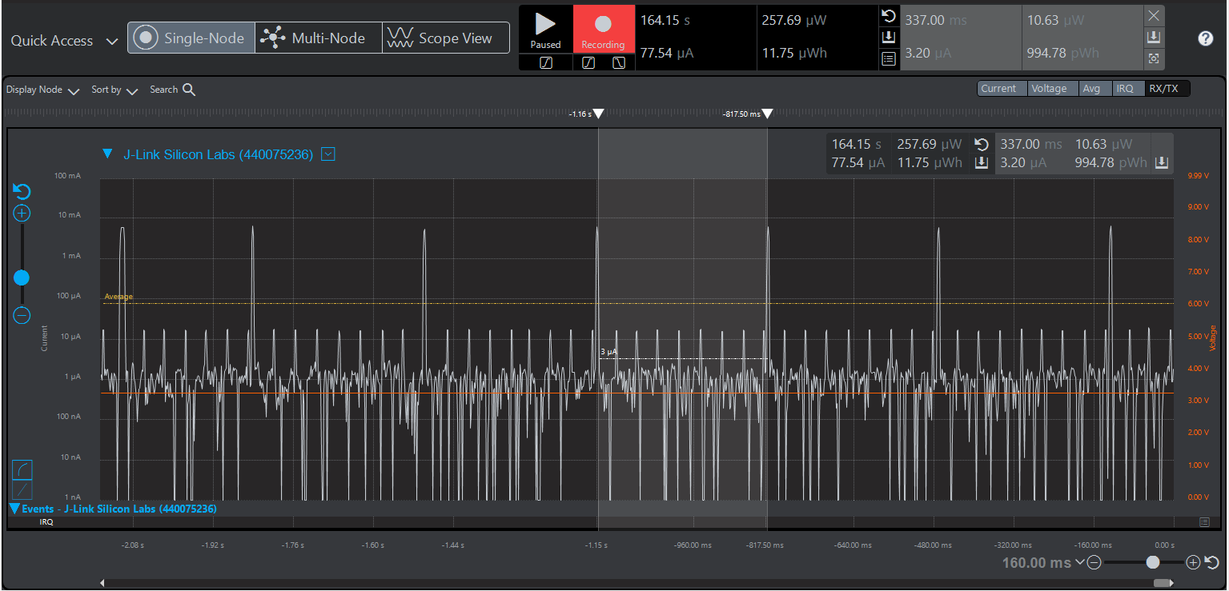

2. Provide screen shot verifying the connection interval setting

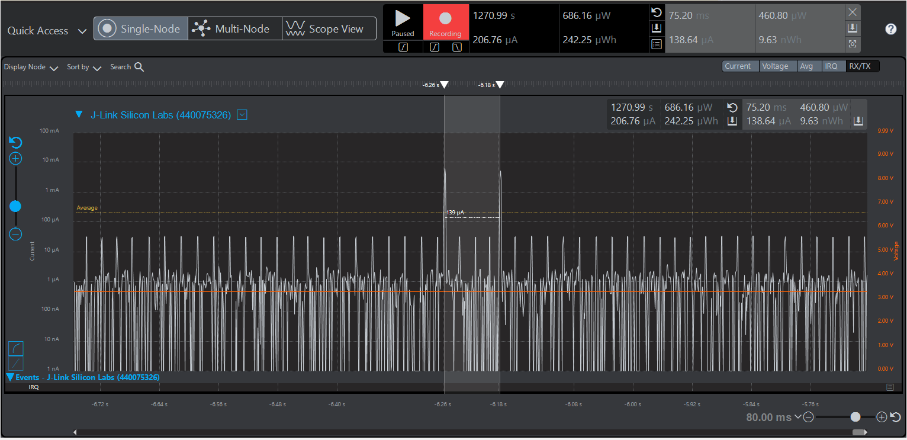

3. Provide screen shot verify slave latency

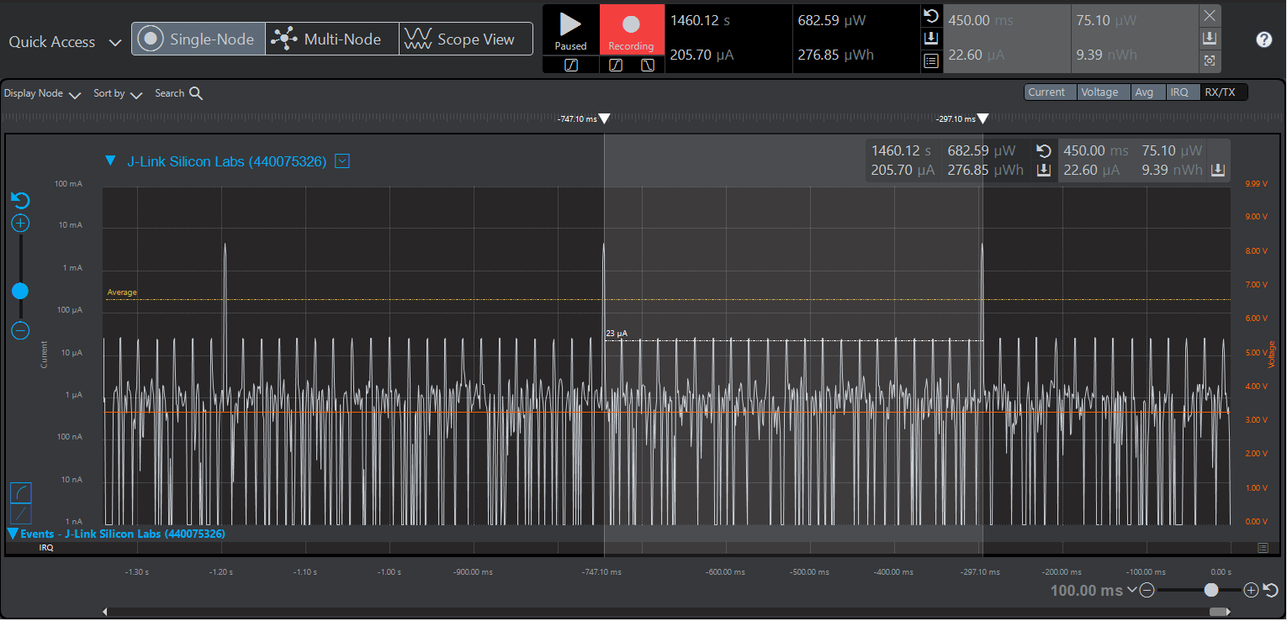

4. What is the average current between advertisements?

1.95 micro amps

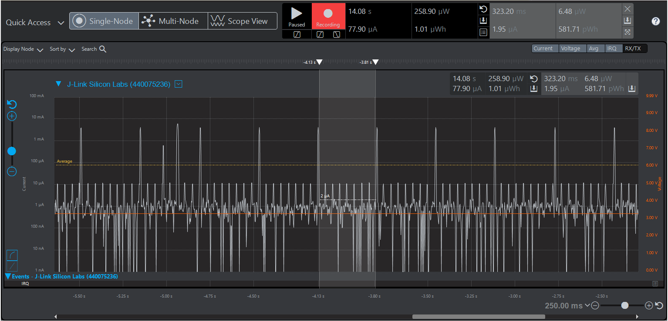

5. What is the average current between connection intervals?

1.91 micro amps

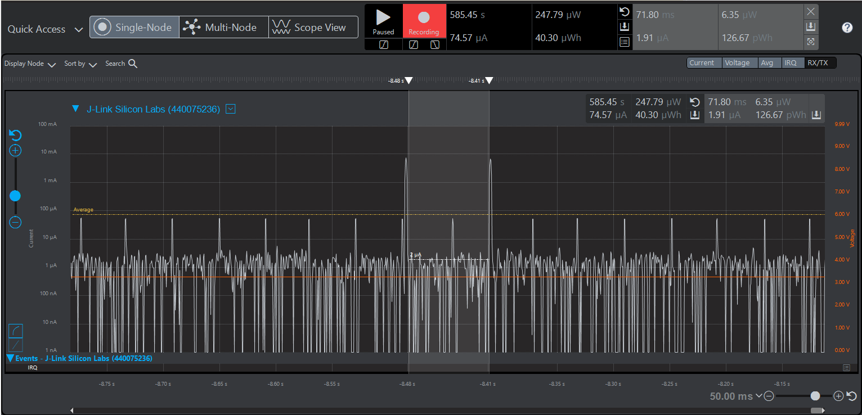

6. What is the peak current of an advertisement?

9.27mili amps

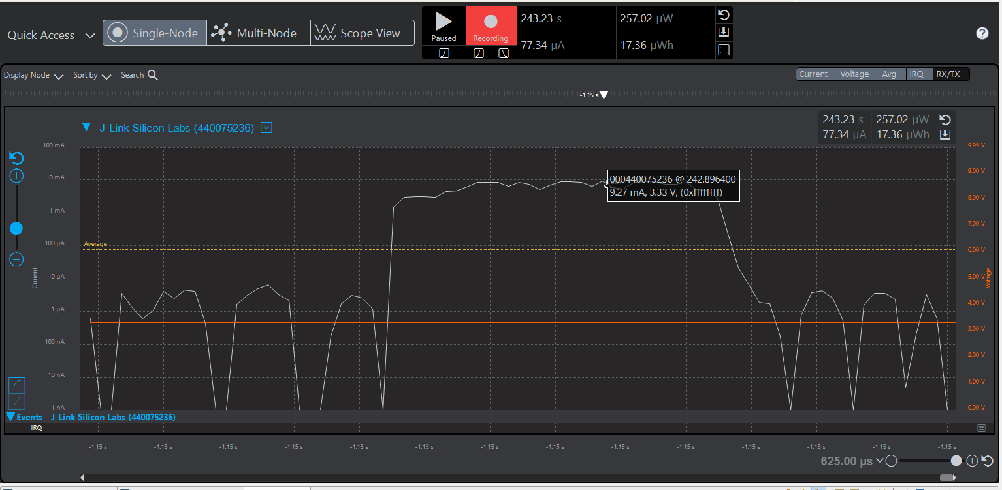

7. What is the peak current of a data transmission when the phone is placed next to the Blue Gecko?

9.97 milli amps at -26 tx power

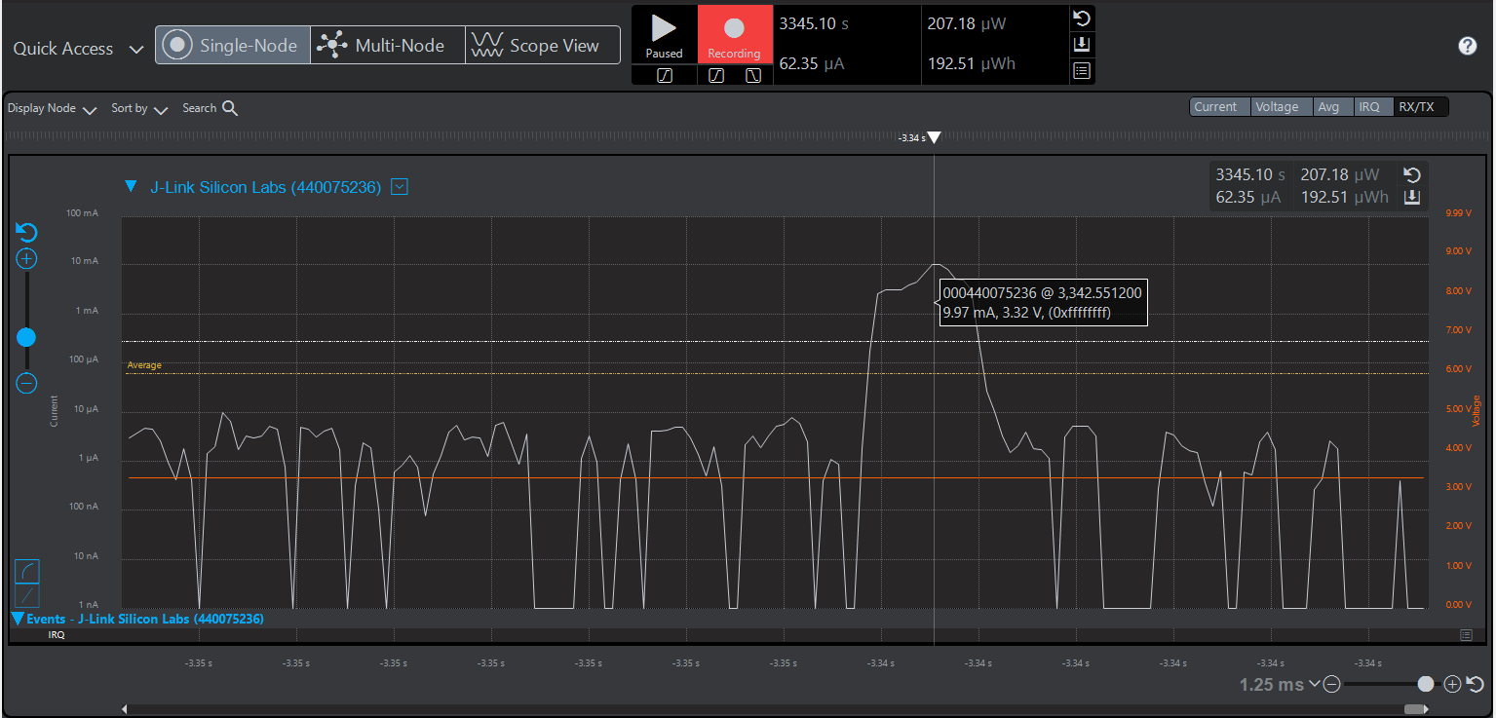

8. What is the peak current of a data transmission when the phone is placed 20 feet away from the Blue Gecko?

21.08 milli amps at 8 tx power

