**Automated install-Assignment**

Deb1: 192.168.74.134; apache2

Deb2: automatic installiation

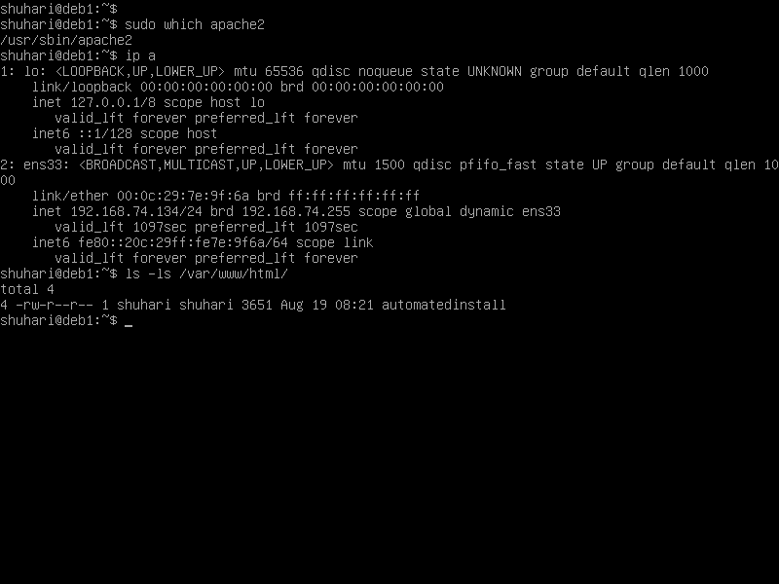

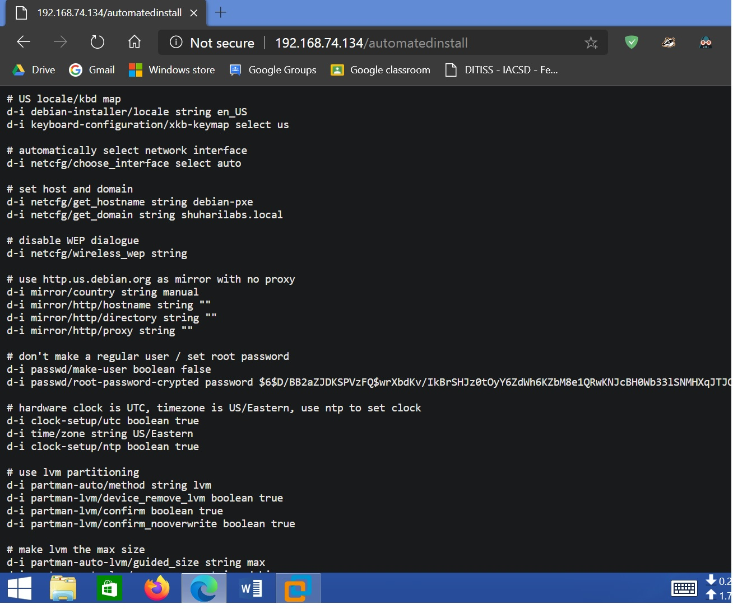

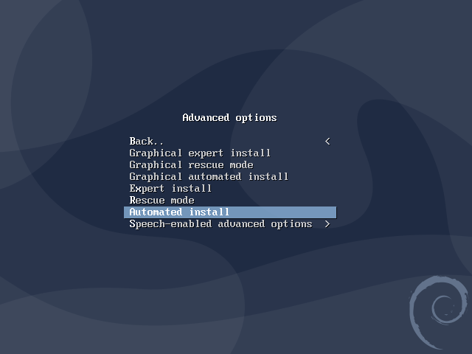

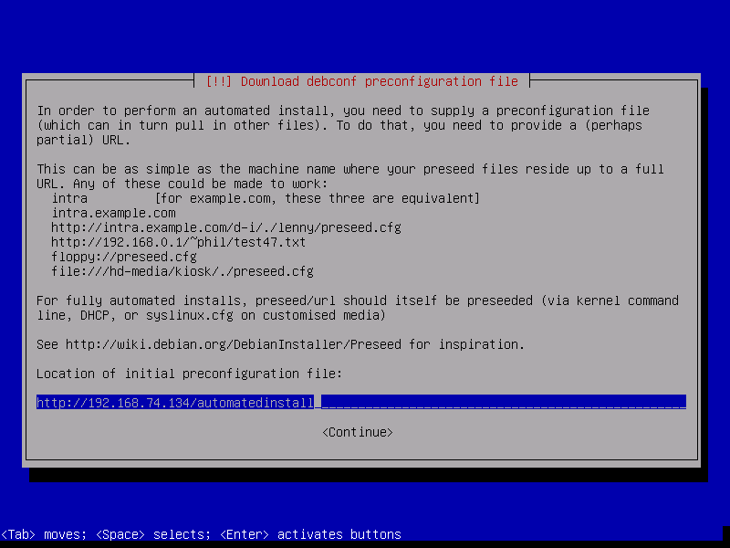

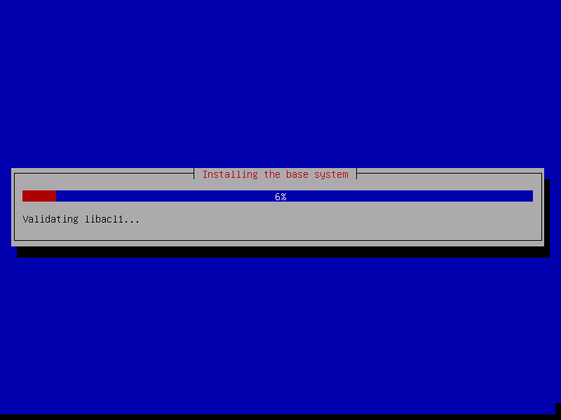

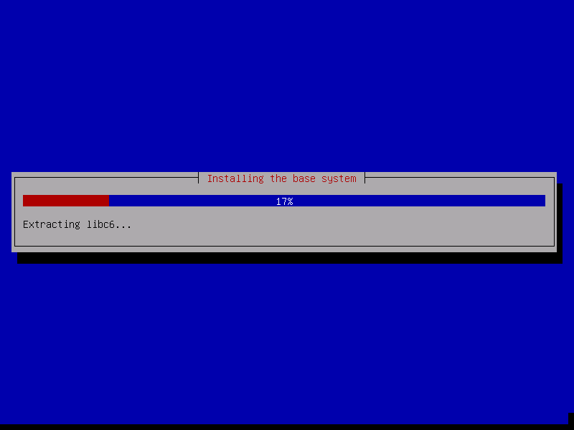

Sample answer file

# US locale/kbd map

d-i debian-installer/locale string en_US

d-i keyboard-configuration/xkb-keymap select us

# automatically select network interface

d-i netcfg/choose_interface select auto

# set host and domain

d-i netcfg/get_hostname string debian-pxe

d-i netcfg/get_domain string shuharilabs.local

# disable WEP dialogue

d-i netcfg/wireless_wep string

# use http.us.debian.org as mirror with no proxy

d-i mirror/country string manual

d-i mirror/http/hostname string ""

d-i mirror/http/directory string ""

d-i mirror/http/proxy string ""

# don't make a regular user / set root password

d-i passwd/make-user boolean false

d-i passwd/root-password-crypted password $6$D/BB2aZJDKSPVzFQ$wrXbdKv/IkBrSHJz0tOyY6ZdWh6KZbM8e1QRwKNJcBH0Wb33lSNMH$

# hardware clock is UTC, timezone is US/Eastern, use ntp to set clock

d-i clock-setup/utc boolean true

d-i time/zone string US/Eastern

d-i clock-setup/ntp boolean true

# use lvm partitioning

d-i partman-auto/method string lvm

d-i partman-lvm/device_remove_lvm boolean true

d-i partman-lvm/confirm boolean true

d-i partman-lvm/confirm_nooverwrite boolean true

# make lvm the max size

d-i partman-auto-lvm/guided_size string max

d-i partman-auto-lvm/new_vg_name string debian

# use the following partition scheme on /dev/sda

d-i partman-auto/disk string /dev/sda

d-i partman-auto/choose_recipe select boot-lvm

# /boot 500M ext4

# /tmp 2G ext4

# /var/log 4G ext4

# / 8G+ ext4

d-i partman-auto/expert_recipe string \

boot-lvm :: \

500 500 500 ext4 \

$primary{ } $bootable{ } \

method{ format } format{ } \

use_filesystem{ } filesystem{ ext4 } \

mountpoint{ /boot } \

. \

2048 5000 200% linux-swap \

$lvmok{ } \

lv_name{ swap } in_vg { debian } \

method{ swap } format{ } \

. \

2048 4000 2048 ext4 \

$lvmok{ } \

lv_name{ tmp } in_vg { debian } \

method{ format } format{ } \

use_filesystem{ } filesystem{ ext4 } \

mountpoint{ /tmp } \

. \

8192 3000 8192 ext4 \

$lvmok{ } \

lv_name{ root } in_vg { debian } \

method{ format } format{ } \

use_filesystem{ } filesystem{ ext4 } \

mountpoint{ / } \

. \

# remove any RAID partitioning

d-i partman-md/device_remove_md boolean true

# don't confirm anything

d-i partman-basicfilesystems/no_mount_point boolean false

d-i partman-partitioning/confirm_write_new_label boolean true

d-i partman/choose_partition select finish

d-i partman/confirm boolean true

d-i partman/confirm_nooverwrite boolean true

# setup non-free and contrib repositories

d-i apt-setup/non-free boolean true

d-i apt-setup/contrib boolean true

# install standard system

tasksel tasksel/first multiselect standard, ssh-server

# upgrade all packages or not

d-i pkgsel/upgrade select none

# disable popularity contest

popularity-contest popularity-contest/participate boolean false

# force grub install to /dev/sda

d-i grub-installer/only_debian boolean true

d-i grub-installer/with_other_os boolean true

d-i grub-installer/bootdev string /dev/sda

# don't wait for confirm, just reboot when finished

d-i finish-install/reboot_in_progress note