Machine Learning Operations (MLOps) –AIMLCZG523
Assignment 01

Heart Disease Prediction
An End-to-End MLOps Pipeline: from Data to a Monitored API on Kubernetes

Submitted by | SHREYA RAJ
BITS ID | 2025ae05052
Course | Machine Learning Operations (MLOps) – AIMLCZG523
Repository | https://github.com/Shreya2025ae05052/MLOps_Assignment1
Date | October 2026

Contents
1. Introduction
2. System Architecture
3. Setup and Installation
4. Data Acquisition and EDA
5. Feature Engineering and Model Development
6. Experiment Tracking with MLflow
7. Model Packaging and Reproducibility
8. CI/CD Pipeline and Automated Testing
9. Model Containerization
10. Production Deployment on Kubernetes
11. Monitoring and Logging
12. Conclusion

1. Introduction
In this assignment I built a classifier that predicts heart disease from 13 patient health measurements, and I took it all the way to a monitored API on Kubernetes. My goal was a pipeline that is reproducible and automated, not only a good model.
Area | Tool I used | Why
ML and EDA | pandas, scikit-learn, seaborn | standard, well-tested Python libraries
Experiment tracking | MLflow | compares runs side by side, stores models
Testing / CI | pytest, flake8, GitHub Actions | runs automatically on every push
Serving | FastAPI + Docker | input validation and auto docs; same environment everywhere
Deployment | Kubernetes (Docker Desktop) | allowed by the assignment, runs locally
Monitoring | Prometheus + Grafana | standard open-source metrics stack

My objectives, following the assignment:
- Model: clean the data, explore it and train at least two tuned models.
- Reproducibility: track every experiment and package the model so results can be repeated.
- Automation: lint, test and retrain automatically on every push, and stop on errors.
- Deployment: serve the model as an API in Docker and deploy it on Kubernetes.
- Monitoring: log every request and show live metrics on a dashboard.

2. System Architecture
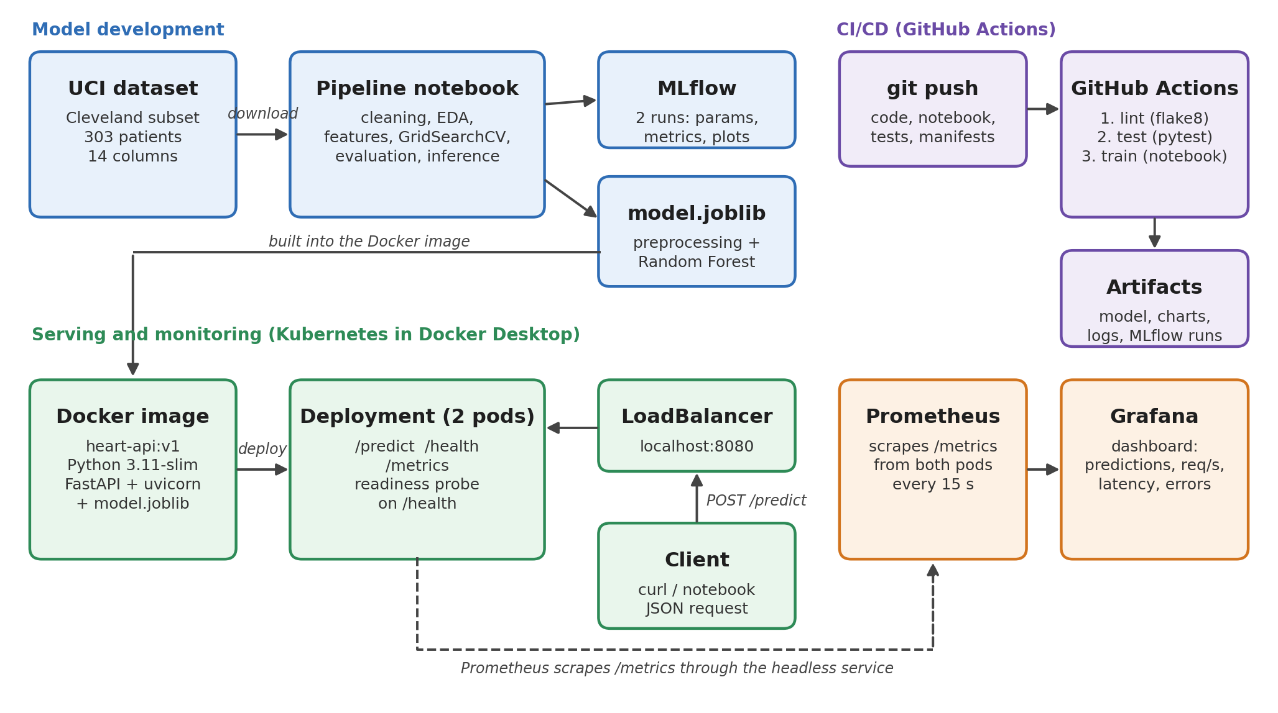
Figure 1: Architecture of the pipeline
- Model development: the notebook cleans the data, trains two models, logs them to MLflow and saves the best one as models/model.joblib.
- CI/CD: every git push runs lint, unit tests and the full notebook in GitHub Actions.
- Serving: the model is packed into a Docker image with a FastAPI app; Kubernetes runs 2 copies behind a LoadBalancer.
- Monitoring: Prometheus collects metrics from both pods every 15 seconds and Grafana shows them.

3. Setup and Installation
Requirements: Python 3.11 (3.12 also works), Git, and Docker Desktop with Kubernetes enabled (kubeadm). All commands are run from the project folder.
git clone https://github.com/Shreya2025ae05052/MLOps_Assignment1.git
cd MLOps_Assignment1
python -m venv venv
venv\Scripts\activate # Mac/Linux: source venv/bin/activate
pip install -r requirements.txt
jupyter nbconvert --to notebook --execute --inplace heart_disease_pipeline.ipynb
pytest -v
mlflow ui # http://localhost:5000
docker build -t heart-api:v1 .
kubectl apply -f k8s/
Access: API at http://localhost:8080 (Kubernetes) or http://localhost:8000 (Docker), Prometheus at :9090, Grafana at :3000 (admin/admin). Example:
curl.exe -X POST http://localhost:8080/predict -H "Content-Type: application/json" --data-binary "@sample_input.json"
→ {"prediction": 0, "confidence": 0.6976}

4. Data Acquisition and EDA

4.1 Data and cleaning
- Source: I used the Cleveland subset of the UCI Heart Disease dataset (303 patients) because it is the most complete; the other hospital subsets miss most values in several columns. The notebook downloads it automatically.
- Missing values: Only ca (4) and thal (2) had missing values, shown as "?". I removed these 6 rows because they are just 2% of the data, and guessing medical values could add errors.
- Target: I turned num (0–4) into a binary target, 0 = no disease and 1 = disease, because the task is to predict presence or absence.
Result: 297 clean rows, saved as data/cleaned/heart_cleaned.csv.

4.2 EDA findings
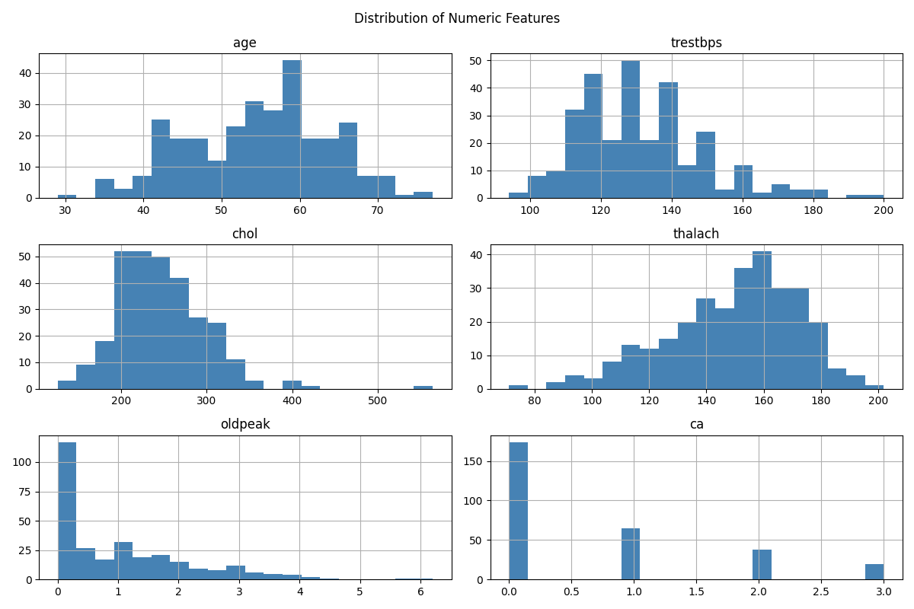
Figure 2: Distribution of the numeric features
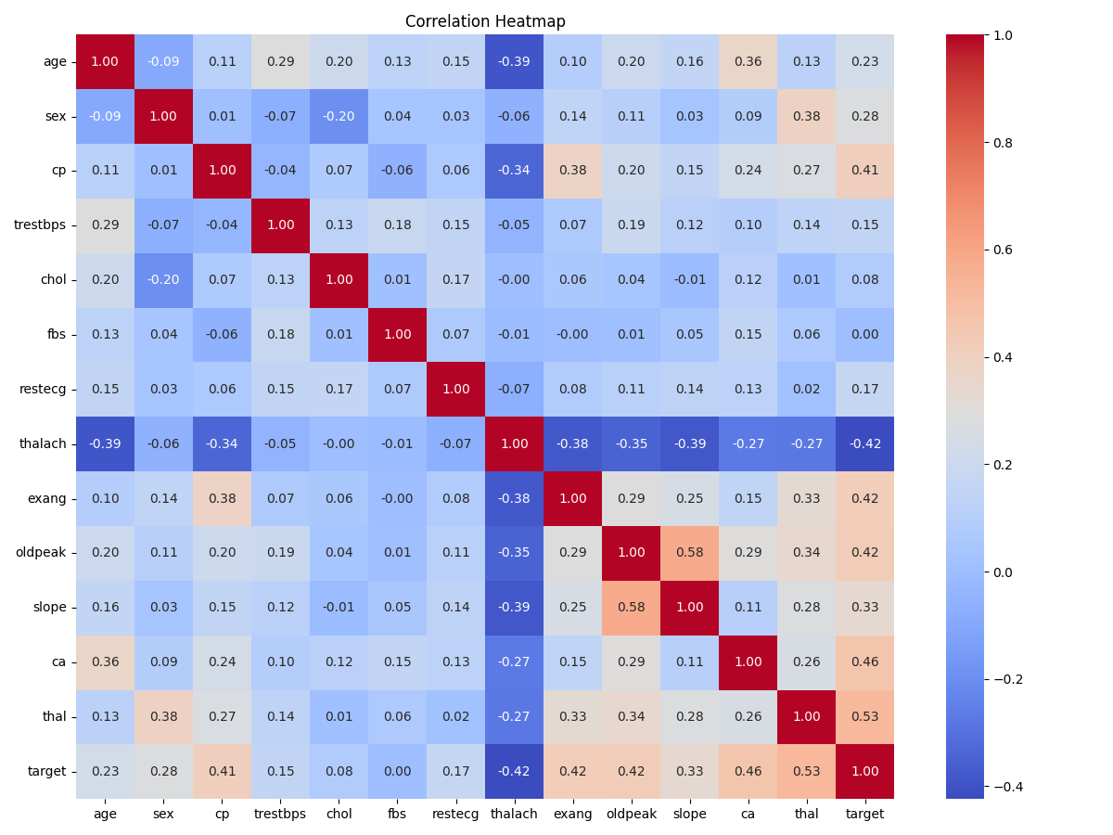 | 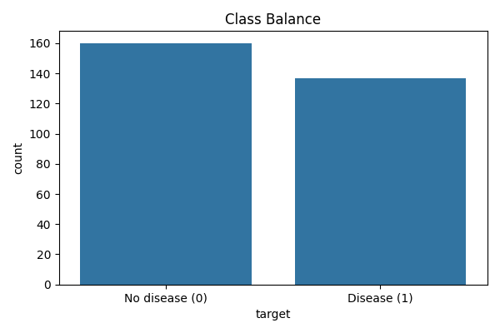
Figure 3: Correlation heatmap (left) and class balance (right)
- Balanced classes: 160 healthy (54%) vs 137 with disease (46%). This is close to balanced, so I did not need resampling, and accuracy is a fair metric.
- Strongest features: thal, ca, exang, oldpeak and cp have the strongest link to disease (0.41–0.53). A lower maximum heart rate (thalach, −0.42) also means higher risk.
- Weak features kept: fbs and chol are weak alone, but I kept them because they can still help in combination with other features.
- No multicollinearity: No pair of features is strongly correlated (highest 0.58), so I kept all 13 features.

5. Feature Engineering and Model Development

5.1 Features
- Scaling: I scaled the 6 numeric features with StandardScaler, so large values like cholesterol do not dominate the model.
- Encoding: I one-hot encoded the 7 categorical features, because their numbers are labels, not amounts (chest pain type 4 is not "twice" type 2).
- One pipeline: I put both steps and the model in one scikit-learn Pipeline, so the scaler only learns from training data (no data leakage) and new data is always transformed the same way.

5.2 Models, tuning and results
I split the data 80/20 with stratification (237 train, 60 test) and tuned both models with GridSearchCV and 5-fold cross-validation.
Model | Why I chose it | Best settings found
Logistic Regression | simple, interpretable baseline | C = 0.1
Random Forest | captures non-linear patterns | 200 trees, max_depth = 5, min_samples_split = 2

Metric | Logistic Regression | Random Forest
CV accuracy / precision / recall | 0.835 / 0.858 / 0.778 | 0.814 / 0.834 / 0.760
CV ROC-AUC | 0.8955 | 0.8959
Test accuracy / precision / recall | 0.867 / 0.885 / 0.821 | 0.867 / 0.885 / 0.821
Test ROC-AUC | 0.952 | 0.944

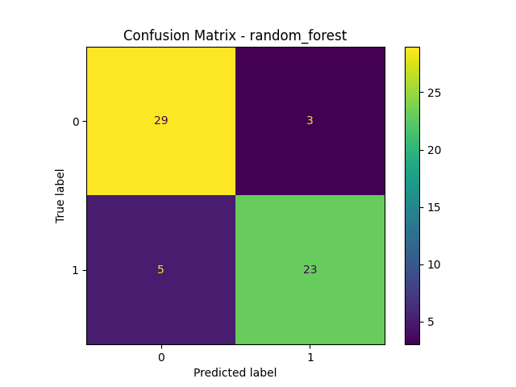 | 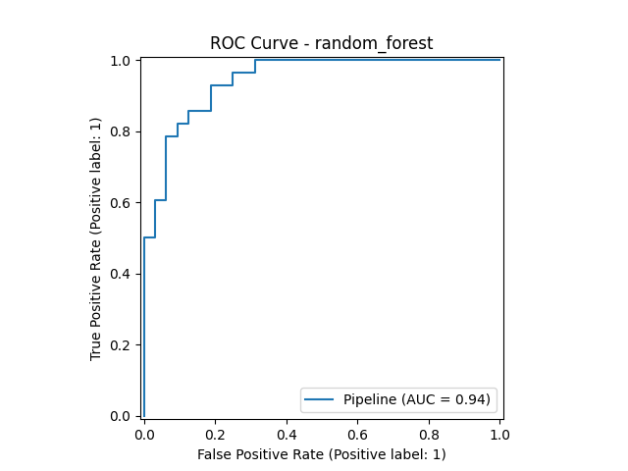
Figure 4: Random Forest on the test set: confusion matrix and ROC curve

5.3 Model selection
I selected Random Forest because it has the highest cross-validated ROC-AUC. I used ROC-AUC because it measures how well the model separates sick and healthy patients at every threshold, and cross-validation because it uses all 237 training rows instead of only 60 test rows. The two models are very close, so both are good choices for this data. Limiting tree depth to 5 helped Random Forest, because deeper trees overfit the small dataset.

6. Experiment Tracking with MLflow
I logged each model as one MLflow run, so I can compare them side by side and reproduce any result. Each run stores the parameters (best settings), 8 metrics (CV and test accuracy, precision, recall, ROC-AUC) and artifacts (confusion matrix, ROC curve, grid search results and the model itself).

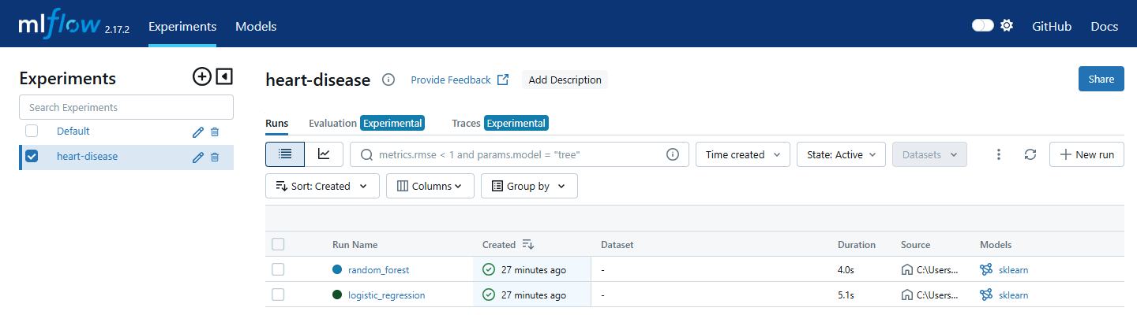
Figure 5: MLflow experiment with both runs
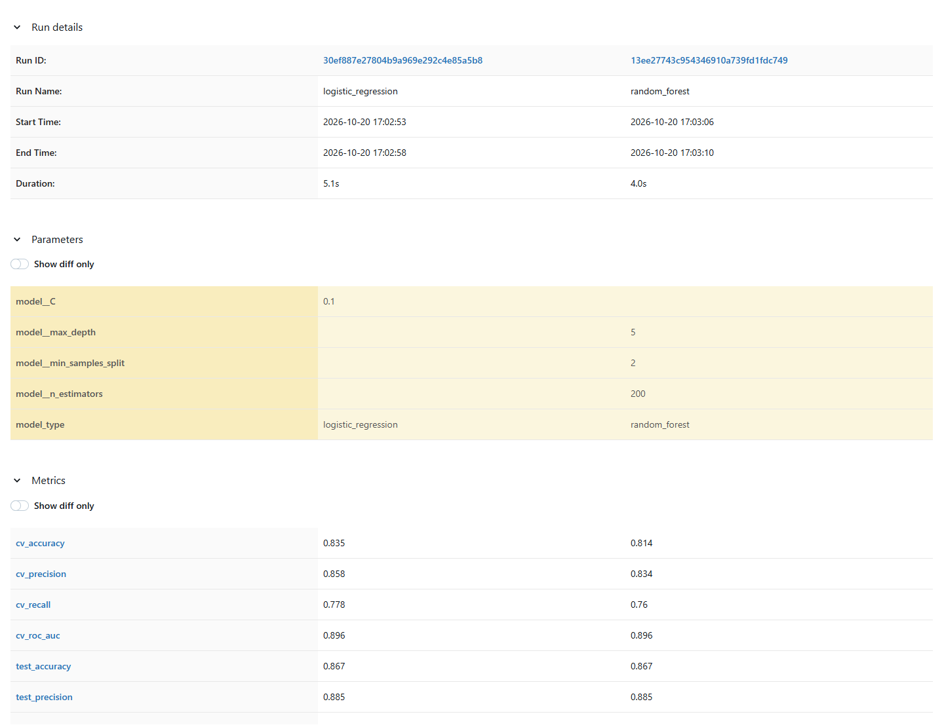
Figure 6: Comparison of the two runs: parameters and metrics
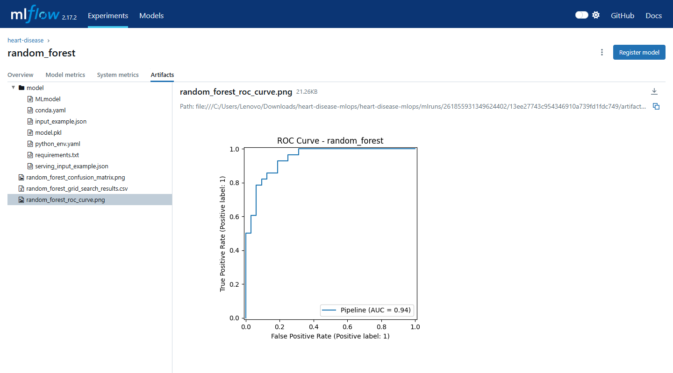
Figure 7: Artifacts of the Random Forest run

7. Model Packaging and Reproducibility
- One file: I saved preprocessing and model together in models/model.joblib, so the API uses exactly the same transformations as training.
- Pinned versions: I pinned every library version in requirements.txt, because a newer version can change results or break the saved model.
- Fixed randomness: I set random_state = 42 for the split, CV folds and Random Forest, so every run gives the same numbers.
- Clean-setup check: The CI train job runs the whole notebook on a fresh GitHub server, which proves the pipeline works from a clean setup.

8. CI/CD Pipeline and Automated Testing
I wrote 14 pytest tests: data cleaning and preprocessing (5), model training, saving and inference (5), and the API (4). They run on small fake data, so they take seconds and need no download.
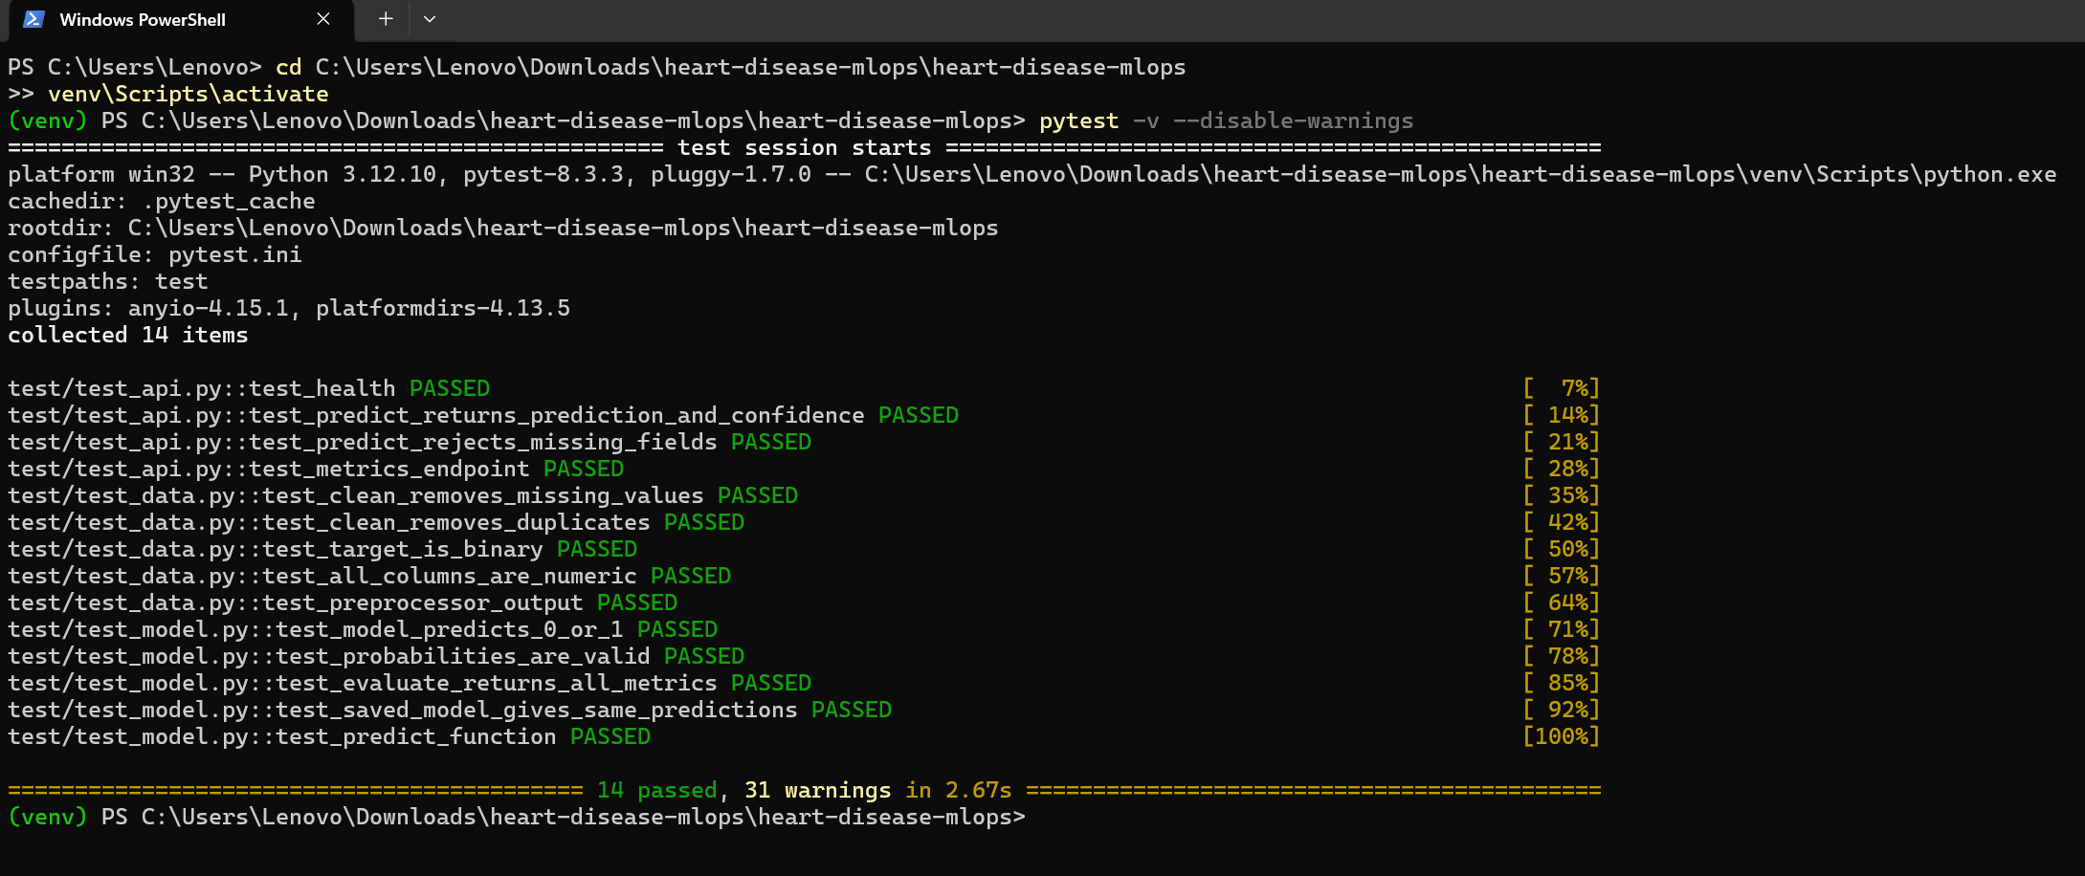
Figure 8: All 14 unit tests passing
My GitHub Actions workflow has three jobs in order: lint (flake8) → test (pytest) → train (runs the notebook). Each job only starts if the previous one passed, so a code or test error stops the pipeline. Every run uploads test results, logs, the model and charts as artifacts.
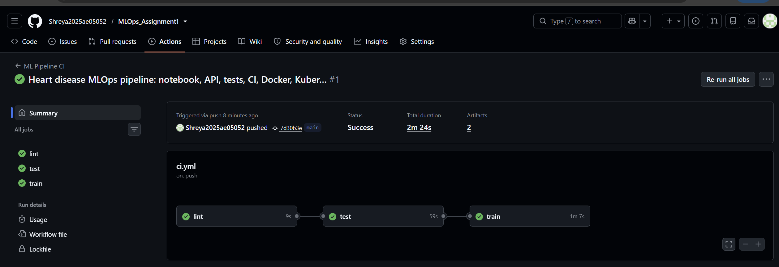
Figure 9: Successful run: lint, test and train passed
To prove that the pipeline stops on errors, I pushed a test with a wrong expected value. The test job failed and train was skipped; the next commit fixed it.
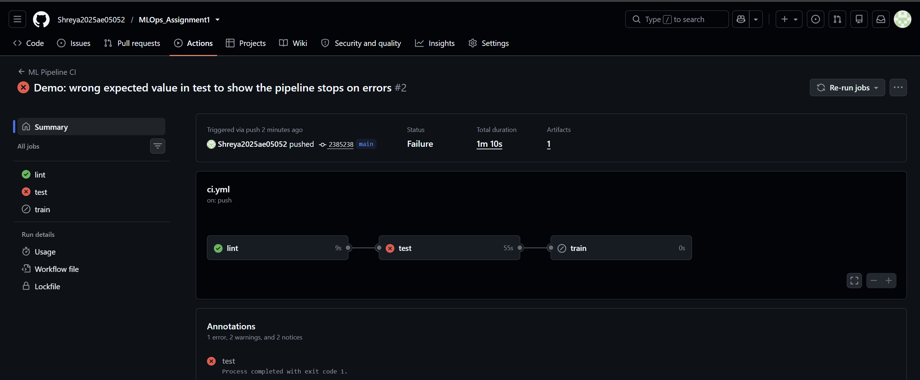
Figure 10: Failed run: test failed, so train was skipped
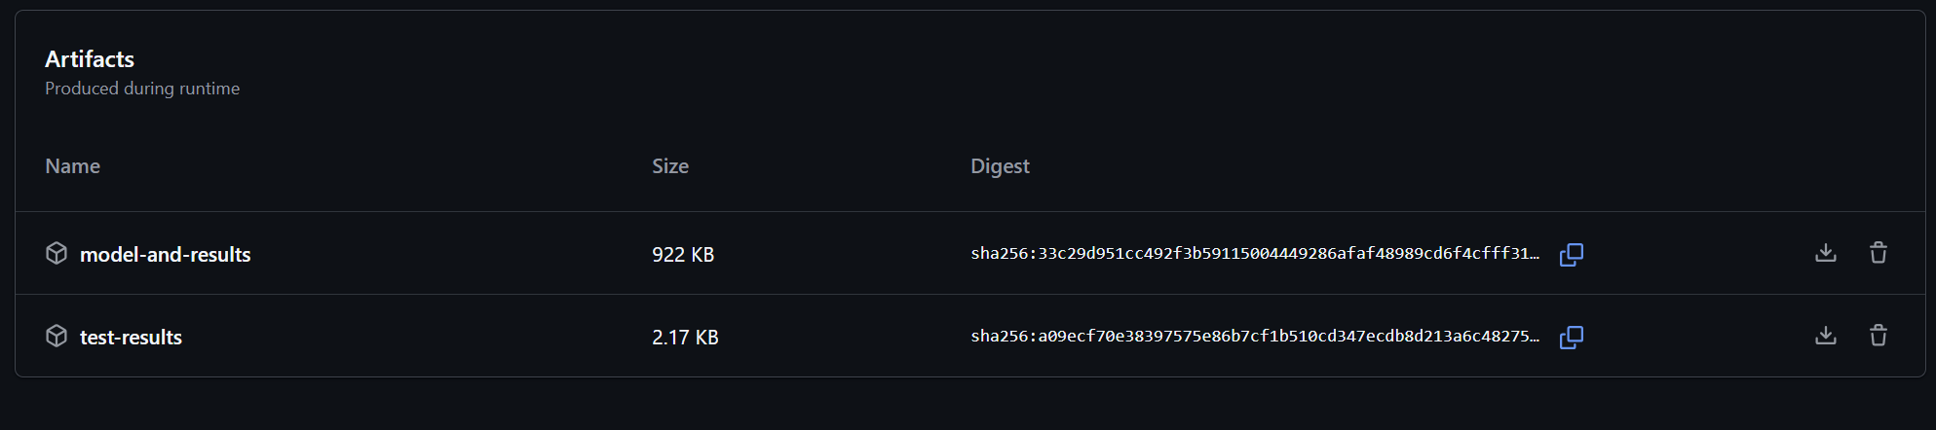
Figure 11: Artifacts uploaded by a workflow run

9. Model Containerization
I built the API with FastAPI because it validates the input automatically (a request with missing fields gets HTTP 422) and creates interactive docs at /docs.
Endpoint | What it does
POST /predict | takes the 13 features as JSON, returns prediction (0/1) and confidence
GET /health | returns {"status": "ok"}; used by the Kubernetes readiness probe
GET /metrics | Prometheus metrics: request count and latency

My Dockerfile uses python:3.11-slim and installs the libraries before copying the code, so rebuilds are fast. Training files, data and tests are excluded to keep the image small.
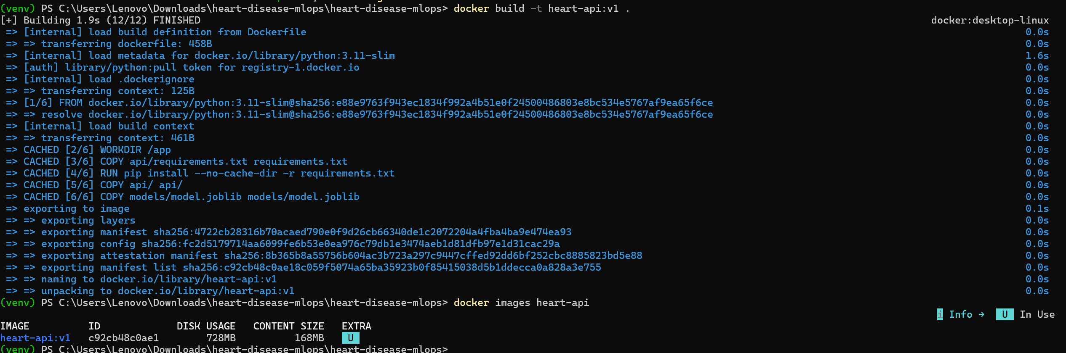
Figure 12: Docker image build
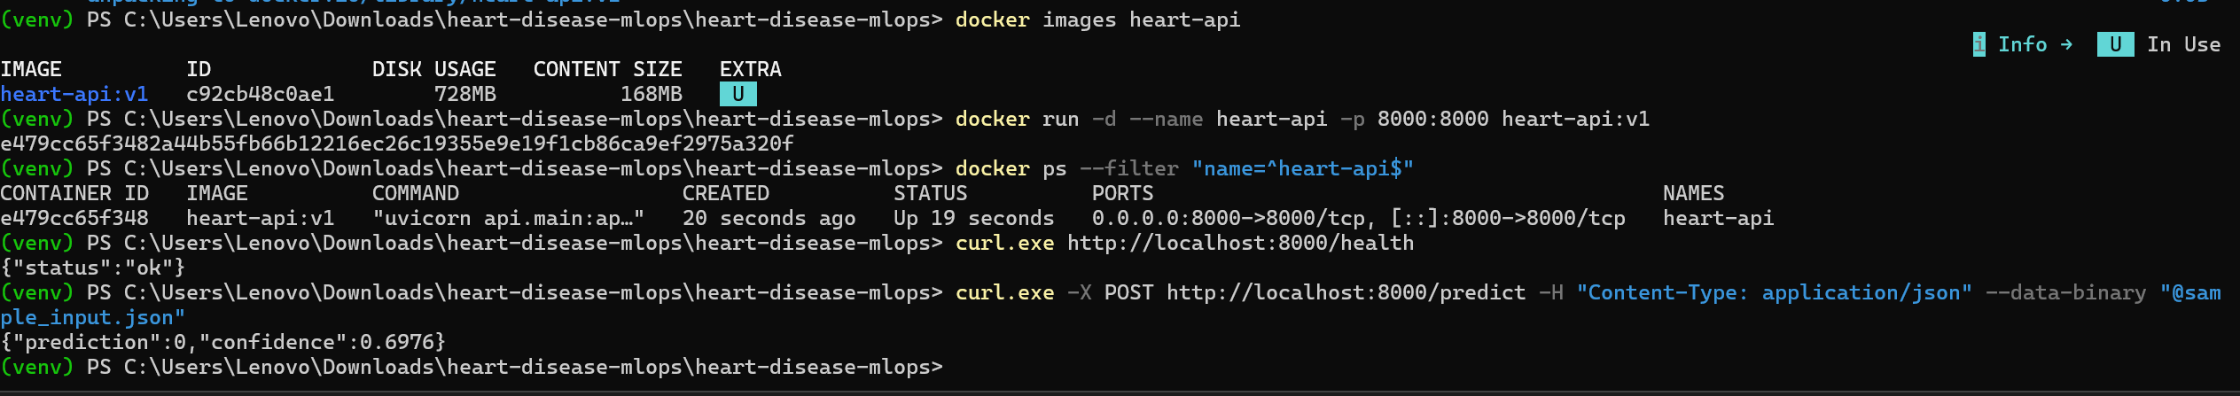
Figure 13: Container answering /health and /predict

10. Production Deployment on Kubernetes
I deployed on the Kubernetes cluster in Docker Desktop, which the assignment allows, using k8s/api-deployment.yaml:
- Deployment: 2 replicas, so the API keeps working if one pod stops.
- Readiness probe: traffic only goes to a pod after /health answers.
- LoadBalancer: one address for both pods: http://localhost:8080.
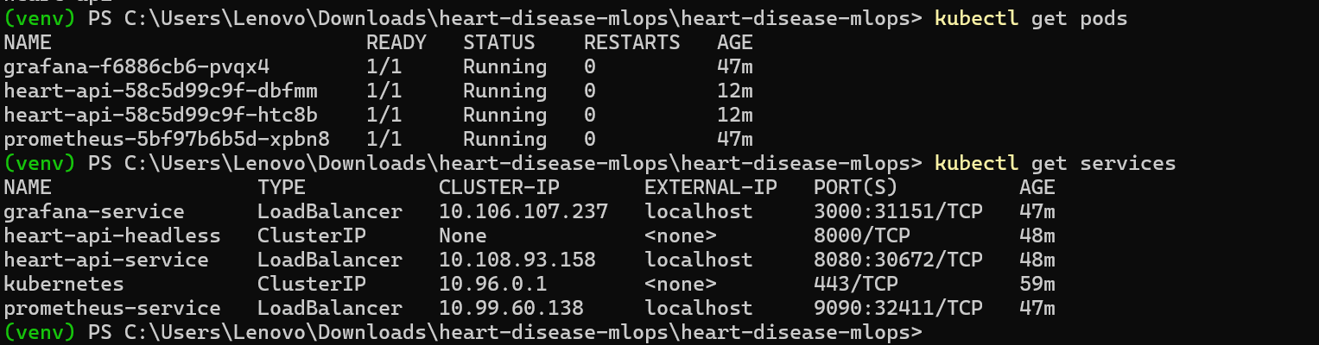
Figure 14: Running pods and services
Figure 15: Prediction through the LoadBalancer on port 8080

11. Monitoring and Logging
- Logging: the API logs every request (method, path, status, time) and every prediction (input, result, confidence), viewed with kubectl logs.
- Metrics: Prometheus scrapes /metrics from both pods every 15 seconds through a headless service.
- Dashboard: my Grafana dashboard shows total predictions, requests per second, response time and errors. I sent test traffic, including a few invalid requests, to see each panel react.

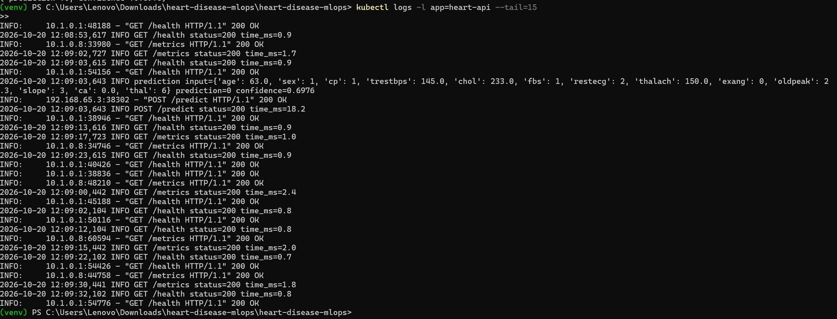
Figure 16: Request and prediction logs from the pods

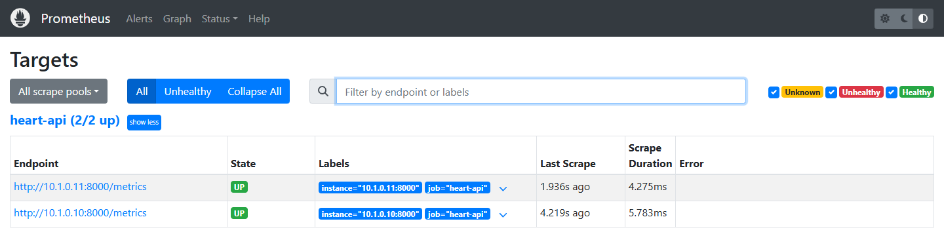
Figure 17: Prometheus: both API pods are UP

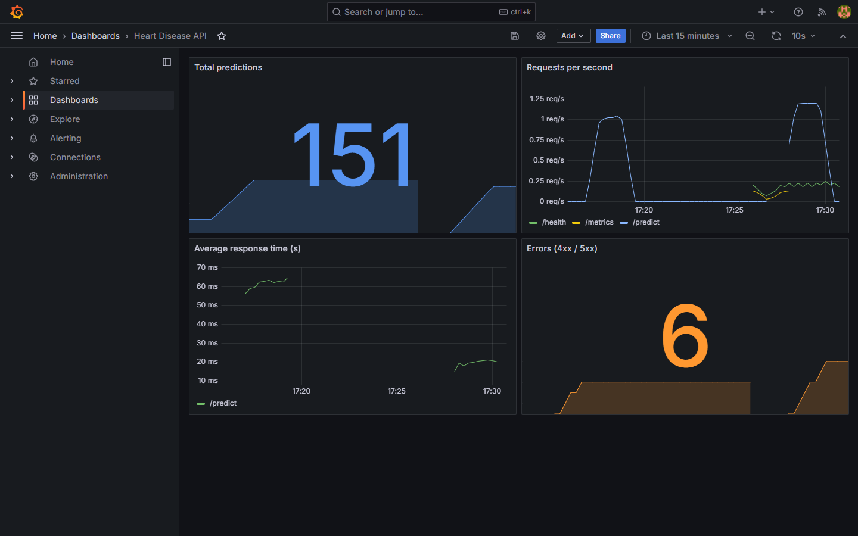
Figure 18: Grafana dashboard

12. Conclusion
I built a complete, working MLOps pipeline for heart disease prediction. Starting from the raw UCI data, I cleaned and explored it, trained and tuned two models, and selected a Random Forest that reaches 86.7% accuracy and 0.944 ROC-AUC on unseen patients. Every step is tracked in MLflow, tested by 14 unit tests and re-run automatically by GitHub Actions on each push. The model is served by a FastAPI app in Docker, runs as two pods on Kubernetes, and is monitored with Prometheus and Grafana.
Along the way I learned that small details matter in MLOps:
- Exact numbers: selecting the model on rounded scores made a near-tie look like an exact tie, so I switched to the exact values.
- Pinned dependencies: an unpinned library (scipy) changed the environment and caused warnings, so I pinned it.
- Tests as a safety net: a deliberately broken test stopped the pipeline before training, which is exactly what should happen.
Next, I would lower the decision threshold to catch more patients with disease (recall is 0.82), add more data from the other UCI hospitals, and use the MLflow Model Registry to version models for deployment.
Code repository: https://github.com/Shreya2025ae05052/MLOps_Assignment1

