Write a Python program to extract all email addresses from a block of text using regular

expressions. GitHub Copilot along with VS Code. Use zero shot prompting give prompt

Prompt : Write a python program that takes Extract all email addresses from a block of text using regular expressions

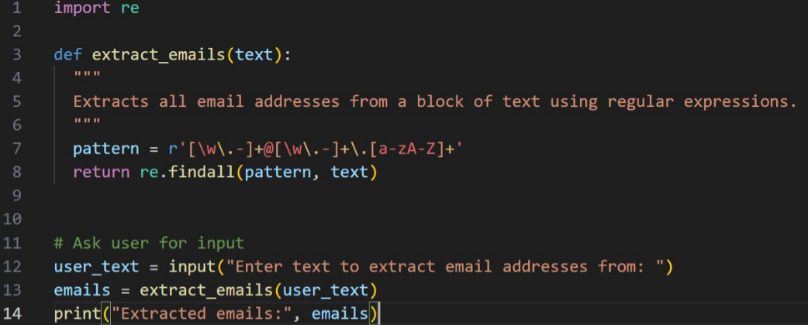

#Output:

