

**TITLE**​ **OF THE PROJECT**

OIL​ BUSINESS OUTCOME ANALYZER

MINI PROJECT REPORT

Submitted in partial fulfillment of the requirements for the award of the degree of

**BACHELOR OF ENGINEERING**

IN

**INFORMATION TECHNOLOGY**

By

<Thodupunoori Shreya>< 1602-19-737-042>

<P.Keerthana Reddy ><1602-19-737-183>

**Department of Information Technology**

**Vasavi College of Engineering (Autonomous)**

**(Affiliated to Osmania University)**

**Ibrahimbagh, Hyderabad – 31**



**VASAVI COLLEGE OF ENGINEERING(AUTONOMOUS)**

**(AFFILIATED TO OSMANIA UNIVERSITY)**

**HYDERABAD - 500 031**

**Department of Information Technology**

**DECLARATION BY CANDIDATE**

We, Thodupunoori Shreya and P.Keerthana Reddy​**,** ​bearing hall ticket numbers, ​**<**​1602-19-737-042​**>** ​and​**<**​1602-19-737-183>,

hereby declare that the project report entitled ​**<**​” Oil Business Outcome

Analyzer”​**>**

Department of Information Technology, Vasavi College of

Engineering, Hyderabad, is submitted in partial fulfillment of the requirement for the award of the degree of ​**Bachelor of** **Engineering**​in​**Information Technology**

This is a record of bonafide work carried out by me and the results embodied in this project report has not been submitted to any other university or institute for the award of any other degree or diploma.

**<Thodupunoori Shreya>**

**<1602-19-737-042>**

**<P.Keerthana Reddy>**

**<1602-19-737-183>**



**ACKNOWLEDGEMENT**

It gives us immense pleasure to thank the Department of INFORMATION TECHNOLOGY, for introducing the subject “mini-project” in BE third semester that let us learn and explore more features in “C programming language”.

I would also like to show my appreciation to our honorable principal, Dr. S V RAMANA sir, for supporting us and our beloved mini-project lecturer, Mrs.

LEELAVATHI ma’am, for letting us properly understand the process of doing the mini-project using c and for providing insight and expertise that greatly assisted the project.

My parents were my first teachers and they have provided me with such a great exposure that has helped me bloom. My family and friends will always be loved for sticking by me through thick and thin. THANK YOU!



**ABSTRACT**

A business outcome analytical report is a type of business report that uses qualitative and quantitative company data to analyze as well as evaluate a business strategy. Our project Business Outcome Analyzer is based on this concept. The basic purpose of the project is to lessen the manual work of businessmen who usually have hectic schedules. This business outcome analyzer performs tasks like-it monitors the stocks and informs the user about the requirements, helps the user to track his returns of the business, tells the user how long it will take to run in profits,displays the status of the user’s business through bar graphs.



​**INTRODUCTION**

Our project is an oil business outcome analyzer.The purpose of choosing the business outcome analyzer concept is to reduce the manual work for the business users who usually are preoccupied with a lot of things. It offers many benefits than manual records such as avoiding confusion, displays clear pictures of the information, predicts the needed stocks if any, graphical representation of the data, and it is also time saving and energy saving, tracks monthly info. It offers security as all the data entered by the user is maintained as a record in the account created by the user, which is also protected by a password.

The basic priority of the project is to make it as efficient and easy as it can be so that no complications or obstacles may arise while storing data of a business instead of maintaining piles of books as records. This application serves in order to save both time and energy. The procedure to create an account, input every month is also simple and easy. So, it is compatible to handle and has password protection for the user’s account. Analysis of every month’s sales is displayed in the form of bar graphs which makes the user to clearly understand the progress of his business.



**TECHNOLOGY**

To implement any project successfully, there will be technological requirements which can either be software or hardware requirements.

**a)Software requirements**

Since our project was supposed to be based on the C programming language, it is a bare necessity to have the knowledge and syntaxes of the language and a proper compiler and a text editor to run and write the programs. Our project also includes some of the C graphics libraries such as graphics.h,libbgi.a,winbgim.h and we are supposed to link the libraries and change TDM GCC 32 compiler settings,as it does not work on GCC 64 bit compiler.Any text editor can be used for writing the program such as Sublime,Vim,Atom,Notepad,Notepad++.We chose Sublime text editor to write our code as it is a sophisticated text editor for code and it is customizable.

Compiler

Many of the C compilers include: 1) Borland Turbo C

1. Tiny C compiler
2. Portable C compiler
3. TDM GCC 32 bit compiler
4. Clang

Among the many available compilers, we have installed and used the TDM GCC 32 bit compiler to run/execute the code for “Image Steganography” that we have written.

**b)Hardware requirements**

The most common set of requirements defined by any operating system or software application is the physical computer resources, also known as hardware. A hardware requirements list is always accompanied by a hardware compatibility list (HCL), especially in case of operating systems. An HCL lists tested, compatible and sometimes incompatible hardware devices for a particular operating system or application.

Hardware requirements for present project are:

Processor: Intel Core i3

RAM: 8GB

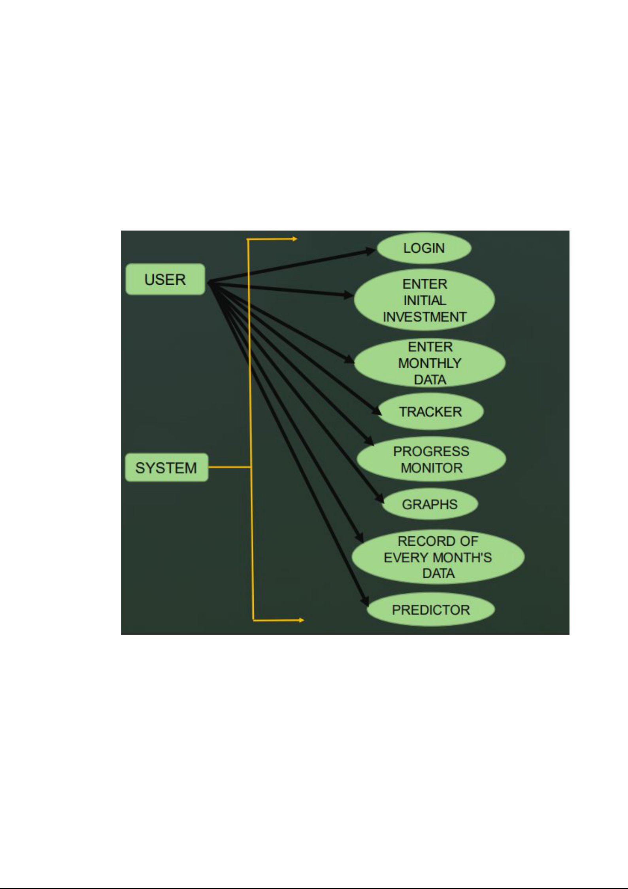

​**PROPOSED**​ **WORK**

​**a) Design**

**I. Use case Diagram:**

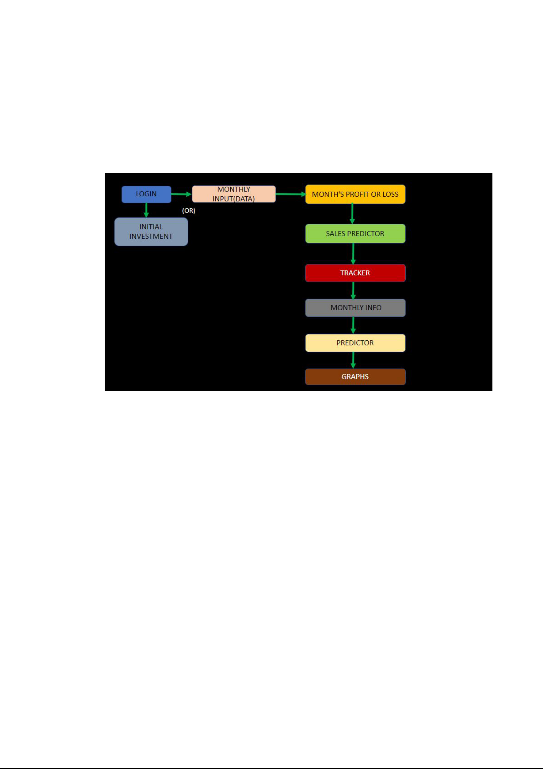

**II. Flow Chart**

When the user runs the program,a welcome page is popped up which directs to the login page.The user can log in if he already has an account or create an account if he is new.If the user creates the account he is asked to enter initial investment of his business and exit.The analyzer starts recording all the info entered from then.If the user already has an account and logs in,he must enter every month’s info such as material cost,weight of the material,labour charge,rent,electricity bill,number of bottles produced,number of bottles sold.Then the analyzer retrieves the info and displays the profit earned in that month.Then the predictor predicts the number of bottles needed for the next month based on the stock remaining.The user can view the info of a particular month such as data entered,profit earned.The till date returns are also displayed to the user and how long will the business take to get the returns.Analysis of sales over the months entered is

displayed in the form of bar graphs.



**b)Implementation**

(Sample code)

#include<windows.h>

#include<stdio.h>

#include<stdlib.h>

#include<conio.h>

#include<string.h>

#include<math.h>

#include<graphics.h>

void loginPage();

void welcome();

void barGraphs();

void Predictor();

void Month_info();

int Month_ProfitOrLoss(int,int,int,int);

void Monthly_Input(char);

void Tracker(int,int,int,int,int);

int Sales_Predictor(int,int);

void password();

void Monthly_Input(char choice)

{

FILE *fp,*fp1,*fpm; int cost;

X:

system("cls");

system("COLOR 0E");

gotoxy(40,20);

printf("If this is initial investment enter 's'");

gotoxy(40,22);

printf("If this the feed for the monthly input ,enter 'n'"); gotoxy(40,24);

printf("Enter your choice: ");

scanf("\n%c",&choice);

if(choice == 's')

{



fp=fopen("monthlyData.txt","w");

system("cls");

gotoxy(40,20);

system("COLOR 0A");

printf("Enter initial investment : ");

scanf("%d",&cost);

fprintf(fp,"%d\n",cost);

fclose(fp);

fpm=fopen("month.txt","w");

fprintf(fpm,"%d",0);

fclose(fpm);

system("cls");

system("COLOR 07");

}

else if(choice == 'n')

{

fp = fopen("monthlyData.txt","a");

int

month,sales,weight,Material_Cost,Labour_cost,bill,rent,output,price,previous_month_s ales=0,Pft_B,month_return;

fpm=fopen("month.txt","r");

fscanf(fpm,"%d",&month);

fclose(fpm);

month=month+1;

fpm=fopen("month.txt","w");

fprintf(fpm,"%d",month);

fclose(fpm);

if(month == 1)

{

fp1 = fopen("stock_monitor.txt","w");

system("cls");

gotoxy(50,6);

printf("ENTER 1st MONTH DETAILS ");

gotoxy(40,10);

system("COLOR 07");

printf("Enter material cost : ");



scanf("%d",&Material_Cost);

fprintf(fp,"%d ",Material_Cost);

gotoxy(40,12);

printf("Enter weight of material : ");

scanf("%d",&weight);

fprintf(fp,"%d ",weight);

gotoxy(40,14);

printf("Enter Labour charge : ");

scanf("%d",&Labour_cost);

fprintf(fp,"%d ",Labour_cost);

gotoxy(40,16);

printf("Enter electricity bill : ");

scanf("%d",&bill);

fprintf(fp,"%d ",bill);

gotoxy(40,18);

printf("Enter Rent : ");

scanf("%d",&rent);

fprintf(fp,"%d ",rent);

gotoxy(40,20);

printf("Enter manfacturing cost of each bottle : "); scanf("%d",&cost);

fprintf(fp,"%d ",cost);

gotoxy(40,22);

printf("Enter selling price per bottle : ");

scanf("%d",&price);

fprintf(fp,"%d ",price);

gotoxy(40,24);

printf("Enter no of bottles produced : "); scanf("%d",&output);

fprintf(fp,"%d ",output);

gotoxy(40,26);

printf("Enter the no of bottles sold : ");

scanf("%d",&sales);

fprintf(fp,"%d ",sales);



Pft_B = price - cost;

month_return = Month_ProfitOrLoss(0,sales,Pft_B,0); fprintf(fp,"%d\n",month_return);

fprintf(fp1,"%d %d %d %d %d %d",output-sales,sales,Material_Cost,weight,output,Pft_B);

fclose(fp);

fclose(fp1);

Tracker(weight,Material_Cost,output,sales,previous_month_sales);

system("cls");

system("COLOR 02");

gotoxy(40,17);

printf("Would you like to view month-data?");

char chn;

gotoxy(40,19);

printf("if yes enter 's' or any other key to skip"); gotoxy(40,21);

printf("Enter your choice : ");

scanf("\n%c",&chn);

if(chn=='s')

Month_info();

else

{

system("cls");

system("COLOR 07");

Sleep(200);

Predictor();

barGraphs();

}

}

else

{

int instock; char ch;

system("cls");

gotoxy(50,6);

printf("ENTER %d MONTH DETAILS ",month); gotoxy(40,10);



system("COLOR 07");

printf("Enter material cost scanf("%d",&Material_Cost); fprintf(fp,"%d ",Material_Cost);

: ");

gotoxy(40,12);

printf("Enter weight of material

scanf("%d",&weight);

fprintf(fp,"%d ",weight);

: ");

gotoxy(40,14);

printf("Enter Labour charge

scanf("%d",&Labour_cost);

fprintf(fp,"%d ",Labour_cost);

: ");

gotoxy(40,16);

printf("Enter electricity bill : ");

scanf("%d",&bill);

fprintf(fp,"%d ",bill);

gotoxy(40,18);

printf("Enter Rent : ");

scanf("%d",&rent);

fprintf(fp,"%d ",rent);

gotoxy(40,20);

printf("Enter manfacturing cost of each bottle : "); scanf("%d",&cost);

fprintf(fp,"%d ",cost);

gotoxy(40,22);

printf("Enter selling price per bottle : ");

scanf("%d",&price);

fprintf(fp,"%d ",price);

gotoxy(40,24);

printf("Enter no of bottles produced : "); scanf("%d",&output);

fprintf(fp,"%d ",output);

gotoxy(40,26);



printf("Enter the no of bottles sold

scanf("%d",&sales);

fprintf(fp,"%d ",sales);

: ");

fp1=fopen("stock_monitor.txt","r");

int n,pm_Material_Cost ,pm_weight,pm_output,pm_Pft_B; fscanf(fp1,"%d %d %d %d %d

%d",&n,&previous_month_sales,&pm_Material_Cost,&pm_weight,&pm_output,&pm _Pft_B);

fclose(fp1);

instock=(output+n)-sales;

if(output != 0)

{

Pft_B = price-cost;

}

month_return = Month_ProfitOrLoss(n,sales,Pft_B,pm_Pft_B); if(Material_Cost!=0)

{

pm_Material_Cost=Material_Cost;

pm_weight = weight;

pm_output=output;

pm_Pft_B=Pft_B;

}

fp1=fopen("stock_monitor.txt","w");

fprintf(fp1,"%d %d %d %d %d

%d",instock,sales,pm_Material_Cost,pm_weight,pm_output,pm_Pft_B);

fprintf(fp,"%d\n",month_return) ;

fclose(fp);

fclose(fp1);

Tracker(pm_weight,pm_Material_Cost,pm_output,sales,previous_month_sales); system("cls");

gotoxy(40,17);

system("COLOR 02");

printf("Would you like to view month-data?");

char r;

gotoxy(40,19);

printf("if yes enter 's' or any other key to skip");

gotoxy(40,21);



printf("Enter your choice : ");

scanf("\n%c",&r);

system("cls");

Sleep(50);

if(r=='s')

Month_info();

else

{

system("cls");

Sleep(50);

Predictor();

barGraphs();

}

}

}

else

{

system("cls");

int gd=DETECT,gm,i=0,x,xx,y,yy;

DWORD screenWidth = GetSystemMetrics(SM_CXSCREEN); DWORD screenHeight = GetSystemMetrics(SM_CYSCREEN); initwindow(screenWidth,screenHeight,"",-2,-3);

x=getmaxx();

y=getmaxy();

while(i<10)

{

i++;

circle(xx=rand()%x,yy=rand()%y,rand()%30);

setfillstyle(rand()%i,rand()%30);

floodfill(xx,yy,getmaxcolor());

}

settextstyle(BOLD_FONT,HORIZ_DIR,3);

outtextxy(440,440,(char*)"Please enter a valid input");

_getch();

closegraph();

goto X;

}



}

void barGraphs()

{

FILE *fp,*fpm; int inv,sales,extra,n,i=0; char str[100],str1[100];

fpm=fopen("month.txt","r");

fscanf(fpm,"%d",&n);

fclose(fpm);

int gd = DETECT, gm=0;

DWORD screenWidth = GetSystemMetrics(SM_CXSCREEN); DWORD screenHeight = GetSystemMetrics(SM_CYSCREEN); initwindow(screenWidth,screenHeight,"",-2,-3); int left,top,right,bottom;

fp=fopen("monthlyData.txt","r");

fscanf(fp,"%d\n",&inv);

if(n>0)

{

settextstyle(BOLD_FONT,HORIZ_DIR,5); outtextxy(500,50,(char*)"ANALYSIS OF SALES"); setcolor(WHITE);

line(100,50,100,700);

line(100,700,1100,700);

fscanf(fp,"%d %d %d %d %d %d %d %d %d",&sales,&sales,&sales,&sales,&sales,&sales,&sales,&sales,&sales);

fscanf(fp,"%d\n",&extra);

setfillstyle(XHATCH_FILL,BLUE);

sprintf(str,"%d",sales);

settextstyle(BOLD_FONT,HORIZ_DIR,3);

outtextxy(160,(700-5*sales)-35,str);

sprintf(str1,"%d",i+1);

outtextxy(160,710,str1);

setbkcolor(GREEN);

bar3d(left=150,top = 700-5*sales,right = 190,bottom = 700,15,1);

}

for(i=1;i<n;i++)

{



int s;

settextstyle(BOLD_FONT,HORIZ_DIR,5);

fscanf(fp,"%d %d %d %d %d %d %d %d

%d",&sales,&sales,&sales,&sales,&sales,&sales,&sales,&sales,&sales);

fscanf(fp,"%d\n",&extra);

setfillstyle(XHATCH_FILL,BLUE);

sprintf(str,"%d",sales);

setbkcolor(BLACK);

settextstyle(BOLD_FONT,HORIZ_DIR,3);

outtextxy((left+=70)+10,(700-5*sales)-35,str);

sprintf(str1,"%d",i+1);

s=left+10;

outtextxy(s,710,str1);

setbkcolor(GREEN);

bar3d(left,700-(5*sales),right+=70,bottom = 700,15,1);

}

_getch();

closegraph();

fclose(fp);

}

int Sales_Predictor(int sales,int previous_month_sales)

{

float incOrDec; int next_month;

if(previous_month_sales == 0)

return sales;

incOrDec=(sales - previous_month_sales)*100/previous_month_sales; next_month = ceil((100+incOrDec)*sales/100); return next_month;

}

int main()

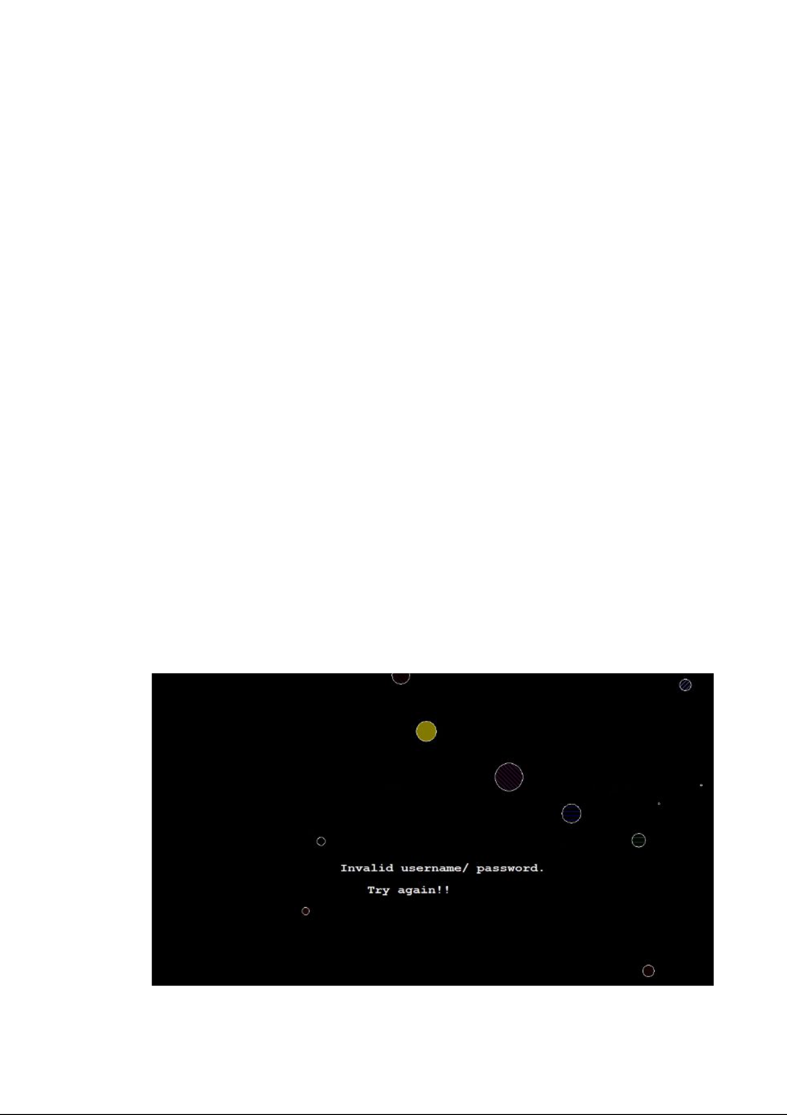

{

welcome();

system("cls");

Sleep(100);

loginPage();

password();

system("cls");

system("COLOR 07");

}

**Github links**

<https://github.com/Shreya4668/Business-outcome-analyzer> <https://github.com/KeerthanaReddy006/Business-Outcome-Analyser>

**c) Testing**

Following are the few ways of how we validated the cases

When the user enters wrong username or password while logging in,the message displayed is:

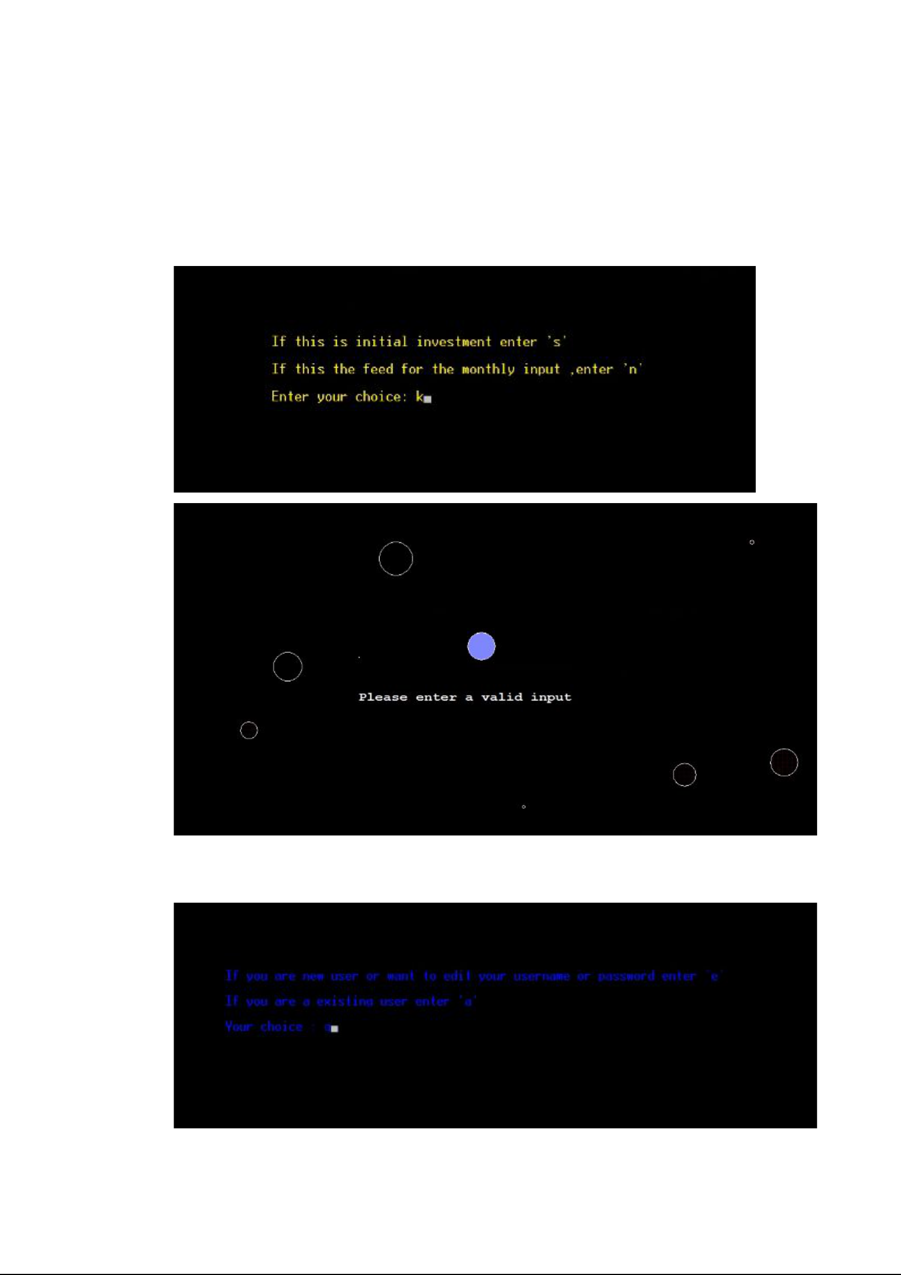

When the user enters a key other than the choices given:

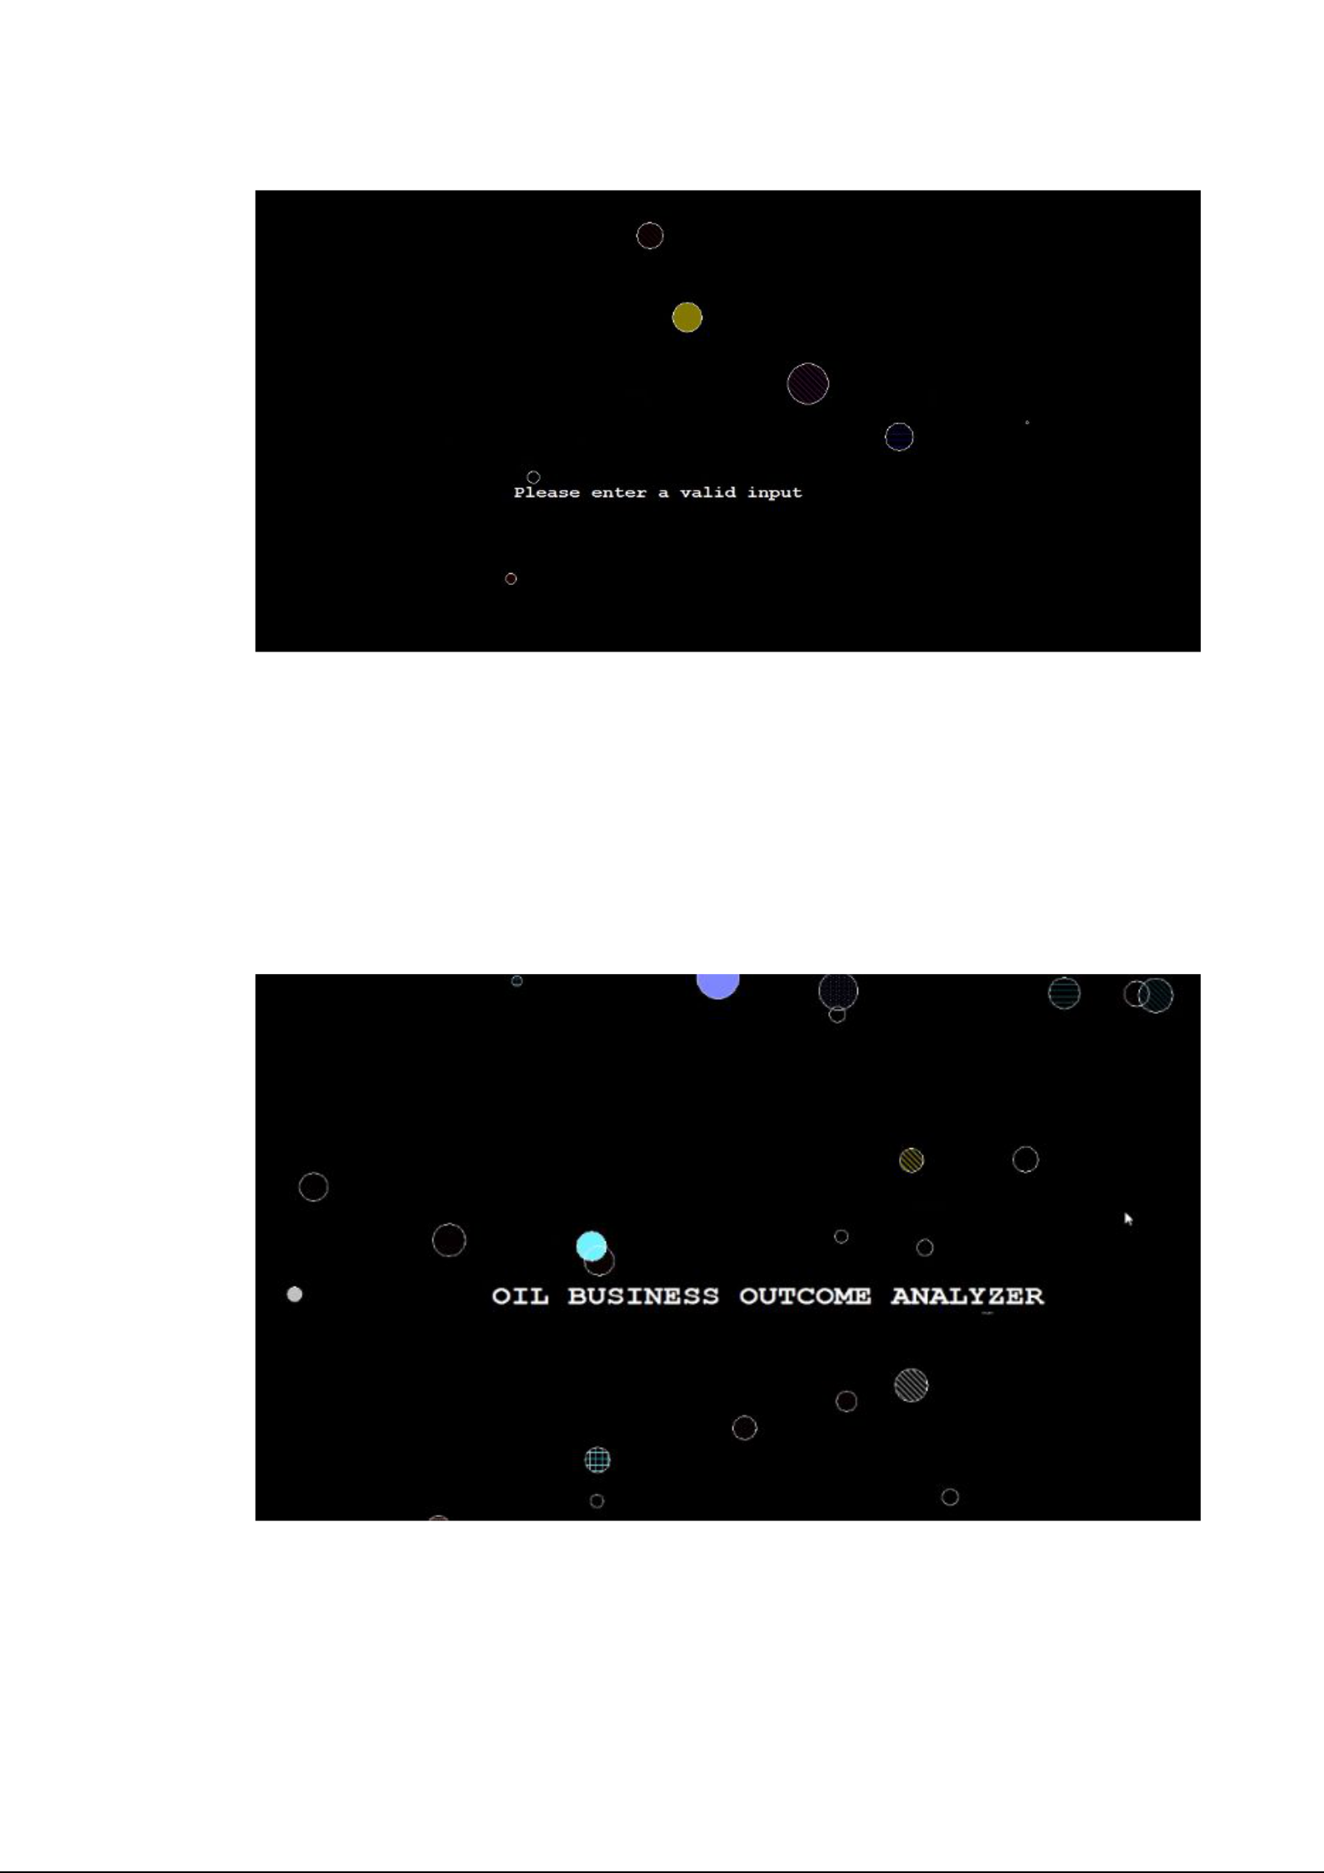

**RESULTS**

a)Login

Allows the user to create an account and login with his password.

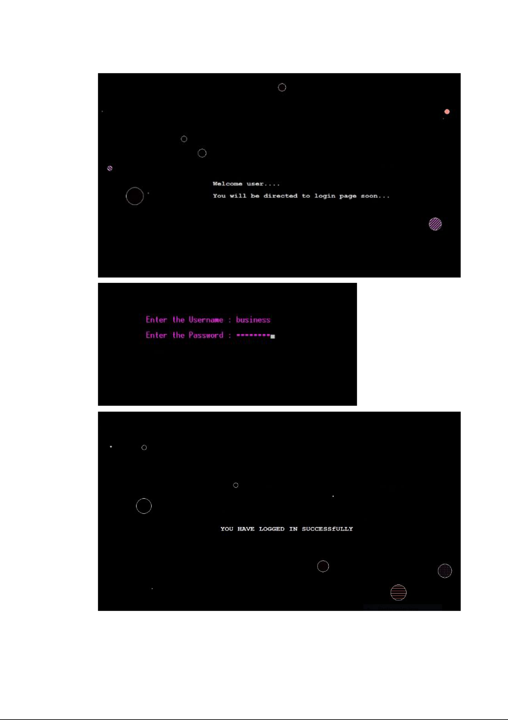

2) Input initial investment

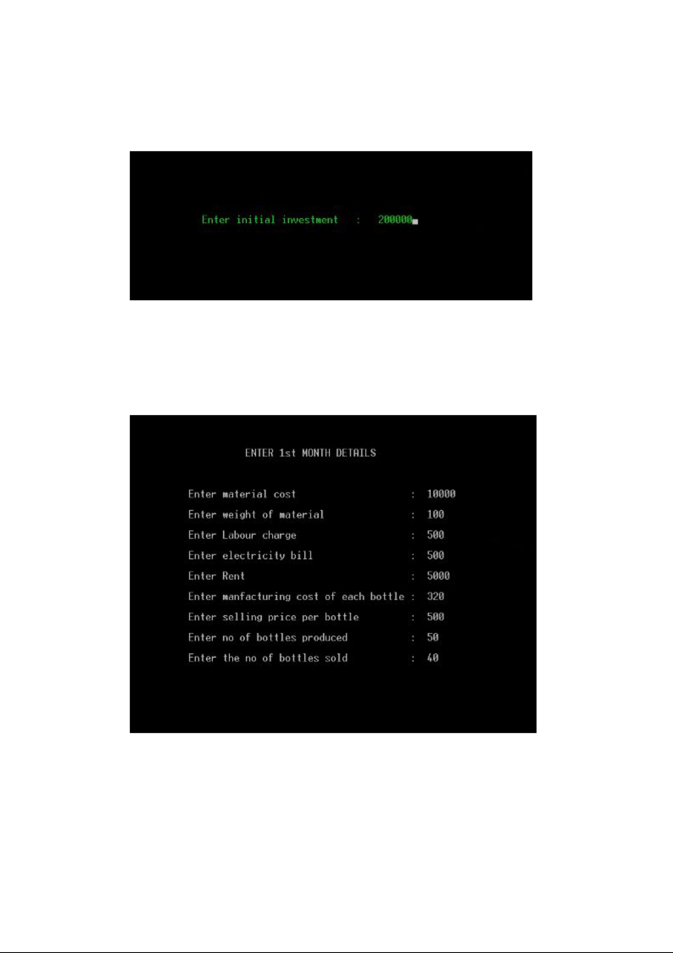

After the user creates an account and logs in, he is asked to enter initial investment of his business which is considered as first month’s info/data.

3) Monthly input

Thereafter, the user must enter every month’s info in the displayed required fields such as rent, electricity bill, material cost, number of bottles produced, number of bottles sold, labour cost, manufacturing cost of each bottle, selling price of each bottle and weight of the material.

4) Month’s Profit or Loss

The progress of the business, profit earned or loss incurred in that particular month is calculated and shown to the user.

Following are the outputs for few cases.

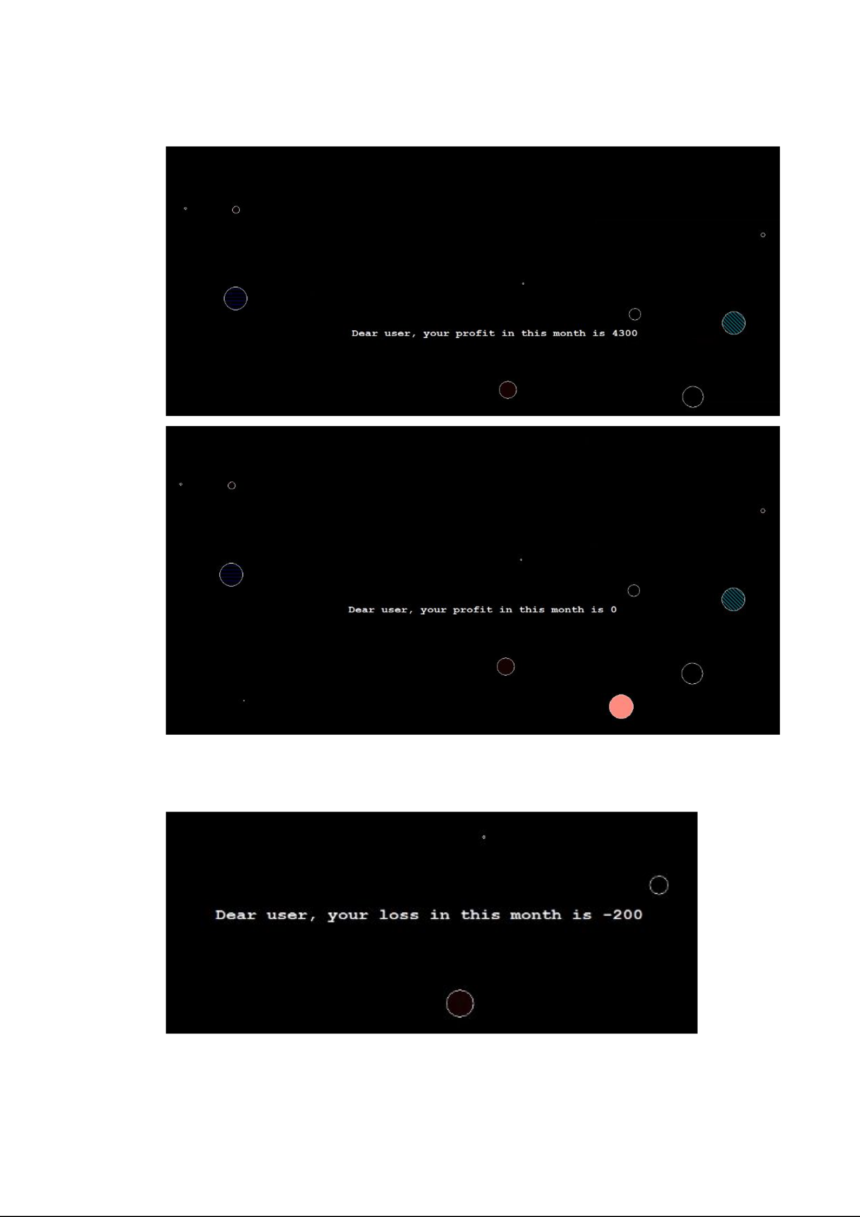

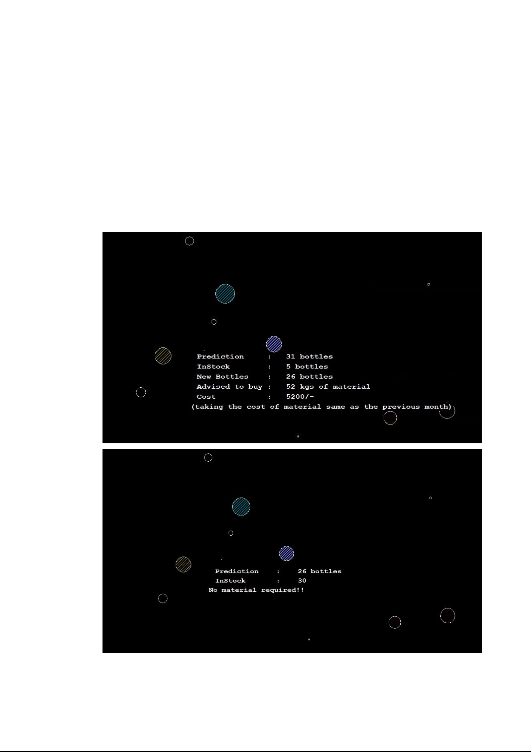

5) Sales Predictor

Predicts the sales of that particular month.

6) Tracker

Keeps a check on every month’s info entered and checks the stock and alerts the user if stock is needed for next month.

Following are the outputs for a few cases.

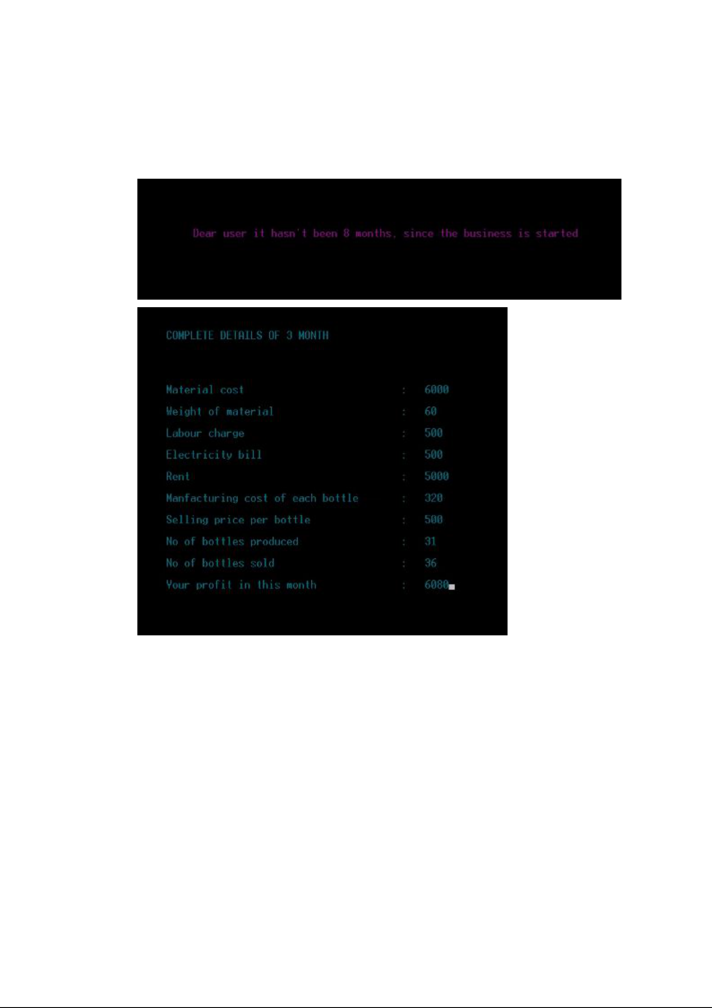

7) Record of every month’s info

The user can see the whole info of a particular month by just entering the number of the month.

8) Predictor

Based on the analysis of the sales that occurred over previous months, the predictor predicts how long it will take to run in profits by gaining returns and suggests the user either to continue the business or discontinue it, if more losses are incurred during previous months.

Following are the outputs for few cases.

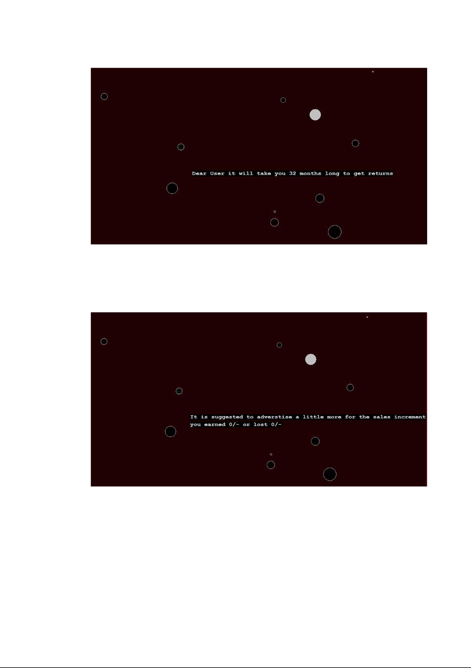

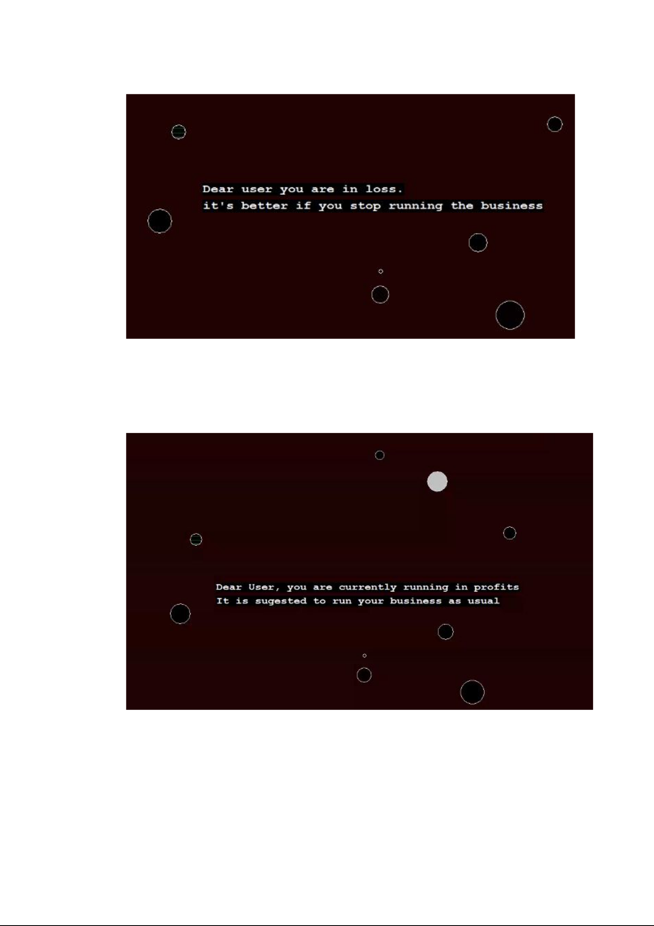

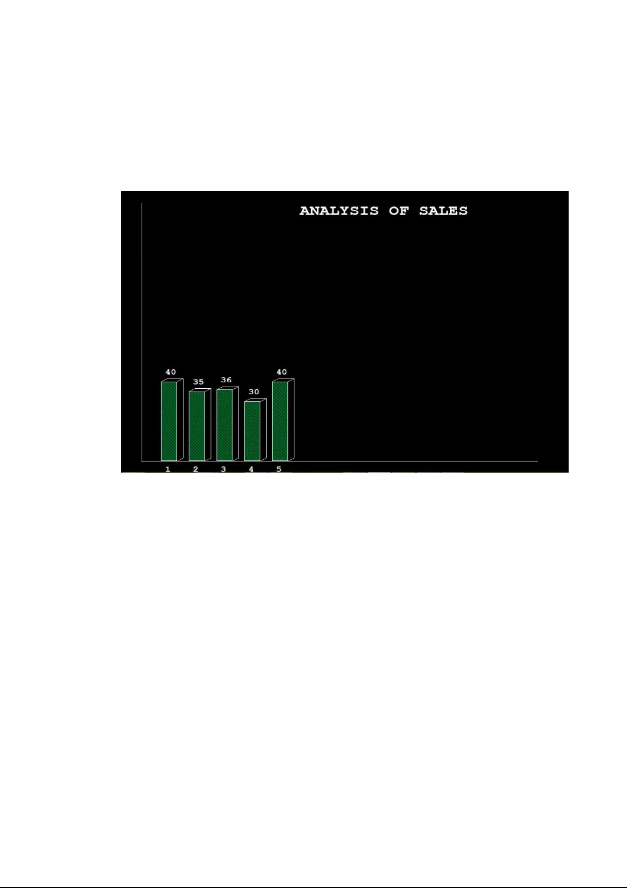

9) Bar Graphs

Displays the profit or loss occurred of all the months whose info is entered as the analysis of the sales in a graphical manner.



**ADDITIONAL LEARNING**

Mini project was greatly beneficial for us because we have revised the concepts of C and also learnt and implemented C graphics in our project which was not there in our curriculum.We learnt about files in depth and how to handle them.Mini project has provided us an opportunity to learn many additional topics such as generating background,setting background for popped windows,and printing text on backgrounds which were very interesting and fun to do.Self-learning and self implementation through team work has been the key thing behind the smooth functioning of the mini project.

As we referred to many sites for gaining knowledge over some concepts in C like C graphics,we even got revised with C concepts and got stronger with them.Mini project was rather about knowledge and implementing it than a mere assigned task.



​**DISCUSSION AND FUTURE WORK**

We have a lot of ideas of adding many features to our project.We want to make it a more sophisticated project to make it suitable for other kinds of businesses too,add a feature which would show the user in which particular field he incurred the loss or profit,give the user more suggestions to improve his business,graph analysis of profit or loss occurred in each month.We even want to develop the project into an app which would be more easy to use and implement machine learning in it so that the predictions would be even more perfect.



**REFERENCES**

<https://www.techcrashcourse.com/2015/08/c-graphics-programming-tutorial.html>

<https://developerinsider.co/graphics-graphics-h-c-programming/>

<https://www.geeksforgeeks.org/tag/c-graphics/>