TEAM: **TheSlayers**

* **Brand kits**:

1. LOGO:

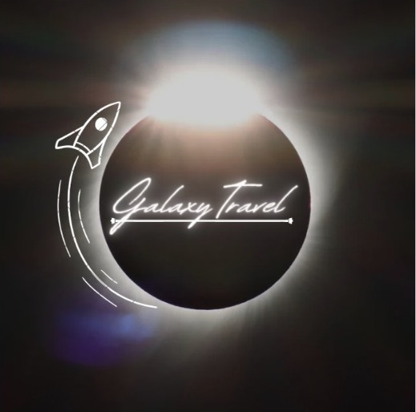

SINCE GALAXYTRAVEL is a space tourism company, it`s logo had to depict fantasies of space to attract the public. This logo is kept simple and elegant with a black background to increase contrast and details for whosoever Is looking at it.

B) Font used:

**Signature font** of canva is used to write the company’s name, it had both the bold and fluid touch to it.

<https://canvatemplates.com/wp-content/uploads/2023/02/Signature-Signature-Fonts-728x410.png>

C) Colour Palate:

#7C8395 (waterloo)

#919595 (oslo Gray)

#BFBAB6 (Cotton seed)

#332F2C (Dune)

* **Printable design**:

Business card:

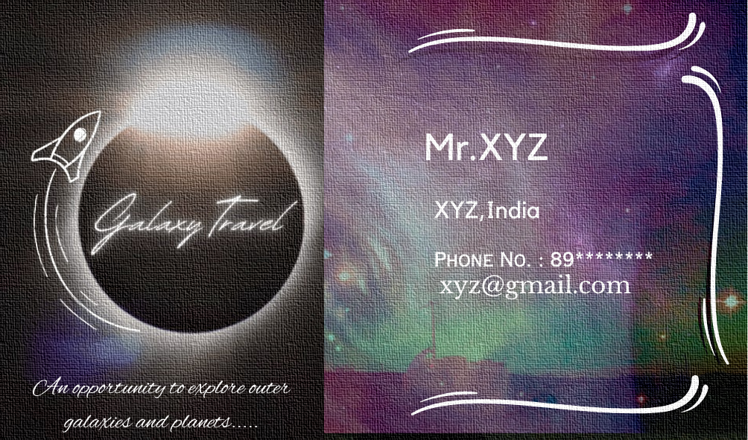

A business card is very important for any company to promote itself, the ideology behind card was to depict the moto as well as keep it formal with every contact information written on it.

* **DIGITAL DESIGN:**

Insta Story:

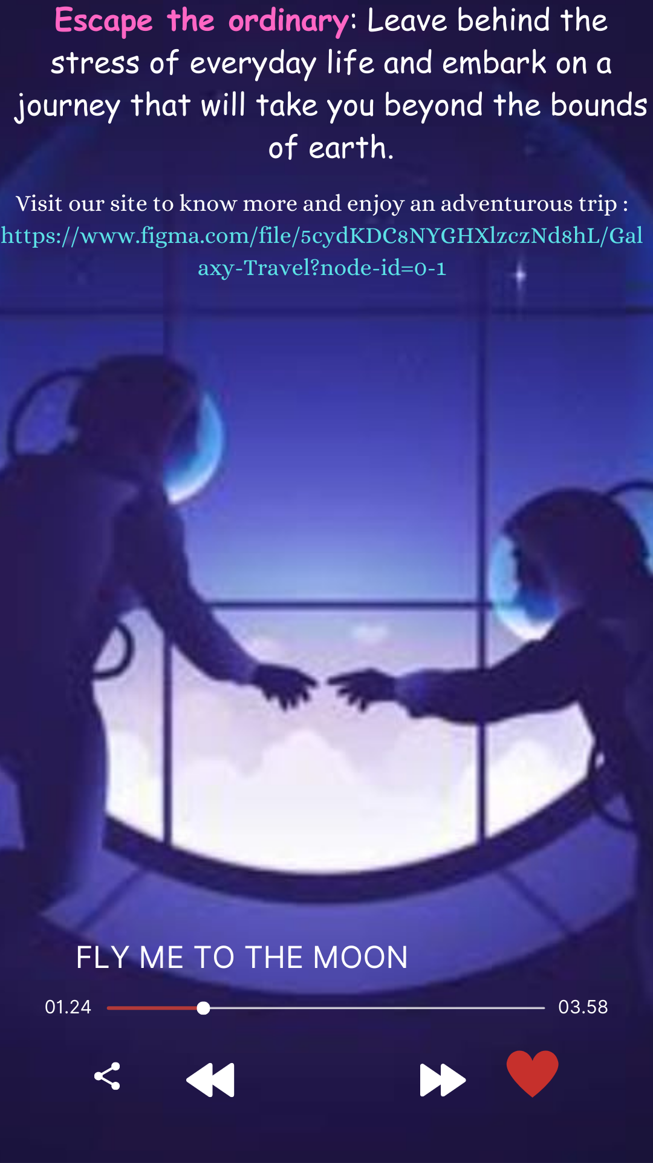

No matter which ever company is it, Promotion on any social media platform is must so that everyone is well aware what new is going to come up, the above Instagram story is made by keeping in mind the youngsters who are always very fascinate about space and is willing to explore more, (Also adding a calm music to it does no harm.)

* **UI/ Video:**

Drive link:<https://drive.google.com/drive/folders/19ycCKOG-Pj_so8eEaJJBaSlP4NeIU8OU?usp=sharing>

Figma link:

<https://www.figma.com/file/5cydKDC8NYGHXlzczNd8hL/Galaxy-Travel?node-id=0-1&t=HnrmRFteNjdvatjo-0>

How we enhanced interface :

Theme : Space exploration and solar system

1st UI :

Child like user interface which contains the logo and tag line of the company used to please and excite the inner child of everyone.

Explore and experience the Adventurous tours to universe ,with proper training and accommodations .

Buttons : Home

Booking

Explore

Reviews

2nd UI :

By clicking on ‘Explore’ button

Covering brief description about different planets and galaxies .

 glimpse of the most gorgeous destination across the universe.

By hovering over the planet ,result in more information about it.

3rd Ui :

.By clicking on “Booking” button will result in booking pages , where interested candidates can search and apply for tours to various planets by accepting the terms and conditions.