**Assignment -1**

**NAME- Shreya Adsule**

**Class- CSIT-2**

**Q1. Introduction to Operating System?**

**Operating System lies in the category of system software. It basically manages all the resources of the computer. An operating system acts as an interface between the software and different parts of the computer or the computer hardware. The operating system is designed in such a way that it can manage the overall resources and operations of the computer.**

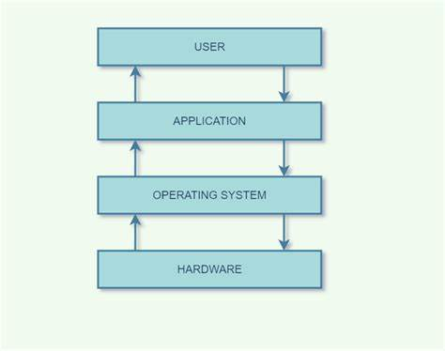

**Q2. Services provided by Operating System?**

* **Program execution**
* **Input Output Operations**
* **Communication between Process**
* **File Management**
* **Memory Management**
* **Process Management**
* **Security and Privacy**
* **Resource Management**
* **User Interface**
* **Networking**
* **Error handling**
* **Time Management**

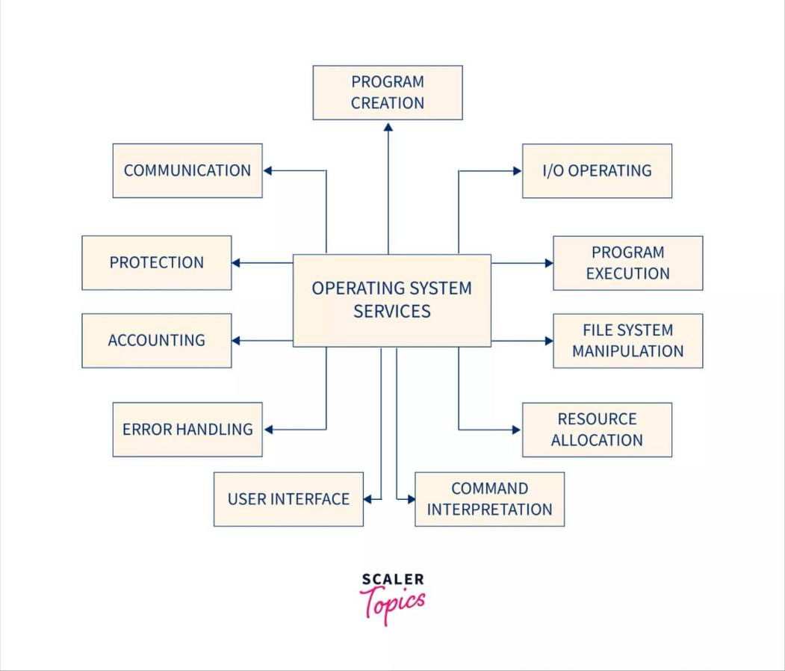

**Q3. Need of Operating System?**

**OS as a platform for Application programs: The operating system provides a platform, on top of which, other programs, called application programs can run**

**Managing Input-Output unit: The operating system also allows the computer to manage its own resources such as memory, monitor, keyboard, printer, etc. Management of these resources is required for effective utilization.**

**Multitasking: The operating system manages memory and allows multiple programs to run in their own space and even communicate with each other through shared memory.**

**Controls memory: It helps in controlling the computer’s main memory. Additionally, it allows and deallocates memory to all tasks and applications.**

**Provides Security: It helps to maintain the system and applications safe through the authorization process. Thus, the OS provides security to the system.**

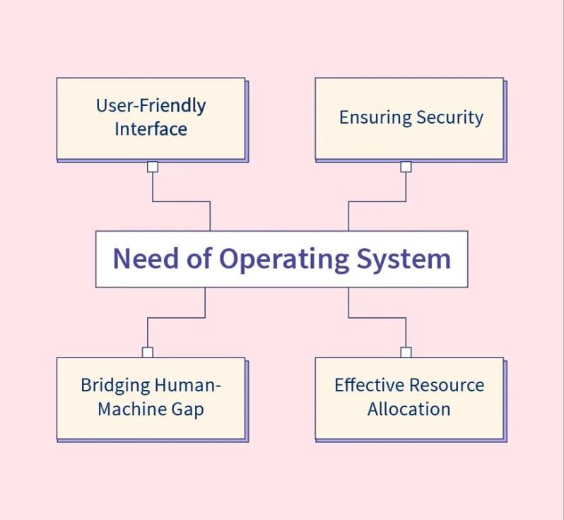

**Q4. What is Linux?**

**Linux is a free and open-source family of operating systems that is resilient and flexible. In 1991, an individual by the name as Linus Torvalds constructed it. The system’s source code is accessible to everyone for anyone to look at and change, making it cool that anyone can see how the system works**

**The Linux Operating System is a type of operating system that is similar to Unix, and it is built upon the Linux Kernel. The Linux Kernel is like the brain of the operating system because it manages how the computer interacts with its hardware and resources.**

**History of Linux :-** **A popular open-source operating system is Linux. It was initially created by Linus Torvalds in 1991. At the time, Torvalds was a computer science student at the University of Helsinki, Finland and began working on the Linux project as a personal endeavour. The name Linux is a combination of his first name, Linus, and Unix, the operating system that inspired his projects. At the time, most operating systems were proprietary and expensive. Torvalds wanted to create an operating system that was freely available to anyone who wanted to use the operating system, He originally released Linux as free software under the GNU General Public License. This meant that anyone could use, modify, and redistribute his source code.**

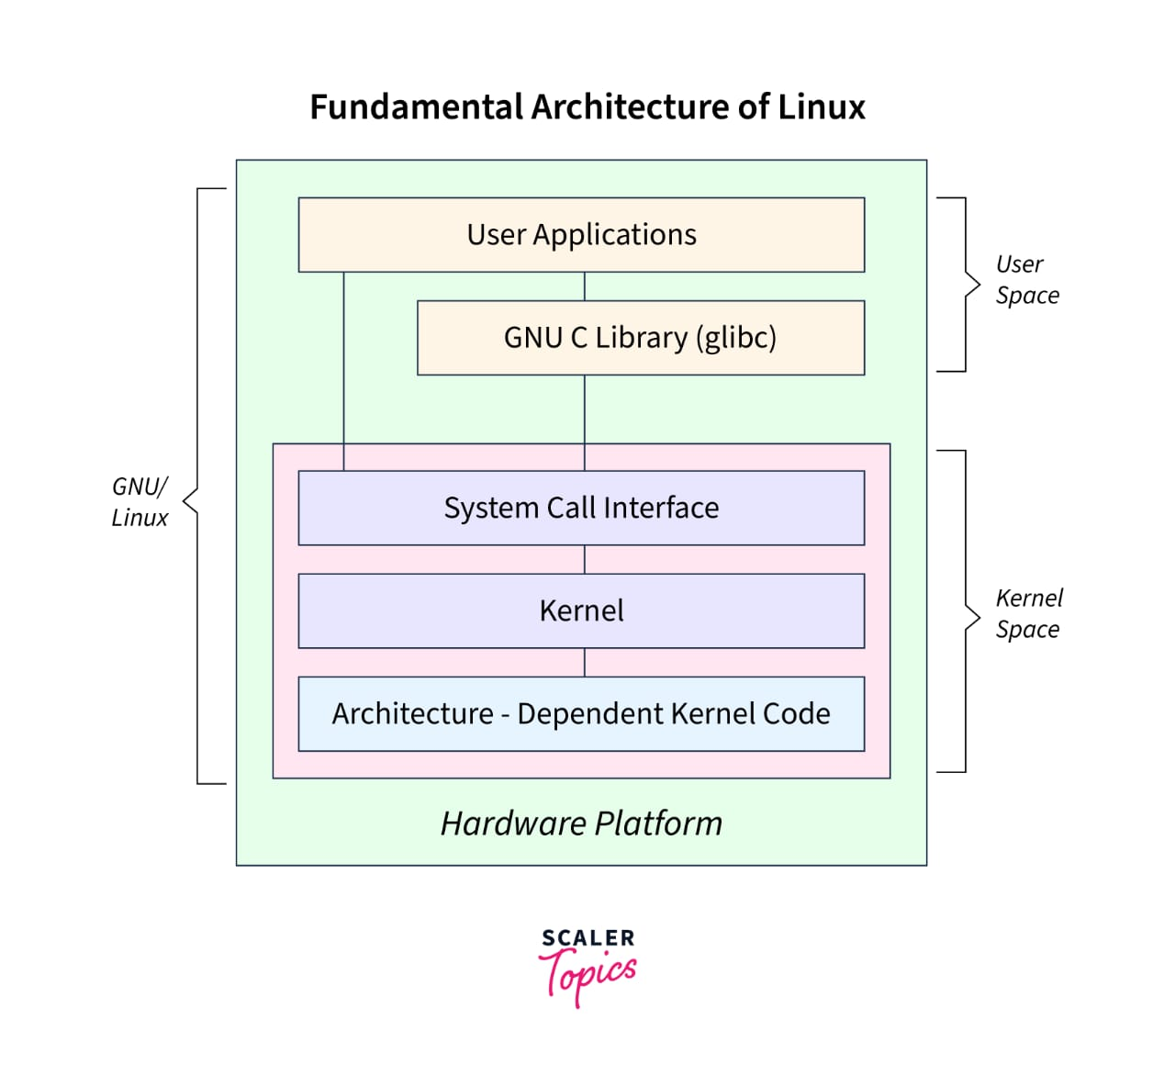

**Q5. Need of Linux?**

1. [Open Source](https://kodekloud.com/blog/reasons-why-you-should-use-linux/" \l "open-source)
2. [Customizable](https://kodekloud.com/blog/reasons-why-you-should-use-linux/" \l "customizable)
3. [Educational](https://kodekloud.com/blog/reasons-why-you-should-use-linux/" \l "educational)
4. [Secure](https://kodekloud.com/blog/reasons-why-you-should-use-linux/" \l "secure)
5. [Reliable](https://kodekloud.com/blog/reasons-why-you-should-use-linux/" \l "reliable)
6. [Easy to Install](https://kodekloud.com/blog/reasons-why-you-should-use-linux/" \l "easy-to-install)
7. [Strong Community Support](https://kodekloud.com/blog/reasons-why-you-should-use-linux/" \l "strong-community-support)
8. [Easy to Use](https://kodekloud.com/blog/reasons-why-you-should-use-linux/" \l "easy-to-use)
9. [Free](https://kodekloud.com/blog/reasons-why-you-should-use-linux/" \l "free)

**Q6. What are the distributions of Linux?**

**[Linux distribution](https://www.geeksforgeeks.org/what-are-linux-distributions/) is an operating system that is made up of a collection of software based on Linux kernel or you can say distribution contains the Linux kernel and supporting libraries and software. And you can get Linux-based operating system by downloading one of the Linux distributions and these distributions are available for different types of devices like embedded devices, personal computers, etc. Around 600 + Linux Distributions are available and some of the popular Linux distributions are:**

* **MX Linux**
* **[Manjaro](https://www.geeksforgeeks.org/installing-and-configuring-jenkins-on-arch-based-linux-distributions-manjaro/" \t "_blank)**
* **Linux Mint**
* **[elementary](https://www.geeksforgeeks.org/elementary-operations-on-matrices/" \t "_blank)**
* **Ubuntu**
* **[Debian](https://www.geeksforgeeks.org/introduction-to-debian-linux/" \t "_blank)**
* **[Solus](https://www.geeksforgeeks.org/solus-operating-system/" \t "_blank)**
* **Fedora**
* **[openSUSE](https://www.geeksforgeeks.org/how-to-find-opensuse-linux-version/" \t "_blank)**

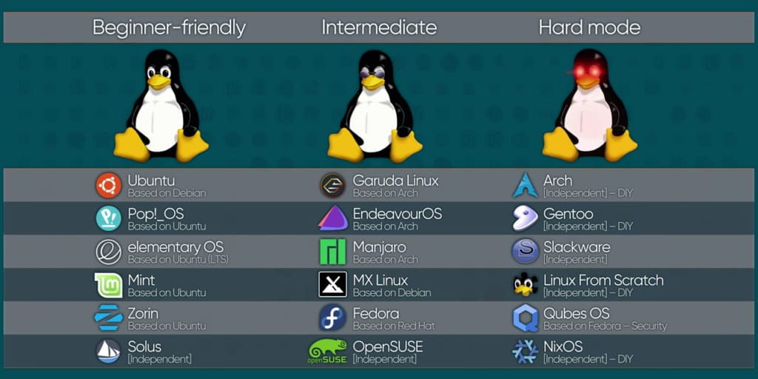

**Q7. What are the services provided by Linux?**

**The following are some Services in Linux :-**

**From sources across the web**

**Security**

**File management**

**Monitoring**

**Networking**

**Backup management**

**Community support**

**Linux change-over**

**Linux engineers**

**Performance**

**Scalability**

