AI-Assisted Threat Detection Dashboard

Introduction
Artificial Intelligence (AI) and Machine Learning (ML) offer advanced techniques for analyzing large volumes of security data, identifying suspicious activities, and improving threat detection capabilities. The AI-Assisted Threat Detection Dashboard aims to leverage these technologies to provide an intelligent and efficient cybersecurity monitoring solution.

Project Overview
The AI-Assisted Threat Detection Dashboard is designed to monitor security-related data, detect potential threats, and provide actionable insights through an interactive dashboard. The system will analyze cybersecurity events and network activities using machine learning models to identify malicious behavior and abnormal patterns.
The dashboard will help security analysts by providing real-time visibility into security events, highlighting suspicious activities, and supporting faster decision-making during incident response.

Problem Statement
Modern organizations generate massive amounts of security logs, network traffic records, and system events every day. Manually analyzing this data is time-consuming and may result in critical threats being overlooked. Furthermore, traditional rule-based systems often struggle to identify new attack techniques that do not match existing signatures.
The objective of this project is to develop an AI-powered threat detection dashboard capable of automatically identifying suspicious activities, detecting anomalies, and assisting in the classification of potential cyber threats.

Objectives
- Develop an intelligent threat detection system using machine learning techniques.
- Detect suspicious and malicious activities within security data.
- Identify abnormal patterns through anomaly detection.
- Provide security insights through an interactive dashboard.
- Support security analysts in threat investigation and response.
- Improve threat detection accuracy while minimizing false positives.

Research Methodology
To determine the most suitable machine learning models for the project, multiple algorithms were researched and evaluated based on several factors relevant to cybersecurity applications.
The evaluation focused on:
- Detection accuracy
- Computational efficiency
- Scalability
- Ability to handle large datasets
- Anomaly detection capability
- Real-time processing suitability
- Ease of implementation and maintenance
Both supervised and unsupervised machine learning approaches were considered to ensure the system can detect both known and unknown threats.

Model Research and Evaluation

1. Logistic Regression

Overview
Logistic Regression is a supervised machine learning algorithm used for binary classification problems. It predicts whether a particular activity should be classified as normal or malicious.

Advantages
- Simple and easy to implement
- Fast training and prediction
- Low computational requirements
- Suitable for basic classification tasks

Limitations
- Limited ability to capture complex relationships
- Lower effectiveness for advanced cybersecurity threats
- Performance decreases with highly complex datasets

Cybersecurity Applications
- Malware classification
- Spam detection
- Basic threat prediction

2. Decision Tree

Overview
Decision Tree is a supervised learning algorithm that uses a hierarchical structure of decisions to classify data.

Advantages
- Easy to understand and visualize
- Supports both numerical and categorical data
- Requires minimal data preprocessing

Limitations
- Prone to overfitting
- Reduced performance on large and complex datasets

Cybersecurity Applications
- Intrusion detection
- Security event classification
- Threat analysis

3. Random Forest

Overview
Random Forest is an ensemble learning algorithm that combines multiple decision trees to improve prediction accuracy and reliability.

Advantages
- High accuracy
- Reduces overfitting
- Handles large datasets effectively
- Provides feature importance analysis

Limitations
- Higher computational requirements
- Less interpretable than individual decision trees

Cybersecurity Applications
- Intrusion detection systems
- Malware detection
- Security risk assessment

4. Isolation Forest

Overview
Isolation Forest is an unsupervised machine learning algorithm specifically designed for anomaly detection. It identifies observations that significantly differ from normal behavior.

Advantages
- Detects unknown and zero-day attacks
- Does not require labeled training data
- Efficient for large datasets
- Effective anomaly detection capability

Limitations
- Does not classify attack categories
- Requires parameter optimization

Cybersecurity Applications
- Insider threat detection
- Abnormal network behavior detection
- User behavior analytics

5. XGBoost

Overview
XGBoost (Extreme Gradient Boosting) is a powerful ensemble learning algorithm known for its high performance and predictive accuracy.

Advantages
- Very high classification accuracy
- Handles imbalanced datasets effectively
- Fast training and prediction
- Excellent performance on structured data
- Provides feature importance information

Limitations
- More complex implementation
- Requires hyperparameter tuning

Cybersecurity Applications
- Threat classification
- Malware detection
- Intrusion detection
- Risk prediction

Model Comparison
Model | Type | Accuracy Potential | Complexity | Primary Use
Logistic Regression | Supervised | Medium | Low | BasicThreat Classification
Decision Tree | Supervised | Medium | Low | Event Classification
Random Forest | Supervised | High | Medium | Intrusion Detection
Isolation Forest | Unsupervised | High | Medium | Anomaly Detection
XGBoost | Supervised | Very High | Medium | Threat Classification

Model Selection Criteria
The final model selection was based on the following criteria:
Criteria | Importance
Detection Accuracy | High
Real-Time Performance | High
Scalability | High
Anomaly Detection Capability | High
Computational Efficiency | Medium
Interpretability | Medium
These criteria were chosen because an effective threat detection system must be accurate, scalable, and capable of identifying both known and previously unseen attacks.

Final Model Selection
After evaluating multiple machine learning algorithms, a hybrid approach was selected for the proposed system.

XGBoost for Threat Classification
XGBoost was selected as the primary threat classification model due to its high accuracy, strong performance on structured datasets, and ability to effectively classify known cyber threats.

Isolation Forest for Anomaly Detection
Isolation Forest was selected because of its ability to identify abnormal behavior and previously unseen attack patterns without requiring labeled data. This makes it particularly valuable for detecting zero-day attacks and unusual activities.
The combination of XGBoost and Isolation Forest provides a balanced approach that supports both threat classification and anomaly detection.

Proposed System Architecture
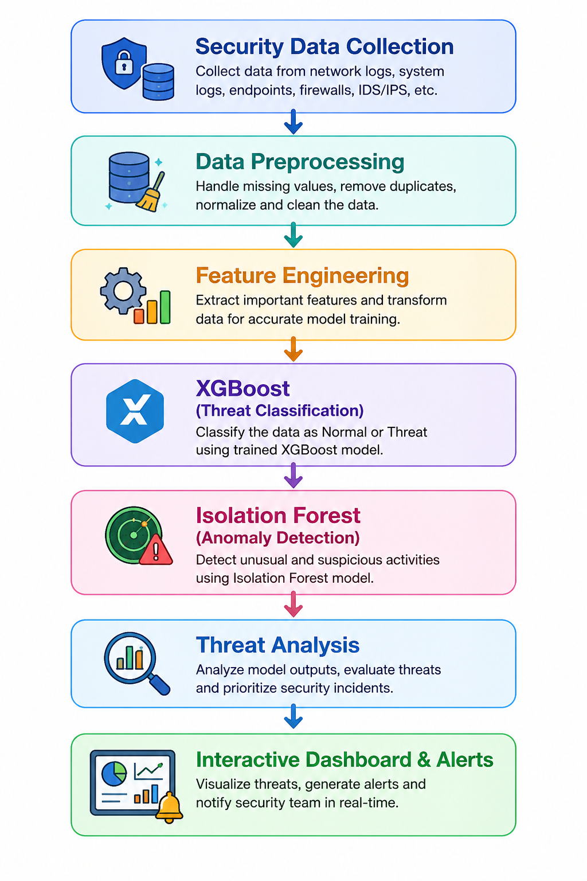
The proposed workflow for the AI-Assisted Threat Detection Dashboard is:

This architecture enables the system to process security data efficiently and provide meaningful insights to security analysts.

Expected Outcomes
The successful implementation of the project is expected to provide:
- Improved threat detection accuracy.
- Early identification of suspicious activities.
- Detection of both known and unknown threats.
- Enhanced visibility through dashboard visualizations.
- Reduced manual effort in security monitoring.
- Faster incident investigation and response.

Conclusion
The AI-Assisted Threat Detection Dashboard aims to enhance cybersecurity monitoring through the application of Artificial Intelligence and Machine Learning techniques. A detailed study of multiple machine learning algorithms was conducted to identify the most suitable models for the project.
Based on the research findings, XGBoost was selected for threat classification due to its high predictive performance, while Isolation Forest was chosen for anomaly detection because of its effectiveness in identifying unusual behavior and unknown threats.
The proposed hybrid approach combines the strengths of both supervised and unsupervised learning, creating a robust foundation for the development of an intelligent threat detection system capable of supporting modern cybersecurity operations.

