SUPERMART SALES ANALYSIS
Data Analytics with AI – Internship Project
Prepared as a practical Data Analytics project
2026

1. Abstract
This project analyzes supermarket sales transactions to understand revenue, profit, order volume, category performance, regional performance and payment patterns. Python and Excel are used for data cleaning, exploratory data analysis, KPI calculation and visualization. A simple Linear Regression model is additionally used to demonstrate monthly sales forecasting. The overall workflow converts raw transaction-level data into business-oriented insights that can support sales planning and inventory decisions.

2. Problem Statement
Supermarket businesses generate large volumes of transactional data. Without structured analysis, it is difficult to identify which categories and regions contribute most to sales and profit, how sales change over time, and what future sales may look like. The project addresses this problem by creating a repeatable analytics workflow and a management-friendly dashboard.

3. Objectives
- Clean and validate transaction-level sales data.
- Calculate business KPIs such as total sales, profit, orders and average order value.
- Analyze sales and profit by category, sub-category, region and state.
- Study monthly sales trends and payment-mode distribution.
- Create clear visualizations and an Excel dashboard.
- Demonstrate a basic AI/ML sales forecasting component using Linear Regression.

4. Dataset Description
The prepared project dataset contains 1,200 transaction records covering January–December 2025. Important fields include Order ID, Customer Name, Order Date, Ship Date, Category, Sub Category, City, State, Region, Quantity, Unit Price, Discount, Sales, Profit and Payment Mode.
Field | Type | Purpose
Order Date | Date | Time-based analysis
Category / Sub Category | Categorical | Product performance
Region / State | Categorical | Geographical analysis
Quantity | Numeric | Volume analysis
Sales | Numeric | Revenue KPI
Profit | Numeric | Profitability KPI
Discount | Numeric | Discount impact
Payment Mode | Categorical | Payment behavior

5. Methodology
- Data collection / preparation
- Data cleaning and validation
- Exploratory Data Analysis (EDA)
- KPI calculation
- Category, sub-category and regional analysis
- Visualization and dashboard creation
- AI/ML forecasting
- Business interpretation and recommendations

6. Key KPIs
Total Sales: 2,168,946.25
Total Profit: 360,665.22
Orders: 1,200
Avg Order Value: 1,807.46
Profit Margin %: 16.63%

7. Exploratory Analysis
The following charts are included to communicate the main patterns found in the prepared dataset.

Monthly Sales Trend
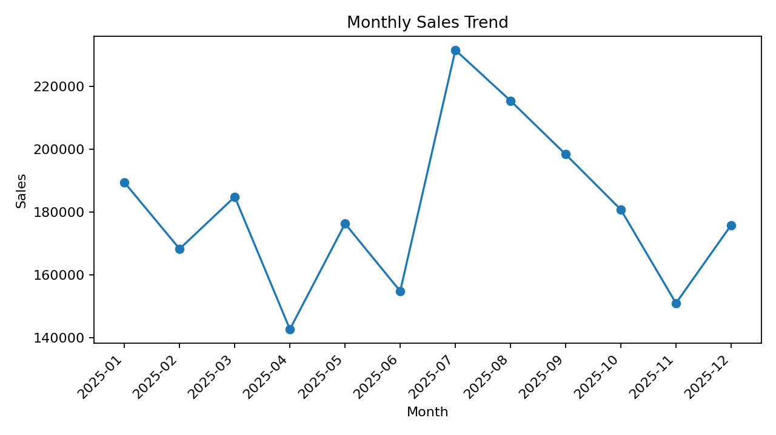

Sales by Category
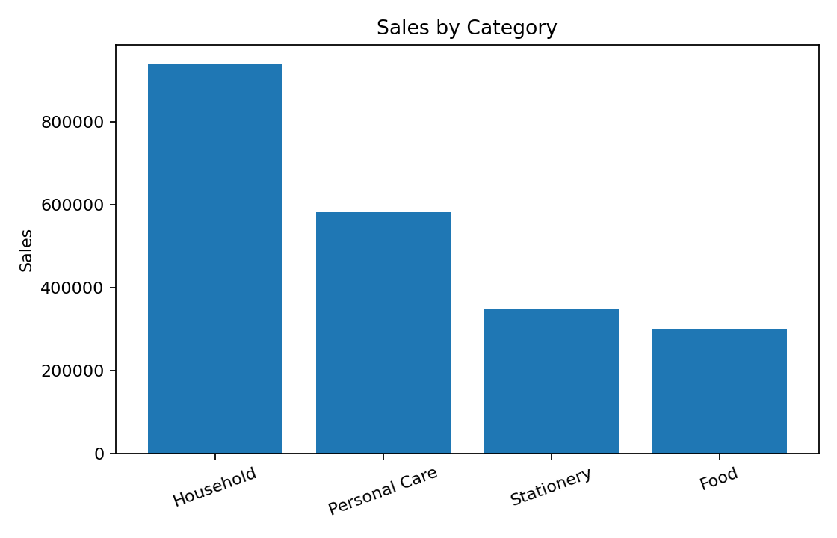

Profit by Region
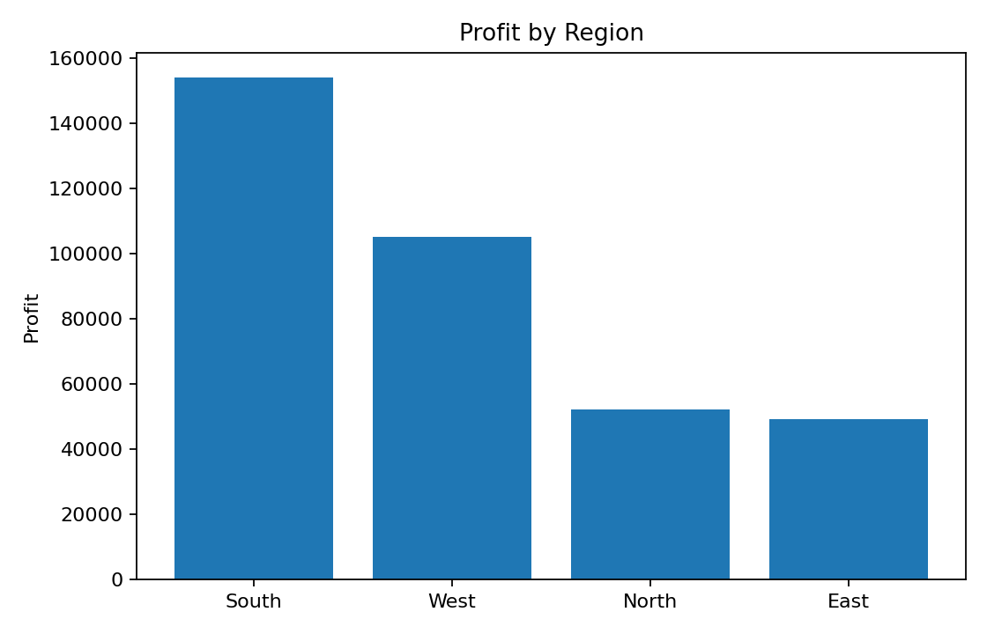

Top 10 Sub-Categories
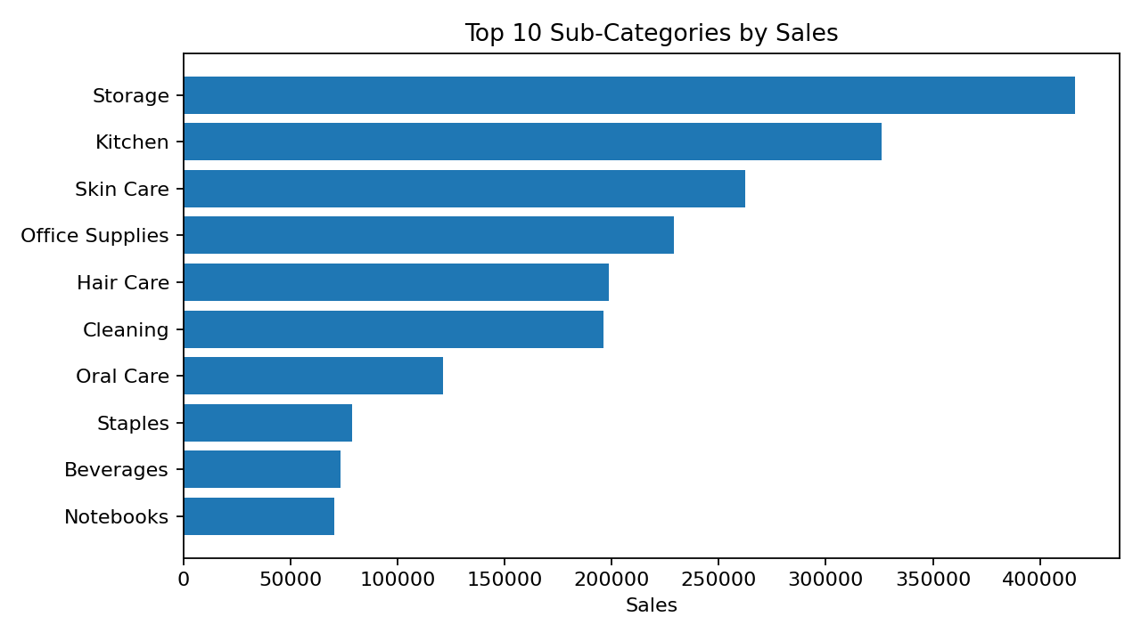

8. AI/ML Component – Sales Forecasting
A Linear Regression model was trained on the monthly sales sequence. The historical-fit R² for this educational model is 0.005. The model was then used to generate a three-month illustrative forecast.
Month | Forecast Sales
2026-01 | 183,904.54
2026-02 | 184,390.54
2026-03 | 184,876.54
Note: This is a demonstration model. A production forecasting system should use richer time-series features, seasonality, promotions, holidays and validation.

9. Business Insights
- Household is the highest-sales category in the prepared dataset.
- Storage is the highest-sales sub-category in the prepared dataset.
- South has the highest aggregate sales among the regions.
- South has the highest aggregate profit among the regions.
- Monthly analysis makes it possible to identify periods of higher and lower demand.
- Payment-mode analysis can help prioritize customer checkout and digital-payment improvements.

10. Recommendations
- Use monthly sales trends to support inventory and staffing planning.
- Prioritize high-performing categories while monitoring their profit margins.
- Investigate low-profit categories for discount, procurement or pricing issues.
- Use regional performance to guide localized promotions.
- Track discount levels alongside profit rather than optimizing only for sales volume.
- Improve the forecasting model later with seasonality, holidays, promotions and additional customer/product features.

11. Limitations
The included dataset is a prepared practice dataset for the project. The forecasting model is intentionally simple and demonstrates the AI/ML workflow rather than a production-grade forecasting solution. Real business deployment would require validated company data, stronger time-series methods and model monitoring.

12. Conclusion
The Supermart Sales Analysis project demonstrates an end-to-end data analytics workflow: preparing data, exploring patterns, calculating KPIs, visualizing business performance and adding a basic predictive component. It provides a strong foundation for explaining practical Python, SQL/Excel-style analytics, visualization and introductory AI/ML skills.

