In this project we have built 4 projects with CNN and RNN, Feature extraction, YOLO and OPENCV to detect facial expressions or emotions from human faces.

To implement this project we are using facial expression dataset which contains faces of seven emotions. See below screen shots of dataset

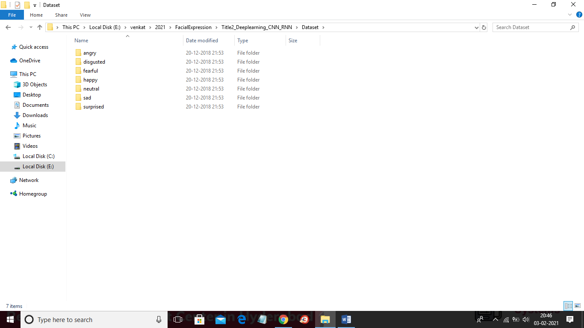

Each folder contains its related faces which can be seen in below happy folder with happy faces

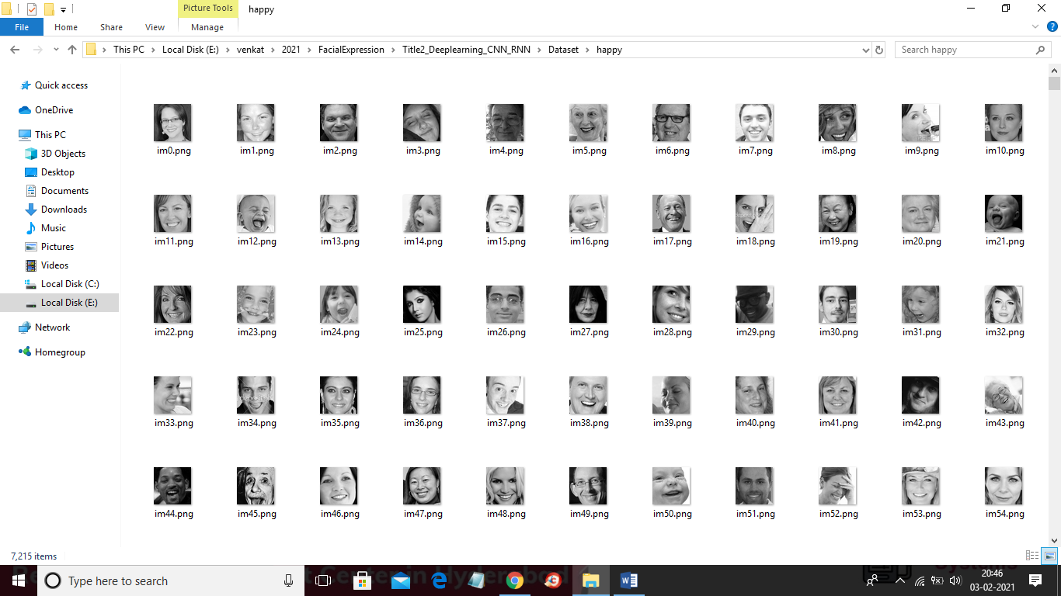

In above screen we can see faces from each emotion and using above dataset we have implemented following modules

1. In title 1 we are applying PCA feature extraction algorithm to extract important features from dataset and then train CNN and RNN algorithm and then compare accuracy of both algorithms
2. In title 2 we are using above dataset and deep learning CNN and RNN algorithms to build emotion prediction model and then calculate and compare accuracy between CNN and RNN
3. In title 3 we are using combination of YOLO face detection and CNN to build emotion prediction model and this title gave better prediction result and accuracy compare to title1 and title2.
4. In title 4 we are using combination OPENCV and CNN to build deep learning to predict human faces emotion. In this title we are reading dataset images using OPENCV and then training with CNN using SOFTMAX function and then calculate loss/error rate. This module give better prediction accuracy and less error rate with good emotion detection result compare to above 3 algorithms.

Below screen showing implementation of all 4 titles

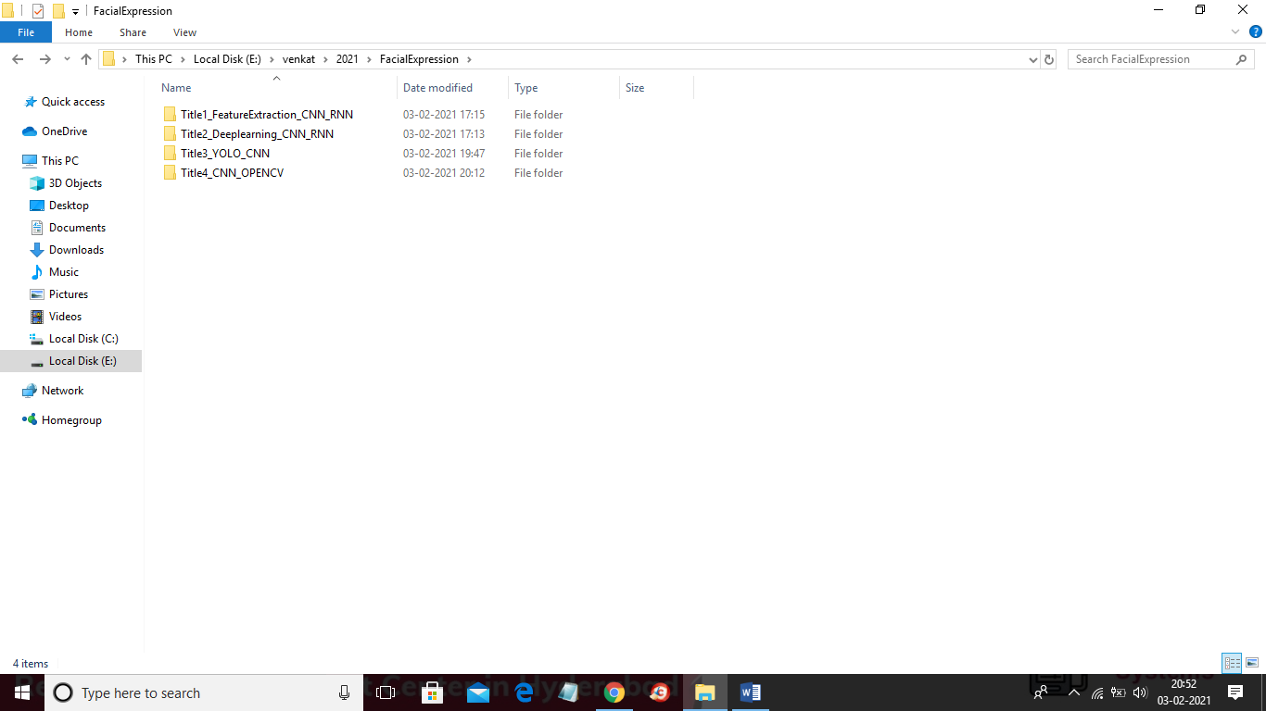

In above screen go inside title1 folder and then click on ‘run.bat’ file to get below screen

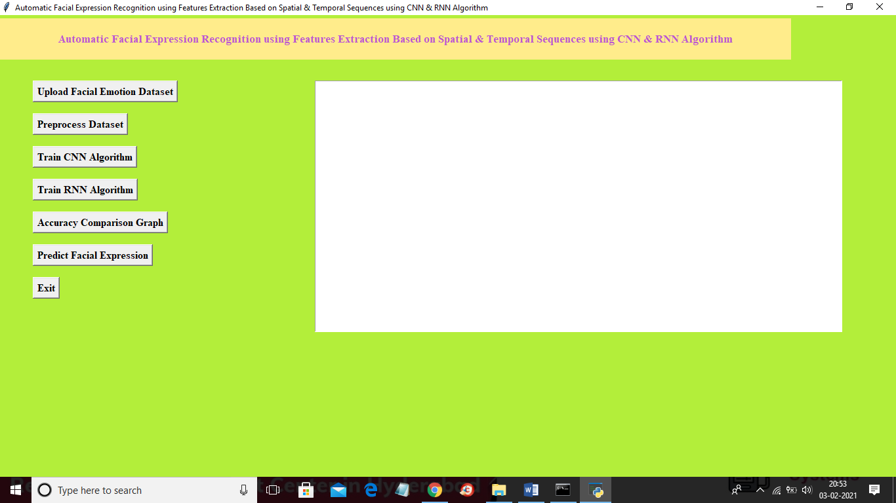

In above screen click on ‘Upload Facial Emotion Dataset’ button to upload dataset

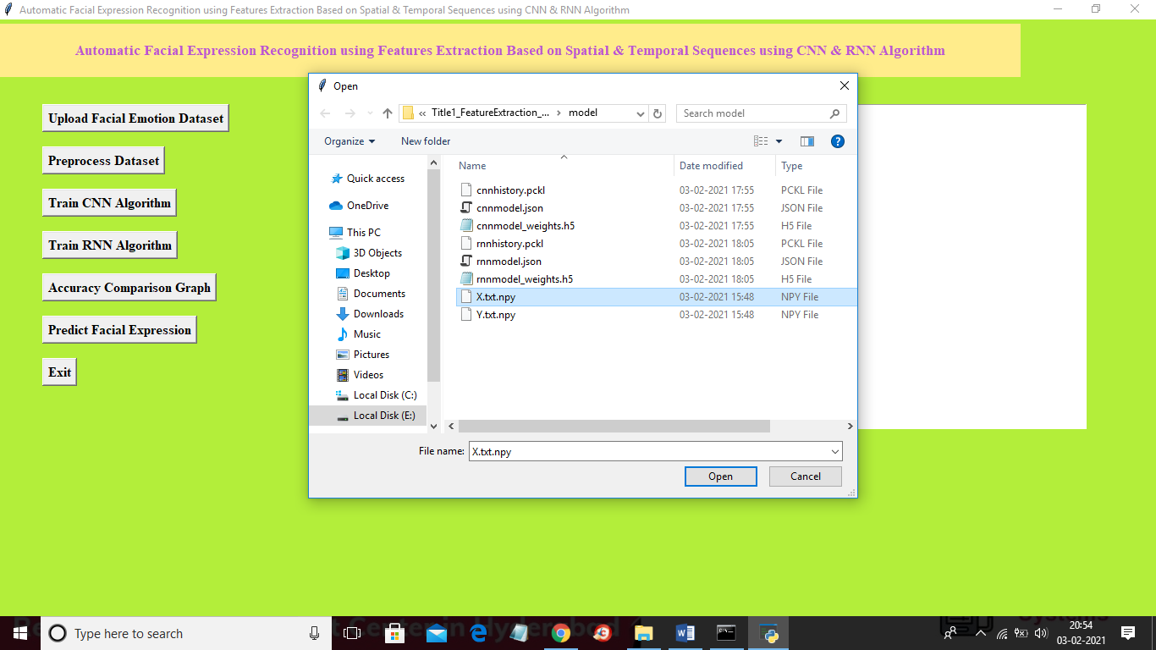

In above screen selecting and uploading ‘X.txt.npy’ file which contains images of all emotion faces and then click on ‘Open’ button to load dataset and to get below screen

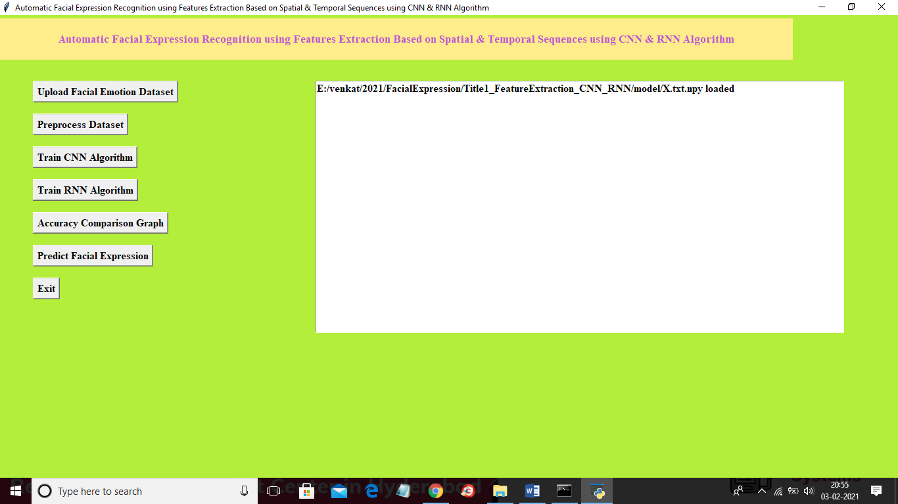

In above screen dataset loaded and now click on ‘Preprocess Dataset’ button to read all images and then apply feature extraction algorithm called PCA to read important features from dataset and to get below screen. This module may take 5 to 8 minutes time to give output so please wait till process complete like below screen

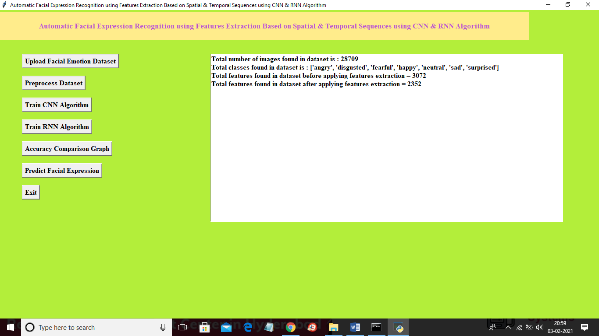

In above screen we can see dataset contains total 28709 images and before applying feature extraction algorithm total images features/pixels are 3072 and then after applying features reduces to 2352 as PCA remove unimportant pixels and used only important pixels/features. Now image data is ready and now click on ’Train CNN Algorithm’ button to train CNN with process image features

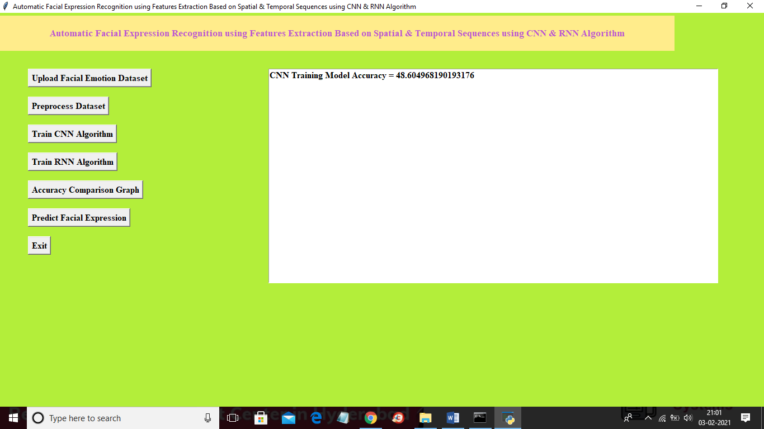

In above screen CNN accuracy is 48 and now click on ‘Train RNN Accuracy’ button to train dataset with RNN

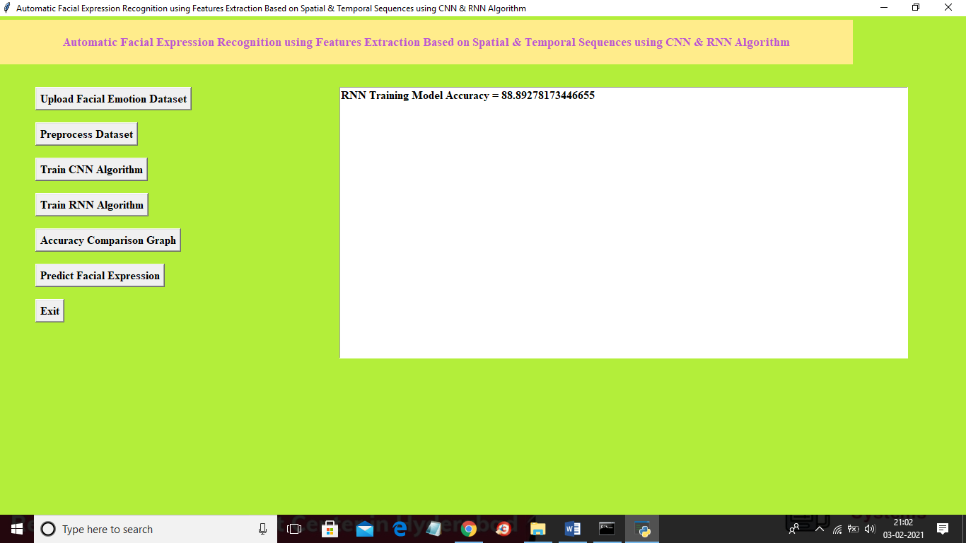

In above screen RNN accuracy is 88% and now click on ‘Accuracy Comparison Graph’ to get below graph of both algorithms

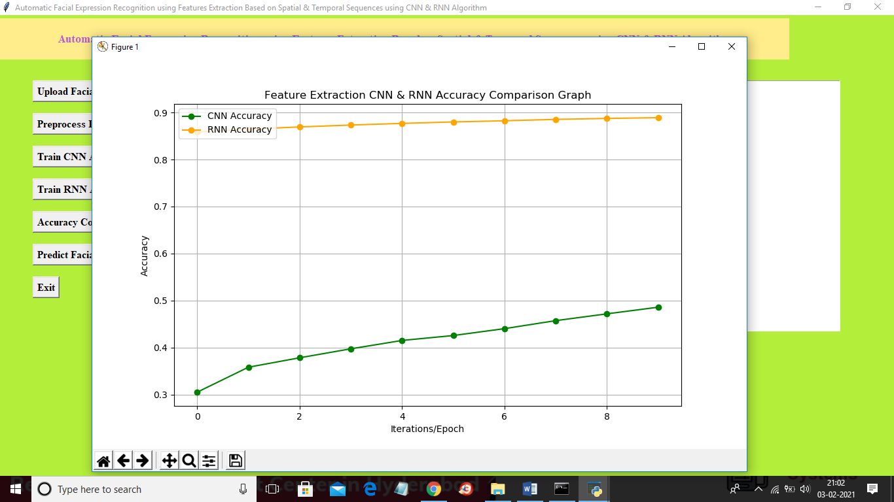

In above screen x-axis represents epoch/iteration ad y-axis represents accuracy and in above graph orange line represents RNN accuracy and green line represents CNN accuracy and from above graph we can see with further epoch/iteration both algorithm accuracy get better and better and from above graph we can conclude that RNN is giving better result. Now click on ‘Predict Facial Expression’ button to upload new test image and the application predict emotion from it

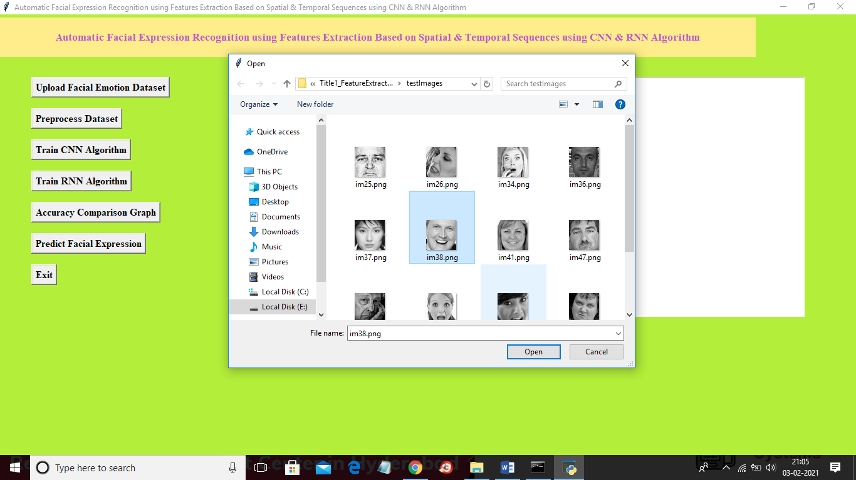

In above screen selecting and uploading im38.png image and then click on ‘Open’ button to get below result

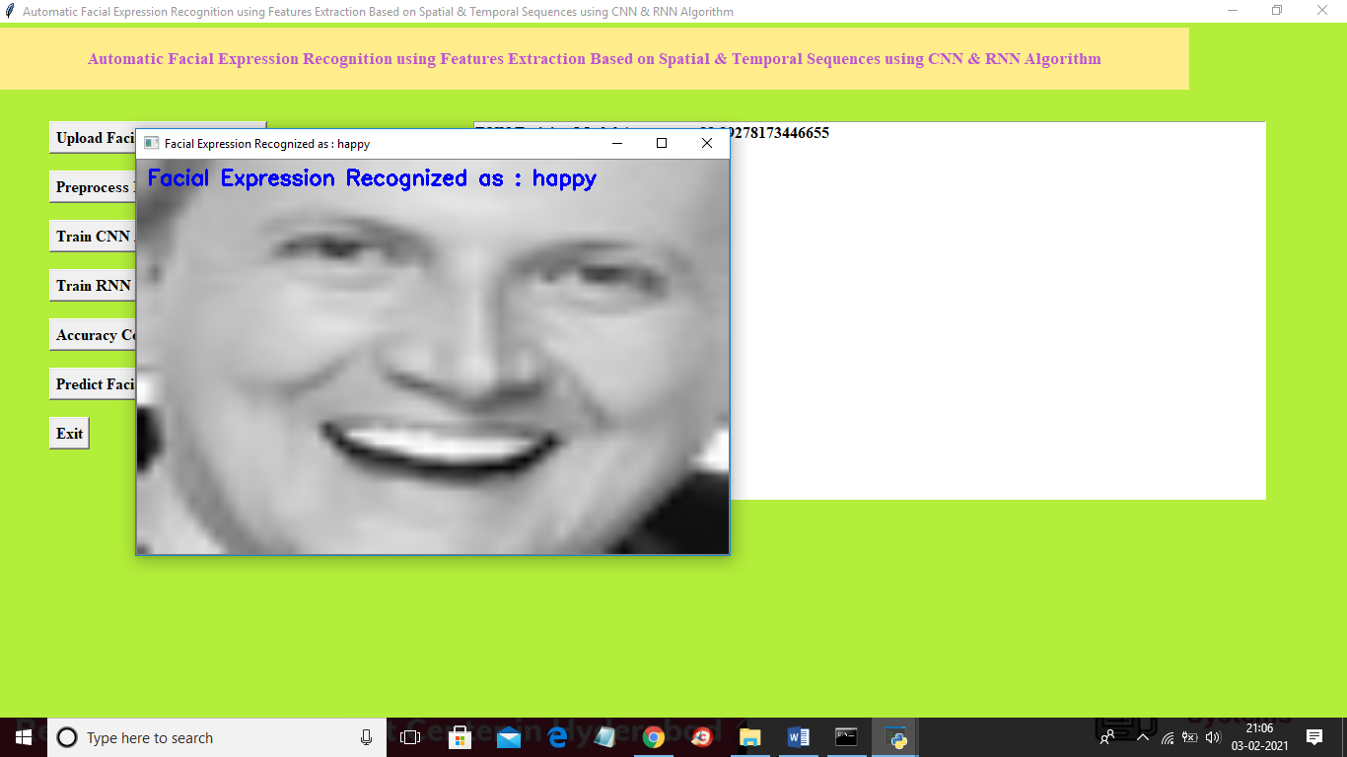

In above screen we got detected emotion as ‘happy’ and similarly you can upload any image and then predict emotion. So this is the output of TITLE 1.

Now run title 2 project by double click on ‘run.bat’ file from ‘Title2_Deeplearning_CNN_RNN’ folder to get below screen

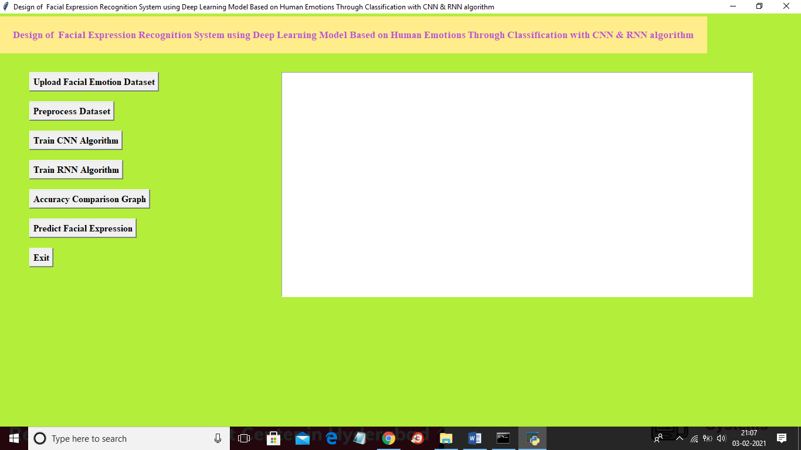

In above screen click on ‘Upload Facial Emotion Dataset’ button to load dataset and to get below screen

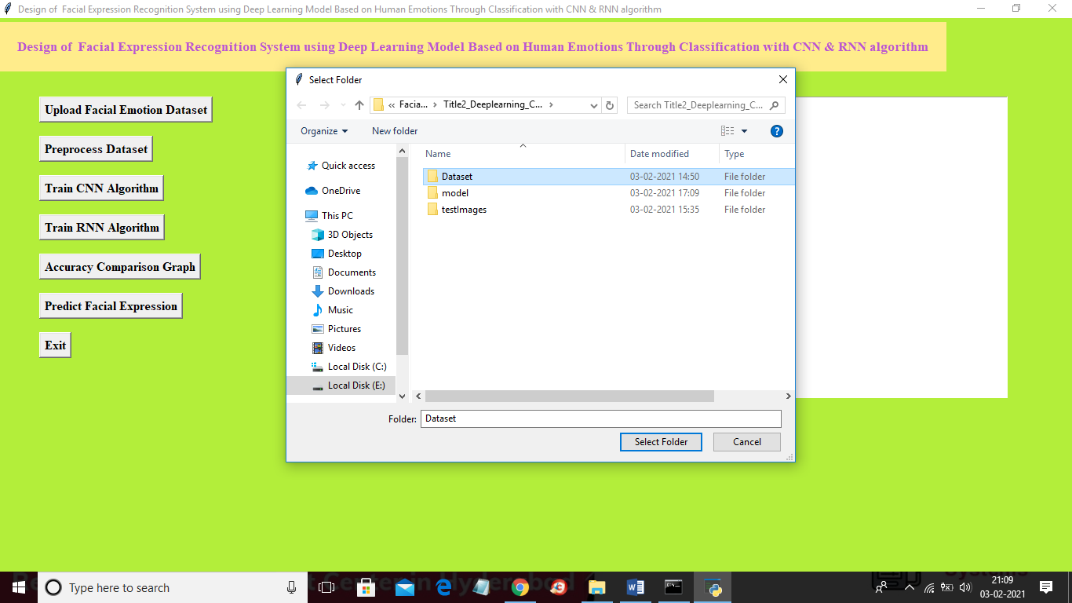

In above screen select and upload ‘Dataset’ folder and then click on ‘Select Folder’ button to load dataset and to get below screen

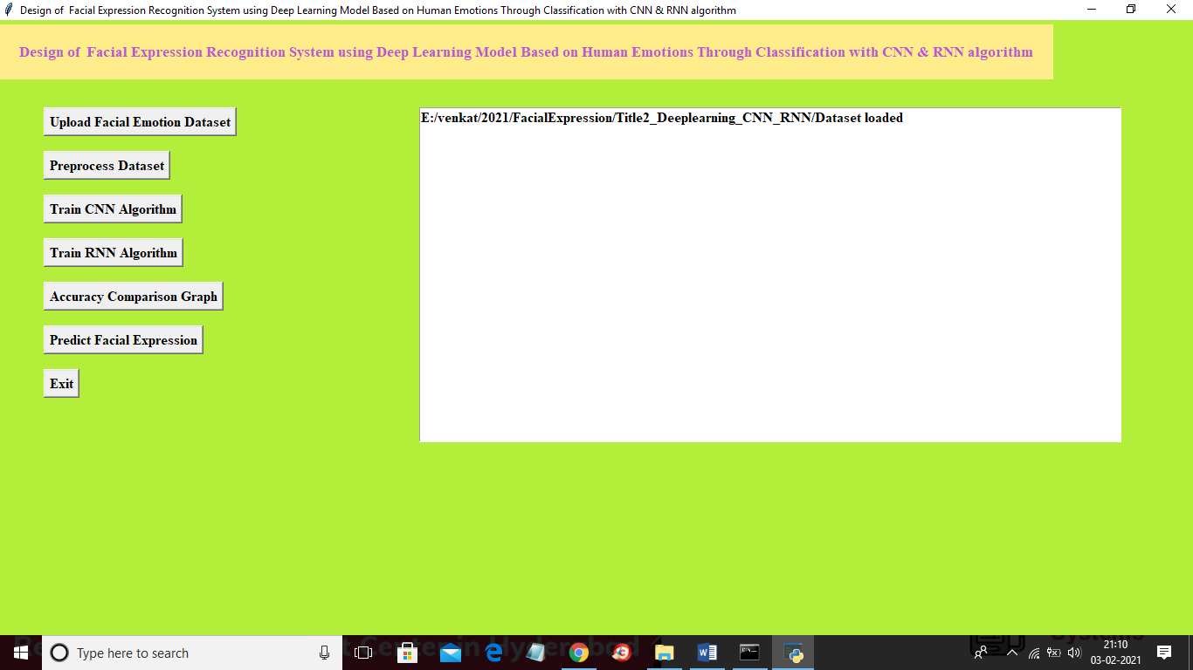

In above screen dataset loaded and then click on ‘Preprocess Dataset’ button to read all images for training and to get below screen

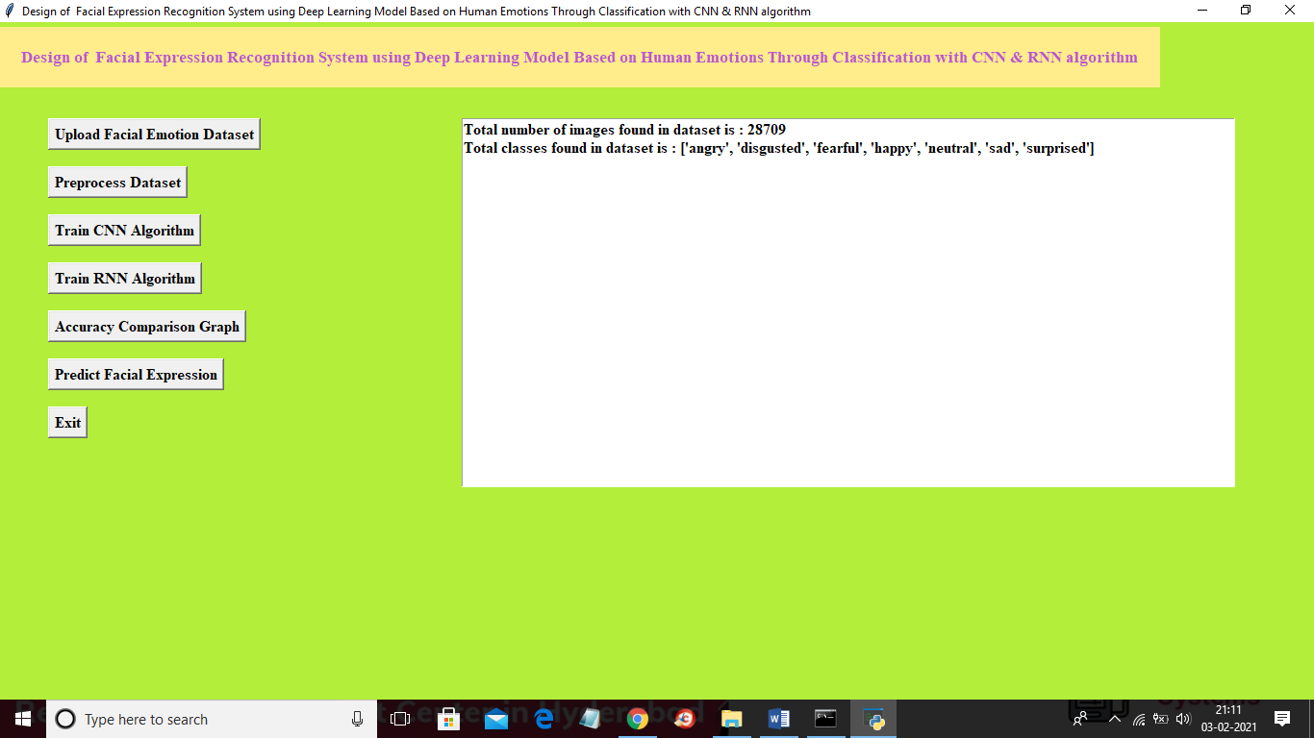

In above screen application read 28709 images from 7 different emotions and now dataset is ready and now click on ‘Train CNN Algorithm’ button to train above dataset.

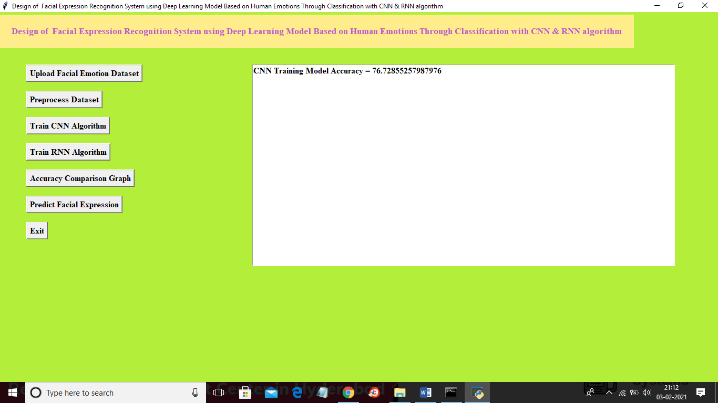

In above screen CNN accuracy is 76% and now click on ‘Train RNN Algorithm’ button to train dataset with RNN algorithm

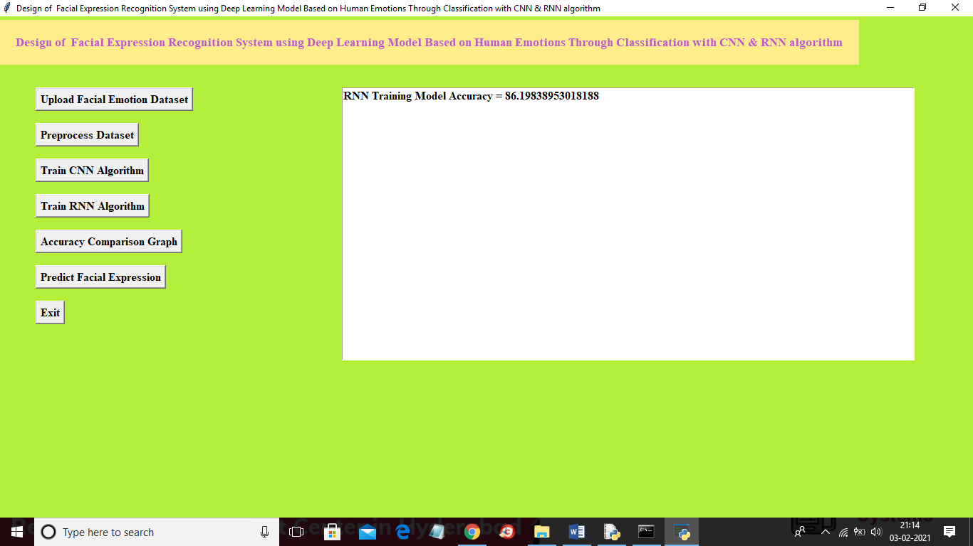

In above screen RNN train with accuracy as 86% and now click on ‘Accuracy Comparison Graph’ to get below graph

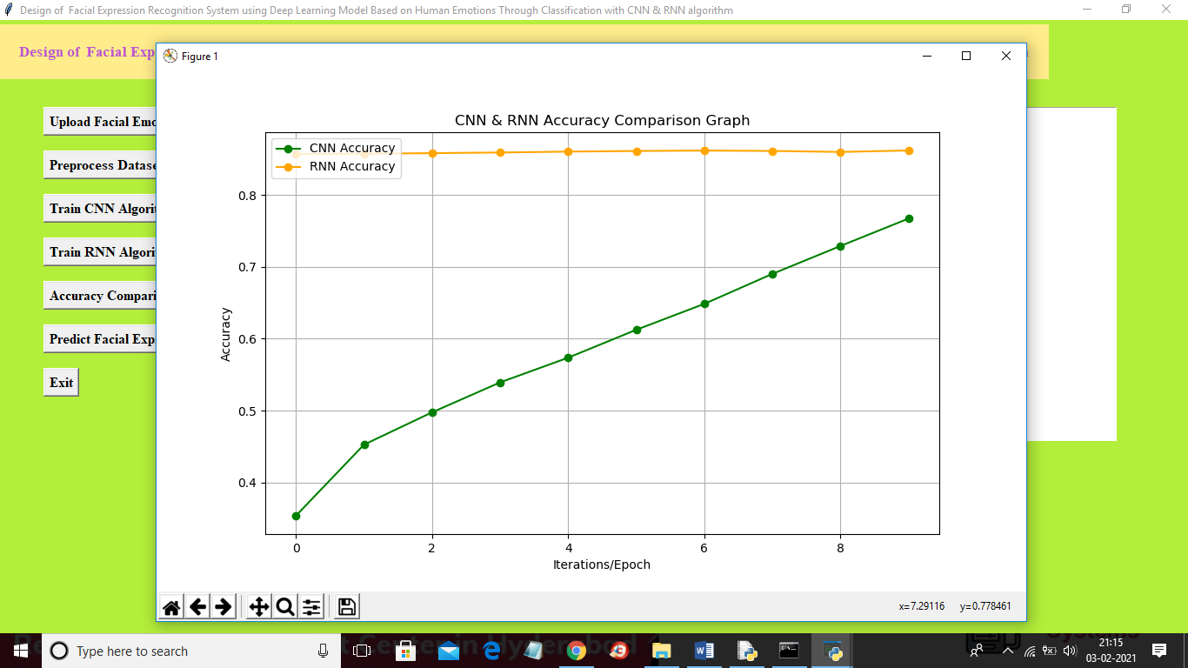

Now click on ‘Predict Facial Expression’ button to upload test image and then application will predict emotion

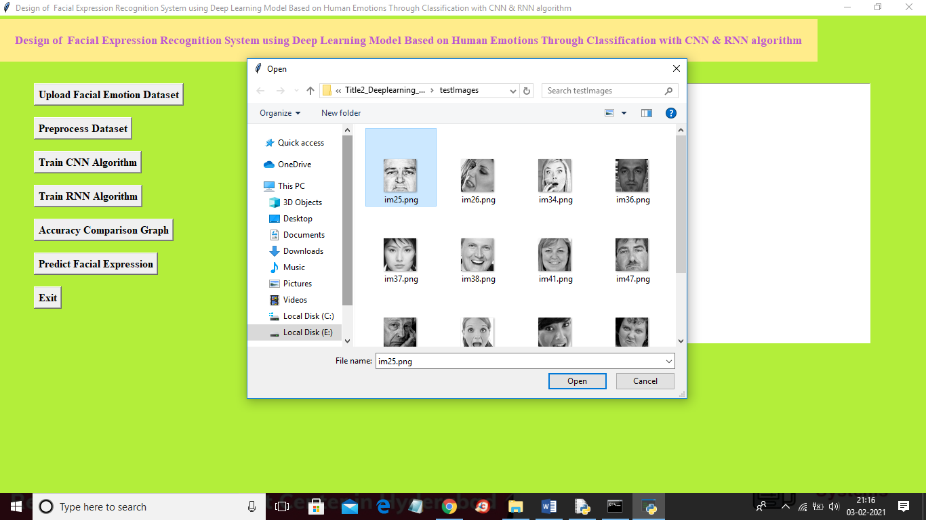

In above screen selecting and uploading im25.png and then click on ‘Open’ button to get below result

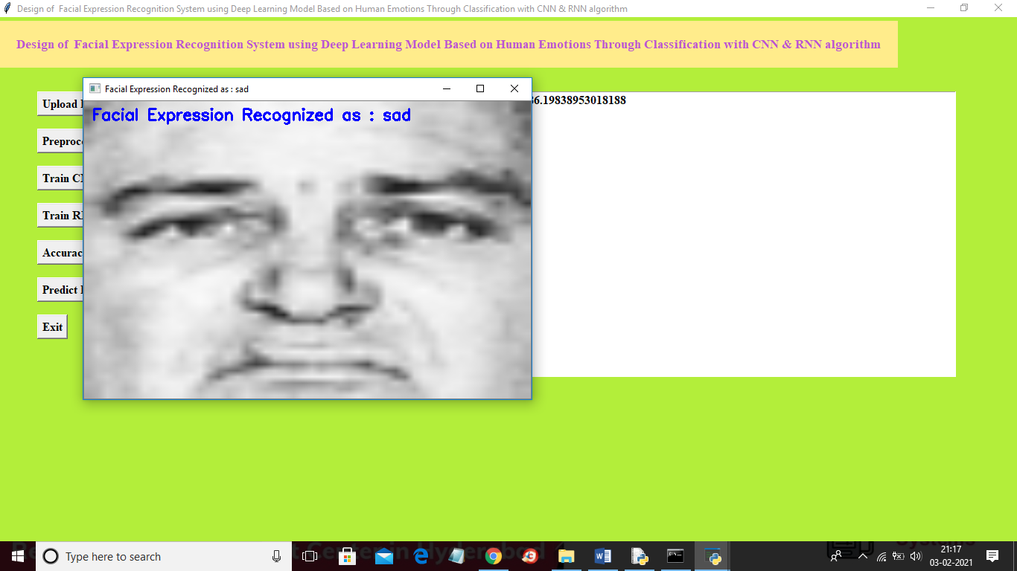

In above screen emotion detected as ‘sad’. Now run title3 by clicking on ‘run.bat’ file from ‘Title3_YOLO_CNN’ folder to get below screen

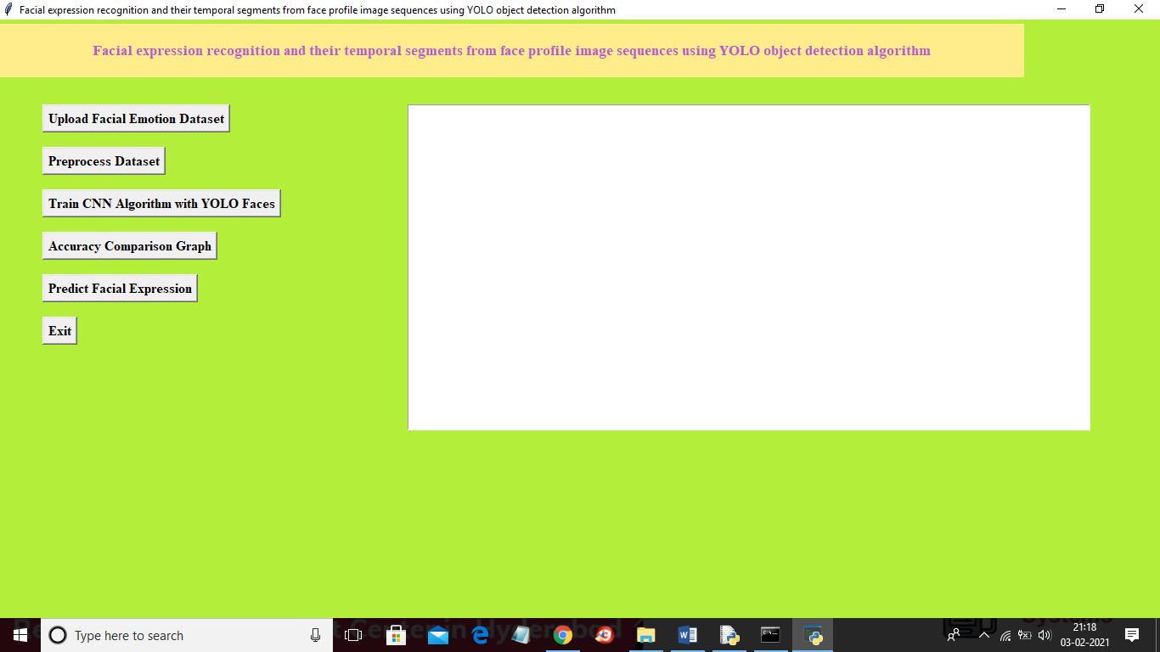

In above screen click on ‘Upload Facial Emotion dataset’ button to load dataset and to get below screen

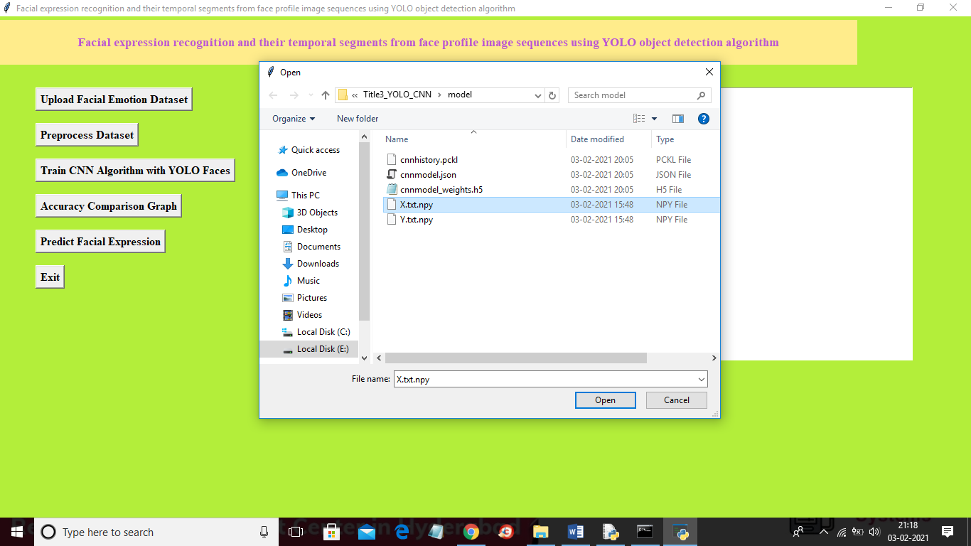

In above screen select and upload ‘X.txt.npy’ file which contains all emotion faces and then click on ‘Open’ button to load dataset and to get below screen

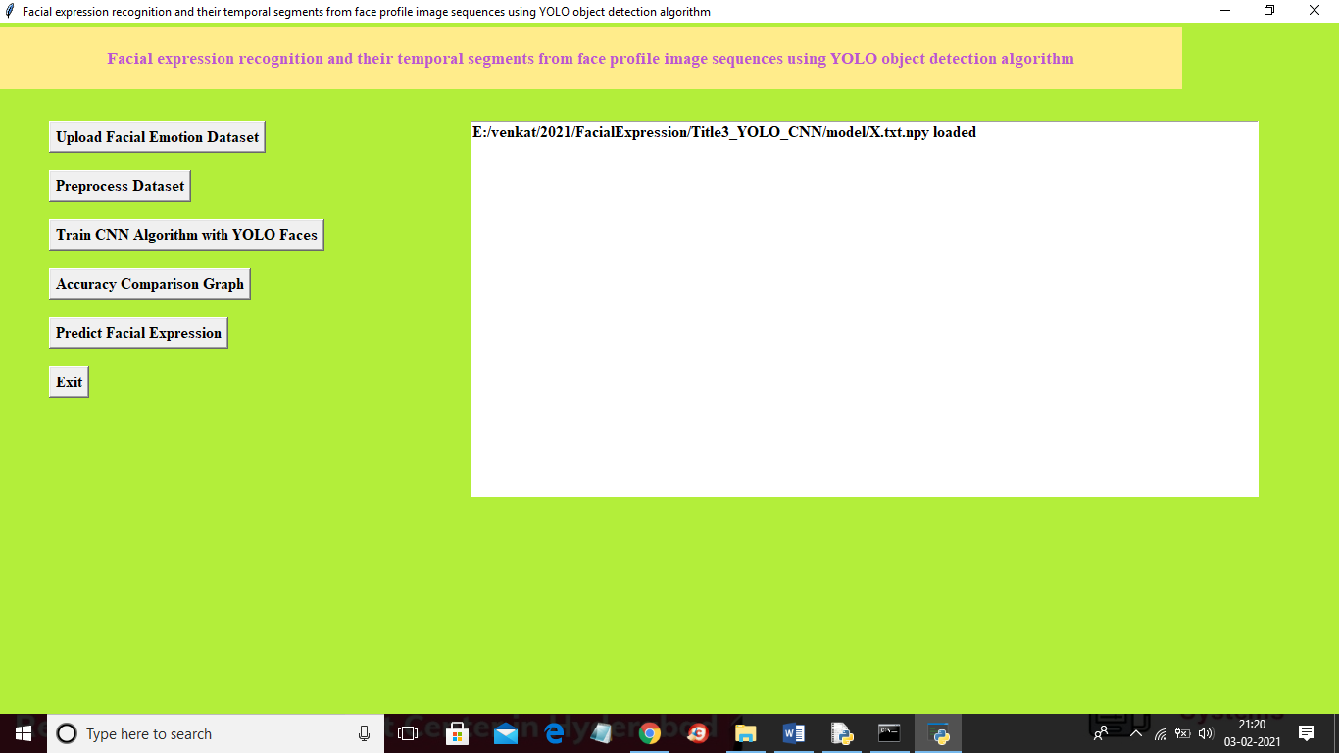

In above screen dataset loaded and similarly you can click on all button to get output and its accuracy details.

Similarly you run title4 project and upload dataset and then run all modules to get error rate.