How to use QLabel
- To place an image into a QLabel object
- To add a hyperlink into a QLabel object
- To align the QLabel object with respect to the window
- Download Sample
To place an image into a QLabel object
- Drop a QLabel object from tool box onto the form.
- Select object and browse to the pixmap property in the property editor window.
- Click the value box of the pixmap property and click on ‘choose file’. From the file dialog, select the required image file. The images is now displayed in the label widget.
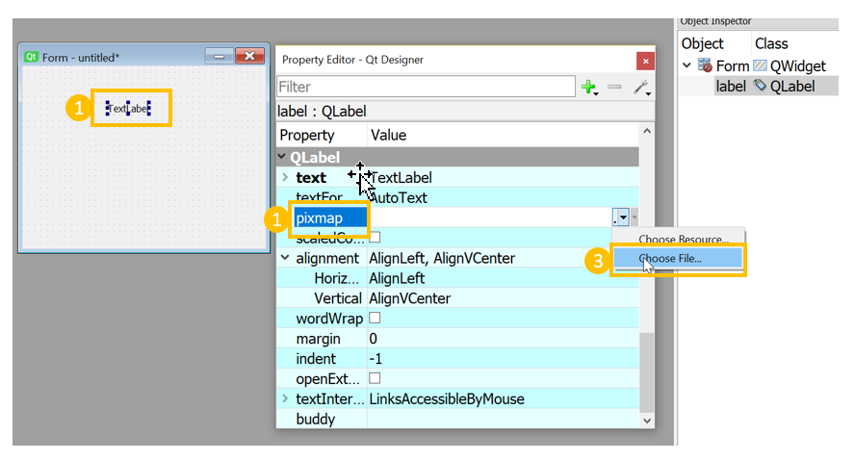
To add a hyperlink into a QLabel object
- Drop a QLabel object from tool box onto the form.
- Select the QLabel object and scroll to the text property.
- Click the Edit text button to the right of the text label box.
- To make this a hyperlink, click the Source tab below and add the HTML attribute tag with the required text. In this example, a link to the Internshala trainings website is added.
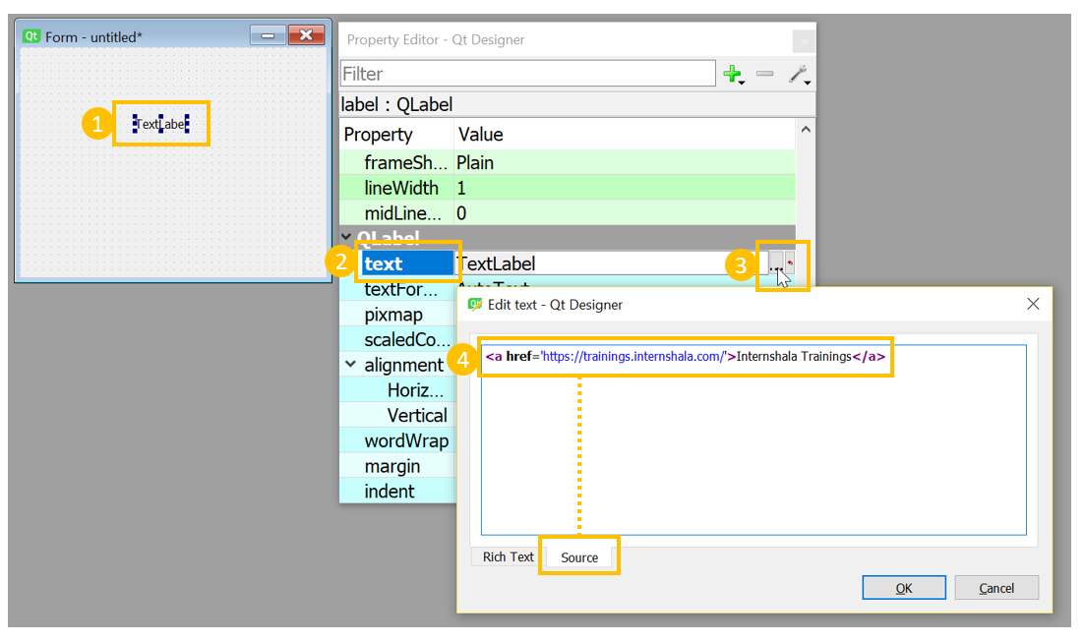
- To open the hyperlink in a new window, scroll to the OpenExternalLinks property.
- Select the box to set it to true.
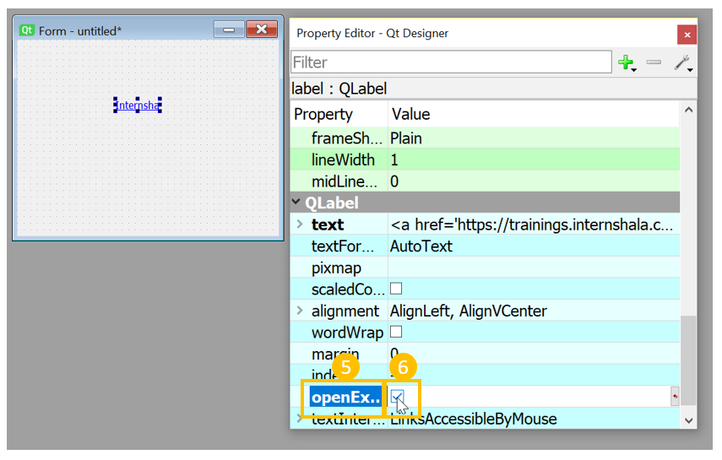
To align the QLabel object with respect to the window
- Select the QLabel object and scroll to the alignment property node.
- Set the horizontal property to the required alignment, for example AlignHCenter.
- Set vertical property to the required alignment, for example AlignVCenter.
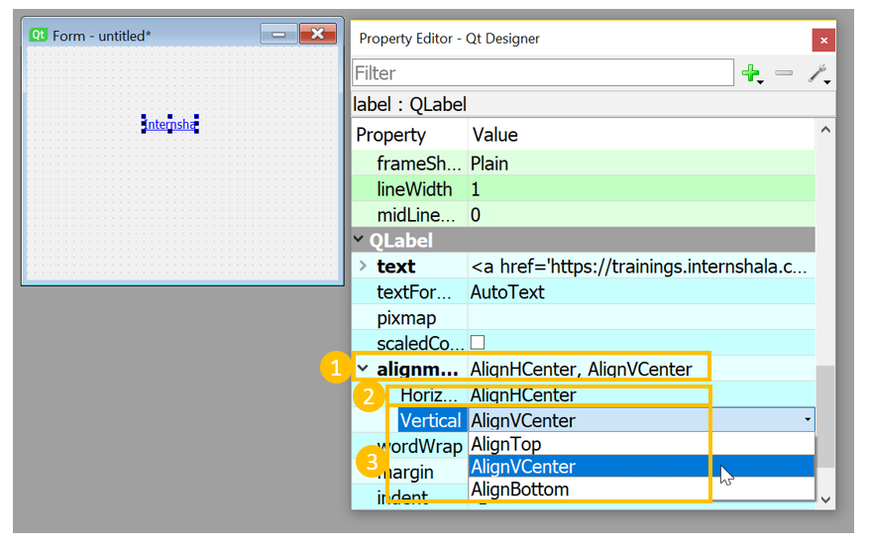

How to use QLineEdit - An Example
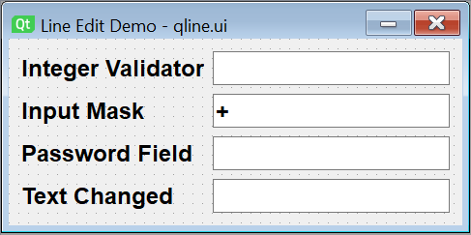

- Step 1
- Step 2
- Step 3
- Step 4
Adding the widgets to the form
- Drop four pairs of QLabel and QLineEdit widgets on the form and put them in Form Layout.
- Change the names of the line edit fields to t1, t2, t3 and t4.
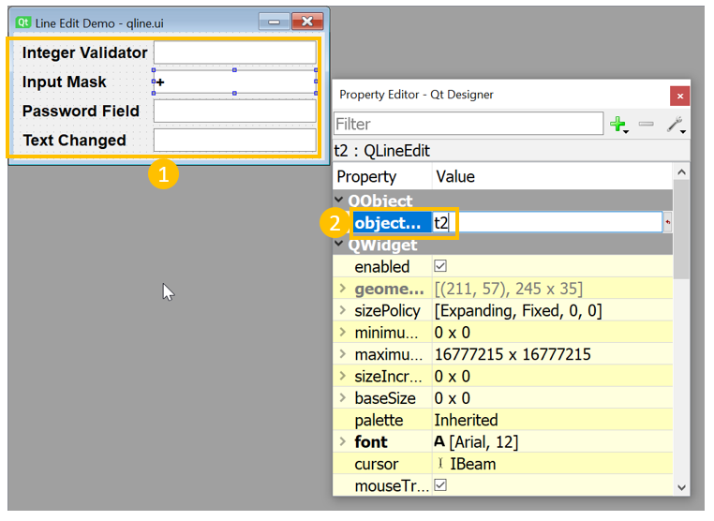
Setting properties and saving ui
- In order to let t2 to accept a phone number in the format +91 965 253 6547, set the InputMask property to +99 999 999 9999.
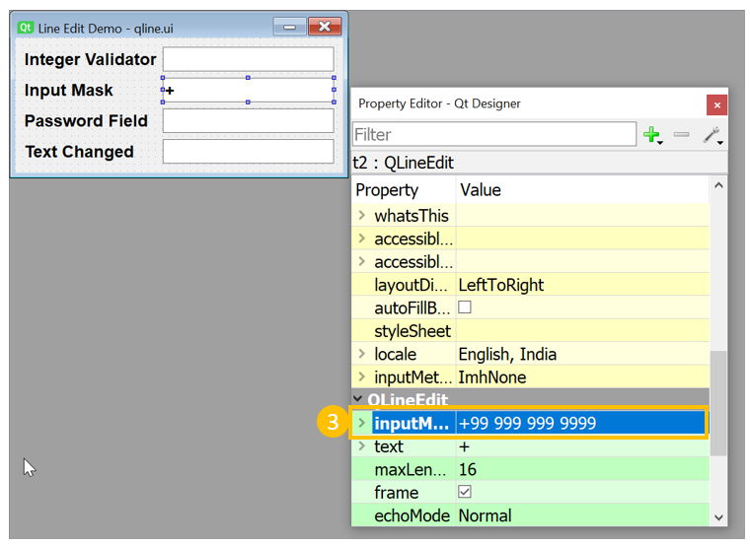

- For t3, set EchoMode property to password.
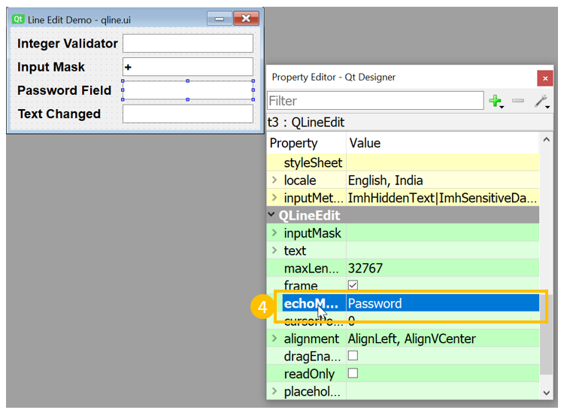

- Save the form as qline.ui.
- Using the pyuic5 utility, generate the Python script.
Event Handling
- To restrict t1 to accepting integers, apply the IntValidator on t1 by add the following statement in setupUi() method.
self.t1.setValidator(QtGui.QIntValidator())
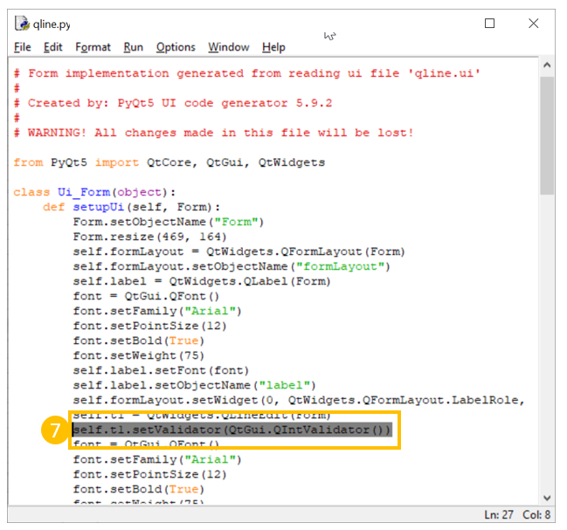

- To restrict t4 to accept only alphabets, add the following method in the class Ui_Form.
def textchange(self, text):
if text.isalpha()==False:
print ("non-alphabet character not allowed")
self.t4.setText("")
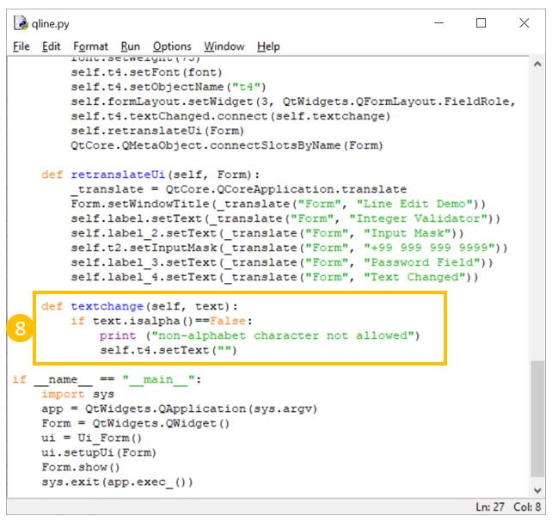

- To set the method added above as a slot for textChanged signal emitted by t4, add the following statement in setupUi() method.
self.t4.textChanged.connect(self.textchange)
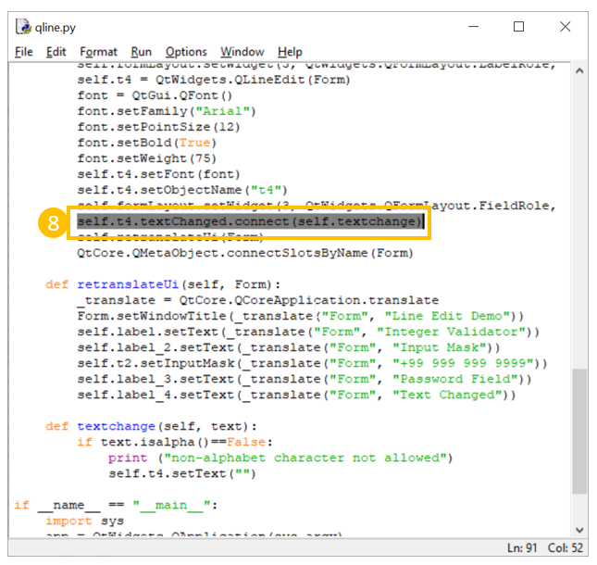

How to use QPushButton - An Example
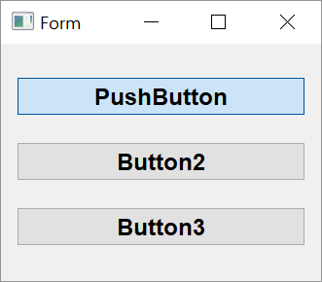

- Step 1
- Step 2
- Step 3
- Step 4
Adding the widgets to the form
- Drop three instances of Push Button widgets on the form and put them in Vertical layout.
- Assign object names as b1, b2 and b3.
- Save the form as btn.ui and generate its Python script using pyuic5 utility.
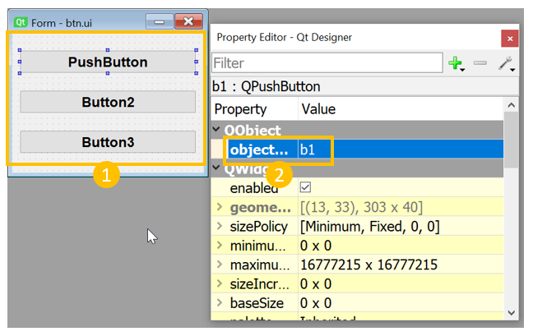
Creating a toggle button
- For setting btn 1 as a toggle button, add the following lines in setupUi() method:
self.b1.setCheckable(True)
self.b1.toggle()
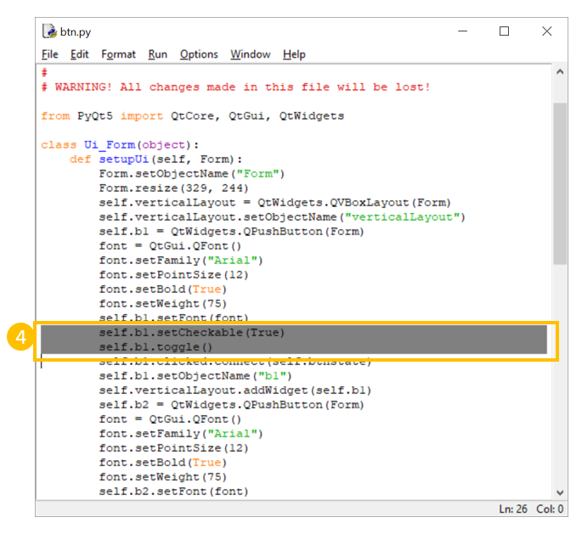

- For the toggle button, to change the caption of b1 according to its state, add the following method in the Ui-Form class generated by pyuic5 utility
def btnstate(self): if self.b1.isChecked(): self.b1.setText("pressed") else: self.b1.setText("released")
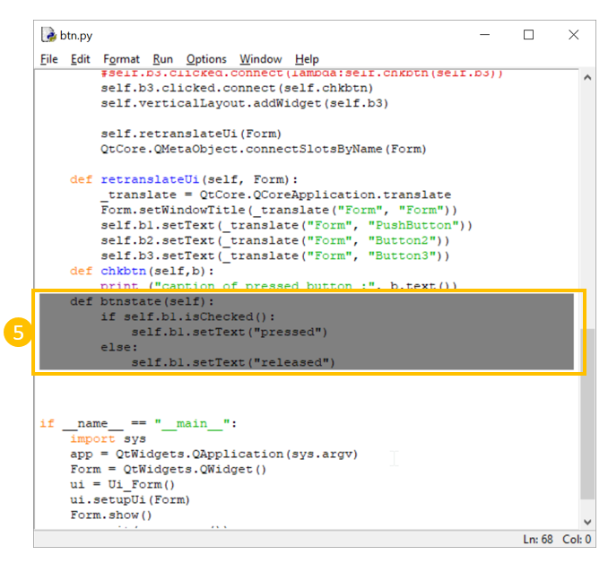

- Use this method as slot for clicked signal emitted by b1. Add the following statement in the script. self.b1.clicked.connect(self.btnstate)
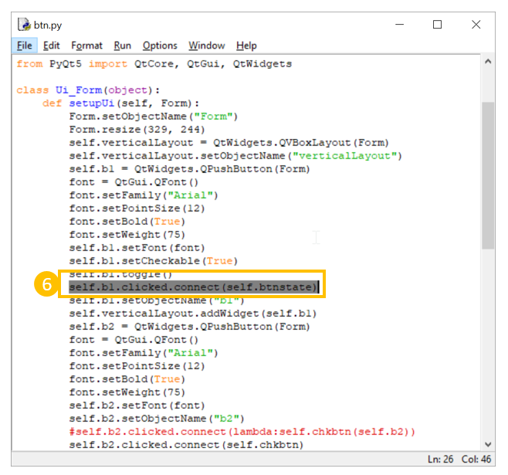
Identifying which button has been clicked
- We want to identify which button out of b2 and b3 has been clicked. Add following method in the class and connect the same to clicked signal of b2 and b3.
def chkbtn(self,b): print ("caption of pressed button :", b.text())
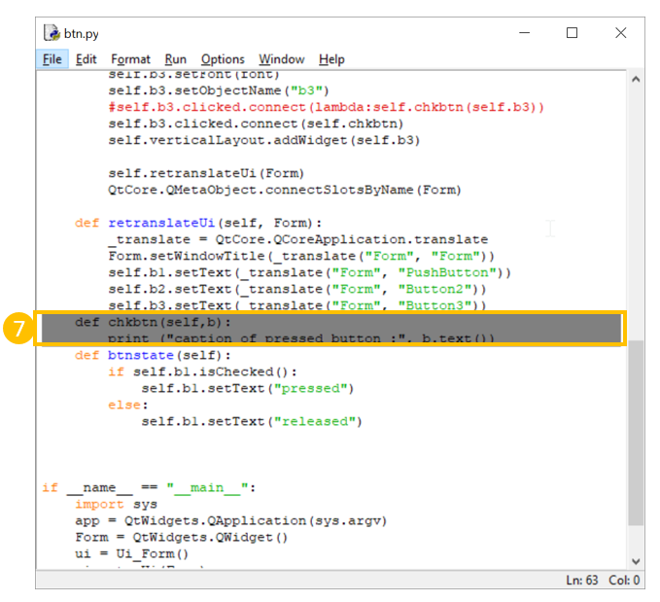

- Add following lines in setupUi() method
self.b2.clicked.connect(lambda:self.chkbtn(self.b2))
self.b3.clicked.connect(lambda:self.chkbtn(self.b3))
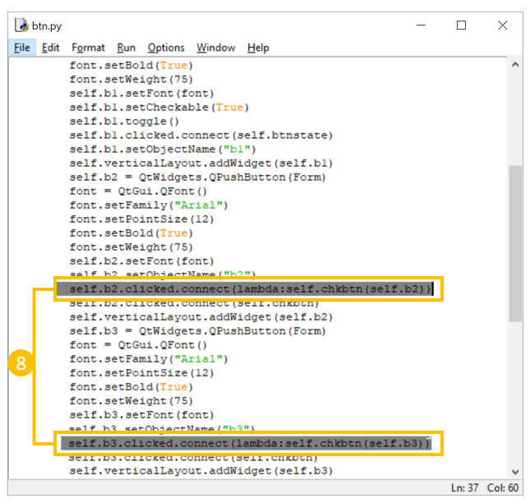

How to use QRadioButton - An Example
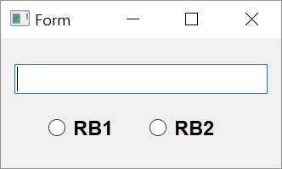

- Step 1
- Step 2
- Step 3
Adding the widgets to the form
- Place a QLineEdit box, two radio button objects and two horizontal spacers in horizontal layout on the form and apply vertical layout to parent window.
- Name the text box as t1 and radio buttons as rb1 and rb2.
- Set checkable property of both radio buttons to true from property editor window.
- Save this form as rbtn.ui and obtain its Python script by using conversion utility pyuic5.
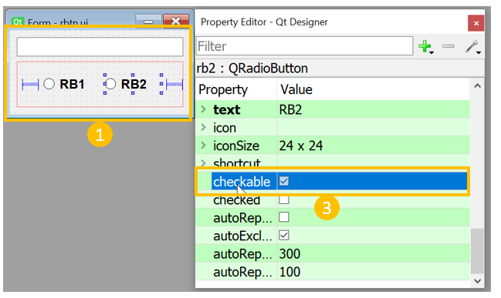
Event Handling
- Open the rbtn.py file. QRadioButton widget emits toggled signal. Connect this signal to following event handler method.
def checkstate(self):
state1='OFF'
state2='OFF'
if self.rb1.isChecked()==True:
state1='ON'
else:
state1='OFF'
if self.rb2.isChecked()==True:
state2='ON'
else:
state2='OFF'
self.t1.setText("Button1 is {} Button2 is {}".format(state1,state2))
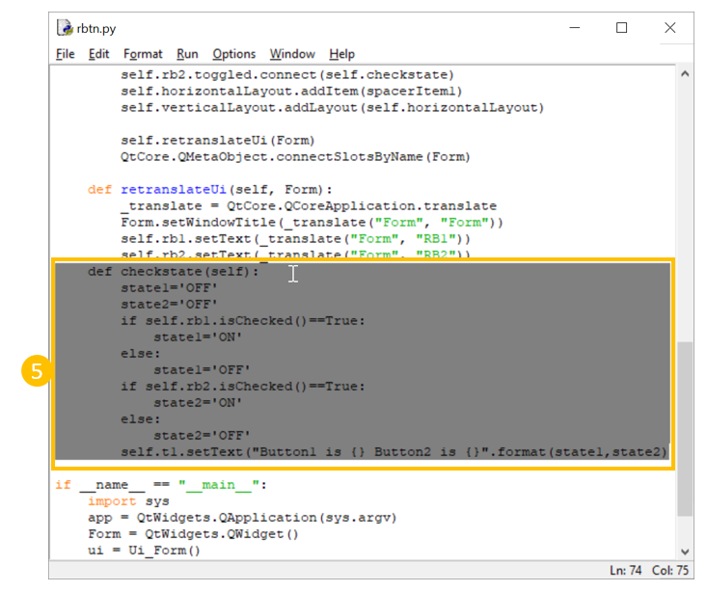

- Following statements connect this method to radio buttons.
self.rb1.toggled.connect(self.checkstate)
self.rb2.toggled.connect(self.checkstate)
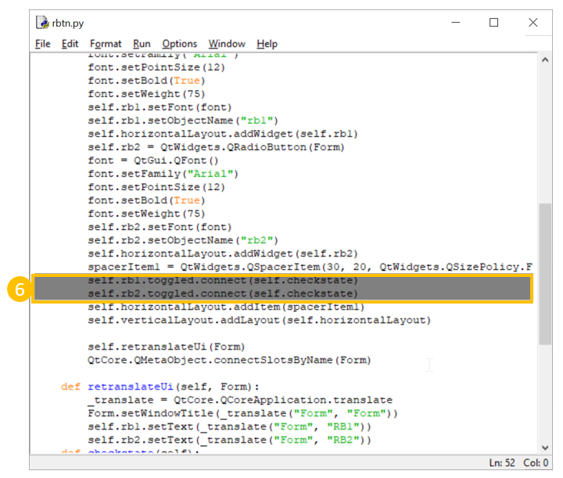

How to use QCheckBox - An Example
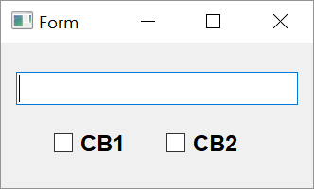

- Step 1
- Step 2
- Step 3
Morphing the widgets
The design of form to show usage of checkbox widget is similar to radio-button example. Except, radio buttons are replaced by checkboxes. So, you can convert the radiobutton ui file from the previous section into a checkbox.
- Open rbtn.ui with Qt designer.
- Right click on the radio button and choose morph into->QCheckBox from popup menu.
- Change object names to CB1 and CB2 respectively.
- Save it as chkbox.ui and generate equivalent Python script chkbox.py.
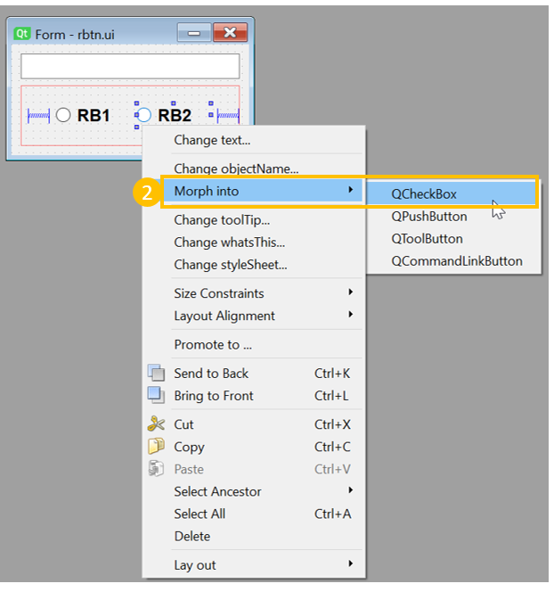
Event Handling
- Open chkbox.py with IDLE. Add following method in Ui-form class:
def checkstate(self):
state1='Unchecked'
state2='Unchecked'
if self.rb1.isChecked()==True:
state1='Checked'
else:
state1='Unchecked'
if self.rb2.isChecked()==True:
state2='Checked'
else:
state2='Unchecked'
self.t1.setText("cb1 is {} cb2 is {}".format(state1,state2))
- Connect stateChanged signal of both checkboxes to this method.
self.cb1.stateChanged.connect(self.checkstate)
self.cb2.stateChanged.connect(self.checkstate)

How to use QComboBox - An Example
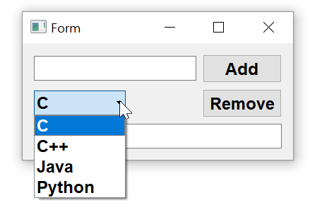

- Step 1
- Step 2
- Step 3
Adding the widgets to the form
In following example, there are two horizontal layouts and a LineEdit control placed on a form with vertical layout. In upper horizontal layout, another lineedit widget t1 and a push button b1 are added. In second horizontal layout, a QComboBox widget combo1 and another button b2 are dropped. The bottom text box is named as t2.

  - To add items in the combo box select it and right click on it. From the resulting popup menu, choose edit items and add items by pressing + button
  - Save the form as combo.ui and generate its Python script by pyuic5 utility.
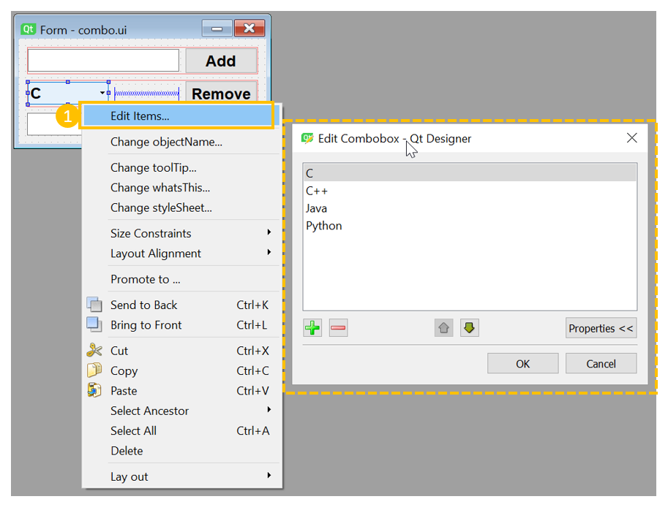
Event Handling
- Open combo.py with IDLE. Add following methods to Ui-Form class
def rmitem(self):
indx=self.combo1.currentIndex()
item=self.combo1.currentText()
self.t2.setText(item+" is removed from combobox")
self.combo1.removeItem(indx)
def additem(self):
self.combo1.addItem(self.t1.text())
self.t2.setText(self.t1.text()+" is added to combobox")
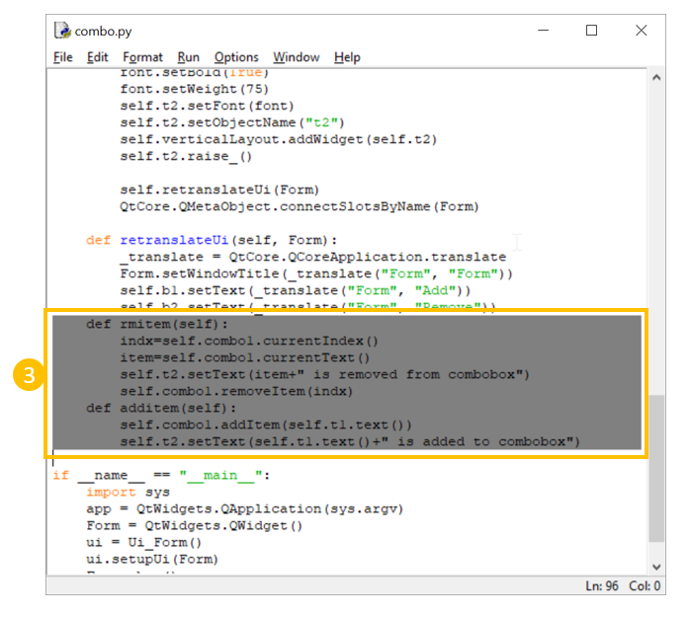

- Use these methods as signals for clicked signal of b2 and b1 buttons respectively by adding following statements in setupUi() method
self.b2.clicked.connect(self.rmitem)
self.b1.clicked.connect(self.additem)
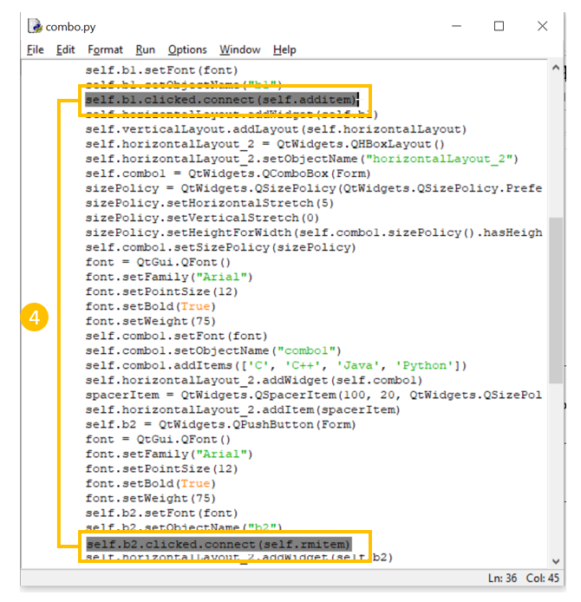

How to use QListWidget - An Example
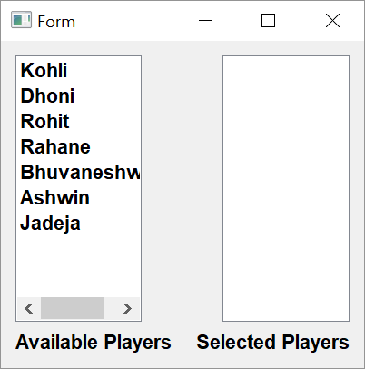

- Step 1
- Step 2
- Step 3
Setting up the form
- In the example two listwidgets are placed in a horizontal layout. First one, list1 being its name is populated at design time (exactly like QComboBox). The list2 object is empty to begin with.
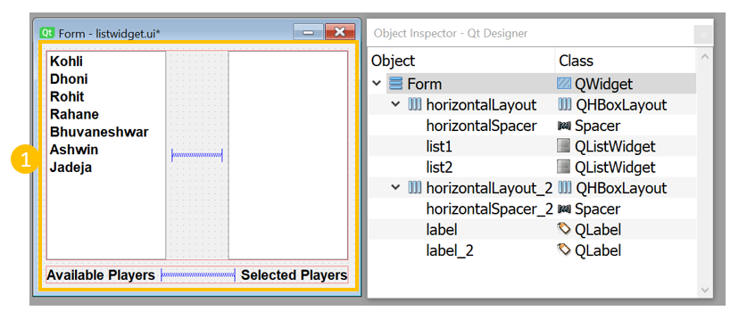
Event Handling
The idea is to select an item in one list, remove the selected item from it and add in other list. For this purpose we use itemDoubleClicked signal emitted by QListWidget widget and connect it to event handler methods.

- Add following methods in Ui_Form class
def removelist1(self, item):
self.list1.takeItem(self.list1.row(item))
self.list2.addItem(item.text())
def removelist2(self, item):
self.list2.takeItem(self.list2.row(item))
self.list1.addItem(item.text())
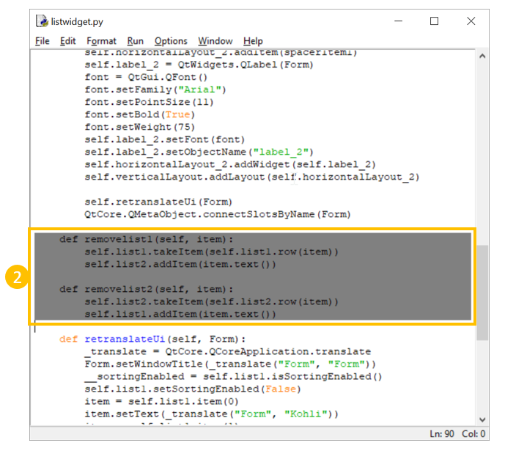

- These two methods are used as event handlers for itemDoubleClicked signal of list1 and list2 objects respectively.
self.list1.itemDoubleClicked.connect(self.removelist1)
self.list2.itemDoubleClicked.connect(self.removelist2)
The QListWidgetItem on which double click event is performed, is sent as argument to these method. Its text() method retrieves the string from the selected item. The removelist1() method removes selected item from list1 and adds it to list2. Similarly removelist2() method removes selected item from list2 and adds it to list1

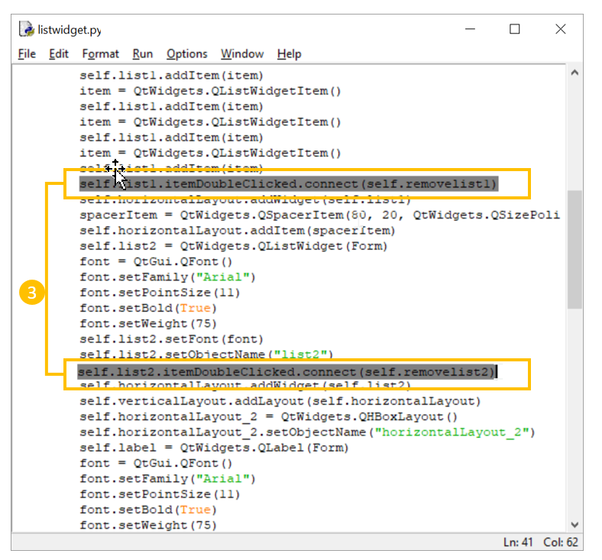

Adding menu Functionality - Method to be added in the Ui_MainWindow class
Note: When using this code in our script, make sure that the indents appear correctly otherwise you may get an error.
def menufunction(self, action):
txt= (action.text())
no=int(self.t1.text())
print (txt, no)
if txt =='Square':
self.t2.setText(str(no*no))
if txt =='Cube':
self.t2.setText(str(no*no*no))
if txt =='SqrRoot':
self.t2.setText(str(math.sqrt(no)))
if txt=='CubeRoot':
self.t2.setText(str(math.pow(no,1/3)))

Event handler for File Menu - Statement in the setupUI method
self.menuFile.triggered[QtWidgets.QAction].connect(self.menufunction)

Context Menu - Method to be added in the Ui_MainWindow class
def context_menu(MainWindow):
menu = QtWidgets.QMenu()
menu.addAction("First option")
menu.addAction("Second option")
menu.addAction(":)")
menu.exec_(QtGui.QCursor.pos())

