Practical 1A Text Formatting tags

<html>

<body>

<b>This is block</b><br>

<i>This is italic</i><br>

<u>This is underline</u><br>

<s>This is strike</s><br>

<big>This is big</big><br>

<small>This is small</small><br>

ab<sup>2</sup><br>

H<sub>2</sub>O<br>

<mark>Highlighted</mark><br>

<em>Emphasized</em><br>

<strong>This is strong</strong><br>

<del>This is deleted</del><br>

<ins>This is inserted</ins><br>

</body>

</html>

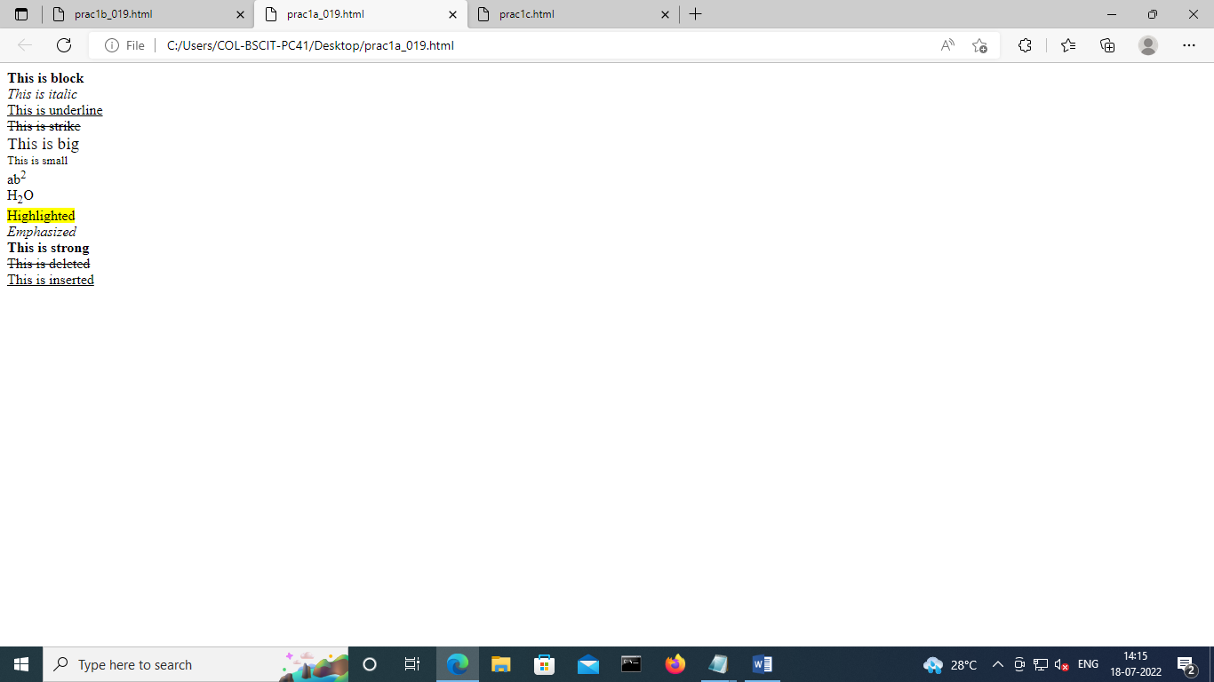

Practical 1A Block Formatting tags

<html>

<body>

<h1>Formatting</h1>

<hr align="left"

size=2px

width=200px>

<p>Arranging the data in a presentable

and strctured manner and making it

look more user friendly</p>

<div align=right>defines a section or division of document

which may require special alignment</div>

<blockquote>This is blockquote</blockquote>

</body>

</html>

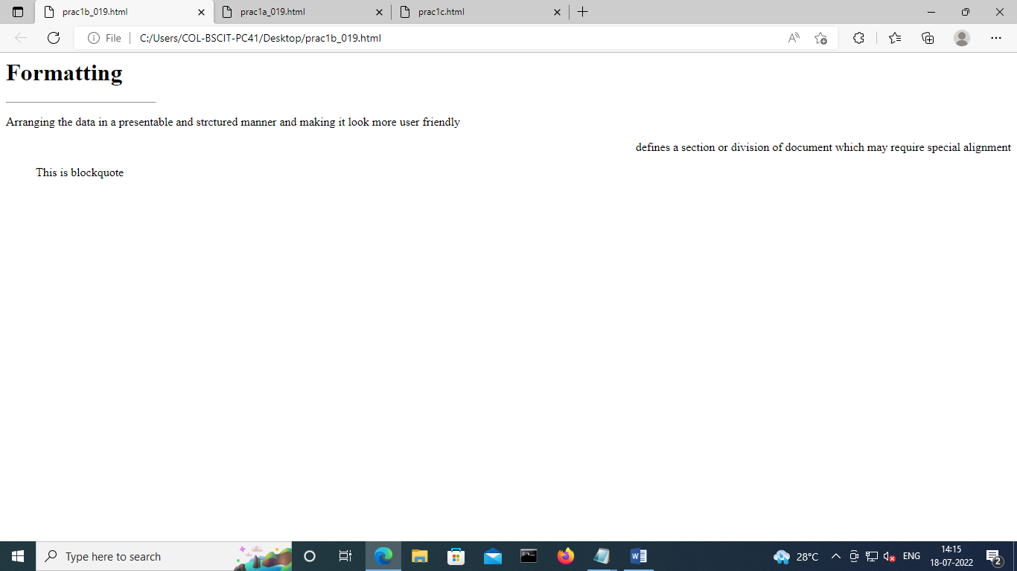

Practical 1C List tags

<html>

<body>

<h1>These are coding languages</h1>

<ol type="1"

start="4">

<li>Python</li>

<li>C++</li>

<li>Webprogramming</li>

</ol>

<h1>Ways to learn</h1>

<ul type="disc">

<li>Reading</li>

<li>Writing</li>

</body>

</html>

