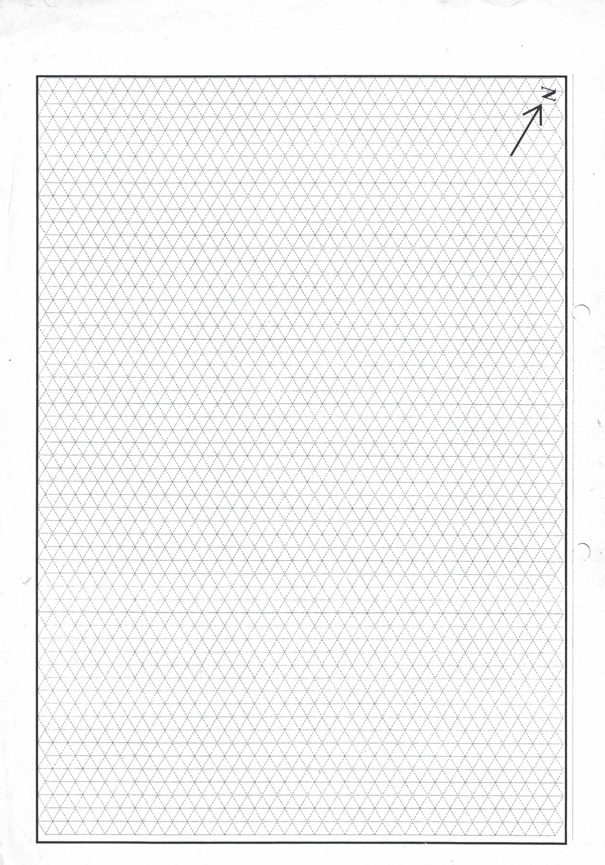
shreyaenterprises.github.io/docs
CLIENT:
PROJECT:
DRAWING NO.:
SHEET NO.:

