NITTE MEENAKSHI INSTITUTE OF TECHNOLOGY
Department of Electronics and Communication Engineering
OBJECT-ORIENTED PROGRAMMING USING C++ LAB
TASK 1 REPORT (WEEKS 1–6)
Submission deadline: 16 October 2026
Student Name | Shreya Fouzdar
USN | NB25ECE170
Section / Batch | 3/C
Task Title / Problem Statement | Student Class Implementation Using OOP Concepts in C++
GitHub Repository URL | https://github.com/ShreyaFouzdar/cpp

1. Aim / Objective
To implement a student class in C++ using object-oriented programming concepts such as encapsulation, parameterized constructors, function overloading, static members, friend functions, operator overloading, and dynamic memory management.

2. Problem Statement
Implement a student class in C++ using encapsulation and a parameterized constructor. The program should include overloaded functions, a static member to count the number of students, a friend function, and an overloaded > operator to compare students based on their marks.

3. Concepts Used
1. Encapsulation – Keeping student data private and accessing it through public member functions.
2. Parameterized Constructor – Initializing student details when objects are created.
3. Function Overloading – Defining multiple functions with the same name but different parameter lists.
4. Static Data Member – Counting the total number of student objects created.
5. Friend Function – Allowing a non-member function to access private members of the student class.
6. Operator Overloading – Overloading the > operator to compare two students based on their marks.

4. Algorithm / Steps
- Start the program.
- Define a student class with private data members to store student details and marks.
- Create a parameterized constructor to initialize the student details.
- Define overloaded functions to perform operations using different parameter lists.
- Declare a static data member to count the number of students created.
- Define a friend function to access and display the required private student details.
- Overload the > operator to compare two students based on their marks.
- Create student objects and initialize them with suitable values.
- Display the student details and the total number of students.
- Compare the students using the overloaded > operator and display the result.
- Stop the program.

5. Source Code
#include <iostream>
#include <string>
using namespace std;

class Student
{
private:
string name;
int marks;
static int count;

public:
// Parameterized constructor
Student(string n, int m)
{
name = n;
marks = m;
count++;
}

// Function overloading
void display()
{
cout << "Name: " << name << endl;
cout << "Marks: " << marks << endl;
}

void display(string title)
{
cout << title << endl;
display();
}

// Static member function
static void showCount()
{
cout << "Total students: " << count << endl;
}

// Friend function
friend void showStudent(const Student& s);

// Operator overloading
bool operator>(const Student& s) const
{
return marks > s.marks;
}
};

// Definition of static data member
int Student::count = 0;

// Definition of friend function
void showStudent(const Student& s)
{
cout << "Friend function: " << s.name << ", Marks: " << s.marks << endl;
}

int main()
{
Student s1("Anu", 85);
Student s2("Riya", 92);

cout << "Student 1:" << endl;
s1.display();

cout << "\nStudent 2:" << endl;
s2.display("Student Details:");

cout << endl;
showStudent(s1);

Student::showCount();

if (s1 > s2)
cout << "Anu has higher marks." << endl;
else
cout << "Riya has higher marks." << endl;

return 0;
}

6. Compilation and Execution
Compiler / IDE used: GCC (GNU Compiler) through Visual Studio Code (VS Code).
Compilation status: ✓ Successful
Execution status: ✓ Successful

7. Output Screenshot(s)
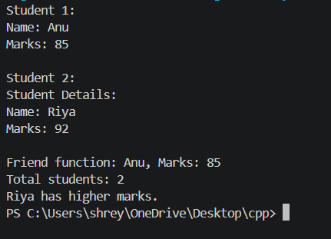

8. Result
The student class was successfully implemented in C++ using encapsulation, a parameterized constructor, function overloading, a static data member, a friend function, and operator overloading. The program was compiled and executed successfully, and students were compared based on their marks.

9. Learning Outcome / Reflection
Through this task, I learned how to implement object-oriented programming concepts in C++. I understood how constructors initialize objects, how function overloading allows functions to have the same name with different parameters, and how static members count objects. I also learned how friend functions access private data and how operator overloading can compare student marks.

10. GitHub Submission Checklist
✓ Report prepared using this template
✓ Source code (.cpp) uploaded
✓Output screenshot(s) uploaded
✓ Program compiled and executed successfully
✓ Files organized in the correct weekly/task repository
✓GitHub repository URL included above
Student Declaration: I confirm that this report and program represent my own work.
Student Signature: Shreya Fouzdar Date: 14/10/2026

