## INTERNAL AUDIT MANAGMENT

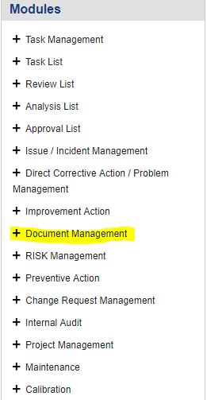

**1**

**1.** Click on the **Document Management** button on the left side of your Screen. A Drop down List will appear.

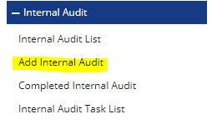

**1.** Click on the **Add Internal Audit** Button & a window will appear soon.

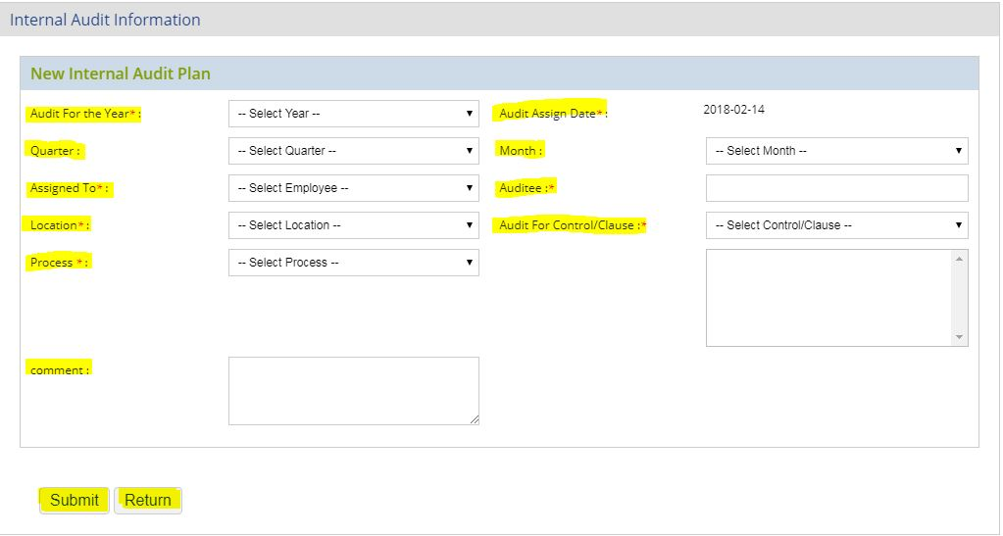

**1.** A form will open named **Internal Audit Information**. Here you fill the marked items to create the issue. Then click on the button below **Submit**. After that Audit is created and a new window is open and it is identified by unique **Audit Id**.

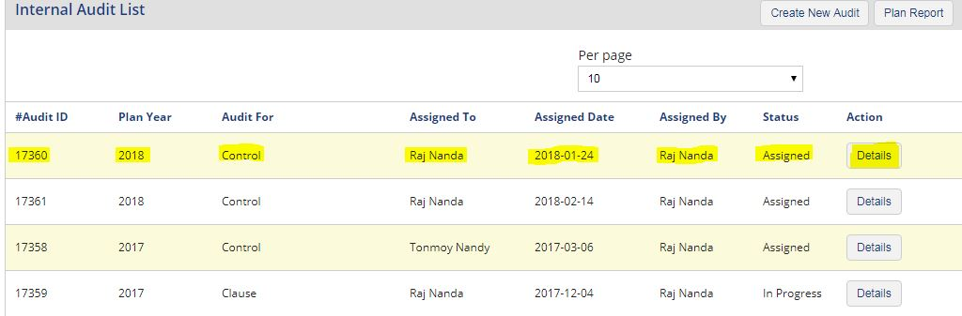

**1.** Here we can create the issue and **Audit-id-22**. After creating the Audit we have to assign the issue to designated persons to work on the issue.

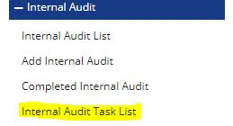

**1.** After creating the Audit go to step-1 and click on the tab. After that a dropdown list will opened. Click on the tab named as **Internal Audit Task List**. A window will then have opened.

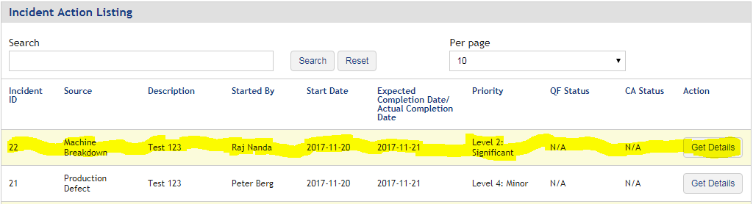

**1.** For assign the issue (issue id-22) we have to click on the button on the right side named (**Get Details)**.

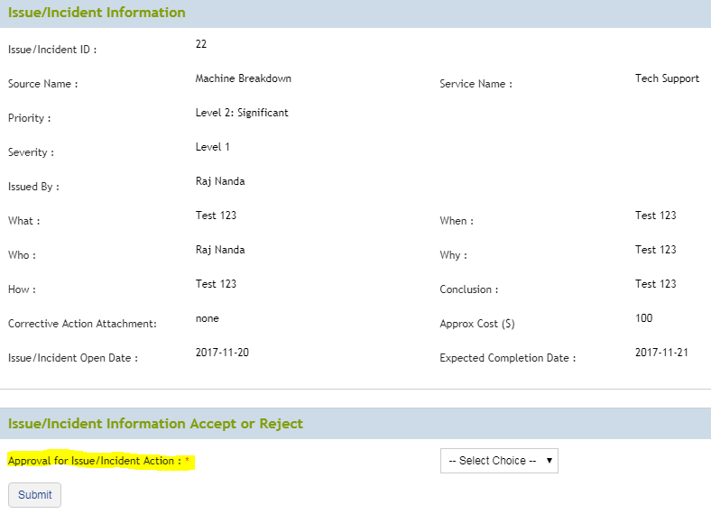

**1.** Here we have to approve the issue first by click on right side drop down list of marked tab.

**2.** If the issue is Accepted then click on submit button for further process.

**3.** If the issue is Rejected then repeat from Step 1 for further process.

**4.** After click on submit button & a window will open.

**1.** If the issue is accepted then first you have to assign one employee as Analyzer of Quick Fix Task.

2. After selecting one employee as Analyzer click on button name as Start Quick-Fix then a window will open

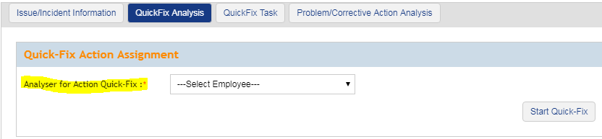

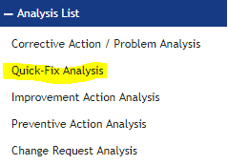

**1.** After assign a analyzer login to that person profile and click on **Analysis List** from the menu names as **Modules** on the left side.

**2.** After click on **Analysis List** one submenu is open. Then click on the marked text named as **Quick Fix Analysis.**

**1.** After click on Quick Fix Analysis a window will open and then click on button named as **Correction/Quick Fix** on the right side of your issue marked on picture(**Here issue id is 22**).

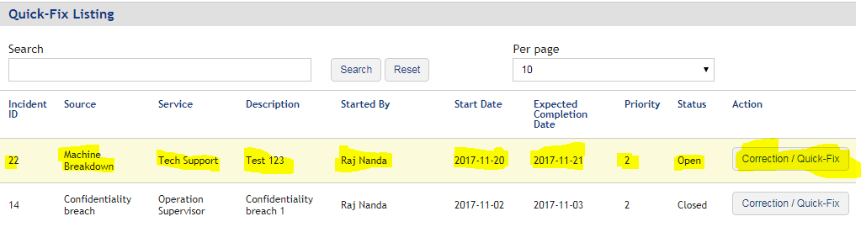

1. After click on **Correction/Quick Fix** button a window will open. Then click on **Analysis Information** tab and write the possible solution of marked item.

2. After click on **Save** button.

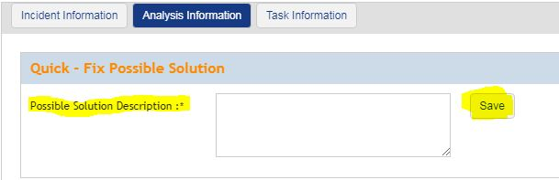

**1.** After click on **Save** button go to the tab Task Information & create a Task & assign a Task to someone.

**2.** After click on **Save** button.

Note: - Multiple Tasks can be created for an issue at the time of **Quick Fix Action**.

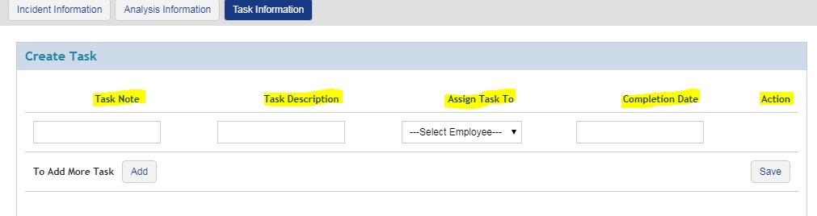

**1.** After creating task again click on the **Issue/Incident Management** menu from left side part named as Modules.

2. After that a submenu will open & click on **Issue/Incident Assignment** & a window will open.

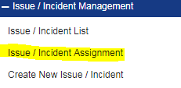

**1.**Click on tab named as **Quick Fix Task** & click on the check box on the left hand side to select the task.

**2.** After that assign a reviewer by clicking on the dropdown list of **Assign Reviewer**.

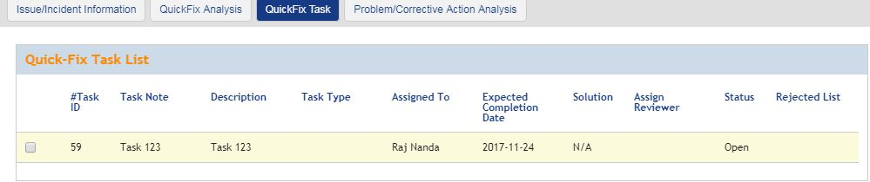

**1.** After click on the **Task List** from menu named as Modules on the left side of your window.

**2.** After click on **Task-List** a submenu will open & from the submenu click on **Task** **From Quick Fix** .Then a window will open.

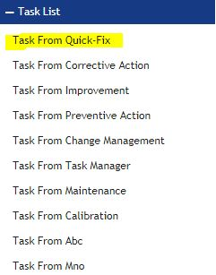

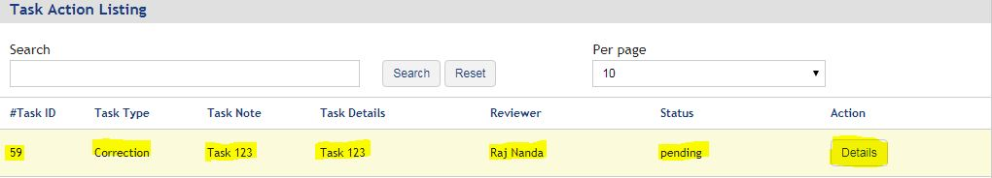

**1.** Then click on Details button on the right side of the window foe further process

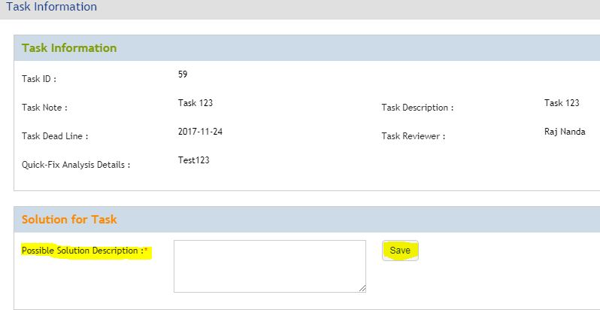

**1.** After fill up the marked field name as **Possible Solution Description** click on the **Save** Button for further progress.

**1.** After click on the **Review List** from menu named as Modules on the left side of your window.

**2.** After click on **Review-List** a submenu will open & from the submenu click on **Review** **From Quick Fix** .Then a window will open.

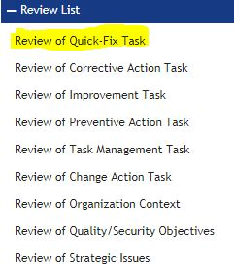

**1.** Here a option named as **Reviewer Opinion .**After selecting one option from dropdown list click on the button named as **Save.**

2. If the Task is **Accepted** then click on submit button for further process.

3. If the issue is **Rejected** then repeat from **Step 14** for further process.*

Note: -

*If the Task is **Rejected** in Review Stage a then a alternative task is generated automatically in **Step 14.**

