# Compliance management

## Security Questionnaire

When companies respond to an RFP or customer requirements, they have to fill out the compliance questionnaire. Below is an example:

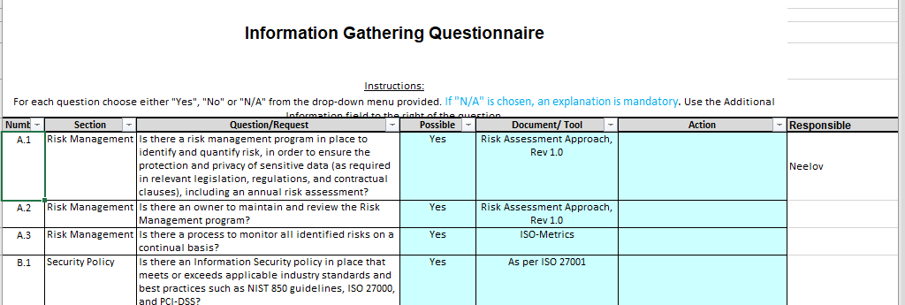

In the “Control” module ISO-Metrics have all the controls required by the organization defined. The “Implementation” field allows the organization in stating how they have fulfilled the requirements of the control.

Each item of the customer questionnaire can be linked to the specific control and that will link the information about how that specific question is addressed.

A questionnaire database will be created over a period of time. The Structure of the Questionnaire table can be as follows:

Questionnaire = Q_ID+ Client Name+ Q_Date+ Response_Due_Date +{Q_Domain (Dropdown)+ Question (VarChar)}+

Response to Questionnaire will be performed by selecting control for each question.

Response = Client Name+ Response Date+ {Question+ Domain+ Compliant (Y/N/Partly)+Control+ Implementation+ Policy+ Procedure}

## Internal Compliance

Organization defines the internal compliance requirement for each department. Each organization can have their own list of items that they want to track. Sometimes it can be directly related to the Security/ Privacy objectives but some times it could be different.

Some examples of “compliance item” for each department could be as follows:

* Access review done every month
* Anti-malware is UpToDate with all laptops
* Employees attended the training
* All critical issues from vulnerabilities have been resolved

A dashboard is maintained to see the status:

|  |  |  |  |  |  |  |  |
| --- | --- | --- | --- | --- | --- | --- | --- |
| Department Name | | | | | | | |
|  | Jan | Feb | Mar | Apr | May | June | Justification |
| Access review done every month |  |  |  |  |  |  | June review is pending |
| Anti-malware is UpToDate with all laptops (Quarterly) |  |  |  |  |  |  |  |
| Employees attended the training (six monthly) |  |  |  |  |  |  |  |
| All critical issues from vulnerabilities have been resolved |  |  |  |  |  |  | Waiting for patches from Microsoft |