**EXPERIMENT-6**

**AIM**: To study Jenkins Master-Slave Architecture to scale your Jenkins standalone implementation by implementing slave nodes.

THEORY**:**

Jenkins is a free and open source automation server. It helps automate the parts of software development related to building, testing, and deploying, facilitating continuous integration and continuous delivery. It is a server-based system that runs in servlet containers such as Apache Tomcat.

Jenkins Master and Slave Architecture

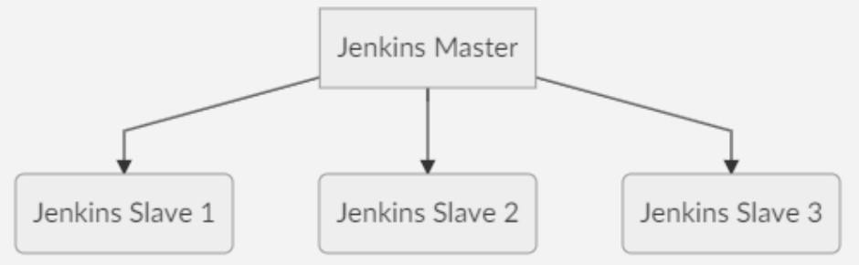

The Jenkins master acts to schedule the jobs and assign slaves and send builds to slaves to execute the jobs. It will also monitor the slave state (offline or online) and getting back the build result responses from slaves and the display build results on the console output. The workload of building jobs is delegated to multiple slaves.

Jenkins Master

Your main Jenkins server is the Master. The Master‘s job is to handle:

* Scheduling build jobs.
* Dispatching builds to the slaves for the actual execution.
* Monitor the slaves (possibly taking them online and offline as required).
* Recording and presenting the build results.
* A Master instance of Jenkins can also execute build jobs directly.

Jenkins Slave

A Slave is a Java executable that runs on a remote machine. Following are the characteristics of Jenkins Slaves:

* It hears requests from the Jenkins Master instance.
* Slaves can run on a variety of operating systems.
* The job of a Slave is to do as they are told to, which involves executing build jobs dispatched by the Master.
* You can configure a project to always run on a particular Slave machine or a particular type of Slave machine, or simply let Jenkins pick the next available Slave.

Output:

Step 1: Create a workspace by creating a folder anywhere in your system

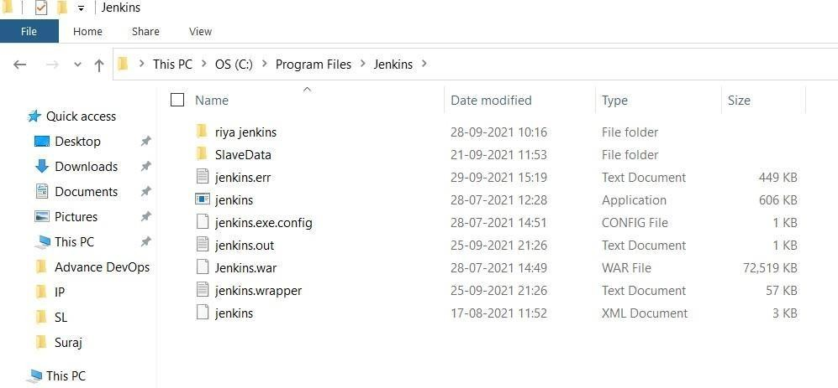

Step 2: Create a new node with the following configuration:

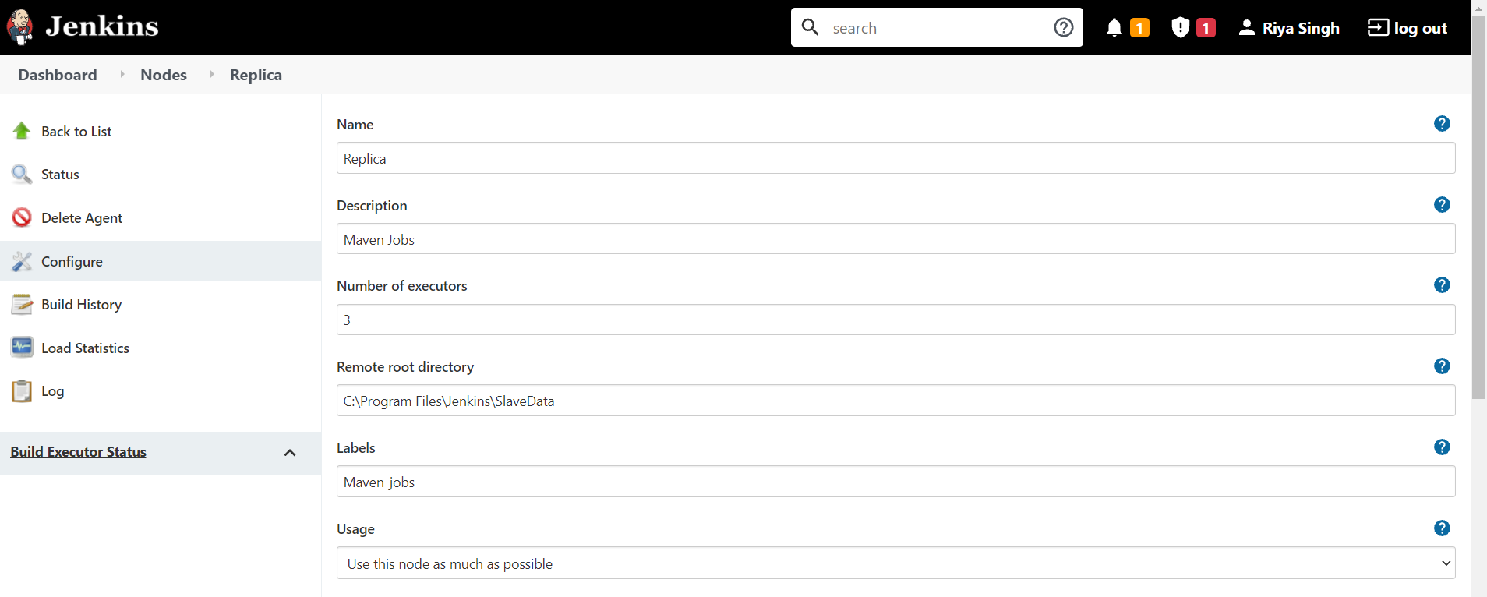

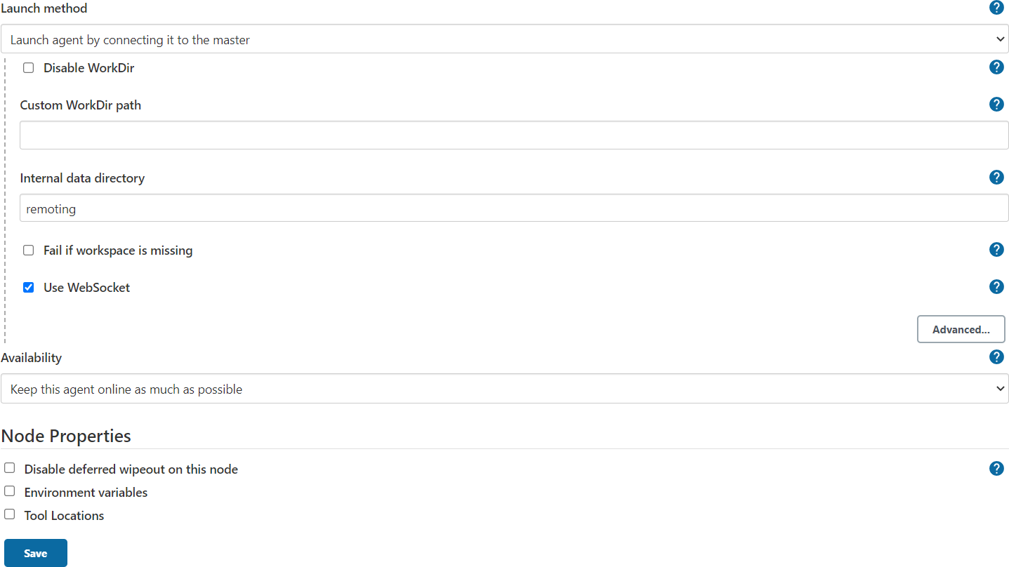

Step 3 : Click on launch to download Jenkins agent.jar and click on agent.jar to download it

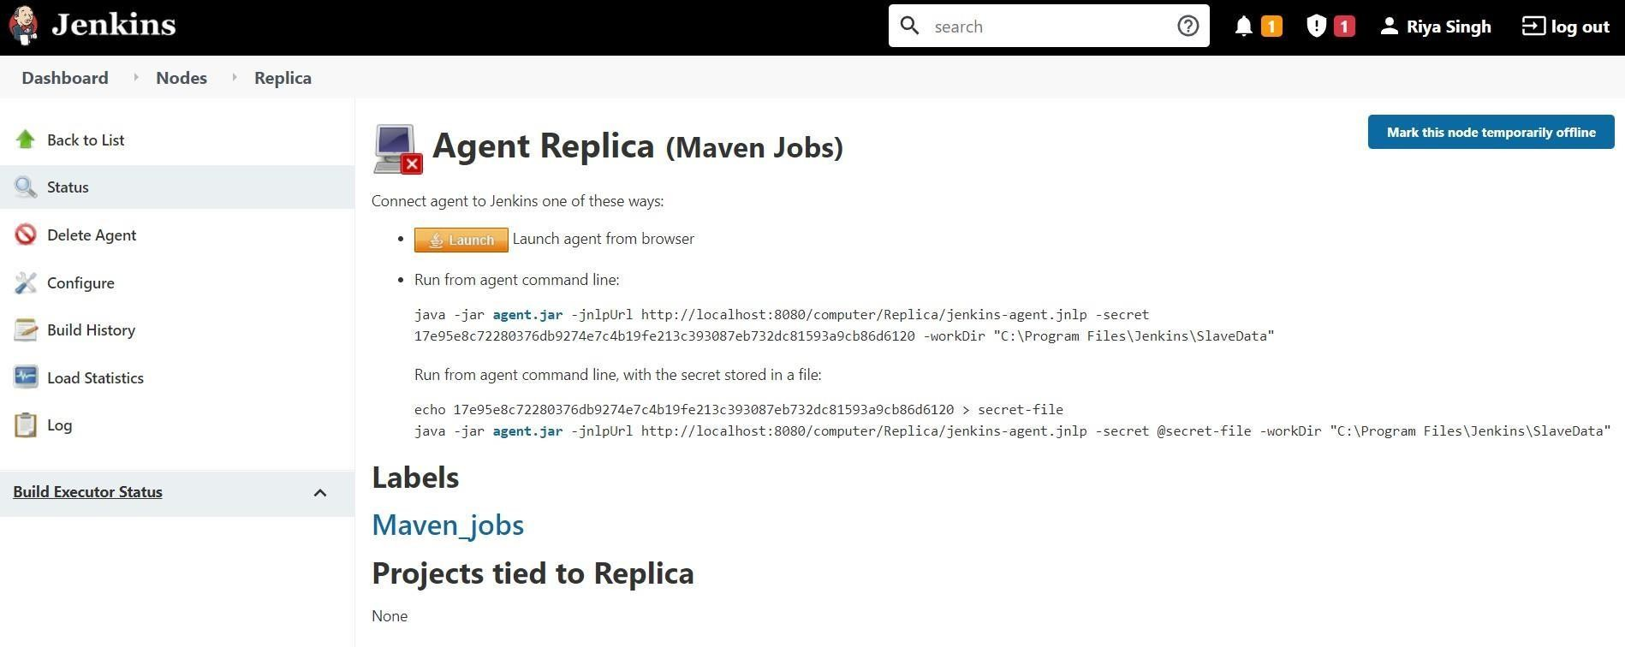

Step 4: Run the following commands being on the same file location where you download above files and observe the status as connected.

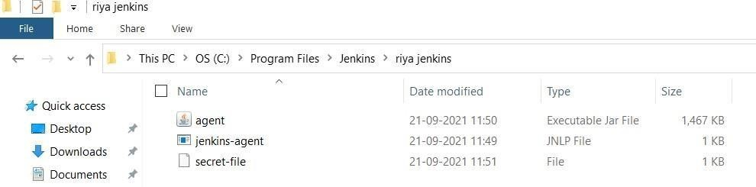

Step 5 : run commands in cmd of your slave node

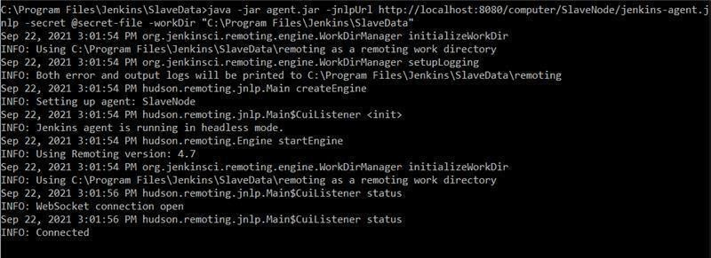

Step 6: Create a new job / item and select the label expression of your slave node under ‗Restrict where this project can be run‘

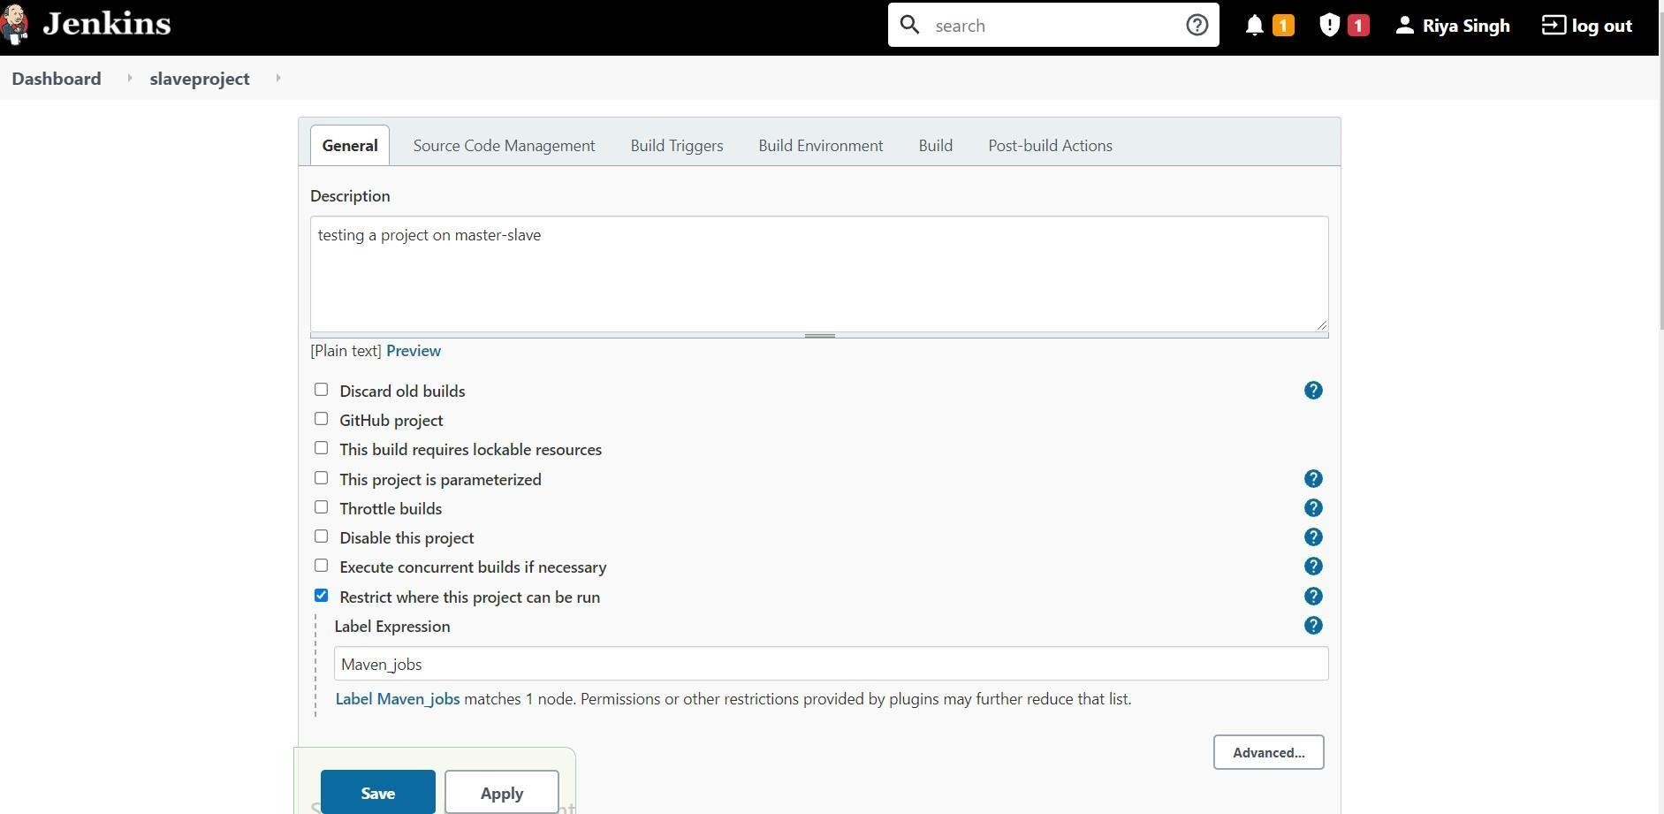

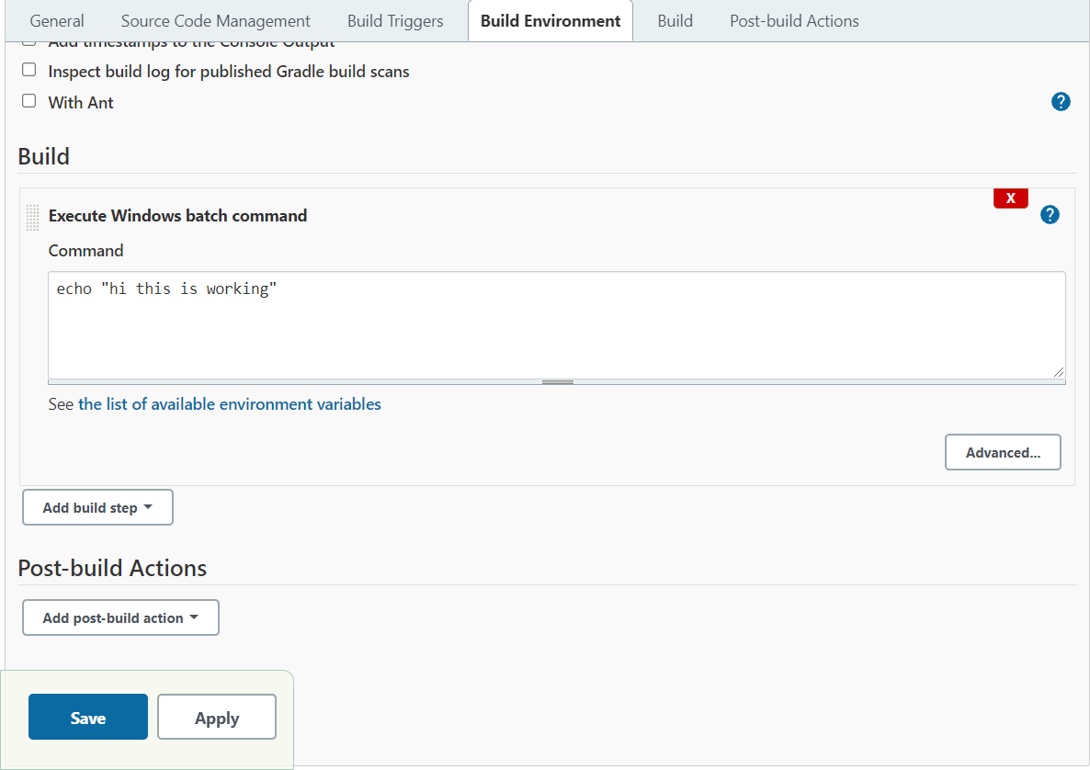

Step 7: Build

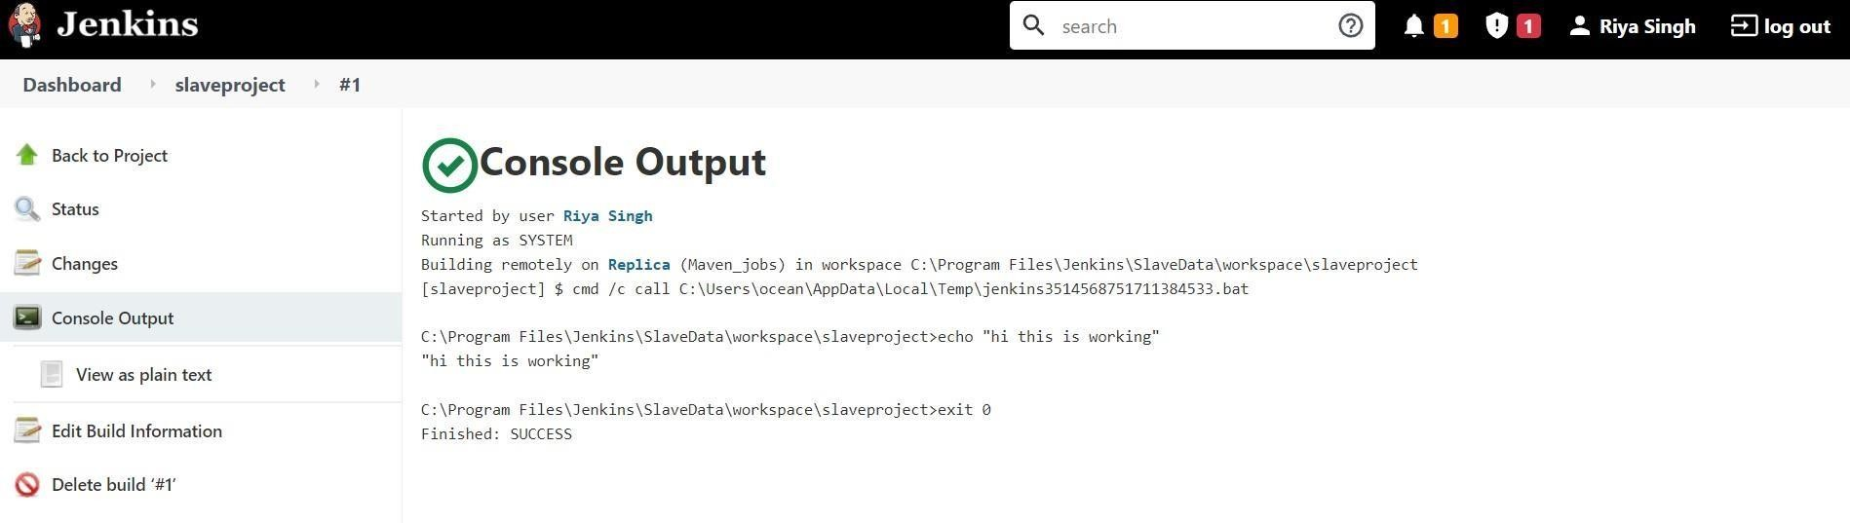

**Result:**

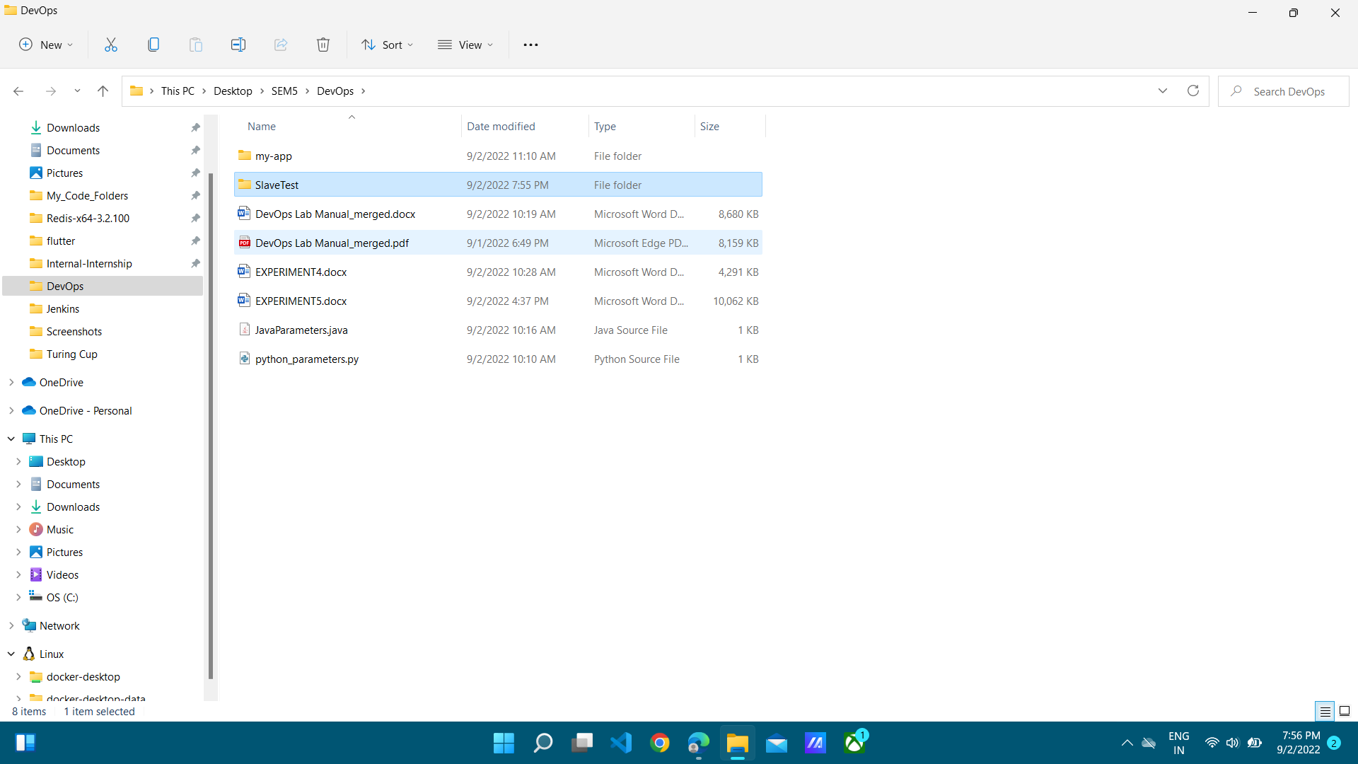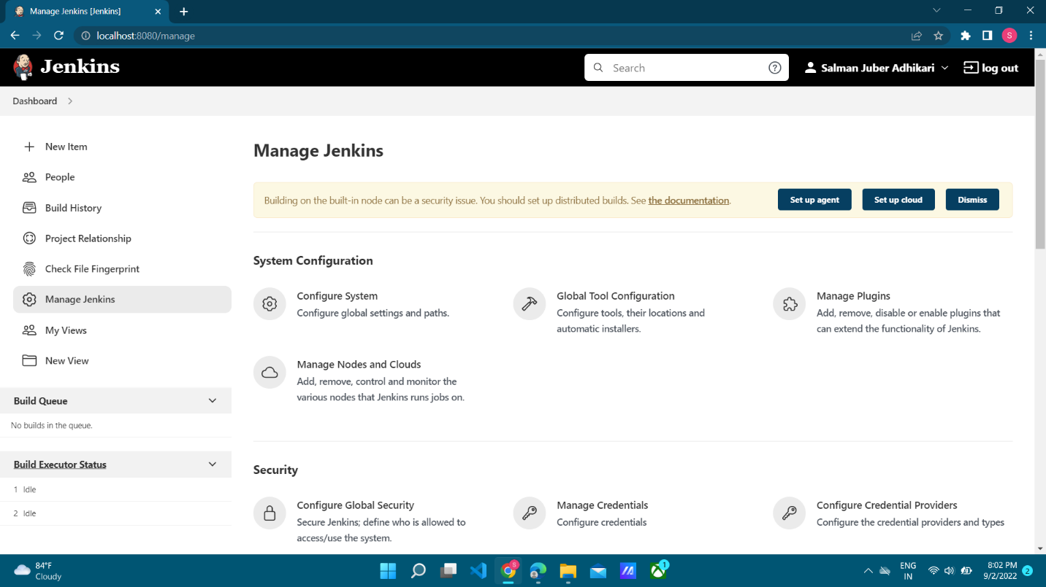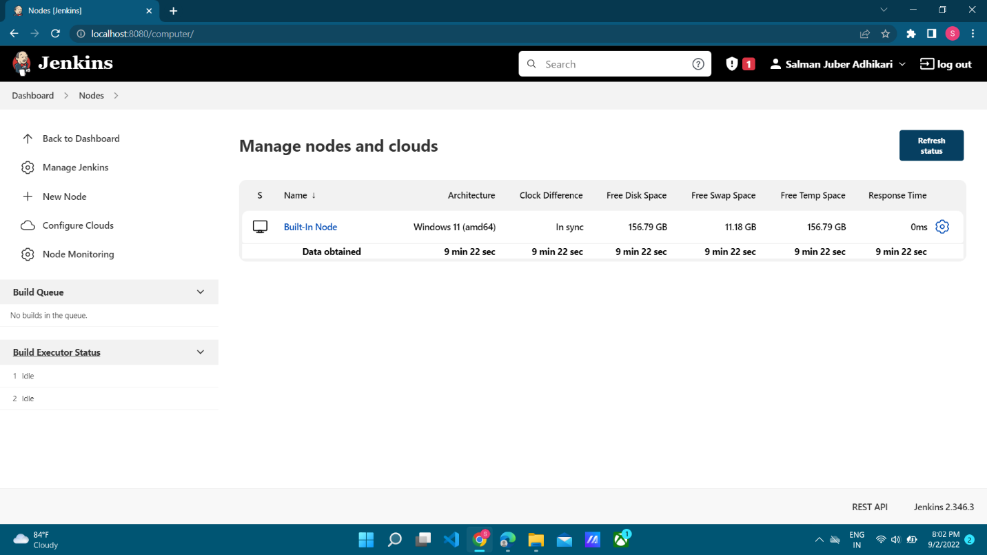 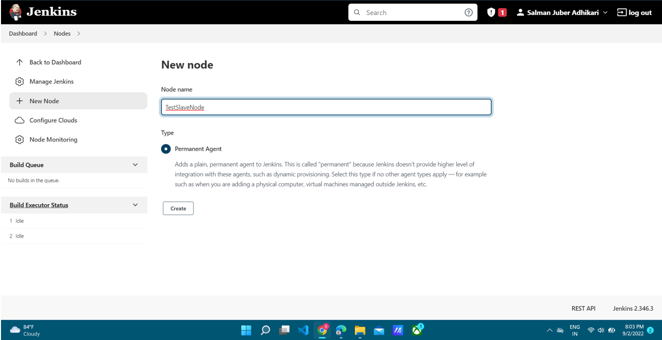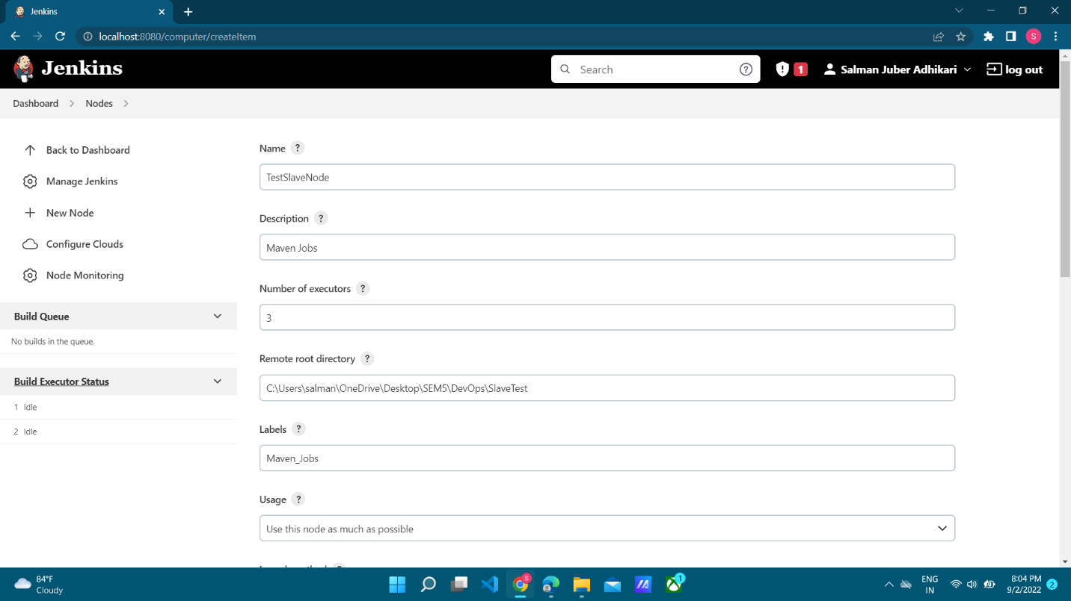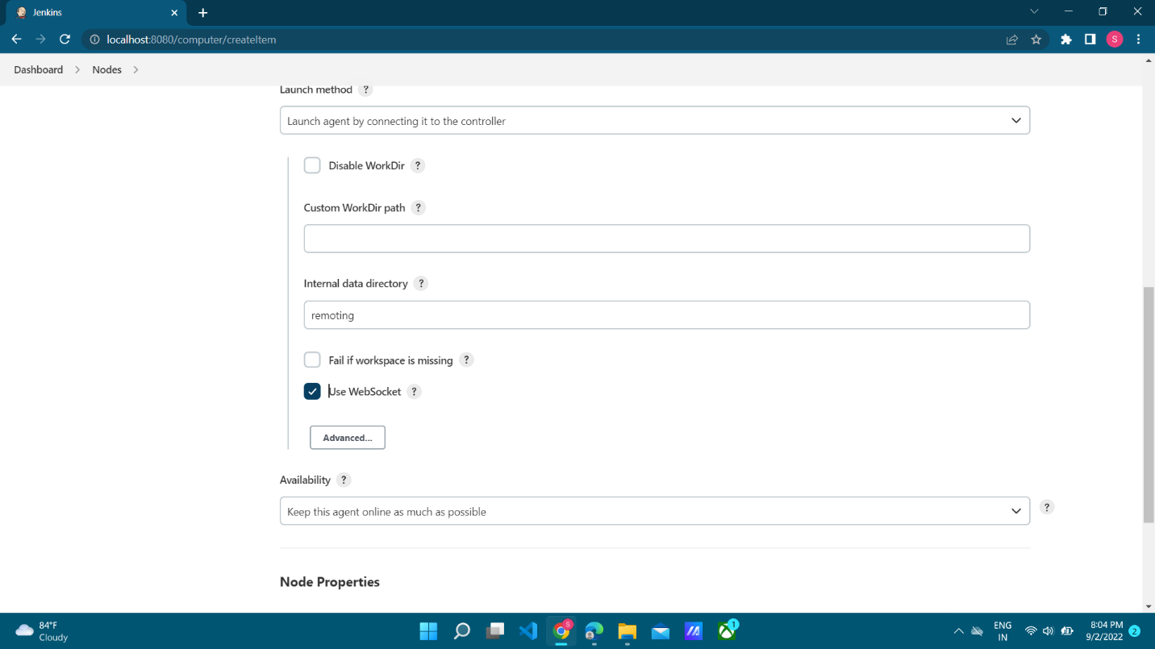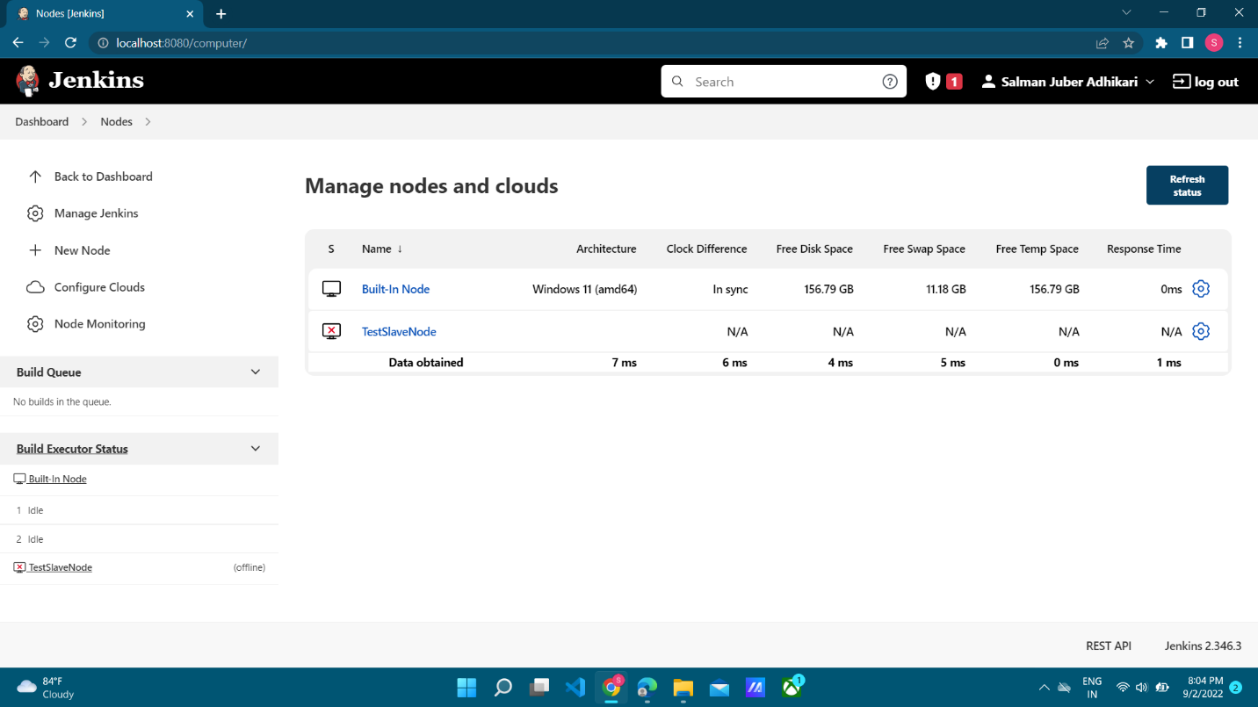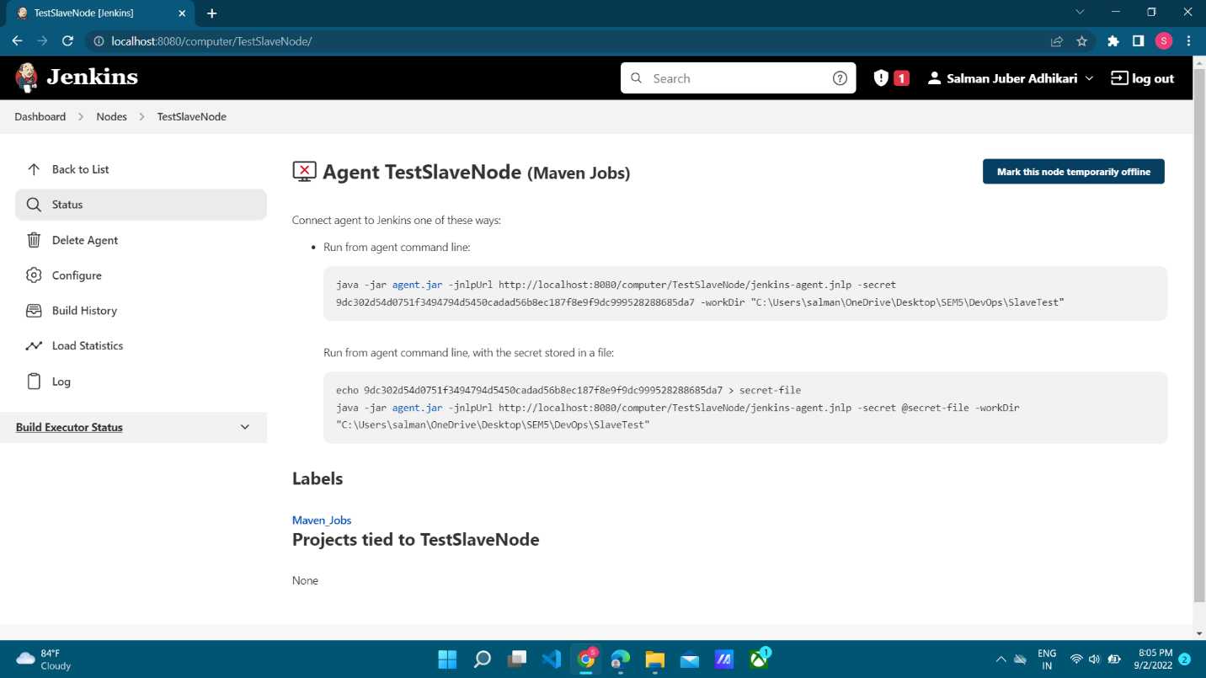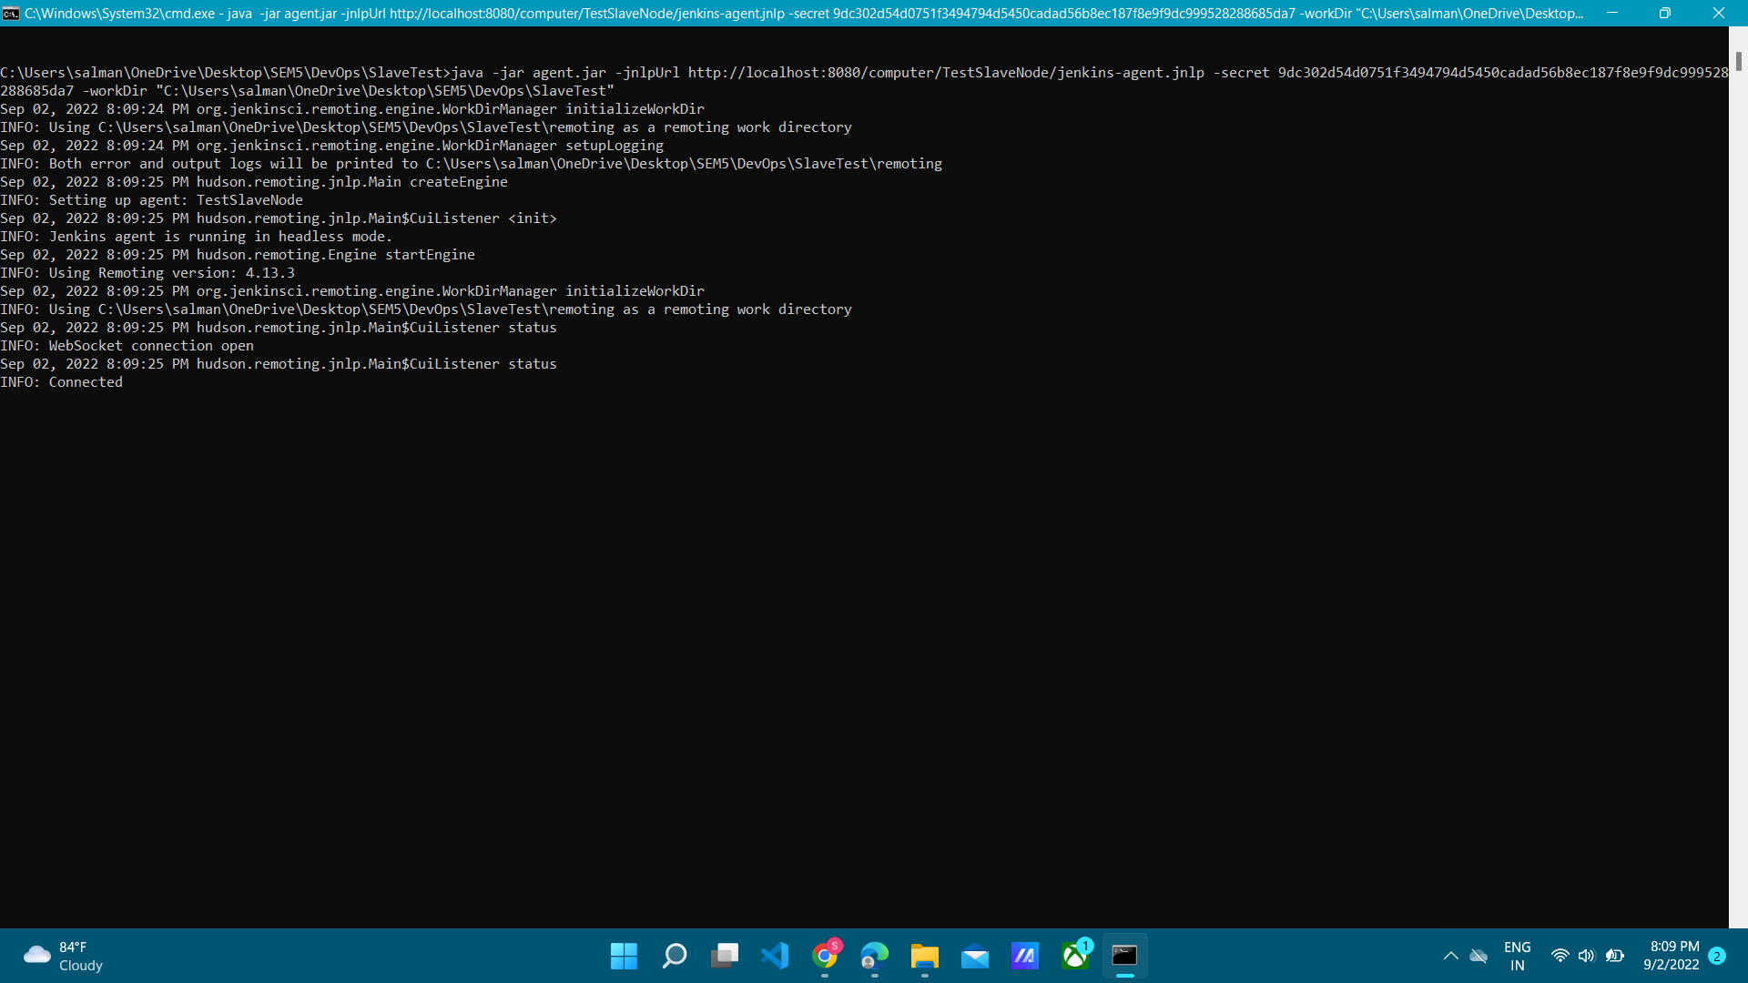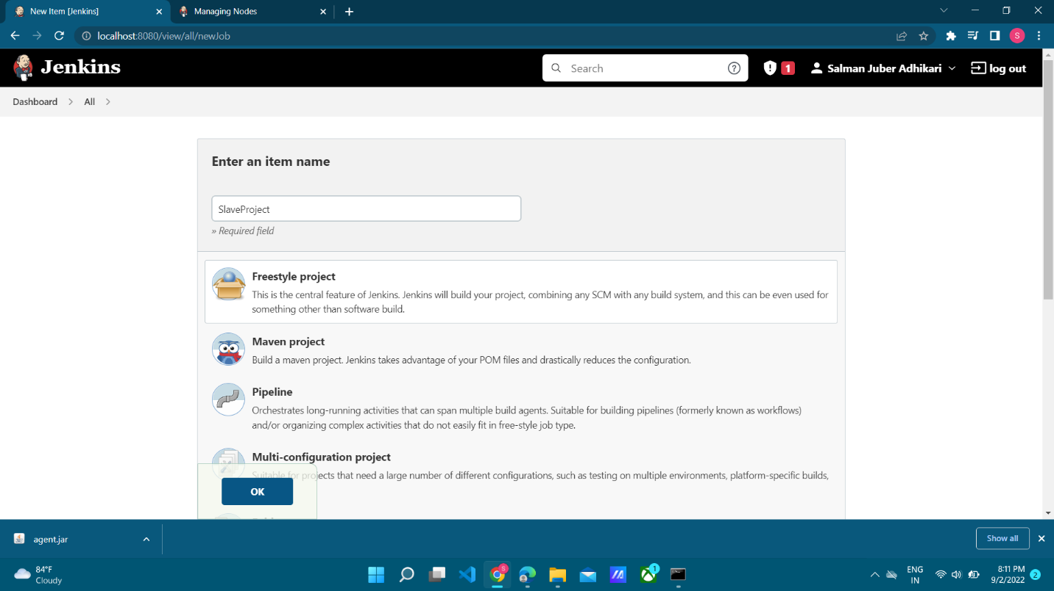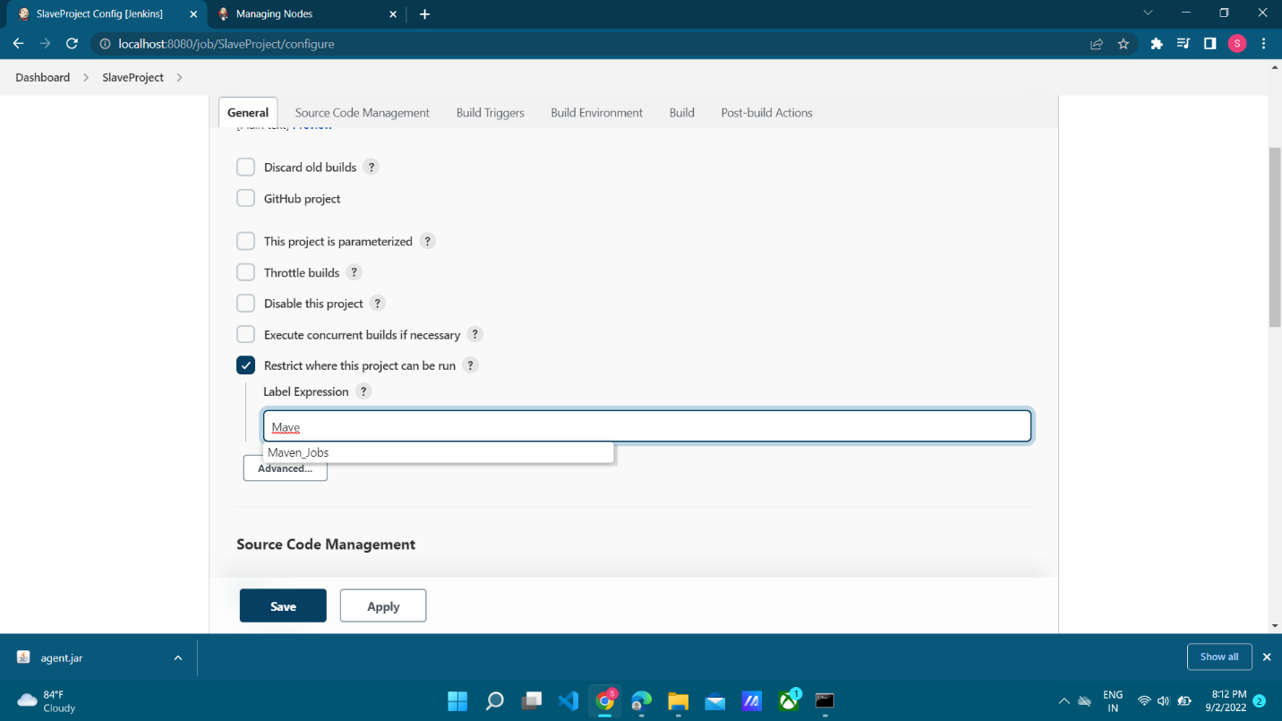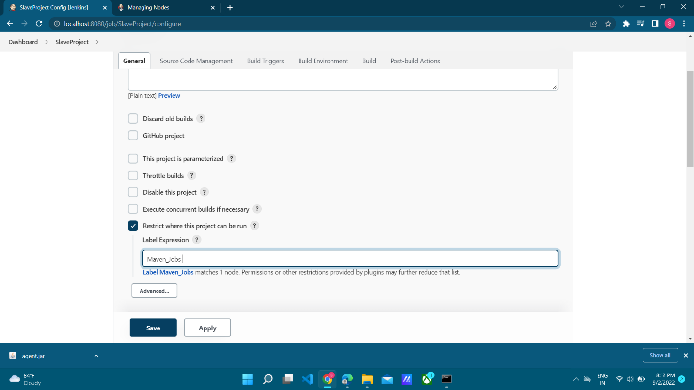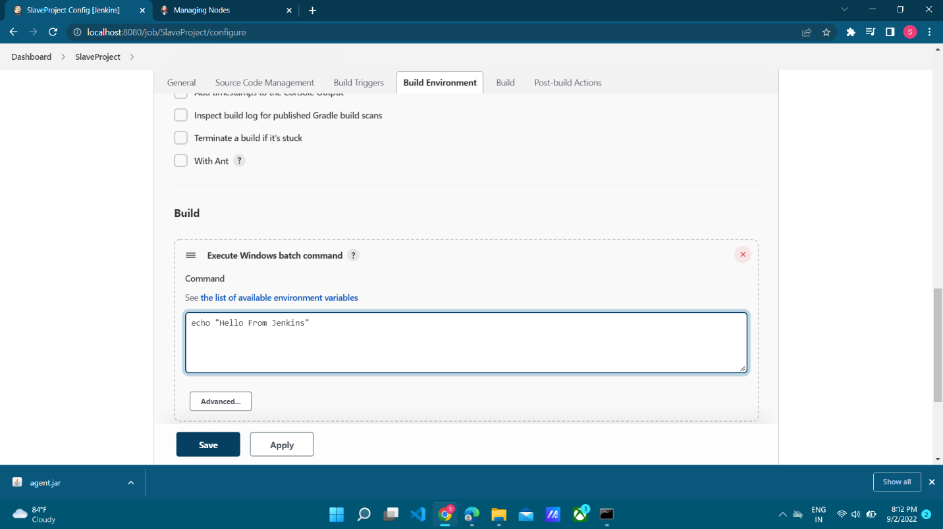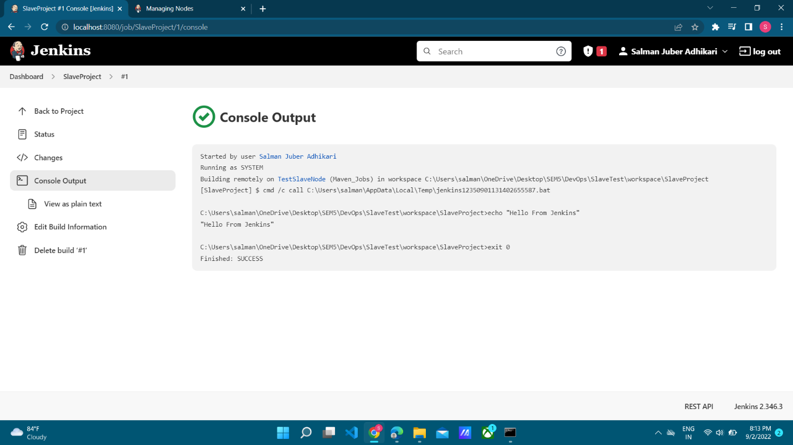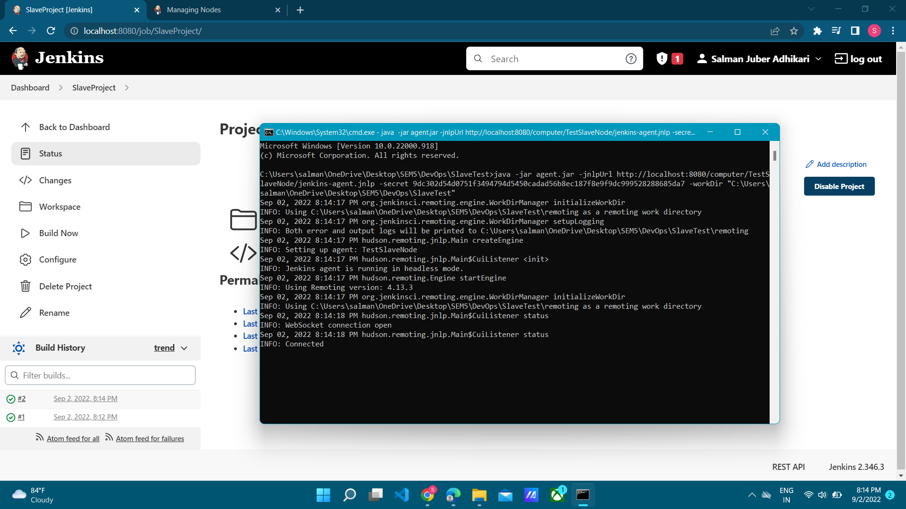

###### Conclusion:

Hence Jenkins Master-Slave Architecture to scale Jenkins standalone has been implemented by implementing slave nodes.