FitSpark

Name: Jaiswal Shreyaben
Date: 04/11/2025
Course Name: Computer Science

Introduction
FitSpark is a mobile fitness application that motivates users to stay active by integrating wearable technology, daily challenges, and social competition. It tracks user activity such as steps, heart rate, and calories burned. FitSpark caters to both busy individuals looking for short, engaging workouts and fitness enthusiasts seeking detailed tracking and competition.
The purpose of this user testing was to evaluate the usability of the FitSpark prototype. The main goal was to gather real user feedback to identify pain points, understand user behavior, and inform improvements to the prototype.

Testing Methodology
- Participants:
Round 1: 4 users (1 female, 3 male; ages 20-30) at Roosevelt class
Round 2: 6 new users (1 female, 5 male; ages 22–30), tested on campus and remotely
- Tasks Tested (Both Rounds):
  - Start a fitness plan
  - Daily tracking for a workout
  - Share a fitness achievement with a friend
- Data Collection:
Observations were recorded manually using a worksheet customized for FitSpark. Follow-up questions were asked after each task to understand user intent, confusion, and suggestion.

Test Protocol
- Original Tasks:
  - Find and complete a quick workout (e.g., 15-minute meditation).
  - View and track activity from the last workout.
  - Share a recent achievement badge with a friend via the app.
- Introductory Script:
“Thank you for participating in this test of FitSpark, a mobile fitness app. I will ask you to complete three tasks. Please think out loud and let me know if anything is confusing. Your feedback will help improve the app.”
- Post-Test Questions:
  - What is the main point of this app?
  - What was confusing or frustrating?
  - What would you suggest to improve this app?
- Note-taking Method:
Written notes using the test worksheet with space for Task, Success, Notes on user behavior, and issues Observed.
Results from First Round of Testing
- Users Tested: 4
- Task Success Rates:
  - Task 1: 3/3 completed successfully
  - Task 2: 2/3 completed successfully
  - Task 3: 2/3 completed successfully
- Pain Points Observed:
  - One user was confused by the Fitness Plan tab and asked: “How is it working?”
  - Another user had difficulty accessing the bottom navigation menu, commenting: “Not flexible?”
  - Not able to see the progress report.
- Notable Quotes:
  - “The quick workouts are a great feature.”

Reflection and Design Revisions
- Key Problems Identified:
  - Confusion about the fitness tab
  - Bottom navigation menu
  - Progress report not accessible
- Design Changes Made:
- Redesigned the Fitness Plan tab
- Moved the Bottom navigation menu on top
- Users can download the progress report
- Justification:
These revisions were prioritized due to their frequency and impact. Clarifying the Fitness Plan improves engagement, fixing the bottom menu enhances navigation, and highlighting the Progress Report boosts user motivation—directly supporting the app’s goals of clarity and a better user experience.

Refined Test and Second Round Results
- Updated Protocol:
  - Reworded tasks for clarity
  - Replaced Task 3 with “Send a workout challenge to a friend” to test improved social features
  - Updated script and questions to reflect revised UI
- Participants:
6 new users (1 female, 5 male; students and working professionals, ages 22–30)
- Tasks Tested & Outcomes:
  - Task 1 (Quick Workout): 3/3 completed successfully
  - Task 2 (Daily Tracking): 3/3 completed successfully
  - Task 3 (Send Challenge): 2/3 completed successfully
- New Feedback:
  - “Much easier to tracking info now.”
  - “I like that it asks before sending the challenge.”
  - One user still unsure if the friend received the challenge — suggested adding a “Sent!” notification
- New Findings:
  - Improved discoverability of features
  - More intuitive user flow
  - Remaining issues with user feedback confirmation (next iteration could include notifications)

Conclusion: Summary of Findings
- Biggest Impact:
Adding clear labels and improving navigation had the strongest effect on usability. Users found the app easier to use and more intuitive after revisions.
- Key Lessons:
User-centered design depends heavily on actual user feedback—not assumptions. Even small labels or design tweaks can significantly improve the experience.
- If I Had More Time:
I would implement a third round of testing with a broader user base, focus more on accessibility, and enhance feedback features (e.g., success messages, progress indicators).

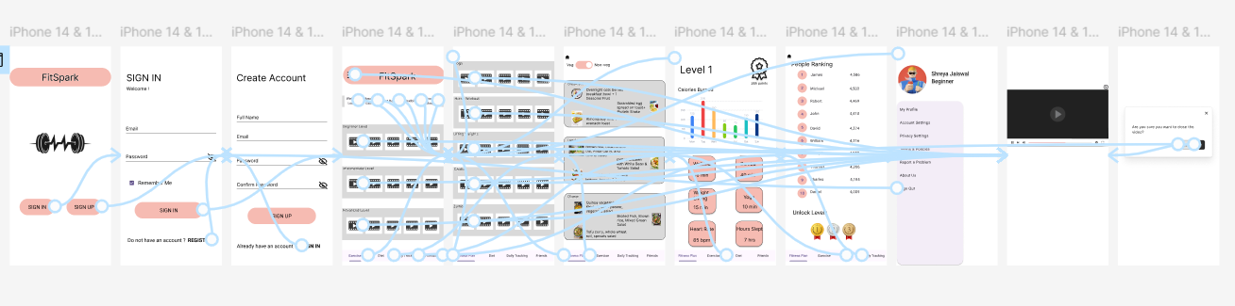
Original Prototypes:

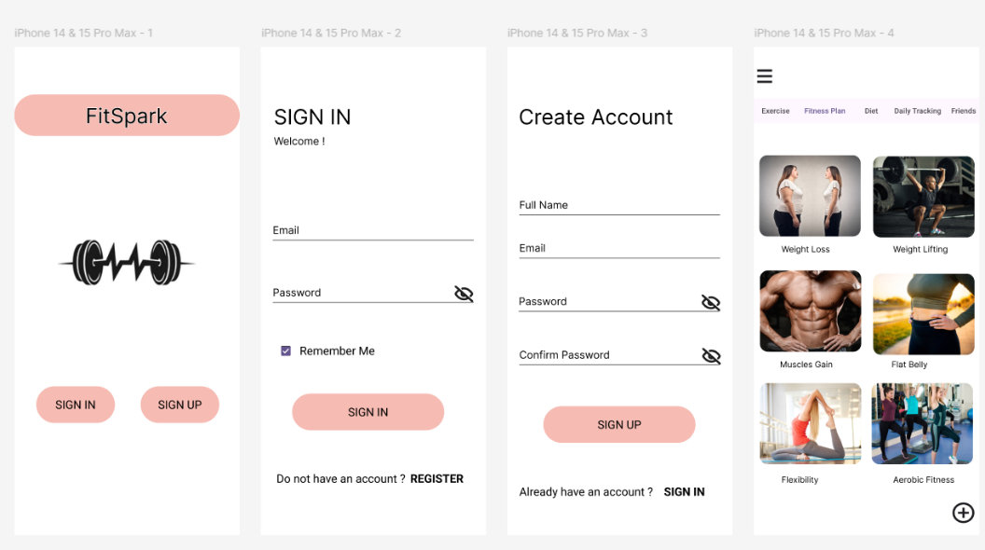
Revised Prototypes:

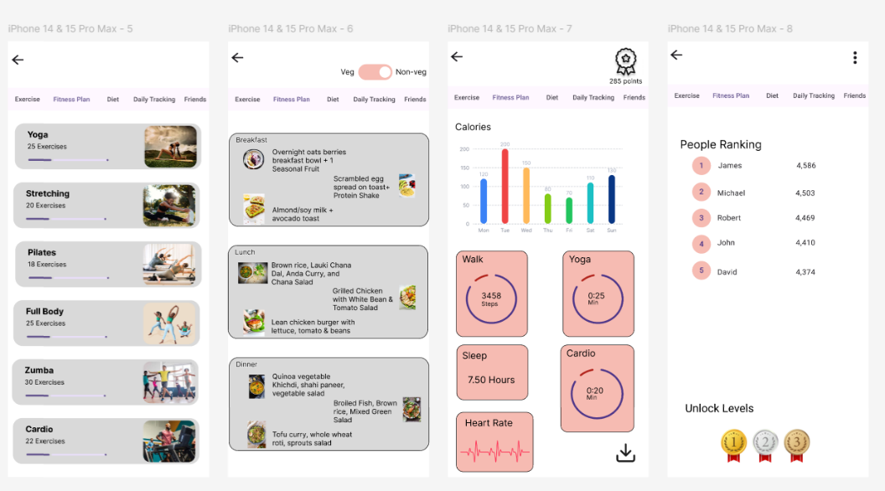

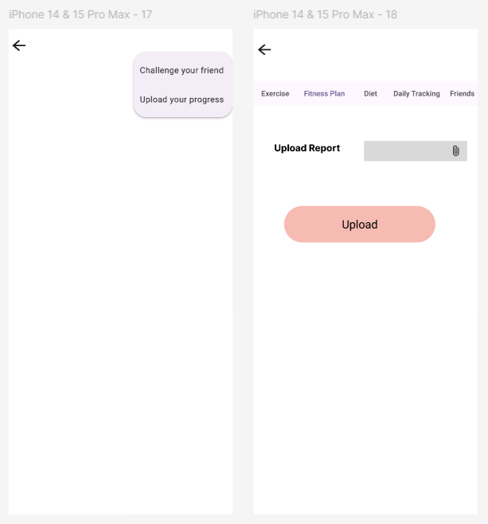
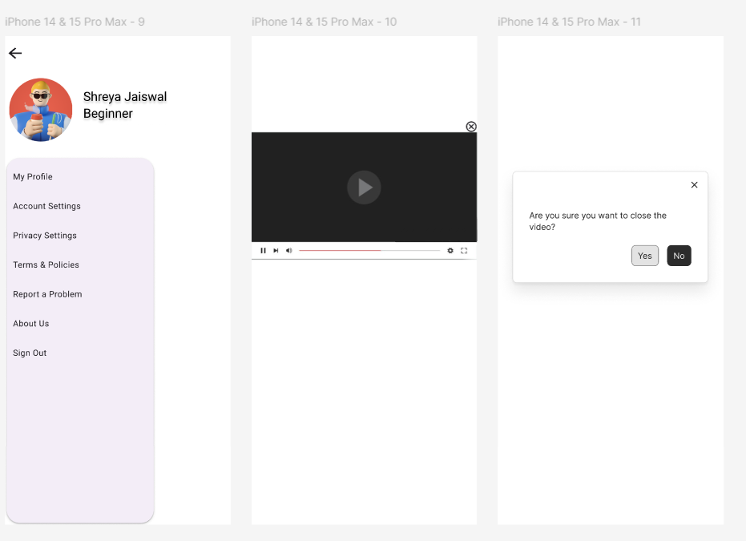
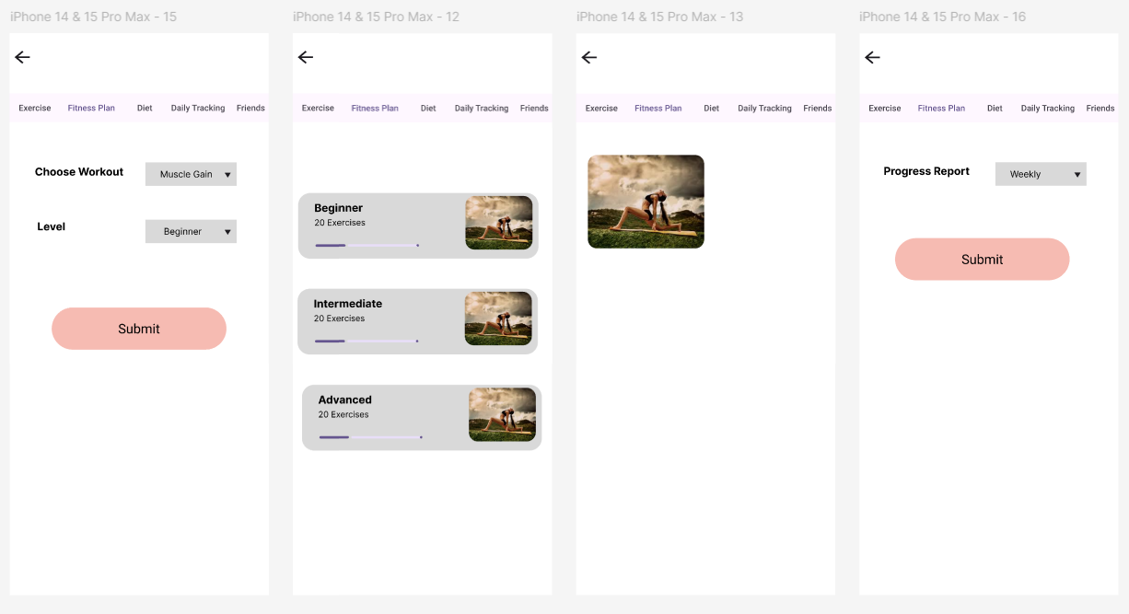
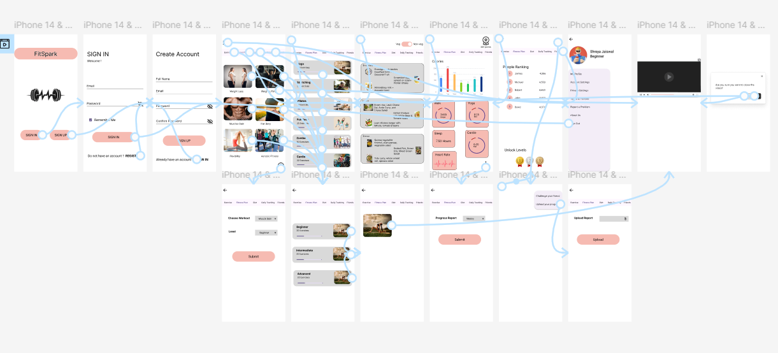

Test Sheet:
  - Script: “Thank you for participating in this test of FitSpark, a mobile fitness app. I will ask you to complete three tasks. Please think out loud and let me know if anything is confusing. Your feedback will help improve the app.”
  - Task List:

Task | Success | User Behavior | Issues Observed
Quick workout
Daily tracking
Sending Challenge

  - Questions:
  - What is the main point of this app?
  - What was confusing or frustrating?
  - What would you suggest to improve this app?

