Tesla Vision: Computer Vision & Neural Intelligence
in Autonomous Driving Systems
A Comprehensive Technical & Academic Analysis of Tesla's Full Self-Driving (FSD) Perception Stack

Submitted by:
Shreya Bosamiya (AIDS20252043)

Abstract
The rapid advancement of autonomous driving technology has brought computer vision to the forefront of artificial intelligence research and industrial deployment. This paper presents a rigorous technical and analytical examination of Tesla's camera-only perception system — branded as Tesla Vision — and its integration within the Full Self-Driving (FSD) suite. Unlike most competitors who rely on LiDAR sensor fusion, Tesla's approach is built entirely around eight high-resolution cameras processed by the HydraNet multi-task neural network, running on custom-designed silicon (the FSD Computer). We analyze the architectural decisions underpinning this vision-only paradigm, examine key subsystems including Bird's Eye View (BEV) generation, occupancy networks, and temporal video modeling, and evaluate the end-to-end training pipeline powered by Tesla's Dojo supercomputer and a global fleet data engine. The paper further compares Tesla's methodology against LiDAR-dependent systems such as Waymo's sensor-fusion stack, assessing trade-offs in accuracy, scalability, cost, and real-world robustness. Technical contributions, deployment challenges, and future research directions are discussed. This work synthesizes public AI Day disclosures, peer-reviewed literature, and industry analyses to produce a comprehensive, evidence-based assessment.

Keywords: Tesla Vision, HydraNet, Full Self-Driving, Computer Vision, Bird's Eye View, Occupancy Networks, End-to-End Learning, Autonomous Driving, Sensor Fusion

1. Introduction
Autonomous vehicles represent one of the most ambitious engineering endeavors in modern history — a convergence of robotics, artificial intelligence, real-time systems, and cognitive science. At the heart of every self-driving system lies a perception stack: the set of sensors and algorithms responsible for translating raw environmental data into actionable understanding. How a company designs this perception stack fundamentally shapes the safety, scalability, and commercial viability of its autonomous driving product.
Tesla's approach stands apart from the industry consensus. Where companies like Waymo, Cruise, and Mobileye have invested heavily in LiDAR (Light Detection and Ranging) sensor fusion — augmenting cameras with laser-based rangefinders capable of millimeter-level depth measurement — Tesla made a bold, and deeply controversial, engineering bet: vision alone is sufficient for autonomous driving. This is not a cost-cutting measure, but a philosophical and technical claim that cameras, paired with sufficiently capable neural networks and massive training data, can replicate and eventually surpass the perceptual capabilities of multi-sensor fusion.
This paper investigates the technical foundations, system architecture, training methodology, deployment realities, and comparative advantages and limitations of Tesla's computer vision-driven FSD system. We draw on publicly available AI Day presentations, peer-reviewed literature from arXiv and IEEE, and industry analyses to construct a rigorous, evidence-based account.
The central research questions guiding this paper are: (1) What algorithmic and architectural innovations underpin Tesla's camera-only perception system? (2) How does this approach compare to sensor-fusion paradigms in terms of safety and scalability? (3) What are the remaining technical and regulatory challenges, and what does the future hold for vision-first autonomous driving?

2. Literature Review
The history of autonomous vehicle perception is a history of sensor evolution. Early systems — dating to the DARPA Grand Challenges of the mid-2000s — relied primarily on LiDAR for 3D mapping and radar for speed estimation, with cameras playing a secondary role. The influential work by Thrun et al. (2006) on the Stanford Racing Team's Stanley vehicle demonstrated that LiDAR-based simultaneous localization and mapping (SLAM) could enable reliable outdoor navigation, establishing a template that most research groups subsequently followed [1].
The deep learning revolution, catalyzed by Krizhevsky et al.'s AlexNet (2012), dramatically altered the landscape for camera-based perception [2]. Convolutional Neural Networks demonstrated that end-to-end feature learning from raw pixels could match or exceed hand-crafted approaches for image classification. This sparked intense research into applying deep learning to object detection (YOLO, Faster R-CNN, SSD), semantic segmentation, depth estimation, and optical flow — all core sub-problems in autonomous driving perception.
Geiger et al.'s KITTI benchmark (2012) provided a standardized evaluation framework for autonomous driving algorithms, revealing a persistent gap between camera-based and LiDAR-based depth accuracy [3]. This motivated the sensor-fusion paradigm: cameras provide rich semantic information while LiDAR provides precise geometry. Waymo's 2020 safety report documented impressive results with this approach but at hardware costs estimated at tens of thousands of dollars per vehicle [4].
Tesla's public break from this consensus was formally articulated at the 2021 AI Day, where Andrej Karpathy and the Tesla Autopilot team presented HydraNet, the Bird's Eye View transformer, and the Fleet Data Engine [5]. Subsequent peer-reviewed work — including Li et al. (2022) on BEV transformers and Chen et al. (2022) on end-to-end driving — provides theoretical grounding for Tesla's industrial deployment [6][7]. The debate between vision-only and sensor-fusion paradigms remains active and unresolved [8].

3. Tesla Vision: System Overview
Tesla's Full Self-Driving (FSD) system is a vertically integrated AI stack. Unlike most technology companies which rely on third-party sensor hardware and general-purpose computing platforms, Tesla designs its own cameras, neural processing unit (the FSD Chip), training supercomputer (Dojo), and writes all software in-house. This vertical integration enables optimization at every layer of the stack — from training data collection to real-time inference.

3.1 The Eight-Camera Array
The perceptual front-end of Tesla Vision consists of eight cameras strategically positioned to achieve full 360-degree coverage with overlapping fields of view.
- Three forward-facing cameras: a narrow telephoto for long-range detection up to 250m; a main camera for standard driving; and a wide-angle camera for nearby objects and intersections.
- Two forward-lateral cameras (B-pillar mounted) covering blind spots and side collision zones.
- Two rear-lateral cameras covering the rear quarter panels.
- One rear-facing camera for reversing and trailing vehicle detection.
All cameras operate at 36 frames per second. Critically, they feed raw video — not still images — into the neural network, enabling the system to exploit temporal motion cues for depth and velocity estimation. This temporal awareness is a foundational design decision that distinguishes Tesla's approach from frame-by-frame inference pipelines.

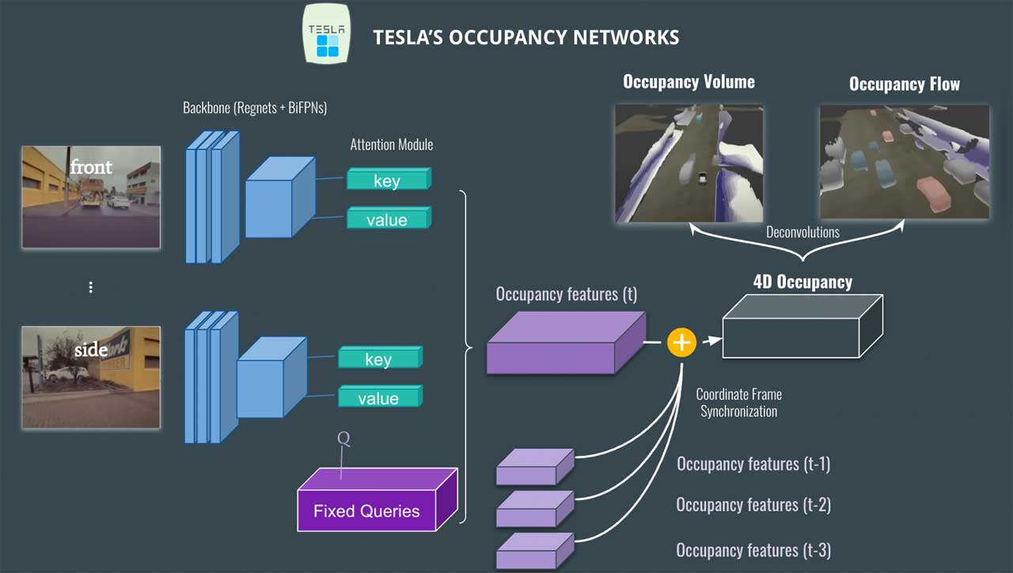
Figure 1. Tesla's eight-camera configuration providing 360-degree environmental coverage. Each camera serves a distinct operational zone with overlapping fields of view.

3.2 The FSD Computer (Custom Silicon)
Neural inference executes on the FSD Computer — a custom System-on-Chip designed in collaboration with Samsung at 14nm. The chip features a dual-redundant architecture: two identical SoCs operate simultaneously, with outputs compared for consistency. Discrepancies trigger safety fallback routines, providing hardware-level redundancy critical for automotive safety standards (ISO 26262). The dual-chip configuration delivers 288 TOPS of neural processing power, handling approximately 2GB of camera data per second — far beyond the capacity of off-the-shelf automotive processors.

3.3 Dojo: The Training Supercomputer
Training occurs on Tesla's Dojo supercomputer — a custom ExaPOD cluster optimized for video processing workloads. Dojo uses Tesla's proprietary D1 chip (7nm, 362 TFLOPS per chip) in a tiling architecture that minimizes memory bandwidth bottlenecks — the dominant constraint in video model training. Tesla processes petabytes of fleet video data daily through Dojo, enabling continuous model improvement at a scale unavailable to competitors with smaller vehicle populations [5].

4. Neural Network Architecture & Core Algorithms

4.1 HydraNet: Multi-Task Vision Transformer
The centerpiece of Tesla's perception stack is HydraNet — a multi-task, multi-camera neural network that processes video from all eight cameras and simultaneously produces outputs for over 50 perception sub-tasks. Its name reflects its ability to serve many outputs from a single shared representational core.

4.1.1 Architectural Design
HydraNet follows a trunk-and-head architecture. The backbone is a RegNet-Y variant — a scalable convolutional architecture optimized for efficient feature extraction. The backbone processes image features independently for each camera, extracting hierarchical representations at multiple spatial scales using a Feature Pyramid Network (FPN).
Per-camera features are then lifted from 2D perspective space into a shared 3D Bird's Eye View representation using a cross-attention transformer. The transformer allows features from all eight cameras to be jointly attended to, resolving ambiguities from any single camera's limited field of view. The BEV feature map serves as the unified substrate from which task-specific heads branch — each head a small neural network specialized for a particular prediction: lane segmentation, vehicle detection, pedestrian tracking, traffic light state, and so on. A single forward pass through the expensive backbone serves all 50+ tasks simultaneously.

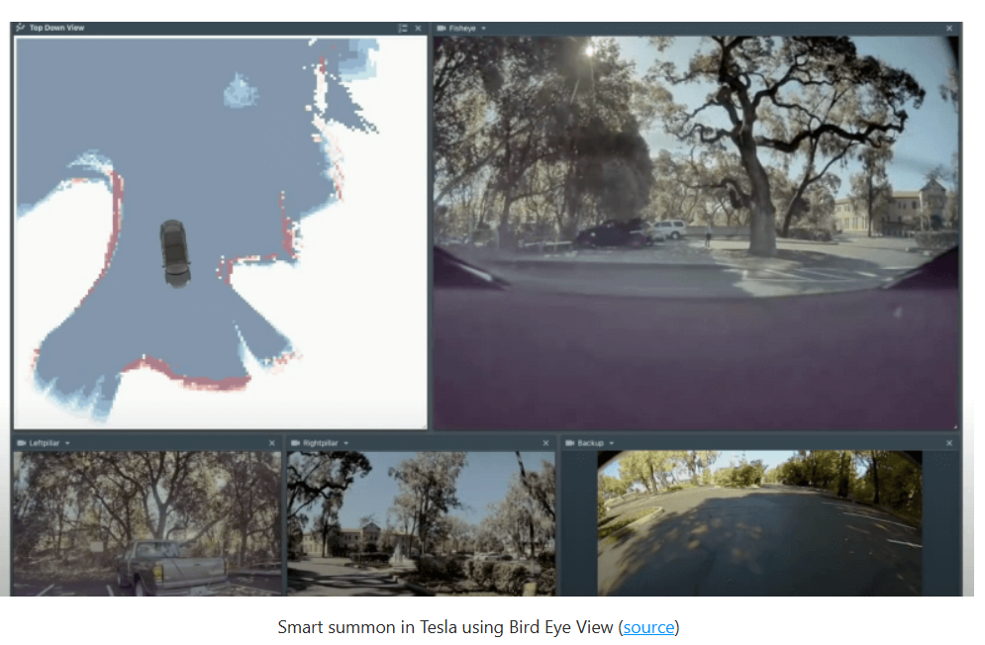
Figure 2. HydraNet architecture: shared backbone features are projected to Bird's Eye View via transformer attention, then decoded by task-specific heads simultaneously.

4.1.2 Temporal Modeling with Video
A critical advantage of HydraNet is its explicit temporal modeling. Rather than processing individual frames, the network ingests short video clips (3-8 frames). A recurrent module maintains temporal memory, allowing the network to estimate velocity, anticipate motion, and maintain consistent object tracking across occlusions. By analyzing how object positions change across frames (optical flow), the network infers depth through a learned form of structure from motion (SfM) — the primary mechanism by which Tesla replaces the direct depth measurement that LiDAR provides.

4.2 Bird's Eye View (BEV) Representation
Classical autonomous driving pipelines detect objects in image space (2D bounding boxes) then separately estimate 3D positions — a two-stage pipeline prone to cascading errors. Tesla's approach collapses this into a single operation: features are directly projected from perspective image space into a top-down BEV map aligned with the vehicle's navigation frame.
The resulting BEV feature map (typically 200x200 meters around the vehicle) is decoded to produce lane geometry, road boundaries, free-space maps, 3D object detections (position, dimensions, velocity), and traffic infrastructure positions. This unified output provides the planning module with a geometrically consistent scene description at every inference step.

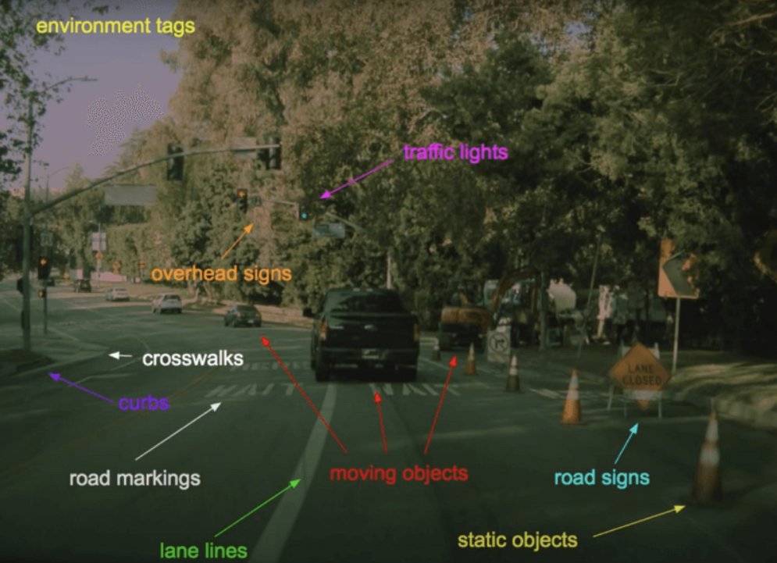
Figure 3. Bird's Eye View construction from multi-camera perspective inputs. Camera features are fused into a unified top-down spatial representation via transformer attention.

4.3 Occupancy Networks: Beyond Bounding Boxes
Traditional object detection represents the world as discrete labeled bounding boxes — a paradigm that struggles with irregular geometry (construction debris, overturned vehicles, plastic bags) and partially occluded objects. Tesla's occupancy network models the environment as a dense 3D voxel grid, where each voxel is assigned an occupancy probability, a semantic label, and a velocity vector.
This occupancy-flow formulation asks a fundamentally different question: rather than 'what objects are present?', it asks 'is this region of space traversable?' — a question more directly relevant to path planning. The network maintains a prior of continued occupancy for unobserved regions through the velocity-flow component, allowing the system to reason about space hidden from current camera views through temporal inference. Compared to bounding box approaches, occupancy networks provide a more complete and continuous understanding of space, enabling better navigation, parking, and obstacle avoidance decisions.

4.4 Tesla vs. Competitors: Comparative Analysis
The table below provides a structured comparison of Tesla's vision-only approach against major competitors employing LiDAR-based sensor fusion architectures:

Feature | Tesla (Vision) | Waymo (Fusion) | Cruise | Mobileye
Sensor Suite | Camera-only (8x) | Camera+LiDAR+Radar | Camera+LiDAR+Maps | Camera+LiDAR+Maps
Primary Network | HydraNet (multi-task) | Multi-model fusion | DriveNet + LiDAR | BEV Transformer
Depth Estimation | Learned (mono/stereo) | LiDAR direct | LiDAR direct | LiDAR direct
HD Map Dependency | Minimal (auto-mapped) | Required | Required | Required
HW Cost (est.) | ~$1,500 / vehicle | ~$75,000+ / vehicle | ~$30,000+ | ~$20,000+
Fleet Scale (2024) | >6 million vehicles | <1,000 test vehicles | <1,000 test | ~500 vehicles
OTA Updates | Yes — continuous | Intermittent | Limited | Limited
Training Data | Billions of miles | Millions of miles | Millions of miles | Tens of millions
Table 1. Comparative analysis of autonomous driving perception systems (2024). Cost estimates are approximate and may vary by deployment configuration.

5. Training Methodology: The Fleet Data Engine

5.1 Fleet-Scale Data Collection & Shadow Mode
Tesla's most significant competitive advantage may not be algorithmic but logistical: a global fleet of over six million vehicles, each equipped with the camera array and compute necessary to identify, record, and upload rare or challenging driving scenarios. This creates a self-reinforcing data flywheel — more vehicles mean more edge cases captured; more edge cases improve the model; better models attract more customers; more customers expand the fleet.
Shadow mode is a critical component: the FSD model runs in the background on all Autopilot-enabled vehicles even when FSD is not engaged. The shadow model makes predictions compared against the human driver's actual decisions. Disagreements flag 'interesting' scenarios for upload — enabling selective capture of corner cases rather than indiscriminate storage of petabytes of mundane highway driving.

5.2 Automated Labeling at Scale
Manual annotation of video data is prohibitively expensive at Tesla's scale. The company developed an offline reconstruction pipeline that re-processes collected clips using stronger models, longer temporal windows, and multi-frame consistency checks to produce high-quality 3D annotations. The pipeline incorporates Structure from Motion (SfM) for static geometry reconstruction, multi-object tracking (MOT) algorithms for consistent 3D trajectories, neural depth prediction as a dense initialization, and human review on statistically sampled subsets for quality control.

5.3 End-to-End Learning
Tesla has progressively shifted toward end-to-end learning architectures — models that directly map camera inputs to control outputs (steering, acceleration, braking) without explicit intermediate symbolic representations. The end-to-end model is trained with imitation learning — learning to mimic human drivers — augmented by reinforcement learning signals in simulation. This approach allows the system to discover implicit representations that humans might not explicitly engineer, potentially capturing correlations that rule-based approaches miss entirely.

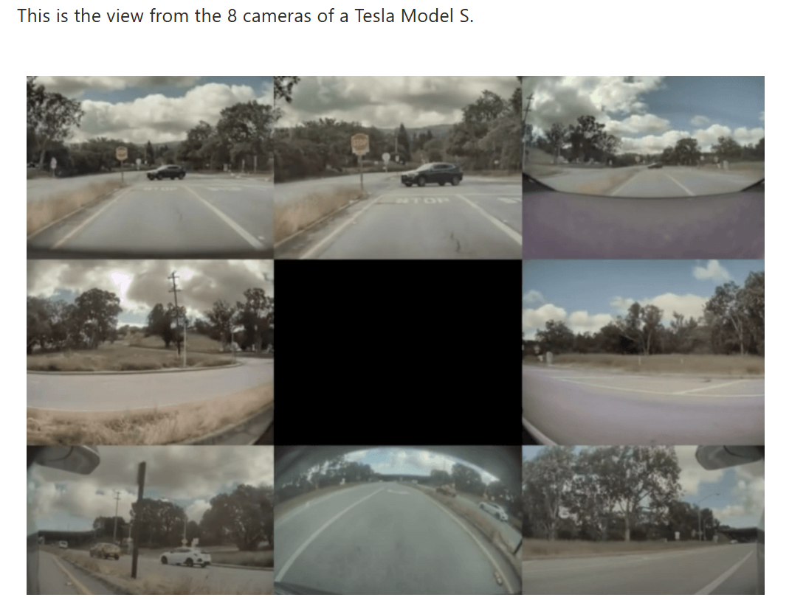
Figure 4. Tesla's FSD end-to-end workflow: from raw camera capture through neural perception, BEV modeling, occupancy estimation, prediction, and control execution.

6. Results and Discussion

6.1 Performance Metrics
Evaluating autonomous driving systems is notoriously difficult — no standardized benchmark captures real-world deployment complexity. Tesla primarily reports progress through disengagement rates and miles driven per FSD-supervised mile. As of 2024, Tesla reported that FSD Beta vehicles completed over 80% of trips with zero driver interventions, up from approximately 40% in 2022 — substantial but not yet commercially sufficient progress [5].
On public benchmarks such as nuScenes, camera-only approaches have historically lagged LiDAR-fusion methods by 5-15% on 3D detection mAP (mean Average Precision). However, recent work using BEV transformers — architecturally similar to Tesla's approach — has largely closed this gap for vehicle detection, while pedestrian and cyclist detection in poor lighting remains an active area of improvement [7].

6.2 Real-World Deployment at Scale
Tesla's real-world deployment provides data at a scale unmatched by any competitor. The company reported 500 million miles driven on FSD Beta by early 2024, revealing both strengths — robust in well-lit standard conditions, capable of reading novel road signs — and persistent weaknesses: reduced performance in heavy rain, fog, and direct sun glare, and difficulty with unconventional lane markings.
One documented systemic issue was phantom braking — the FSD system applying emergency braking in response to shadows or distant objects misclassified as imminent obstacles. Reported by consumers and documented in NHTSA investigations in 2022, this behavior illustrates the cost of removing radar: radar's direct velocity measurement provides an independent safety check that vision alone must replace through learned estimation [8][9].

7. Challenges and Limitations

7.1 Technical Challenges
The camera-only paradigm faces fundamental physical limitations. Cameras are passive sensors — they measure reflected light and cannot directly measure distance or velocity. Depth and motion must be inferred from spatial and temporal patterns affected by lighting, weather, reflective surfaces, and visual ambiguity. While Tesla's networks learn robust priors for typical scenes, rare condition combinations can cause systematic failures.
Adversarial conditions present another significant challenge. Research by Eykholt et al. (2018) demonstrated that small physical perturbations imperceptible to humans can cause neural classifiers to misidentify stop signs with high confidence [10]. The security of the perception stack against deliberate or accidental adversarial inputs remains an open research problem.
The end-to-end learning paradigm introduces an interpretability challenge: when an FSD system makes an unexpected decision, diagnosing the cause is significantly harder than in a modular system with explicit intermediate representations. Safety certification frameworks (ISO 26262, SOTIF) are designed around verifiable, traceable behavior — difficult to demonstrate for opaque neural networks.

7.2 Regulatory and Safety Framework
Tesla's FSD system has faced significant regulatory scrutiny. The NHTSA opened multiple investigations into FSD and Autopilot-related accidents, resulting in a recall of over two million vehicles in December 2023 for a software update addressing Autopilot misuse concerns [9]. This reflects a fundamental tension between the iterative, data-driven improvement model that makes machine learning effective and the pre-deployment validation requirements of traditional automotive safety engineering.

7.3 Ethical Dimensions
The deployment of FSD Beta to hundreds of thousands of consumer vehicles has been characterized by critics as using paying customers as test subjects — a criticism Tesla disputes by emphasizing the active driver supervision requirement. This surfaces a broader ethical question: how much real-world testing risk is acceptable in pursuit of safety improvements that, if achieved, could save tens of thousands of lives annually? Regulatory frameworks are still developing the conceptual tools to address this trade-off meaningfully.

8. Future Work and Research Directions
- Occupancy Flow Modeling: Occupancy Flow Modeling: extending occupancy networks to explicitly model the future flow field — predicting where each occupied voxel will move — enables more sophisticated motion planning under uncertainty.
- Neural Radiance Fields (NeRF): Neural Radiance Fields (NeRF) for Data Augmentation: novel-view synthesis enables generation of photorealistic training data under novel conditions (rain, fog, night) by re-rendering reconstructed scenes, dramatically expanding the effective training set for rare conditions.
- Foundation Models for Driving: Foundation Models for Driving: the success of large vision-language models (CLIP, GPT-4V) suggests potential for large pre-trained vision models fine-tuned for autonomous driving, leveraging internet-scale pre-training for better generalization to long-tail scenarios.
- Formal Verification: Formal Verification and Explainability: research into conformal prediction, runtime monitoring, and interpretable attention mechanisms will be critical for regulatory acceptance of neural autonomous driving systems.
- Dojo at Scale: Dojo at Scale: as Dojo approaches an ExaFLOP of processing capacity, it enables training of qualitatively larger models on longer video sequences — whether FSD performance follows the scaling laws observed in language models is an empirical question with enormous commercial stakes.

9. Conclusion
Tesla's vision-only FSD system represents a genuinely novel and technically ambitious approach to autonomous driving — one that challenges the sensor-fusion orthodoxy established over decades of robotics research. By betting on learned visual perception rather than direct physical measurement, Tesla has made a profound hypothesis: that the information content of camera imagery, properly exploited by deep neural networks trained on sufficient data, is adequate for safe autonomous navigation.
The evidence accumulated since Tesla Vision's 2022 introduction is mixed, instructive, and ongoing. The system has demonstrated impressive capabilities — smooth highway driving, complex intersection handling, and parking maneuvers — that were not achievable just three years earlier. It has also exposed real limitations: phantom braking, reduced robustness in adverse weather, and the systemic challenge of handling the truly unexpected. These are not necessarily fundamental barriers; they may be solvable through continued scaling of data, compute, and architectural sophistication.
What Tesla has unambiguously demonstrated is the power of fleet-scale data collection as a competitive moat. With millions of vehicles generating real-world training signal daily, the company's model improvement trajectory may be structurally faster than competitors relying on smaller test fleets. Whether this advantage is sufficient to overcome the physical limitations of camera-only sensing — or whether the industry will ultimately converge on a hybrid approach — remains the defining open question in autonomous driving research.
The technical innovations embodied in HydraNet, BEV transformers, occupancy networks, and the Dojo training pipeline are genuine and significant contributions to the state of the art, worthy of serious scholarly attention regardless of one's position on the cameras-versus-LiDAR debate. The coming years will provide a large-scale, real-world experiment that no academic benchmark can replicate — and the results will shape the future of transportation.

References
[1] Thrun, S., Montemerlo, M., et al. (2006). Stanley: The robot that won the DARPA Grand Challenge. Journal of Field Robotics, 23(9), 661-692. https://doi.org/10.1002/rob.20147
[2] Krizhevsky, A., Sutskever, I., & Hinton, G. E. (2012). ImageNet classification with deep convolutional neural networks. NeurIPS, 25. https://proceedings.neurips.cc/paper/2012
[3] Geiger, A., Lenz, P., & Urtasun, R. (2012). Are we ready for autonomous driving? The KITTI vision benchmark suite. IEEE CVPR, 3354-3361. https://doi.org/10.1109/CVPR.2012.6248074
[4] Waymo LLC. (2020). Waymo's safety methodologies and safety readiness determinations. https://waymo.com/safety/
[5] Tesla AI Day. (2021). Tesla Autonomy and AI Day Technical Presentation. Tesla, Inc. https://www.tesla.com/AI
[6] Li, Z., Wang, W., et al. (2022). BEVFormer: Learning Bird's-Eye-View Representation from Multi-Camera Images via Spatiotemporal Transformers. ECCV 2022. https://arxiv.org/abs/2203.17270
[7] Chen, D., Koltun, V., & Krahenbuhl, P. (2022). Learning to drive from a world on rails. IEEE TPAMI, 44(12). https://arxiv.org/abs/2105.00636
[8] Janai, J., Guney, F., Behl, A., & Geiger, A. (2020). Computer vision for autonomous vehicles: Problems, datasets and state of the art. Foundations and Trends in Computer Graphics and Vision, 12(1-3). https://arxiv.org/abs/1704.05519
[9] NHTSA. (2023). Investigation Report: Tesla Autopilot and Full Self-Driving Systems. U.S. DOT. https://www.nhtsa.gov/vehicle-safety/automated-vehicles-for-safety
[10] Eykholt, K., Evtimov, I., et al. (2018). Robust physical-world attacks on deep learning visual classification. IEEE CVPR, 1625-1634. https://arxiv.org/abs/1707.08945
[11] Radford, A., Kim, J. W., et al. (2021). Learning transferable visual models from natural language supervision. ICML 2021. https://arxiv.org/abs/2103.00020

