Titanic Machine Learning Project - About the dataset

Welcome to the Titanic dataset project.

The goal is to predict whether or not a passenger survived based on attributes such as their age, sex, passenger class, where they embarked and so on.

**IMPORTANT**: Please run the following command on a web console before starting off with the project, or if you are getting a 404: Not found error on the right side:

rsync -avz --ignore-existing /cxldata/cloudxlab_jupyter_notebooks/ /home/$USER/cloudxlab_jupyter_notebooks/

The dataset is available on Kaggle as a part of their legendary Titanic ML competition. The dataset is available from the below link:

<https://www.kaggle.com/c/titanic/data>

Here is a quick explanation of some of the features:

1. **Survived:** that's the target, 0 means the passenger did not survive, while 1 means he/she survived.
2. **Pclass:** passenger class.
3. **Name, Sex, Age:** self-explanatory
4. **SibSp:** how many siblings & spouses of the passenger aboard the Titanic.
5. **Parch:** how many children & parents of the passenger aboard the Titanic.
6. **Ticket:** ticket id Fare: price paid (in pounds)
7. **Cabin:** passenger's cabin number
8. **Embarked:** where the passenger embarked the Titanic

The dataset is split into 2 parts, train.csv and test.csv for training and testing your Machine Learning models respectively.

# Titanic Machine Learning Project - Step 1 - Import Dataset

In this first step, we would import the Titanic dataset, and split it into training and test set.

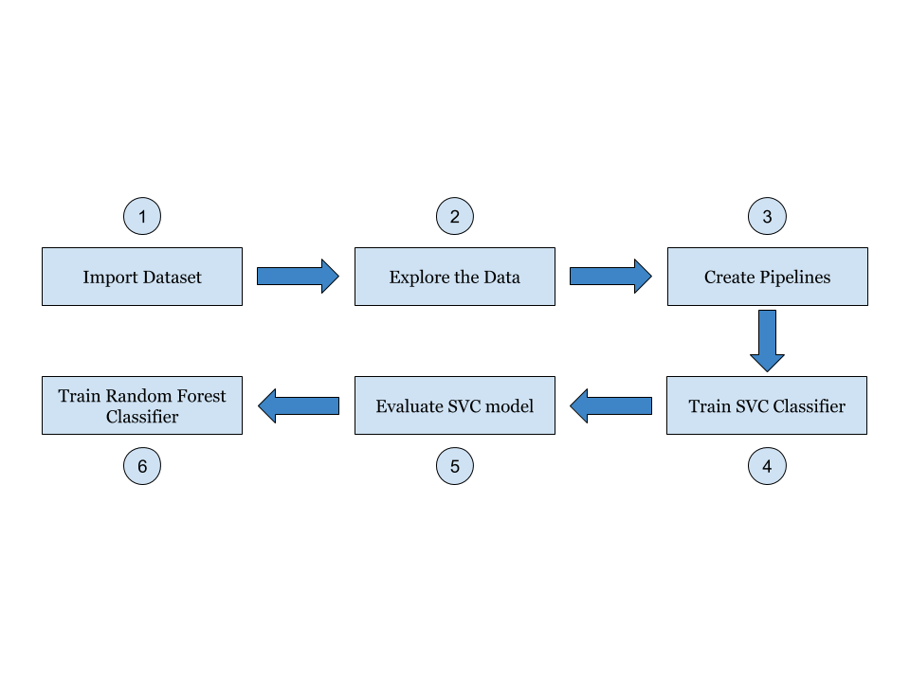

# Titanic Machine Learning Project - Step 2 - Explore the Data

Now that we have split the dataset into training and test set, in this step we will explore the dataset.



# Titanic Machine Learning Project - Explore the Training Data

Now we will look into the training data and analyze it.

# Titanic Machine Learning Project - Step 3 - Create Pipelines

In this step, we will create the pipelines for various numerical and categorical attributes, and then join them.



# Titanic Machine Learning Project - Step 4 - Train SVC Classifier

Now that we have prepared the data for training, we will train and SVC Classifier with this data.

# Titanic Machine Learning Project - Step 5 - Evaluate SVC Model

Now we will evaluate our SVC Classifier.

