# EVENT NOTIFIER

### A PROJECT REPORT

***Submitted by***

**Shreya Mridula G(220701271)**

***in partial fulfillment for the course***

### OAI1903 - INTRODUCTION TO ROBOTIC PROCESS AUTOMATION

***for the degree of***

## BACHELOR OF ENGINEERING

### in

**COMPUTER SCIENCE AND DESIGN**

## RAJALAKSHMI ENGINEERING COLLEGE RAJALAKSHMI NAGAR THANDALAM

**CHENNAI – 602105**

**NOVEMBER 2024**

# RAJALAKSHMI ENGINEERING COLLEGE CHENNAI - 602105

## BONAFIDE CERTIFICATE

Certified that this project report **“ EVENT NOTIFIER”** is the bonafide work of **“Shreya Mridula (220701271)”** who carried out the project work for the subject OAI1903-Introduction to Robotic Process Automation under my supervision.

|  |  |
| --- | --- |
|  | **Ms. U.Farjana, M.Tech.**  **SUPERVISOR**  Assistant Professor  Department of Computer Science and Engineering  Rajalakshmi Engineering College  Rajalakshmi Nagar  Thandalam  Chennai - 602105 |

Submitted to Project and Viva Voce Examination for the subject OAI1903-Introduction to Robotic Process Automation held on __________.

**INTERNAL EXAMINER EXTERNAL EXAMINER**

**ACKNOWLEDGEMENT**

Initially, we thank the Almighty for being with us through every walk of our life and showering his blessings through the endeavor to put forth this report. Our sincere thanks to our Chairman **Thiru. S.Meganathan, B.E., F.I.E.,** our Vice Chairman **Mr. M.Abhay Shankar, B.E., M.S.,** and our respected Chairperson **Dr. (Mrs.) Thangam Meganathan, M.A., M.Phil., Ph.D.,** for providing us with the requisite infrastructure and sincere endeavoring to educate us in their premier institution.

Our sincere thanks to **Dr. S.N.Murugesan, M.E., Ph.D.,** our beloved Principal for his kind support and facilities provided to complete our work in time. We express our sincere thanks to **Dr. P. Kumar, M.E., Ph.D.,** Professor and Head of the Department of Computer Science and Engineering for his guidance and encouragement throughout the project work. **Ms. U.Farjana, M.Tech.,** Assistant Professor**,** Department of Computer Science and Engineering for their valuable guidance throughout the course of the project. We are very glad to thank our Project Coordinators,Professor, **Dr. N.Durai Murugan, M.E., Ph.D.,** Associate Professor, and **Mr. B.Bhuvaneswaran, M.E.,** Assistant Professor (SG), Department of Computer Science and Engineering for their useful tips during our review to build our project.

**SHREYA MRIDULA G (220701271)**

### ABSTRACT

The goal of this project is to develop a UiPath automation workflow that enhances the management of event schedules and ensures timely reminders for stakeholders. The automation will start by extracting event data from various sources such as Excel sheets, calendars, or databases. It will then process this data to identify key event details, such as dates, times, and locations, ensuring the information is accurate and up-to-date.

Through conditional logic, the bot will detect scheduling conflicts (e.g., overlapping events or unavailable venues) and attempt to resolve them by suggesting alternative times or escalating issues that require manual intervention. Once the event schedule is validated, the bot will generate and send reminders to relevant participants, including organizers, attendees, and administrators. These reminders can be delivered via email, SMS, or instant messaging platforms like Microsoft Teams or Slack, ensuring that all stakeholders are informed well in advance.

To maintain operational efficiency, the workflow will include error-handling mechanisms to address issues such as missing data, incorrect event details, or connection failures with external communication systems. Additionally, the bot will generate a summary report of scheduled events, including any conflicts resolved or issues pending, which will be saved in an accessible format such as an Excel file or a shared document.

By automating the event reminder and scheduling process, this project aims to reduce the administrative burden, minimize errors, and improve communication, contributing to smoother event management and better stakeholder engagement.

### 

**TABLE OF CONTENTS**

**CHAPTER NO. TITLE PAGE NO.**

|  |  |
| --- | --- |
| **ABSTRACT** | **iii** |
| **LIST OF FIGURES** | **vi** |
| **LIST OF ABBREVIATIONS** | **vii** |
| **1.INTRODUCTION** | **1** |
| 1.1 INTRODUCTION | 1 |
| 1.2 OBJECTIVE | 3 |
| 1.3 EXISTING SYSTEM | 3 |
| 1.4 PROPOSED SYSTEM | 4 |
| **2.LITERATURE REVIEW** | **5** |
| **3.SYSTEM DESIGN** | **11** |
| 3.1 SYSTEM FLOW DIAGRAM | 12 |
| **4.PROJECT DESCRIPTION** | **14** |
| 4.1 MODULES | 14 |
| 4.1.1 Event DataModule | 14 |
| 4.1.2 Data Normalization Module | 14 |
| 4.1.3 Event Notification Module | 15 |
| 4.1.4 Notification channel Module | 16 |
| **5.OUTPUT SCREENSHOTS** | **17** |
| **6.CONCLUSION** | **19** |
| **APPENDIX** | **20** |
| **REFERENCES** | **32** |

## LIST OF FIGURES

|  |  |  |
| --- | --- | --- |
| **Figure No** | **Figure Name** | **Page No.** |
| 3.1 | System Flow Diagram | 11 |
| 5.1 | Output 1 | 17 |
| 5.2 | Output 2 | 17 |
| 5.3 | Output 3 | 18 |
| 5.4 | Output 4 | 18 |
| 5.5 | Output 5 | 19 |

**LIST OF ABBREVIATIONS**

|  |  |
| --- | --- |
| **ABBREVIATION** | **ACCRONYM** |
| RPA | Robotic Process Automation |
| OTA | Online Travel Agency |
| UI | User interface |
| HTTP | Hyper text transfer protocol |
| GPS | Global positioning system |
| PNR | Passenger Name Record |
| OS | Operating system |
| DB | Database |
| HTML | Hyper Text Markup Language |
| CCV | Card Verification value |

# CHAPTER 1

## INTRODUCTION

### INTRODUCTION

### 

In today’s fast-paced world, managing schedules and events effectively is essential for individuals and organizations to stay productive and organized. However, with events spread across multiple platforms and the constant need for timely updates, manual event management can become a time-consuming and error-prone process. This project harnesses the power of UiPath, a leading robotic process automation (RPA) platform, to revolutionize event management workflows. By automating tasks such as extracting data from calendars, detecting scheduling conflicts, and sending notifications, UiPath provides a seamless and efficient solution to manage events with precision.

At the core of this project is the ability to integrate and consolidate data from various sources, including personal calendars, shared schedules, and external systems. UiPath bots work to analyze this data in real time, identifying potential conflicts and alerting users before issues arise. Additionally, automated notifications, delivered via email or instant messaging platforms, ensure that stakeholders remain informed of updates or changes. This eliminates the stress of manually tracking and resolving scheduling issues, allowing users to focus on more important tasks.

By automating and optimizing the event management process, this project goes beyond simple reminders. It enhances decision-making, improves productivity, and minimizes the risk of missed appointments or overlooked deadlines. Whether applied to personal time management or complex organizational workflows, this solution demonstrates how UiPath can transform routine processes into powerful tools for success, making it a valuable asset in today’s increasingly demanding environments.

Top of Form

Bottom of Form

### OBJECTIVE

### The objective of this project is to automate the process of event reminder notifications

### using UiPath. The automation will extract event details from sources like Excel or calendars,

### identify any scheduling conflicts, and suggest alternative solutions where needed. It will then send

### timely reminders to event participants through communication channels such as email, SMS, or

### messaging platforms like Teams and Slack. Additionally, the system will generate a summary report

### of scheduled events and any conflicts that were resolved, improving overall efficiency and ensuring

### that all stakeholders are informed on time.

### EXISTING SYSTEM

The existing UiPath-based system for comparing and notifying users about events from multiple sources, such as Eventbrite, Meetup, and Facebook Events, automates the process of gathering and extracting event data from various platforms. The system allows users to receive real-time event notifications and reminders, tailored to their preferences and interests. By leveraging robotic process automation (RPA), UiPath enhances the accuracy of data extraction while eliminating the need for manual intervention, ensuring that event information is up-to-date and consistent.

This solution makes event data easily accessible by automatically gathering event details such as dates, locations, categories, and registration links from different websites. The system is designed to adapt flexibly to changes in website structures, meaning it can continue to pull relevant event information even when platforms update or modify their layouts. Additionally, UiPath can handle complex filtering based on user preferences—such as event type, location, or timing—enabling personalized notifications.

### PROPOSED SYSTEM

### The proposed system aims to automate and streamline the management of event schedules and ensure timely notifications for stakeholders. This solution will include several key components to optimize event coordination, enhance communication, and reduce manual effort:

### 1. Data Retrieval Module

### Use UiPath to extract event details from sources like Excel files, Google Calendar, or other scheduling platforms.

### Gather important information such as event names, dates, times, locations, and participants.

### Schedule regular updates to ensure the system processes the latest event data and adjusts to changes.

### 2. Conflict Detection and Resolution

### Develop workflows to analyze event schedules for conflicts such as overlapping events or venue unavailability.

### Use dynamic logic to resolve conflicts by suggesting alternative times or venues.

### Automatically escalate unresolved issues to the appropriate personnel via automated notifications.

### 3. User Input Interface

### Create a dashboard or input form in UiPath, allowing users to:

### Add, modify, or cancel event details.

### Specify parameters like preferred times or locations.

### Trigger the schedule validation and notification process as needed.

### 4. Notification and Reminder Module

### Use UiPath activities to send notifications via email, SMS, or instant messaging platforms like Microsoft Teams or Slack.

### Notify stakeholders about upcoming events, any changes, or conflicts.

### Provide reminders well in advance of event start times to ensure attendees are properly informed.

### 5. Result Presentation

### Generate detailed reports of the event schedule, conflicts, and resolutions using Excel or PDF formats.

### Create visual dashboards using UiPath-integrated tools (e.g., Power BI) to provide an intuitive representation of event data, conflicts, and resource utilization.

### Include charts, tables, and summaries to simplify event management.

### 6. Error Handling and Logging

### Implement error handling for issues such as incorrect data formats, missing information, or failed data retrieval.

### Log errors, warnings, and anomalies in the event schedule for debugging and continuous system improvement.

### Notify administrators of critical issues, such as unresolved conflicts or failed notifications.

### Benefits of the System

### Efficiency: Automates event schedule validation, conflict resolution, and reminders, saving time and minimizing manual effort.

### Accuracy: Ensures error-free event scheduling and conflict resolution by dynamically validating event data.

### Transparency: Provides stakeholders with real-time notifications and visual insights into the event scheduling process, ensuring better coordination.

### This system will empower organizations by automating the event scheduling process, minimizing conflicts, and ensuring timely communication with stakeholders.

### 

## 

## CHAPTER 2

## LITERATURE REVIEW

Efficient event schedule management is crucial for organizations, but challenges such as scheduling conflicts, resource allocation issues, and communication breakdowns often arise. By leveraging automation tools like UiPath, these challenges can be addressed effectively, streamlining processes, reducing errors, and improving communication between stakeholders. Several key concepts and methodologies have shaped the development of this automation system:

**[1] Event Scheduling Conflict Detection and Resolution**

Event scheduling conflict detection focuses on identifying overlapping events, venue availability issues, and conflicts with speaker or participant schedules. Traditional methods often require manual validation, which can be prone to human error and inefficiencies. Automating this process using UiPath workflows allows for real-time conflict detection and resolution. Studies indicate that automation improves scheduling accuracy by dynamically analyzing event data, detecting conflicts, and suggesting alternative solutions such as rescheduled times or venues. Optimization algorithms and conditional logic further enhance this process, ensuring fair and efficient allocation of resources.

**[2] Notification Systems in Automated Workflows**

Timely and accurate notifications are essential for ensuring that all stakeholders are informed of event schedules, changes, or cancellations. Research emphasizes the importance of notifications in reducing disruptions and fostering better engagement among event participants. By integrating UiPath with communication platforms such as **email**, **Microsoft Teams**, **Slack**, and **SMS APIs**, organizations can automate the delivery of notifications and reminders. Real-time alerts during critical changes, such as rescheduling or cancellations, enhance communication flow and prevent last-minute disruptions. Pre-scheduled reminders ensure participants remain informed, leading to higher adherence to event schedules.

**[3] Visualizing and Reporting Event Data**

Data visualization plays a significant role in helping stakeholders understand complex event schedules and identify potential conflicts. Studies show that graphical tools like Gantt charts, bar graphs, and tables provide clearer insights into event timelines and resource allocation. UiPath's integration with platforms such as **Power BI** and **Excel** allows for dynamic report generation, making it easier to visualize event schedules and associated conflicts. By incorporating visual elements, stakeholders can better analyze event patterns, optimize resource usage, and plan future events more effectively.

**[4] Error Handling and System Robustness**

Any automation system must be equipped with mechanisms to detect and address potential issues, such as missing data, incorrect formats, or integration failures. Research on error handling in automated workflows emphasizes the need for robust solutions to ensure system reliability. UiPath provides tools such as **exception handling** and **retry mechanisms** to automatically detect and correct errors. Logging discrepancies and failures and providing real-time alerts to administrators ensures the smooth operation of the event scheduling system, improving its resilience against disruptions and data integrity issues.

**[5] Impact of Automation on Event Scheduling Efficiency**

Studies on automating event scheduling show that organizations adopting such systems benefit from significant improvements in operational efficiency. Automation reduces the administrative burden by handling repetitive tasks like data entry, schedule validation, and notifications. As a result, event managers can focus on higher-level tasks, such as improving attendee experiences and optimizing event outcomes. Additionally, automation supports inclusivity by allowing users to define preferences or constraints, such as time restrictions or accessibility needs, that are difficult to manage manually.

In conclusion, the integration of UiPath automation into event schedule management addresses key challenges such as conflicts, communication gaps, and inefficiencies. Drawing from these insights, the proposed system aims to offer a robust, scalable, and user-friendly solution for event organizers, promoting smoother event planning, better stakeholder communication, and improved operational efficiency.

# CHAPTER 3 SYSTEM DESIGN

### ARCHITECTURE DIAGRAM

An architecture diagram is a graphical representation of a set of concepts, that are part of an architecture, including their principles, elements and components.

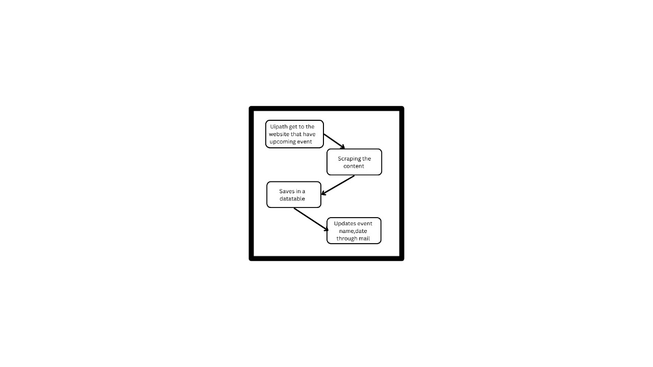

Fig 3.2 Flow Diagram

**CHAPTER 4 PROJECT DESCRIPTION**

**4.1.1 Event Data Retrieval**

This module automates the retrieval of event-related data from various sources using UiPath. The goal is to gather relevant details such as event names, dates, times, locations, descriptions, and other key information.

1. **Event Website Scraping**:
   * **Objective**: Use UiPath to scrape event details from multiple event listing websites (such as Eventbrite, Meetup, etc.).
   * **Process**:
     + Set up UiPath workflows that navigate the event websites, identify relevant event information, and extract it into structured data (e.g., using tables or lists).
     + Utilize web scraping techniques (or APIs, if available) to extract event data at scheduled intervals.
   * **Key Data Points**:
     + Event name
     + Date and time

**4.1.2 Data Normalization Module**

This module ensures that event data gathered from different sources is standardized for consistency, enabling fair comparisons and accurate processing.

1. **Event Date and Time Normalization**:
   * **Objective**: Standardize event date/time across different time zones to avoid discrepancies.
   * **Process**:
     + Convert event times to a single time zone (e.g., UTC or local time zone).
     + Normalize formats (e.g., converting date formats from DD-MM-YYYY to YYYY-MM-DD).
2. **Event Location Normalization**:
   * **Objective**: Standardize event location data, especially when different platforms present addresses in varying formats.
   * **Process**:
     + Geocode event addresses to standardize location formats (latitude and longitude).
     + Ensure consistency in the naming of venues or locations.

**4.1.3 Event Notification Logic**

This module defines the logic that will trigger notifications for users based on specific conditions related to events.

1. **Event Reminder Notifications**:
   * **Objective**: Send automatic reminders to users about upcoming events.
   * **Process**:
     + Set up reminder notifications that are sent at scheduled intervals (e.g., 1 day before, 1 hour before).
     + Use a calendar system to calculate when a reminder should be sent based on event date/time.
2. **Notification Channels**:
   * **Objective**: Send notifications through various communication channels, such as email, SMS, or push notifications.
   * **Process**:
     + Set up email/SMS templates for event reminders.
     + Use UiPath to integrate with email platforms (e.g., Gmail, Outlook) or SMS APIs (e.g., Twilio) to send notifications.

## 

## 

## CHAPTER 5

## OUTPUTSCREENSHOT

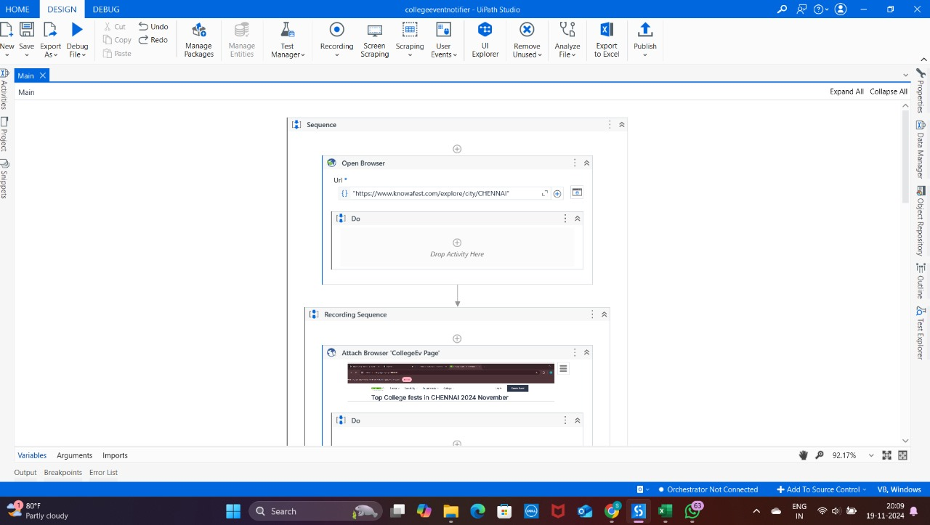

Fig 5.1 Create the project by creating the work flow.

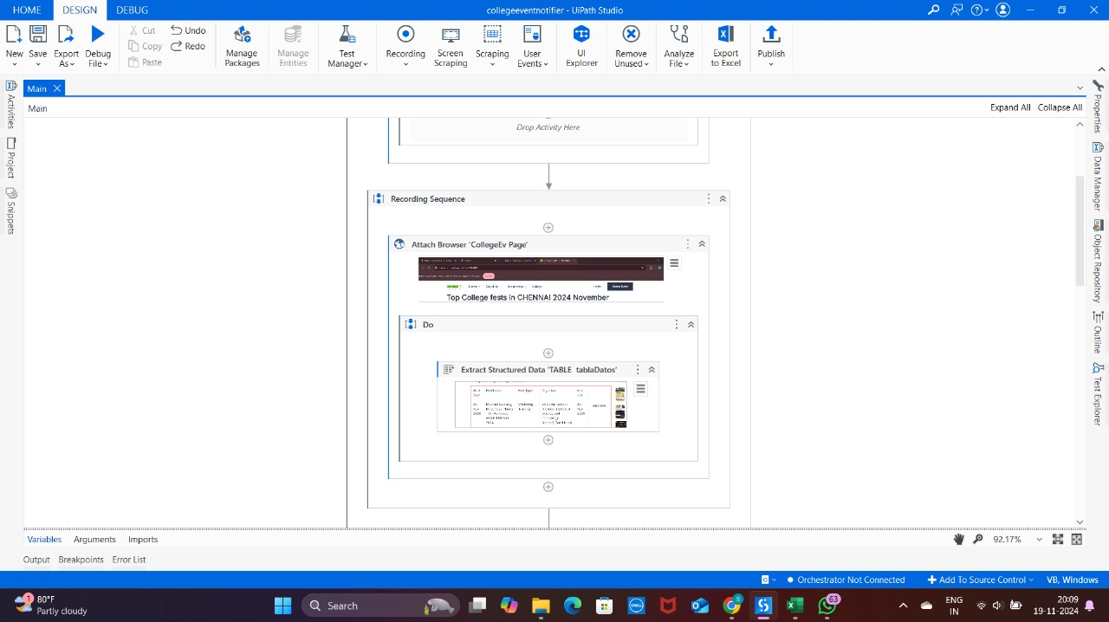

Fig 5.2 Scraping the content from web site.

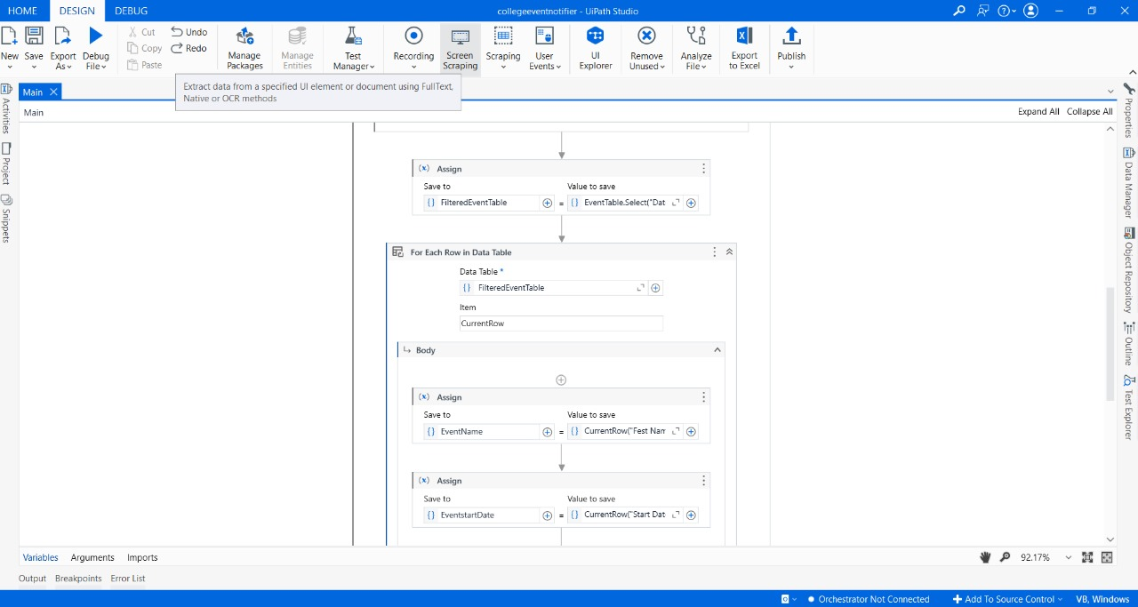

Fig 5.3 Assigning the values to the data table.

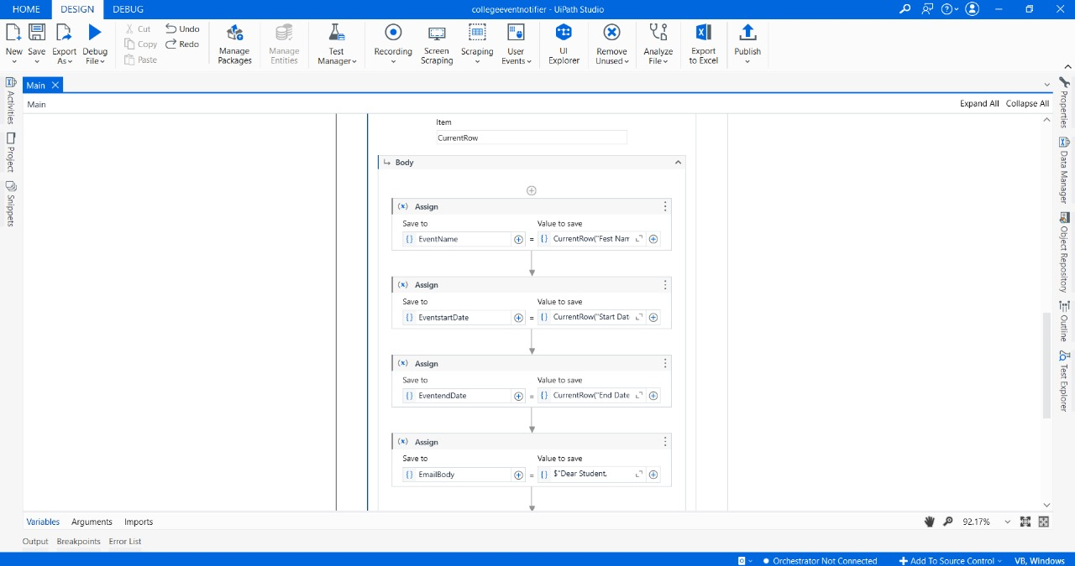

Fig 5.4 Assigning the values to the data table.

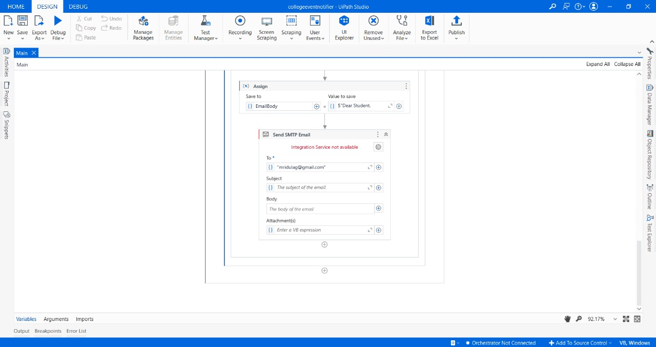

Fig 5.5 Sending mail

## CHAPTER 6 CONCLUSION

In conclusion, UiPath's comparative study of event data from platforms such as Eventbrite, Meetup, and Facebook Events offers valuable insights into the variety and relevance of event information available from different sources. The investigation emphasized the importance of considering multiple event platforms to achieve a more comprehensive and reliable understanding of available events, particularly in areas such as event types, locations, timings, and registration details. By highlighting the differences in event details across platforms, the study revealed the unique strengths of each source. Eventbrite excels at providing detailed professional events, Meetup is ideal for community-driven gatherings, and Facebook Events offers robust social integration and diverse event categories.

With the help of UiPath automation, seamless extraction and comparison of event data from various sources allowed for a holistic view of upcoming activities, enabling users to receive personalized and accurate event notifications based on their preferences. Furthermore, analyzing these platforms' event details and user engagement data highlighted the strengths of each in catering to different user needs, from local events to larger conferences.

In the end, the UiPath automation process not only streamlined the comparison of event data from various sources, but also emphasized the importance of a well-rounded approach that leverages the unique advantages of each platform. Event notifications became more reliable and tailored to user preferences, as UiPath’s efficient and accurate data extraction and processing capabilities ensured users received timely, relevant, and personalized information about events across multiple platforms. This multi-source approach empowered users to make more informed decisions, ensuring they never miss out on an event that aligns with their interests.

## REFERENCES

**[1] Event Recommendation Systems: A Comparative Study of Approaches by R. Patel and M. Smith**

**{https://www.sciencedirect.com/science/article/pii/S0957417422011206}**

[2] **Personalized Event Notification Using Hybrid Recommendation Systems** by T. Sharma and S. Rathi  
{https://www.researchgate.net/publication/32353645}