CUSTOMER SEGMENTATION ANALYSIS REPORT

Using Demographic & Behavioral Clustering Techniques

Prepared By:
Shreya Nikkam
Internship Role:
Data Analytics Intern
Company:
Skillbit Technolologies

Executive Summary

This report presents a comprehensive customer segmentation analysis conducted during the Data Analytics Internship at Skillbit Technolologies. The objective of this study was to identify distinct customer groups based on demographic attributes and purchasing behavior to support data-driven marketing and revenue optimization strategies.
Using clustering logic based on Annual Income and Spending Score, customers were categorized into meaningful segments such as Premium, Conservative, Standard, Potential, and Budget groups. The findings highlight revenue opportunities, customer engagement patterns, and targeted marketing strategies.

1. Project Objective
The primary objective of this project was to segment customers using demographic variables (Age, Gender) and behavioral indicators (Annual Income and Spending Score). The segmentation framework aims to:
• Identify high-value customers
• Understand purchasing behavior patterns
• Enable targeted marketing strategies
• Improve revenue optimization through data-driven insights

2. Dataset Overview
The dataset consists of 200 customer records with the following attributes:
• Customer ID – Unique identifier
• Gender – Male/Female
• Age – Customer age
• Annual Income (k$) – Annual income in thousand dollars
• Spending Score (1–100) – Indicator of purchasing tendency

3. Tools & Technologies Used
• Excel – Data cleaning, preprocessing, and derived column creation
• SQL – Data querying, aggregation, and validation of insights
• Power BI – Interactive dashboard creation and visualization

4. Methodology

4.1 Data Preparation
Data was validated for completeness and consistency. Derived columns such as Income Group, Spending Level, and Revenue Potential Score were created to enhance analytical depth.

4.2 Segmentation Approach
A rule-based clustering technique was applied using Annual Income and Spending Score as primary segmentation variables. Customers were categorized into:
• Premium Customers (High Income – High Spending)
• Conservative Customers (High Income – Low Spending)
• Potential Customers (Low Income – High Spending)
• Budget Customers (Low Income – Low Spending)
• Standard Customers (Moderate Income – Moderate Spending)

4.3 Revenue Potential Estimation
Revenue Potential Score was calculated as:
Revenue Potential = Annual Income × Spending Score
This metric helped identify high-value customers and segment-level contribution.

5. Dashboard Structure
The Power BI solution was divided into three structured pages:
• Overview Dashboard – Customer distribution and behavioral metrics
• Segmentation Dashboard – Cluster visualization and revenue analysis
• Executive Summary – Key findings and strategic recommendations

5.1 Overview Dashboard

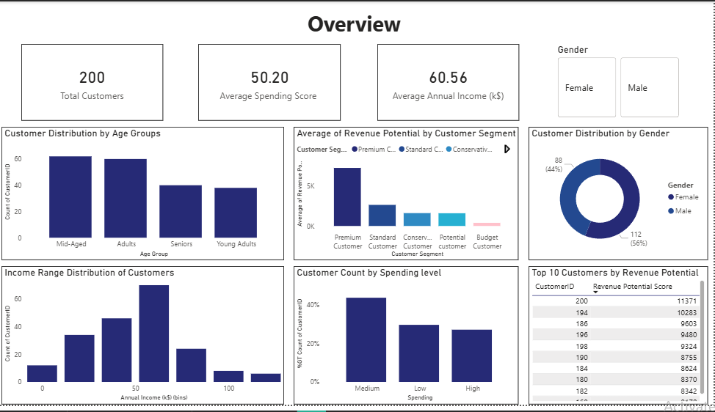
This page provides high-level KPIs including total customers, average income, average spending score, income distribution, and spending distribution

5.2 Segmentation Dashboard

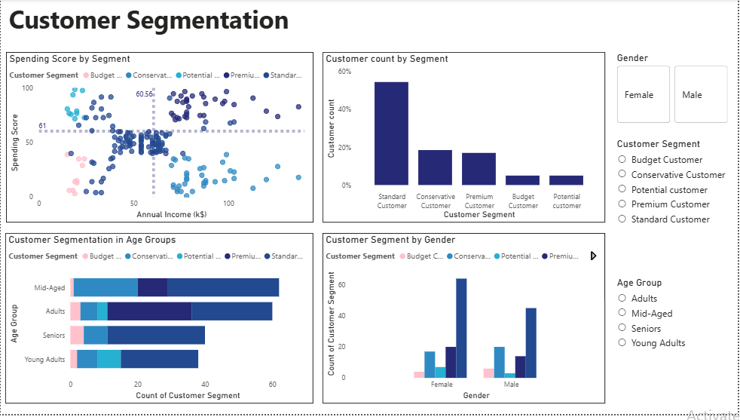
This page includes a scatter plot with constant lines to visually justify clustering, segment contribution analysis, and revenue potential insights.

5.3 Executive Summary Page
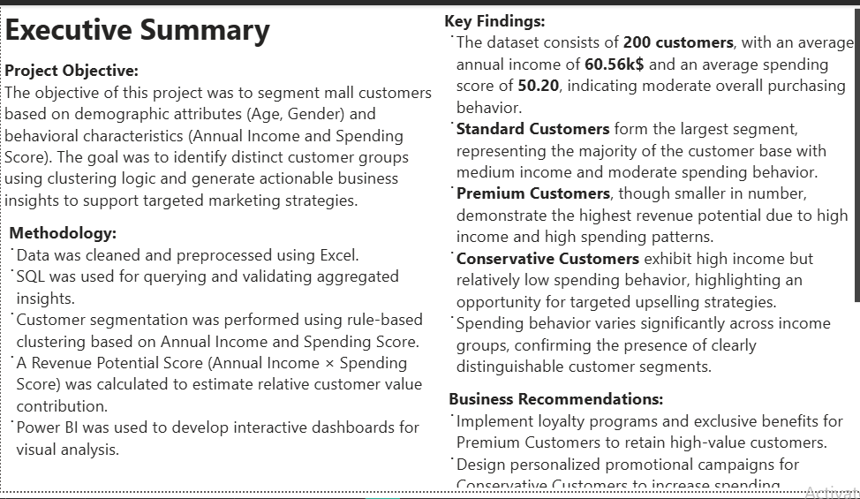

6. Key Findings
• Standard Customers represent the largest share of the customer base.
• Premium Customers contribute the highest revenue potential.
• Conservative Customers present strong upselling opportunities.
• Behavioral clusters clearly justify segmentation strategy.
• Spending patterns vary significantly across income levels.

7. Business Recommendations
• Develop loyalty programs for Premium customers.
• Implement personalized promotions for Conservative customers.
• Offer bundled discounts for Potential customers.
• Design value-driven campaigns for Budget customers.
• Utilize demographic targeting for improved campaign effectiveness.

8. Conclusion
This project demonstrates practical application of customer segmentation and clustering logic in a real-world business scenario. The insights derived support strategic decision-making, targeted marketing initiatives, and revenue optimization strategies.

