INDEX

Sr. No. | Particulars | Page No.
1 | Introduction to system
2 | Need for a system  • Problem Statement  • Objective of the system  • Scope of the system
3 | Requirement analysis  • Feasibility study  • Fact finding techniques  • Hardware & Software specifications
4 | System Analysis  • UML Diagrams
5 | System Design  • Database Design  • User Interface(Screens and Reports)
6 | Limitations &/Or Conclusion
7 | Future enhancements
8 | Bibliography

- Introduction to the System

Steganography is the tool of hiding textual content inside a image.
Steganography is the art and science of hiding information within other seemingly innocuous media, such as images, audio, video, or text. Unlike cryptography, which scrambles data to make it unreadable without a decryption key, steganography conceals the very existence of the message. The word "steganography" is derived from the Greek words steganos (meaning "covered") and graphia (meaning "writing"), translating to "covered writing."
The primary goal of steganography is to embed a hidden message within a carrier file (called a cover medium) in such a way that it remains undetectable to unintended observers. Common forms of digital steganography include hiding messages in the least significant bits (LSB) of image pixels, embedding data in the silence intervals of an audio file, or manipulating the spacing and formatting of text documents.
Steganography is needed to ensure secure and undetectable communication in a digital world where data is constantly at risk. Unlike encryption, which only scrambles the content, steganography hides the existence of the message itself, making it ideal for confidential exchanges. It is especially useful in situations where security is critical but visibility of a message could raise suspicion, such as in journalism, military, or activism. It also plays a key role in digital watermarking, copyright protection, and secure data storage. When combined with encryption, steganography provides a powerful layer of defense against cyber threats
In summary, steganography is a powerful tool for covert communication and data protection, providing an additional layer of security by concealing the very presence of information. When combined with encryption, it can greatly enhance privacy and data integrity in both personal and professional communication systems. This project is build using Python Programming Language.

- Need for a System

2.1 Problem Statement:-
With the rapid growth of digital communication, the need for secure and private information sharing has become more critical than ever. Traditional encryption methods, while effective, often draw attention to the existence of secret information, which may lead to attempts of unauthorized access. To overcome this limitation, steganography provides a way to conceal messages within digital media, making the very existence of the hidden information less detectable.
The problem is that many existing tools for steganography are either complex for non-technical users or lack proper security features such as password protection. Users require a simple, user-friendly application that allows them to embed secret text messages into images and securely retrieve them only with the correct password.
This project aims to develop a GUI-based Steganography Tool that enables users to:
1. Encode: Hide a secret message inside an image file, protected with a password.
2. Decode: Retrieve the hidden message from the image only if the correct password is provided.
The tool ensures message confidentiality, usability through an intuitive interface, and flexibility by supporting common image formats (e.g., .png, .jpg)

2.2 Objective: -
The main objective of a steganography tool is to conceal secret information within a cover medium (such as an image, audio, video, or text file) in a way that prevents detection by unintended recipients. The tool should allow users to embed, transmit, and extract hidden data securely and reliably without altering the visible or audible quality of the cover file.
Objectives include:
1. Data Concealment: Hide sensitive information within a chosen media file.
2. Undetectability: Ensure the hidden message is not noticeable to casual observers or automated analysis.
3. Integrity: Preserve the quality and structure of the original cover file after embedding.
4. Security: Optionally use encryption alongside hiding to ensure only authorized users can extract the message.
5.Ease of Use: Provide a user-friendly interface for embedding and extracting data.

2.3 Scope of the system
This tool can be used by industry experts, IT professionals, cyber security experts, students and all other who want to protect their important and sensitive information. Educational Demonstration for cyber security training. This project will only convert the text into an image; hence can only limit scope for text.
Support for Multiple Formats: Work with various file types (e.g., PNG, MP3, MP4) for flexibility.
This project will run on Linux, Windows Operating System.
- Requirement analysis
3.1 Feasibility study
Definition:
A feasibility study for a mini-project is a preliminary analysis to assess its practicality and potential for success by evaluating technical, economic, and operational factors before full commitment. It provides an objective report on whether the project is a worthwhile use of time, resources, and budget, identifying potential challenges and helping stakeholders decide to proceed, modify, or abandon the project.

- Technical Feasibility
• Python provides libraries like PIL/Pillow, OpenCV, Tkinter, and cryptography to implement image steganography and password protection.
• Hardware requirements are minimal: a standard laptop/PC is sufficient.
• The tool can run cross-platform (Windows/Linux).

- Economic Feasibility
- Project development uses open-source libraries, so no additional cost.
- Required hardware (laptop/PC) is already available.
- Maintenance cost is negligible since updates only involve code improvements.

- Operational Feasibility
- The system will be user-friendly with a GUI, where users can:
- Upload an image.
- Enter secret text and password.
- Hide/retrieve the message securely.
- It can be used by students, researchers, or anyone who wants to protect information in digital media.
No advanced training is required for end-users.

3.2 Fact Finding technique
Definition :- Fact-finding techniques are methods used to gather information, data, and requirements to understand an existing system or identify needs for a new one. Common techniques include interviews, questionnaires, observations, document sampling, research, prototyping, and joint requirement planning. The goal is to collect accurate information to ensure the project's success by meeting its objectives effectively.

- Observation
• We observed that users often share sensitive information (like passwords, private notes, or confidential data) through normal text or files.
• Such information, if intercepted, can be easily misused.
• Current file-sharing tools do not provide built-in hidden communication features, highlighting the need for a secure steganography tool to hide text inside images.

- Literature Survey
• We referred to existing tools, research papers, and tutorials on image steganography.
• Popular methods include LSB (Least Significant Bit) substitution, masking/filtering, and transform domain techniques.
• This survey helped identify the scope: hiding and retrieving text from images, along with a password-based security layer.

- Discussion and Interviews
Discussions with peers and faculty highlighted requirements:
- Should support hiding text in commonly used formats (e.g., PNG, JPG).
- Must have an option to add a password check and password strength verification.
- Retrieval process should be simple, even for non-technical users.

- Experimentation
- Initial experiments with Python libraries (PIL, cv2, tkinter) showed that embedding and retrieving text from images is achievable.
- Adding password strength checks (regex, string library) increases usability and security.
- Prototype testing confirmed the feasibility of combining GUI with steganography functions.

3.3 Hardware and Software Specifications
Hardware Requriments:-
Processor :- Intel
Ram:- 1GB - 4GB or even higher
Storage:- 100MB - 500MB free space
Input devices:- Keyboard, Mouse
Software Requirements:-
Operating System:- Windows or Linux
Programming Language:- Python
Libraries:- Pillow(for image manipulation),
numpy(for scientific computing & data analysis)
Compiler/ IDE:- Visual Studio, VS Code

- System Analysis
4.1 UML Diagram
- Use-case diagram:-
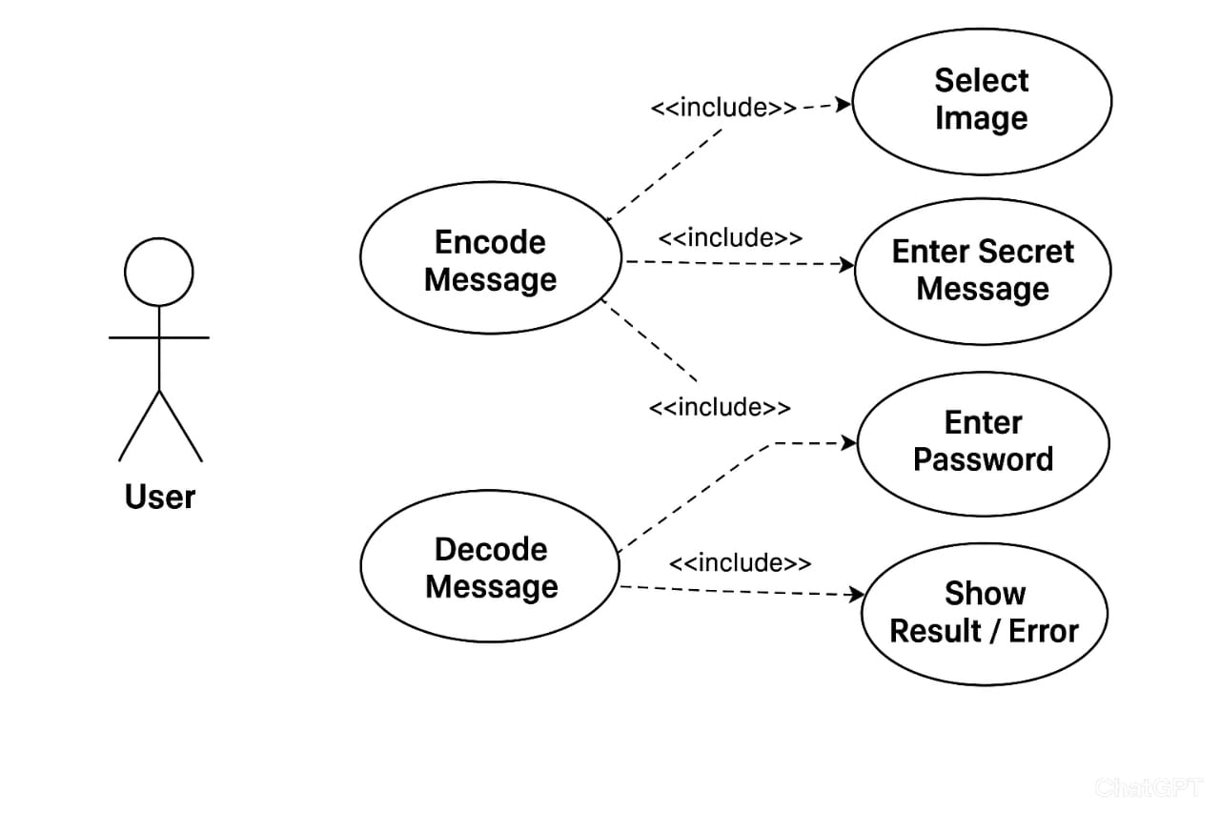

- Class Diagram
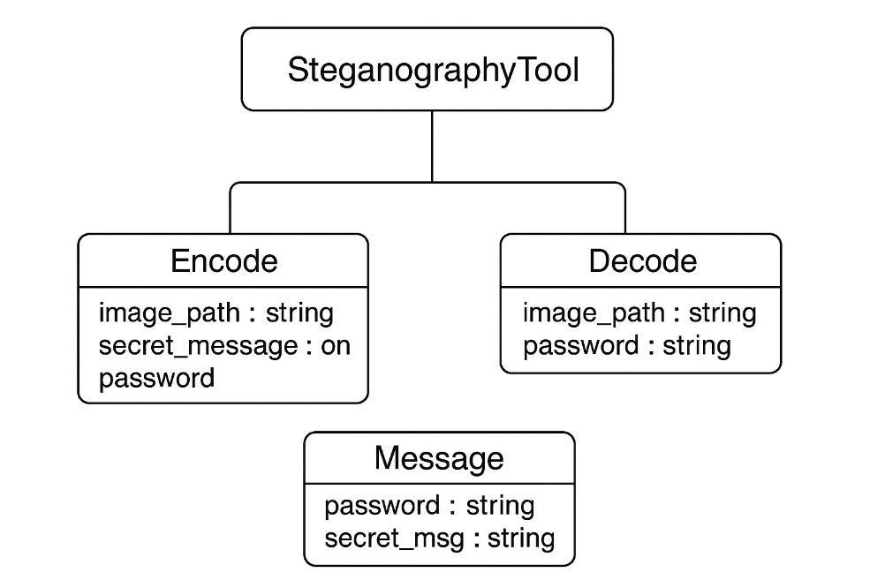

- Activity Diagram
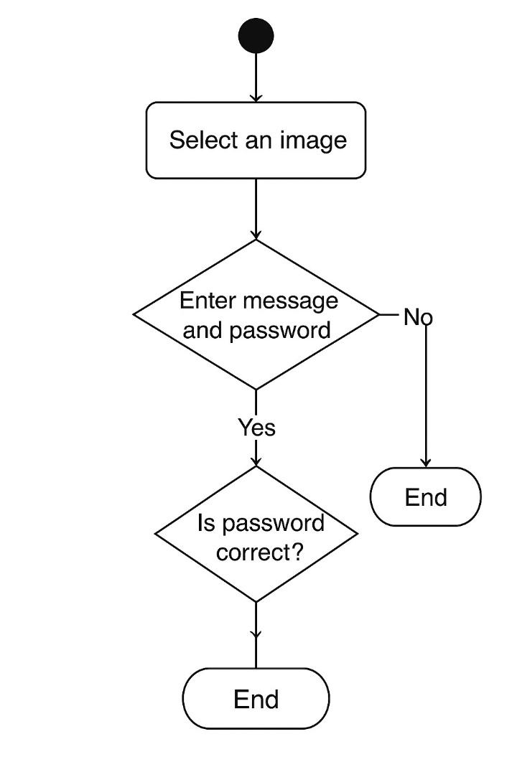

- Object Diagram
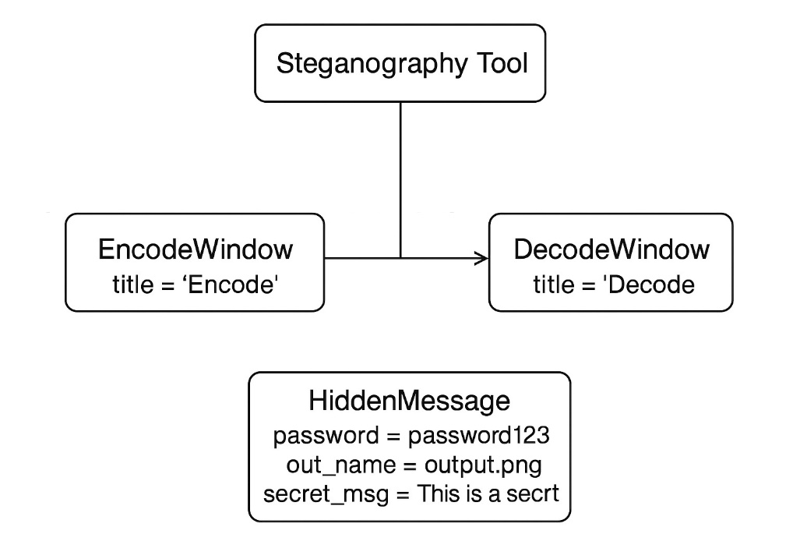
- Sequence Diagram:-
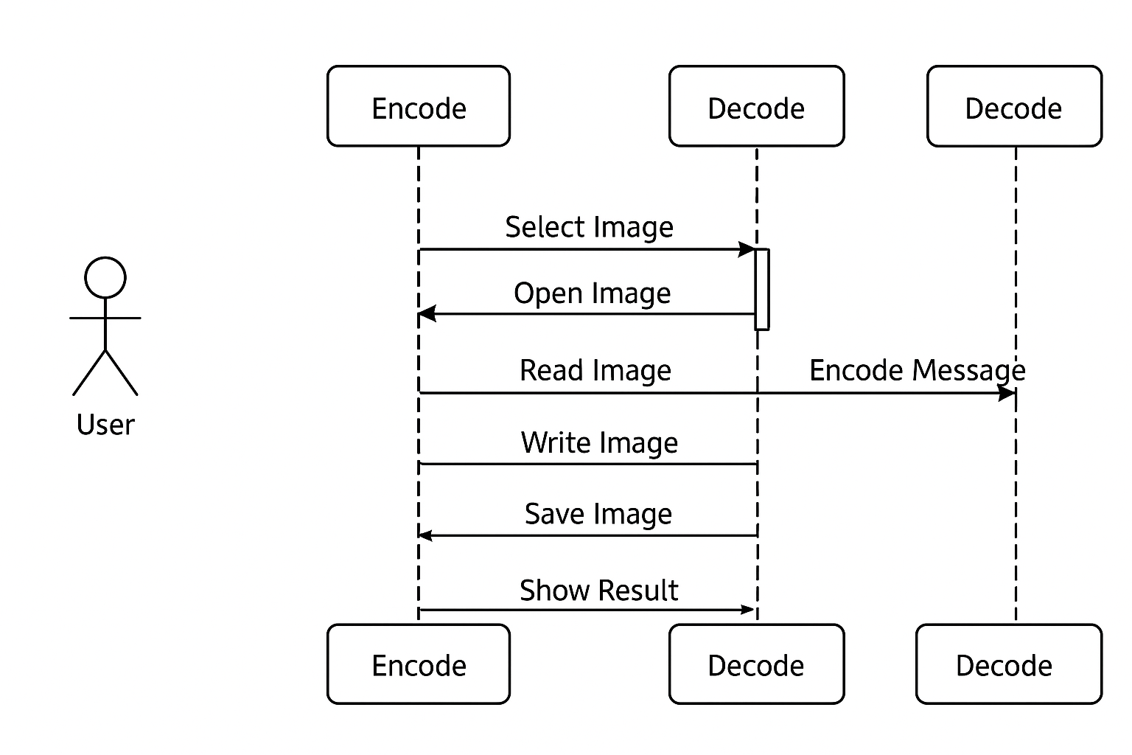

- System Design
  - User Interface

FIRST INTERFACE
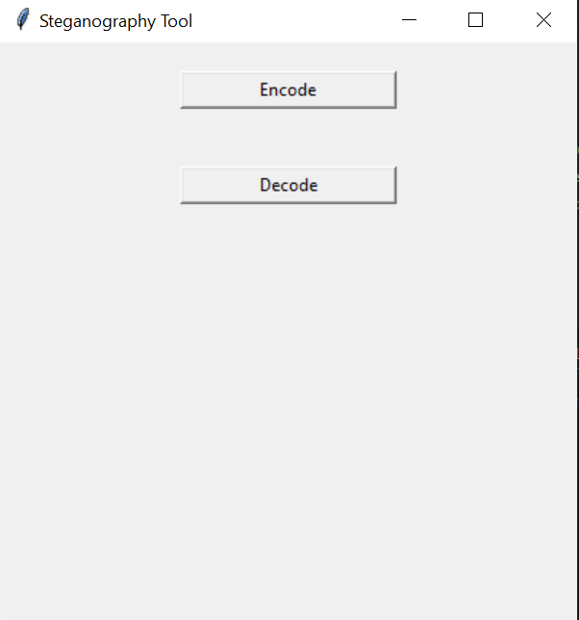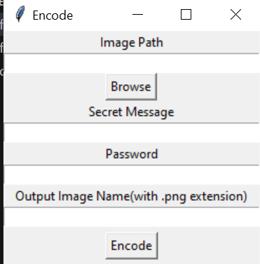

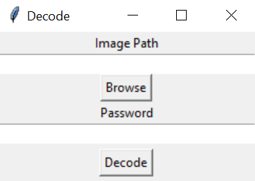

6. Limitations and Conclusion
6.1 Limitations
1. Limited File Formats – The tool currently supports only basic image formats like .png and .jpg. Other formats (e.g., .bmp, .gif) are not supported.
2. Message Size Restriction – The amount of data that can be hidden depends on the image size. Very small images cannot hold large messages.
3. Password Protection – Although the tool uses a password for access, it is a basic text-based check and not advanced encryption. A skilled attacker may still attempt brute force attacks.
4. Image Quality – While the changes to the image are visually negligible, repeated encoding or use of compressed formats (like .jpg) may reduce quality or corrupt hidden data.
5. No Multimedia Support – The tool only works for hiding text messages. It cannot hide other file types (e.g., audio, video, documents).
6. Not Resistant to Attacks – The hidden data may be destroyed if the image undergoes operations such as resizing, cropping, or heavy compression.
7. No Advanced Security Measures – The system does not use cryptographic algorithms like AES or hashing for message protection, making it less secure for highly confidential information.
8. GUI Simplicity – The graphical user interface is simple and functional but lacks advanced features like drag-and-drop support or batch processing.

  - Conclusion
The Steganography Tool successfully demonstrates how digital images can be used as carriers for secret communication. By embedding text messages within image files and protecting them with a password, the project provides a simple yet effective way to achieve data hiding. The GUI-based design makes the tool user-friendly, allowing even non-technical users to encode and decode hidden messages with ease.
Although the system has certain limitations—such as support for only text messages, limited image formats, and basic password protection—it still fulfills its primary objective of providing a secure and accessible medium for covert communication.
This project highlights the importance of steganography in data security and privacy. It serves as a foundation that can be further enhanced with stronger encryption techniques, support for multiple media types, and resistance against image manipulations. Overall, the tool provides a practical and educational approach to understanding how information can be hidden in plain sight

7. Future Enhancement
1. Support for Multiple File Types
Extend the tool to work with more image formats (e.g., .bmp, .gif, .tiff) and even other media types like audio and video for higher versatility.
2. Advanced Encryption
Integrate cryptographic algorithms (e.g., AES, RSA) along with steganography, so that even if the hidden data is extracted, it remains encrypted and unreadable without the decryption key.
3. Larger Data Capacity
Enhance the algorithm to store larger messages or even files (documents, images, etc.) within the carrier image without affecting its quality.
4. Improved Password Security
Implement secure hashing or key-based authentication instead of plain text passwords to reduce the risk of brute force or dictionary attacks.
5. Robustness Against Image Processing
Develop techniques to make the hidden data resistant to compression, resizing, cropping, or other common image transformations.
6. Stealthier Encoding Techniques
Use more sophisticated methods (like LSB with noise addition, DCT, or spread spectrum) to make detection even harder for attackers.
7. User Interface Improvements
Add features like drag-and-drop, batch processing, preview options, and progress indicators to improve usability.
8. Cross-Platform Support
Extend the application for mobile platforms (Android/iOS) and web browsers, enabling secure communication on multiple devices.
9. Error Detection and Recovery
Include error-correction codes to ensure the hidden data can still be retrieved even if parts of the image get corrupted.
10. Cloud Integration
Allow secure upload, storage, and sharing of stego images through cloud platforms with end-to-end encryption.

8. Bibliography
• Python Software Foundation. Python Language Reference, version 3.x. Available at: https://www.python.org/
• Python Tkinter Documentation. Tkinter — Python interface to Tcl/Tk GUI toolkit. Available at: https://docs.python.org/3/library/tkinter.html
• Pillow (PIL Fork) Documentation. Python Imaging Library (Pillow) for image processing. Available at: https://pillow.readthedocs.io/en/stable/
• Sommerville, Ian. Software Engineering, 10th Edition. Pearson, 2016.
• Kessler, Gary C. An Overview of Steganography for the Computer Forensics Examiner. (2001). Available at: https://www.garykessler.net/library/steganography.html
• Johnson, Neil F. & Jajodia, Sushil. Exploring Steganography: Seeing the Unseen. IEEE Computer, Vol. 31, No. 2, 1998.
• TutorialsPoint. Python GUI Programming (Tkinter). Available at: https://www.tutorialspoint.com/python/python_gui_programming.htm
• GeeksforGeeks. Image-based Steganography in Python. Available at: https://www.geeksforgeeks.org/image-based-steganography-using-python/

