**What is GitHub? When was it created? Why? By who? What similar platforms exist? Why would you use such a platform?**

GitHub is Git Repository hosting service which is used to store your code with proper versioning and bug tracking. It has many features like one of which is collaboration where work can be collaborated from other repositories. With the free account we can’t create private repository. GitHub was founded in February 2008 by Chris Wanstrath , Tom Preston-Werner and PJ Hyett. If one has paid for the GitHub account they can also create private repositories. Platforms similar to GitHub are SVN, Bitbucket, GitKraken, etc. Git is usually used when, large number of people work on a huge project and every team member pushes their part of the code to git which can be merged later on. It helps ease the process for merging the code, and resolve any conflicts which may arise while merging if necessary. Later the merged code can be pulled, so every member works on updated copy of the project code.

**Git tutorial**

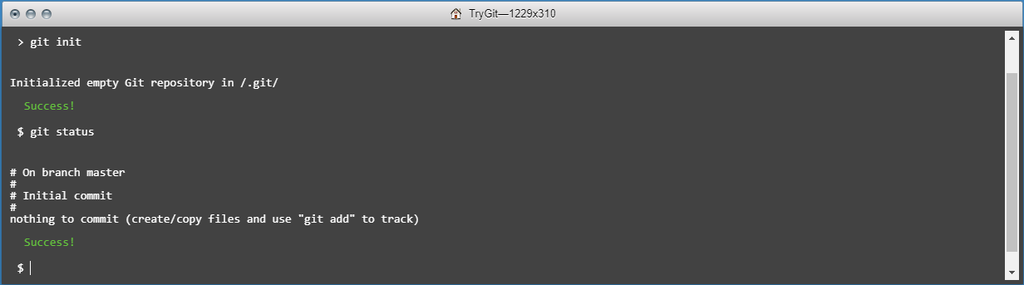

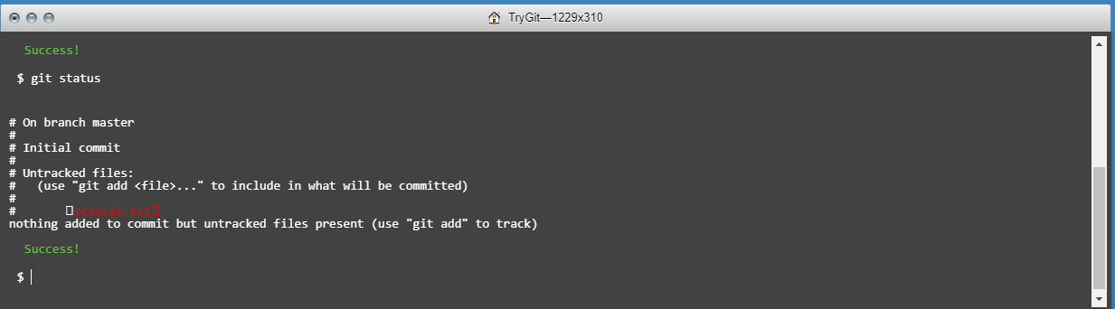

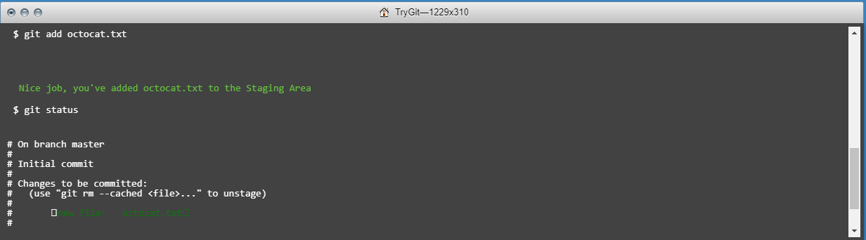

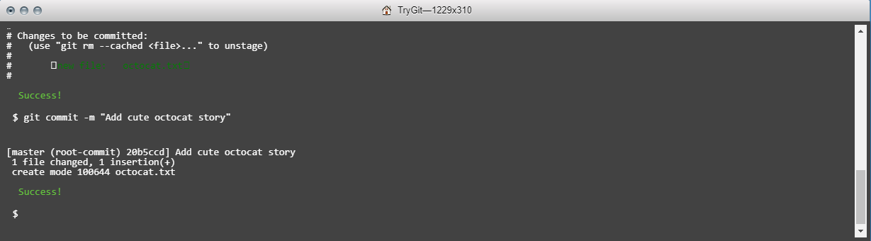

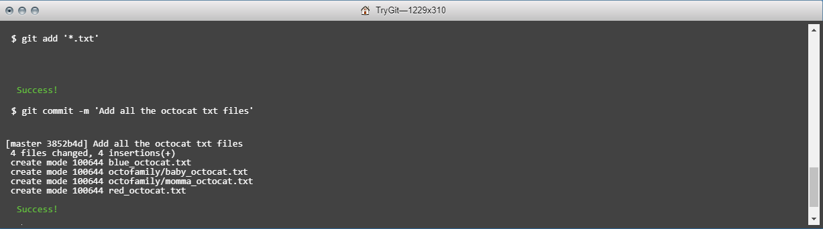

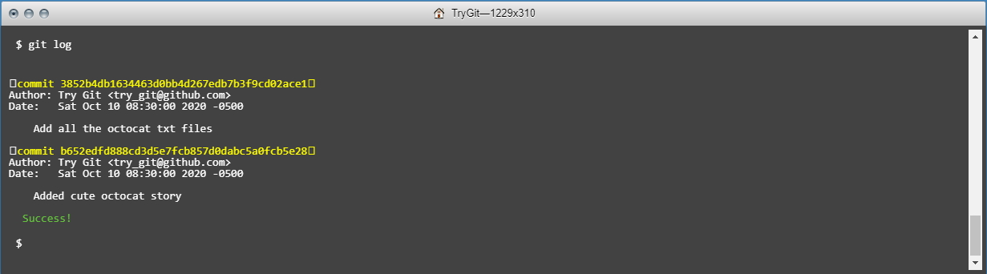

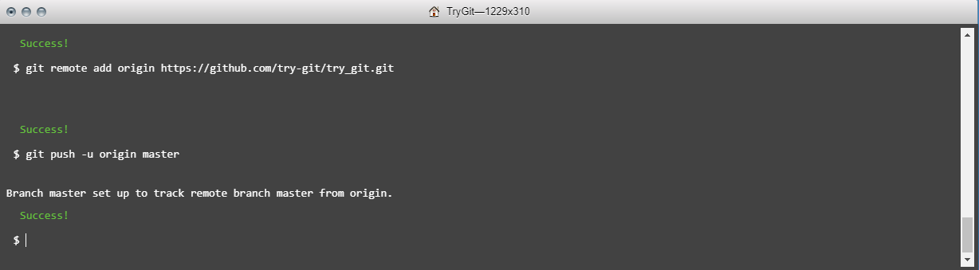

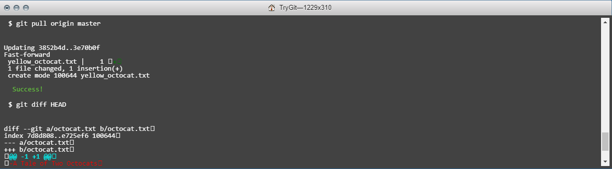

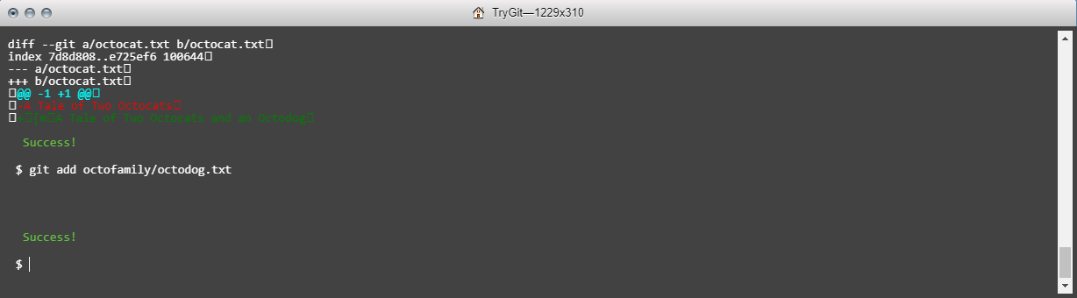

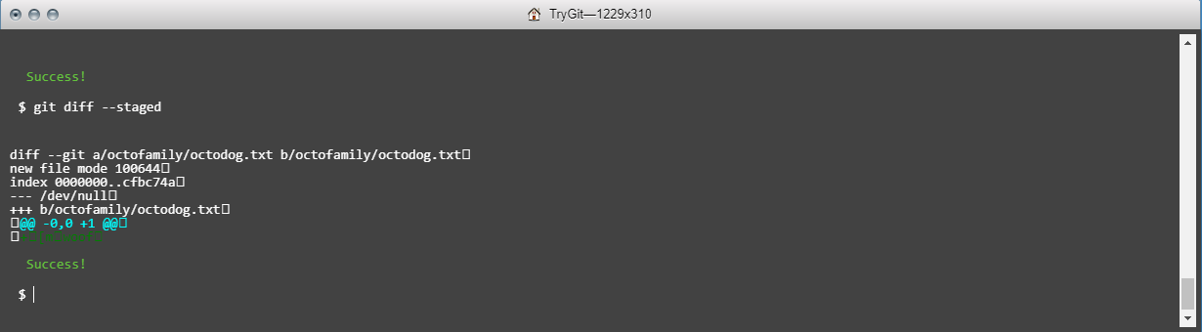

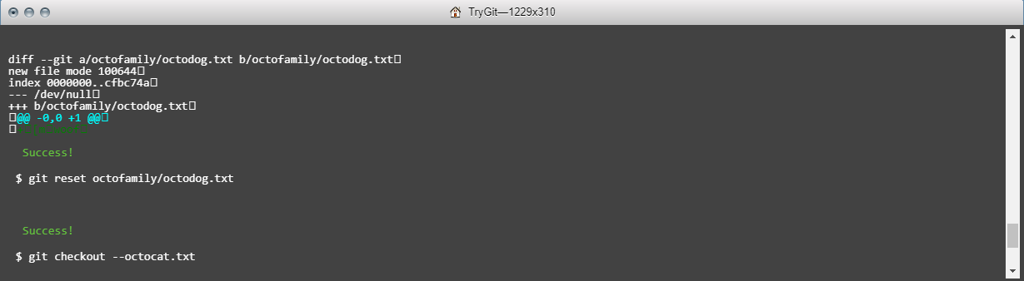

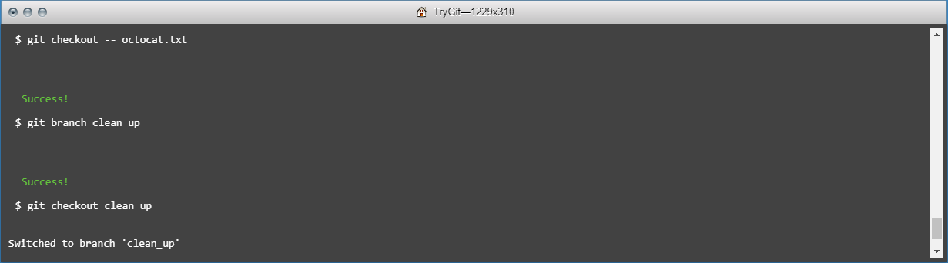

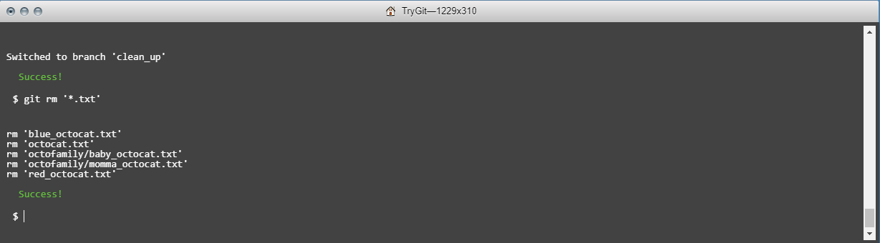

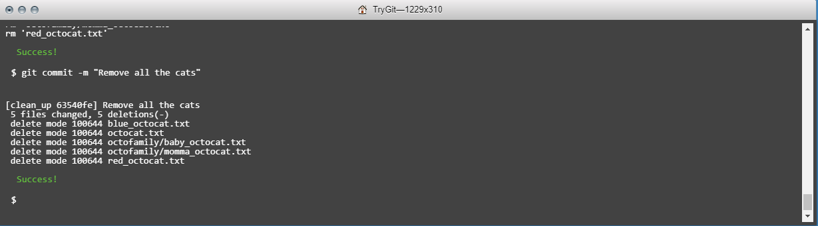

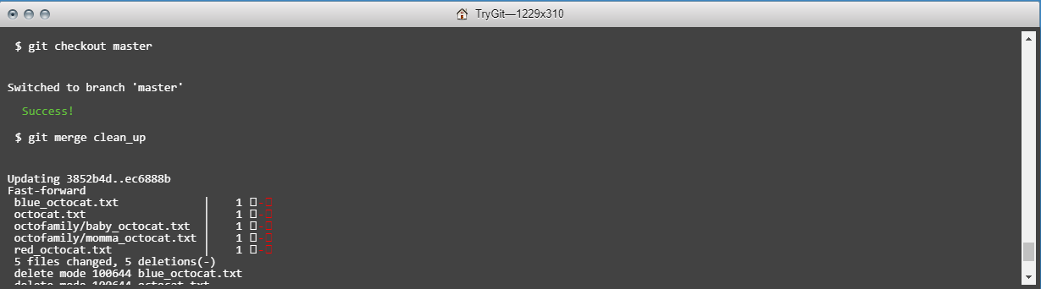

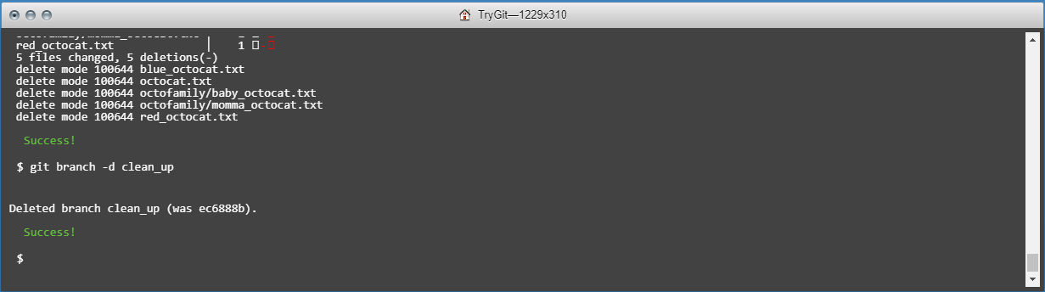

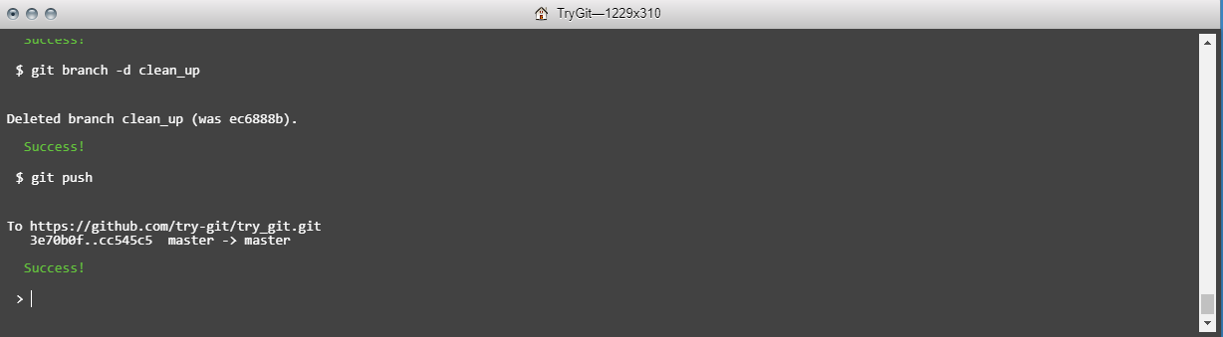

**Definitions**

* Repository

Repository is used to store project specific files which also include all the documents. It also stores the versioning information.

* Commit

Commit can be used to save the changes to the project file you are working on. Change can be on single or multiple files. Git creates a unique id for each commit along with which we can provide a commit message to every commit.

* Push

Push is used to move the changes to a remote repository. One can do the changes locally and then push the changes to remote repository followed by a commit message.

* Branch

It’s one of the features of versioning system in which a branch is basically made so that one can make changes on local branch and then it can be merged to master branch. Changes to this branch does not affect master repository.

* Fork

Fork is used to make a copy of another user’s repository. Changes made to this copy of repository dies not affect main user’s repository.

* Merge

Merge is used to merge changes made from several local branches to master branch, Or from one branch to another branch. Any merge conflicts can be resolved later.

* Clone

Clone is used to make a copy of a repository on local machine. One can edit the files locally and later push and merge the changes.

* Pull

It is used to pull the changes made by other users and merge them to a local repository. For example, if any user has made some change and committed to an online repository then the Pull will fetch the changes and will merge to the local repository.

* Pull request

It is used to propose the changes to a repository which can be either accepted or reject by users.

**Steps used to create pull request**

Step 1) git init

Step 2) git pull https://github.com/paceuniversity/courses.git

Step 3) Made changes to the Readme file.

Step 4) git commit –m “September 12 07:45 PM”

Step 5) git request-pull v1.0 https://github.com/paceuniversity/courses.git master