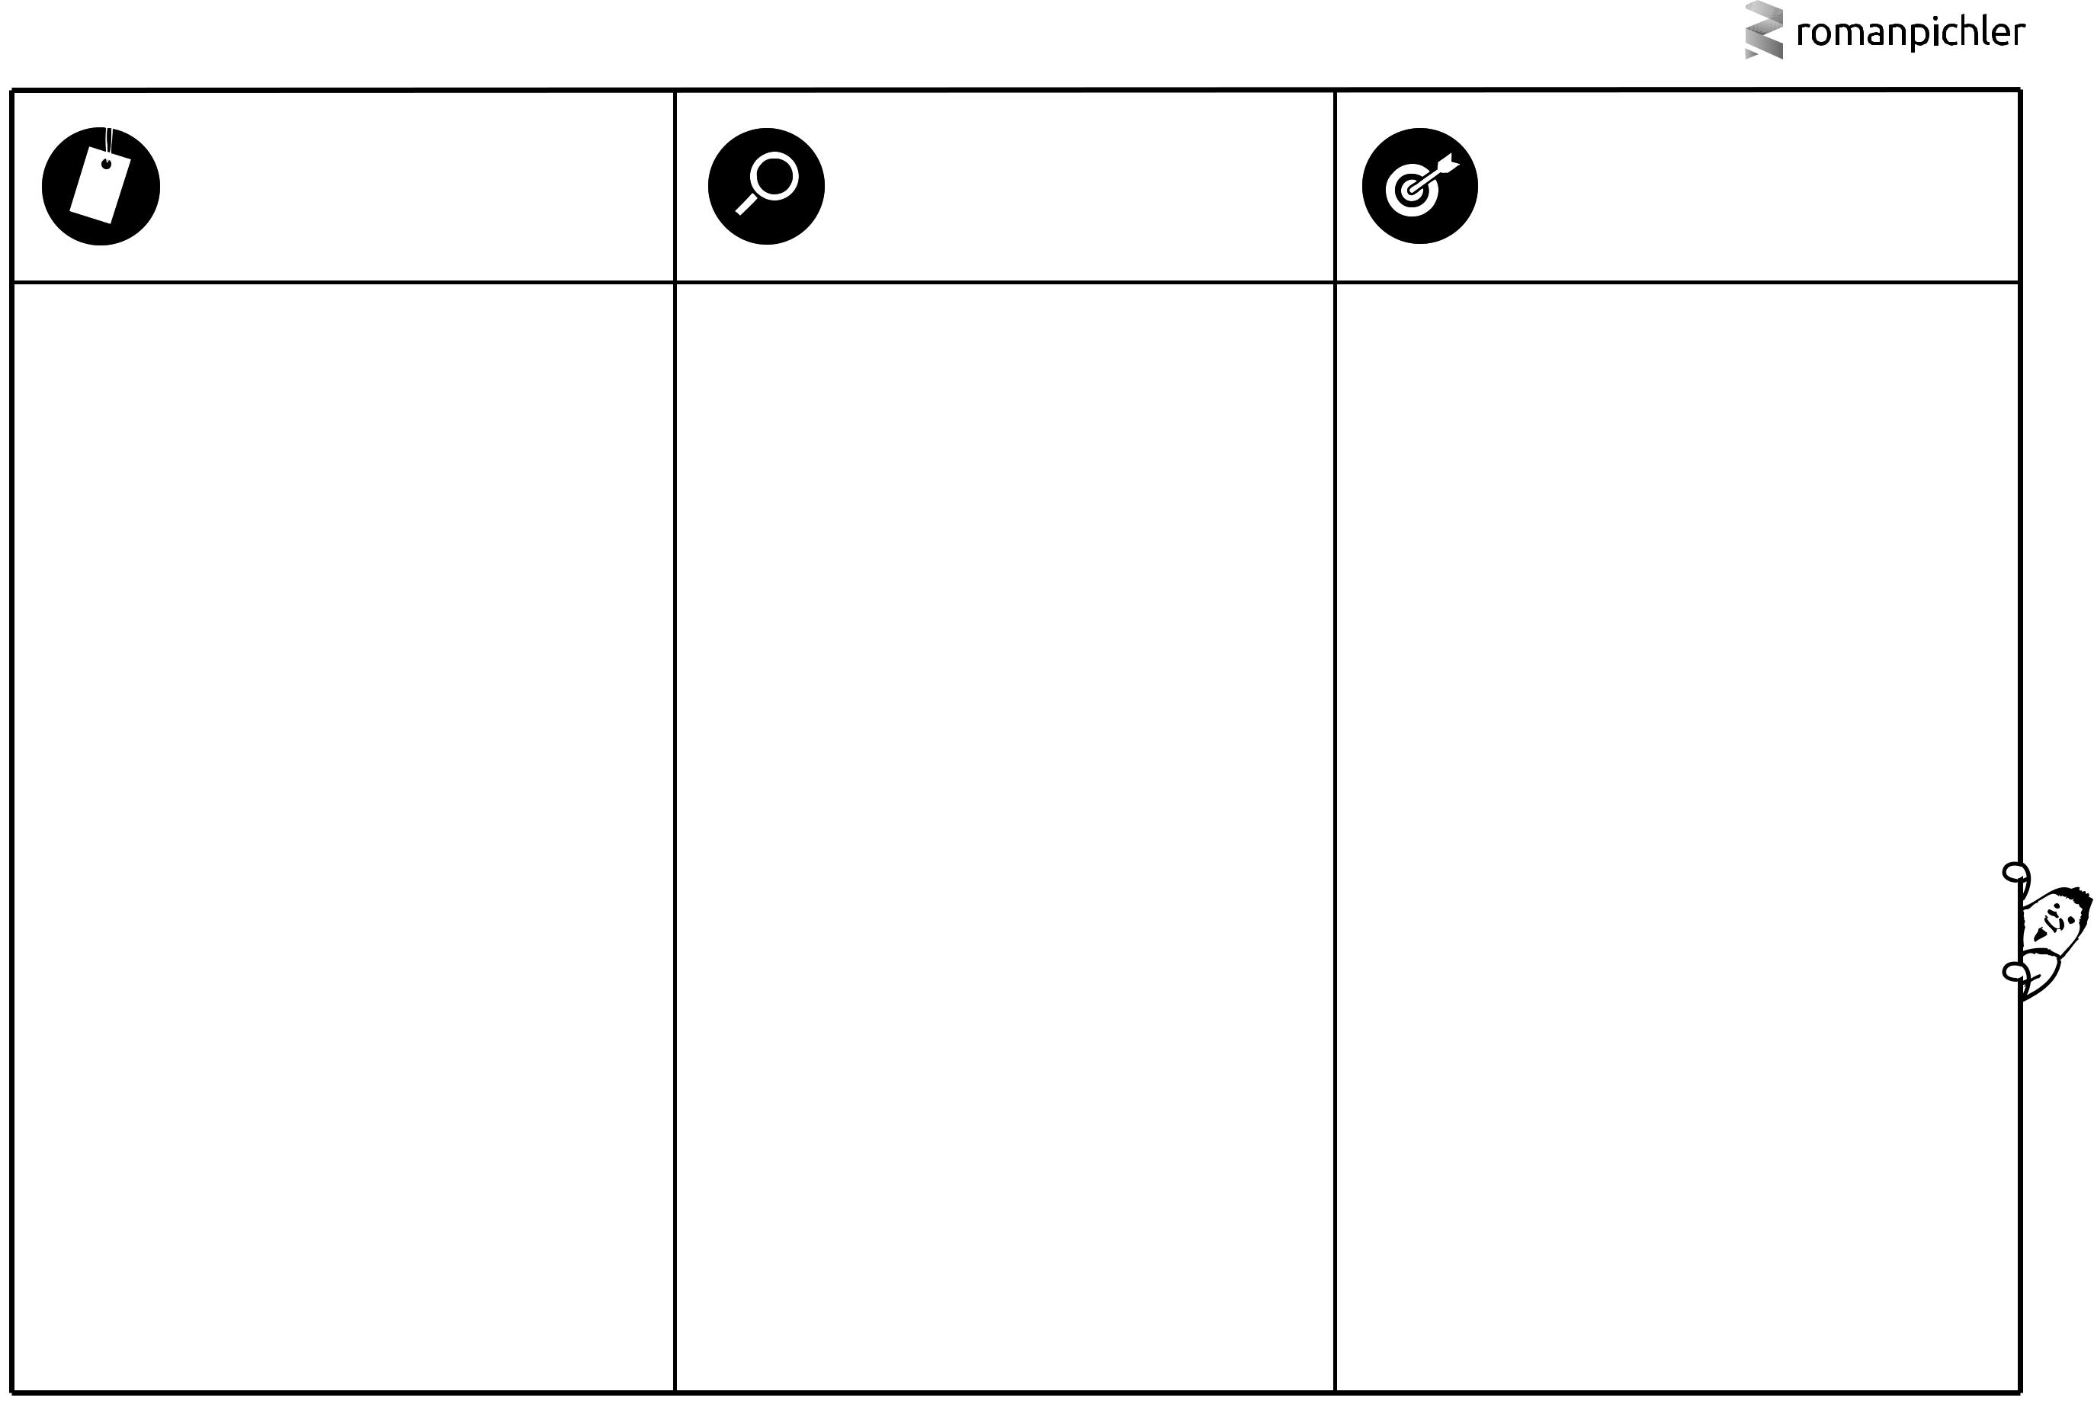
ROMAN’S PERSONA TEMPLATE

PICTURE & NAME | DETAILS | GOAL

What does the persona look like? What is its name? Choose a |  | What are the persona’s relevant characteristics and behaviours? |  | What problem does the persona want to solve or which benefit
realistic and believable picture and name. |  | For instance, demographics, such as age, gender, occupation, |  | does the character seek? Why would the persona want to use or
 |  |  | and income; psychographics, including lifestyle, social class, and |  | buy the product?
 |  |  | personality; and behavioural attributes like usage patterns,
 |  |  | attitudes, and brand loyalty. Only list relevant details.

Jeff is 28 years old. He works in a rural area

Jeff just started a new job. He walks to work everyday

He needs to make sure he is not late to work
Jeff doesn’t have good internet connectivity to stay updated about the weather conditions

Jeff would want to use a Weather service which will work without internet connectivity, so that he leaves early to work and also carries an umbrella with him

With just a SMS away the weather service app can inform him about the weather condition through a voice call

Jeff - working in a rural city

This work is licensed under a Creative Commons


Attribution-ShareAlike 3.0 Unported License

