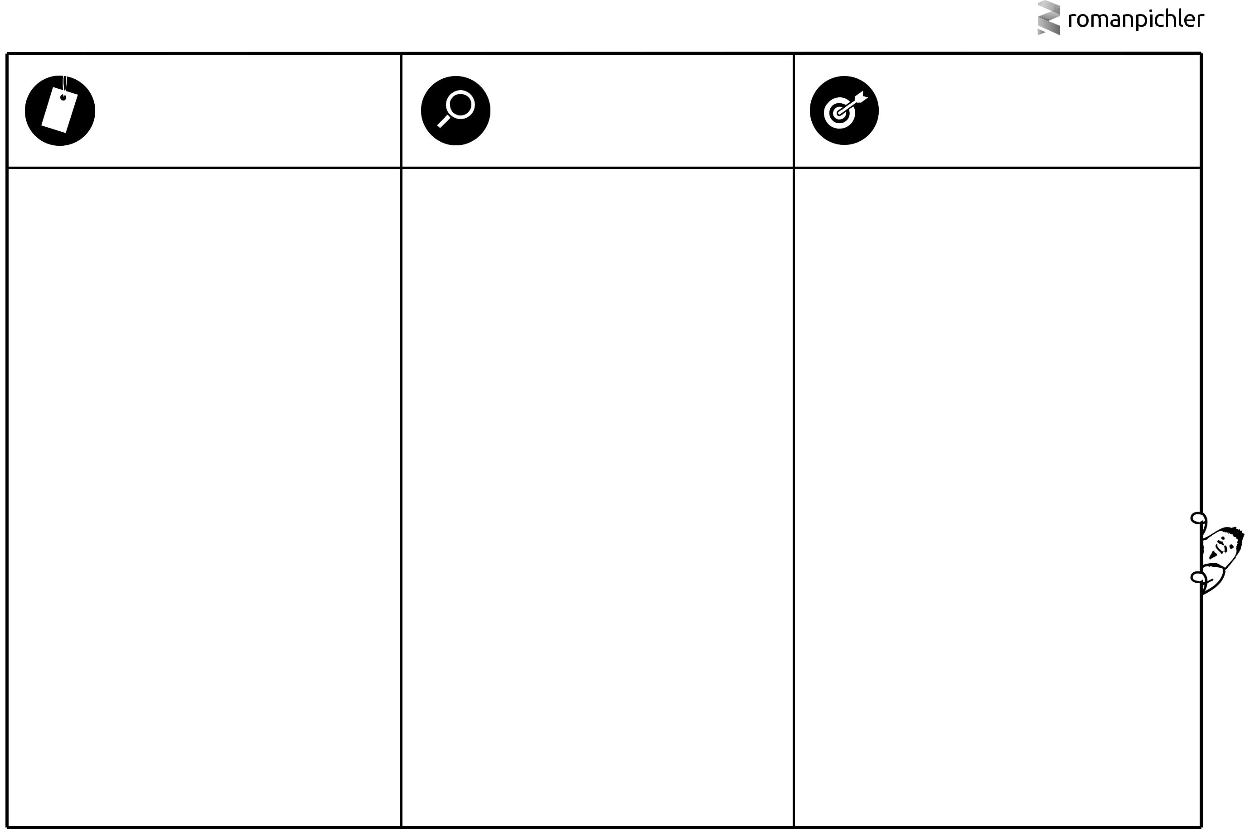
ROMAN’S PERSONA TEMPLATE

PICTURE & NAME | DETAILS | GOAL

What does the persona look like? What is its name? Choose a realistic and believable picture and name. | What are the persona’s relevant characteristics and behaviours? | What problem does the persona want to solve or which benefit
 | For instance, demographics, such as age, gender, occupation, | does the character seek? Why would the persona want to use or
 | and income; psychographics, including lifestyle, social class, and | buy the product?
 | personality; and behavioural attributes like usage patterns,
 | attitudes, and brand loyalty. Only list relevant details.

He does not have any resources to make informed farming decisions based on weather conditions

He does not have internet connectivity to stay updated about weather conditions

With just a SMS away the weather service app can inform him about the weather condition through a voice call
Bob is a farmer whose livelihood depends on his farm productivity

He is 55 years old. He needs to make sure the crops are planted and harvested at the right time to get maximum productivity

He can’t afford to get his crops affected due to weather conditions so he needs to plan the farming schedule in advance

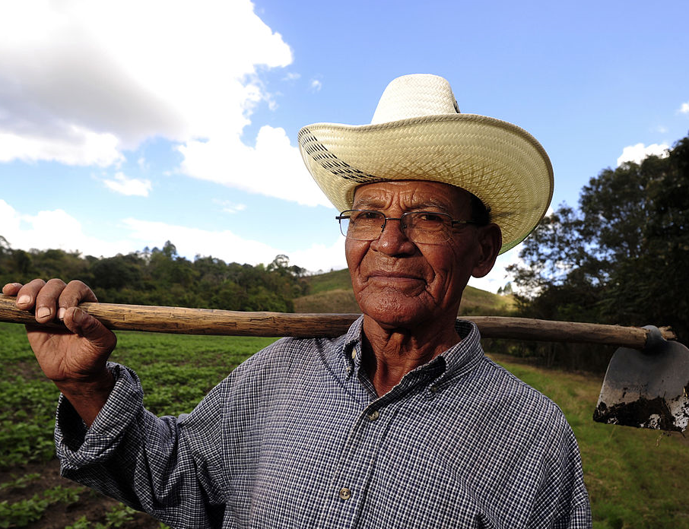

Bob- Farmer

