QR Code Generator

Shreya Rai
University of the Cumberlands
Course Number: MSCS-630-A01
Dr Vouama
05/31/2026

QR Code Generator

This project is a QR Code Generator built using Python. It takes a URL as input and generates a QR code image using the qrcode library. The generated QR code is saved as a PNG file and can be scanned using any mobile QR scanner.
Screenshot of the terminal
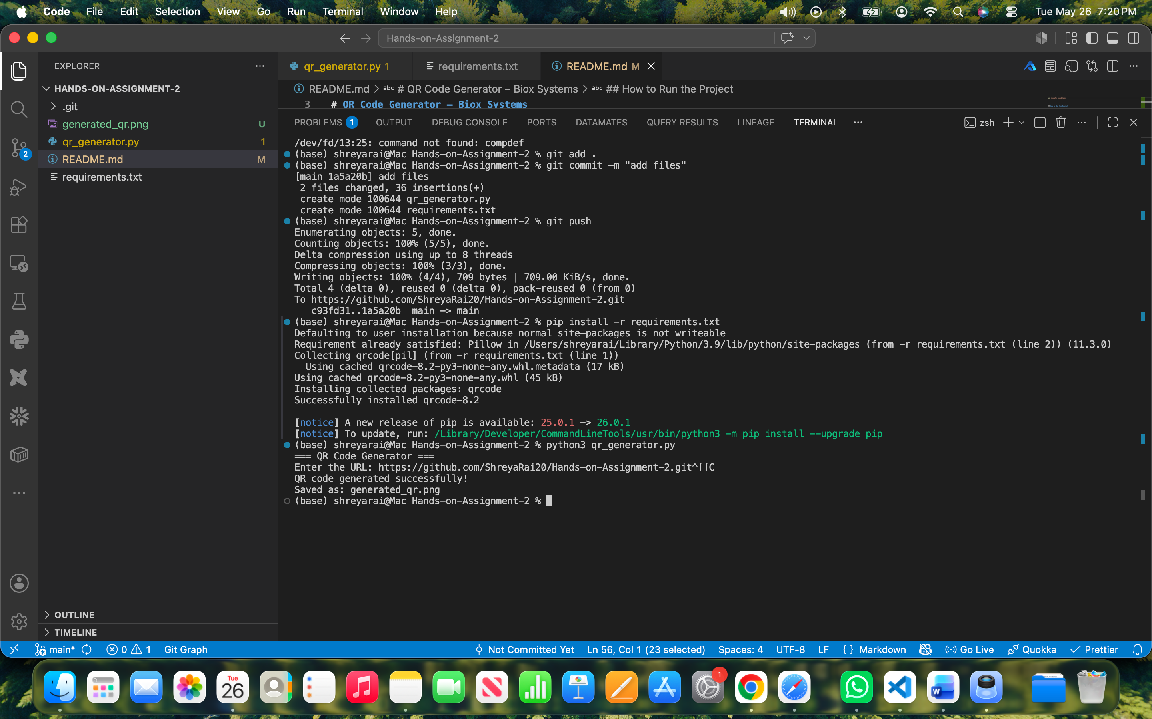

QR code


GitHub Repository:
https://github.com/ShreyaRai20/Hands-on-Assignment-2

