ASSIGNMENT 1
Problem Statement :
Write a c program to check whether the year is a leap year or not.
Code :
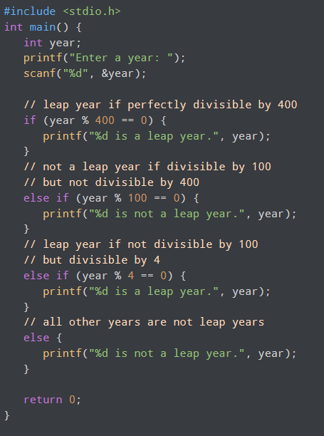

Output :
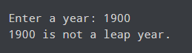

ASSIGNMENT 2
Problem Statement :
Write a menu driven program in C to implement the base arithmetic operations such as Addition, Substraction, Multiplication and Division
Code :
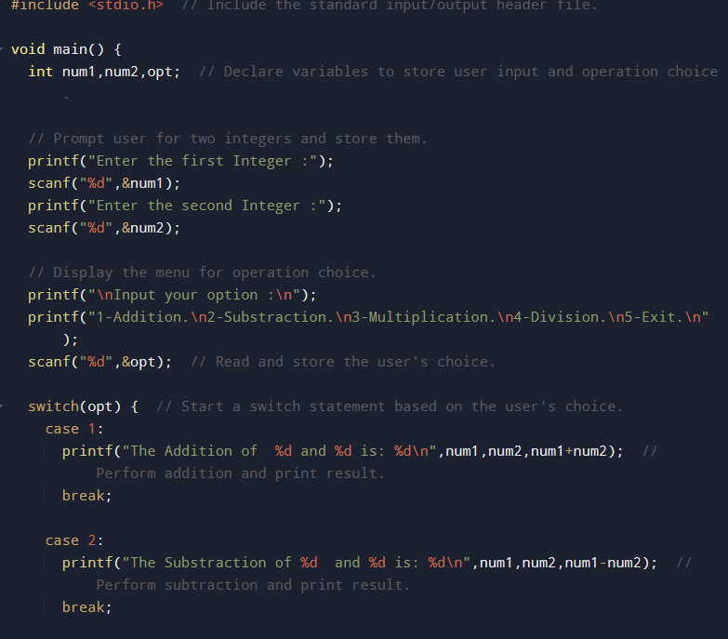
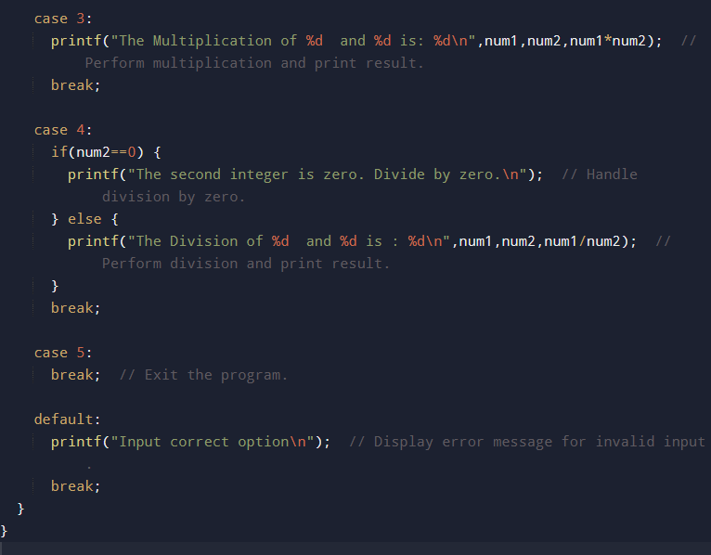
Output :
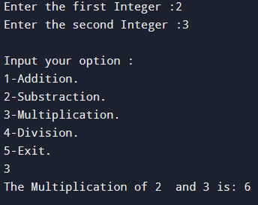

ASSIGNMENT 3
Problem Statement :
Write a program in C to generate multiplication tables for a given number.
Code :
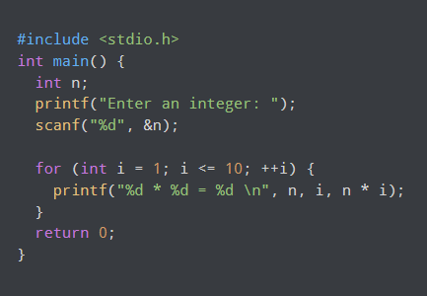
Output :
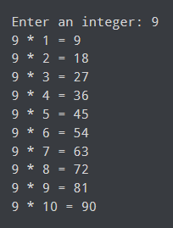
ASSIGNMENT 4
Problem Statement :
Write a C program to calculate the salary of an employee given his basic pay. Calculate gross salary of employee. Let HRA be 10% of basic pay and TA be 5% of basic pay. Let employees pay professional tax as 2% of total salary. Calculate net salary payable after deduction.
Code :
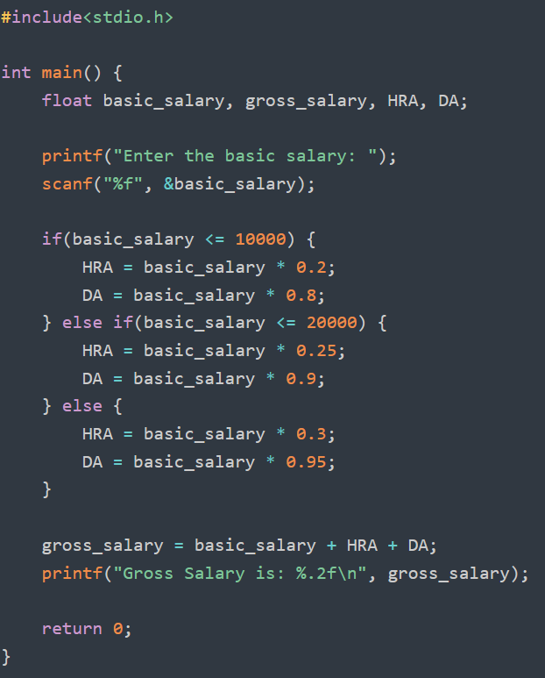
Output :
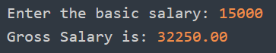

ASSIGNMENT 5
Problem Statement :
Write a program in C to perform basic matrix operations such as:
1. Addition of two matrices
2. Saddle point of a matrix
3. Inverse of a matrix
4. Magic square of a matrix
Code :
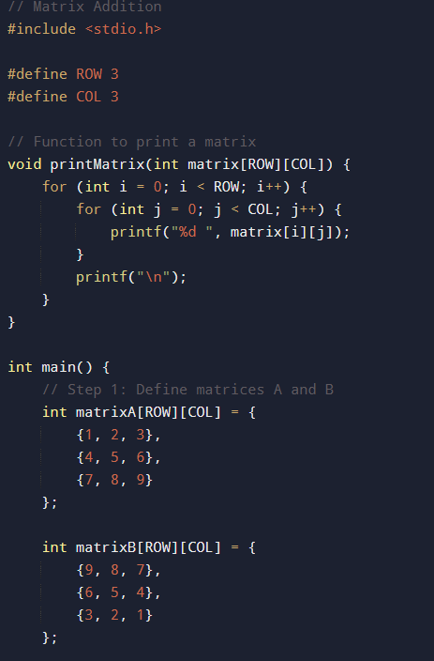
Output :
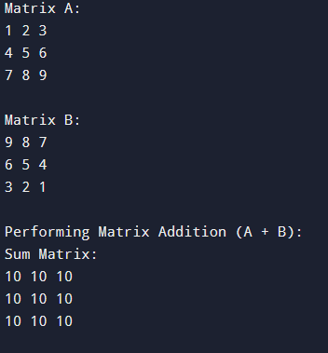

ASSIGNMENT 6
Problem Statement :
Write a C function to compute the factorial of a number with and without recursion.
Code :
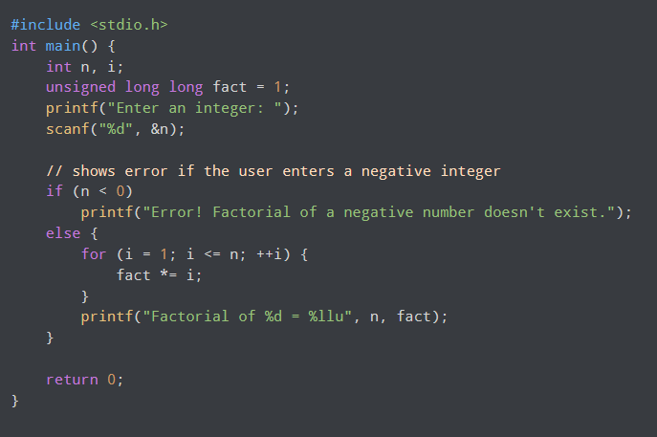
Output :
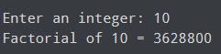

ASSIGNMENT 7
Problem Statement :
Write a C program to accept student details and display their result using an array of structures
Code :
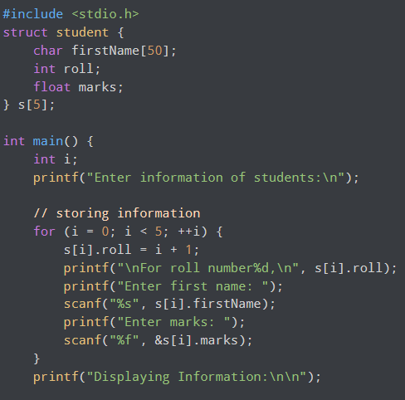
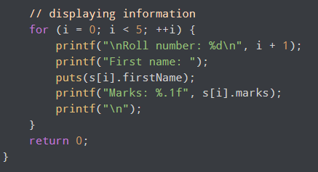
Output :
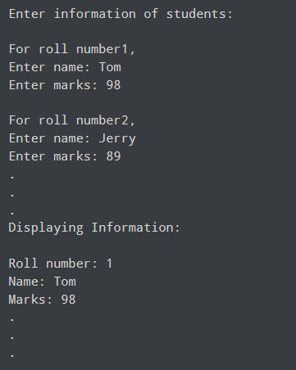

ASSIGNMENT 8
Problem Statement :
Write a program in C to accept marks of 5 courses of a student and compute the result. A student is considered PASS if he/she scores 40 marks or above in each course. If the student passes, calculate the aggregate percentage and assign the grades as follows :
1) >= 75% - Distinction
2) >= 60% - First division
3) >= 50% - Second division
4) >= 40% - Third division
Code :
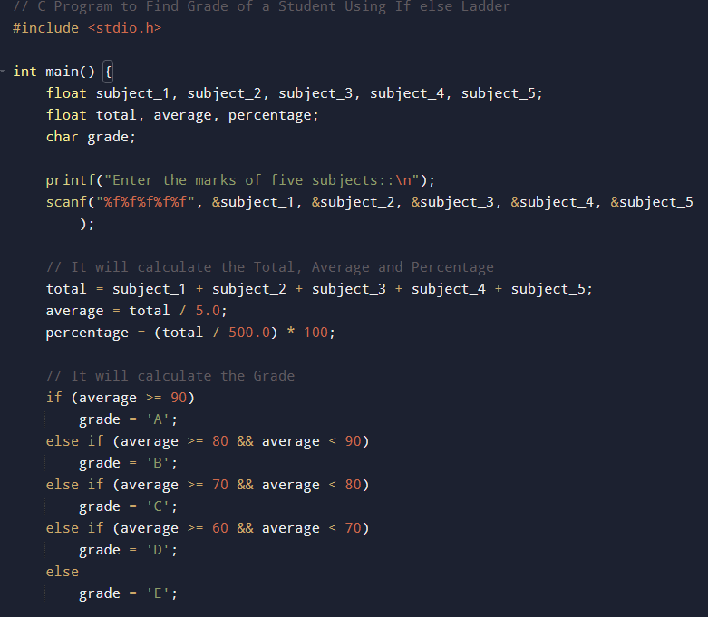

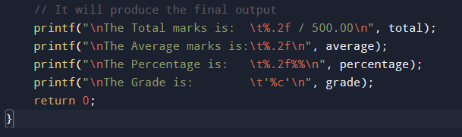
Output :
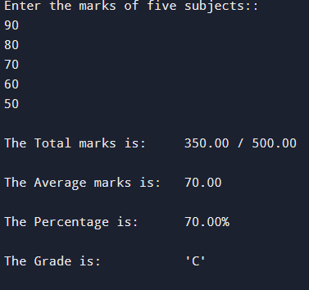

ASSIGNMENT 9
Problem Statement :
Write a program in C to check whether the given number is an Armstrong number or not. An Armstrong number is an integer with 3 digits such that the sum of the cubes of its digits is equal to the number itself.
Code :
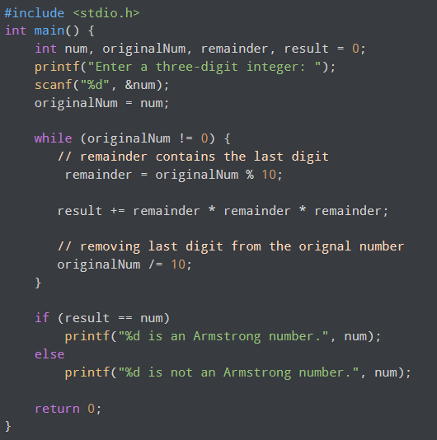

Output :
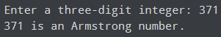

ASSIGNMENT 10
Problem Statement :
Write a program in C to simulate a simple calculator that performs basic arithmetic operations such as Addition, Substraction, Multiplication and Division. The calculator should also perform special operations like computing x^y (power) and x! (factorial).
Code :
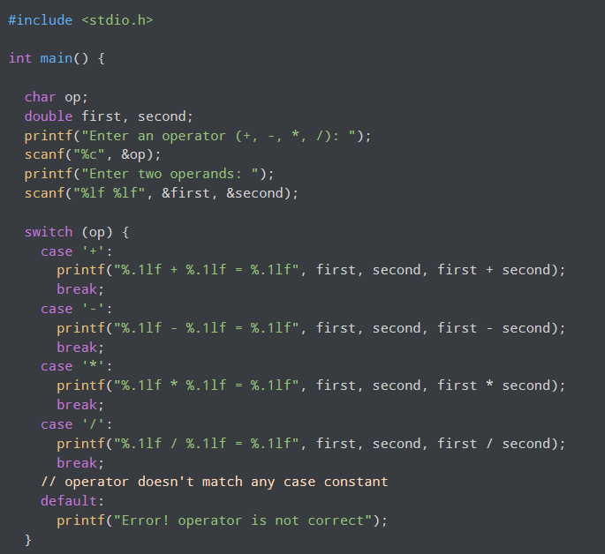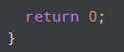
Output :
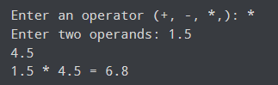

ASSIGNMENT 11
Problem Statement :
Write a program in C to accept a number from the user and compute the following :
1) Square root of the number
2) Square of the number
3) Cube of the number
4) Check whether it's a prime number
5) Factorial of the number
6) Prime factors of the number
Code :
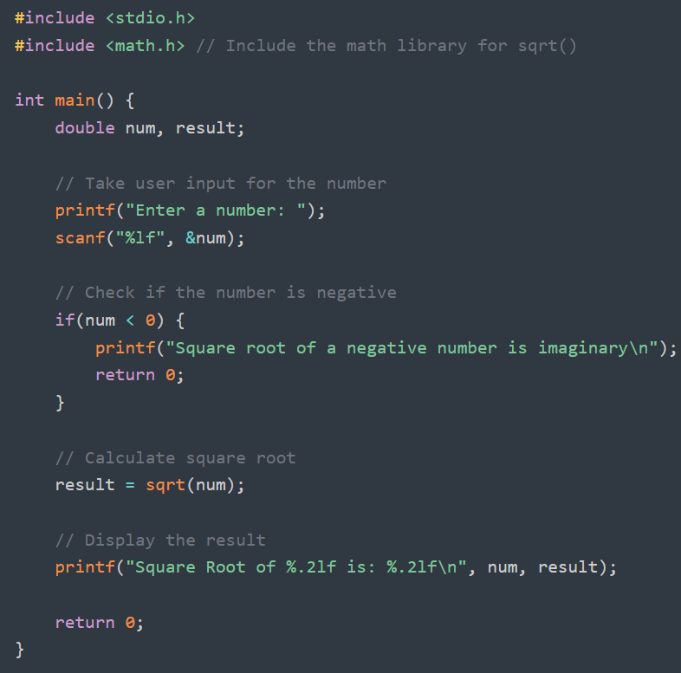
Output :
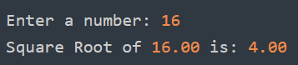

ASSIGNMENT 12
Problem Statement :
Write a program in C to accept 2 number from the user compute :
1) The smallest common divisor of the two numbers (other than 1, if any)
2) The GCD of the two numbers
Code :
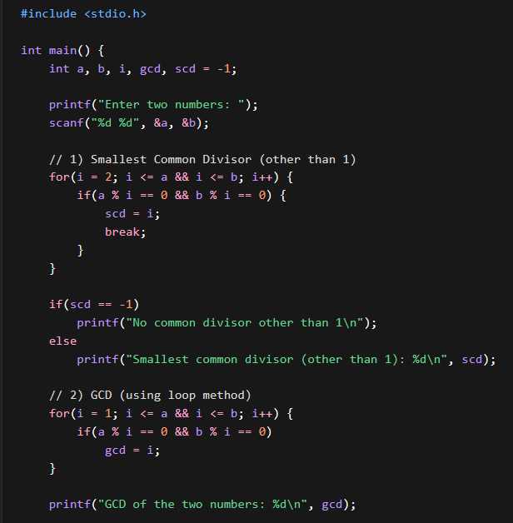
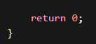
Output :
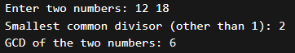

ASSIGNMENT 13
Problem Statement :
Write a program in C to accept a number from the user and print the digit of the number in reverse order.
Code :
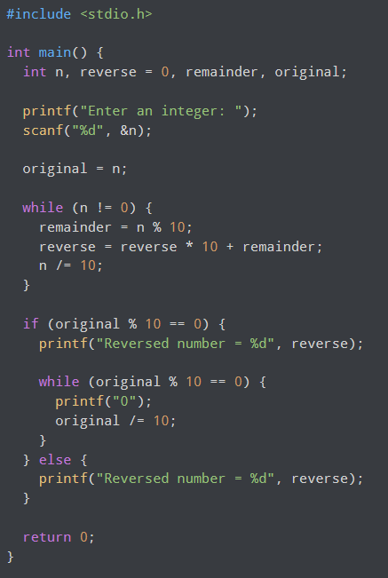
Output :
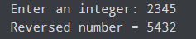

ASSIGNMENT 14
Problem Statement :
Write a program in C to input a binary number from the user and convert it into a decimal number.
Code :
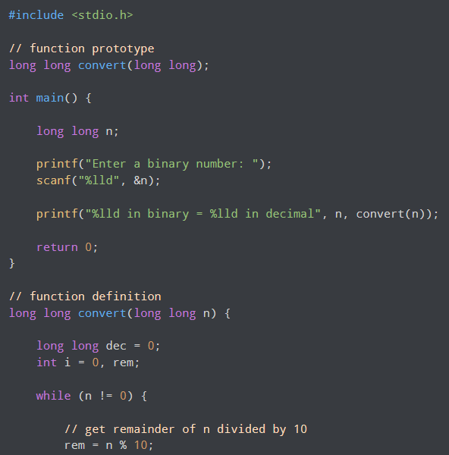

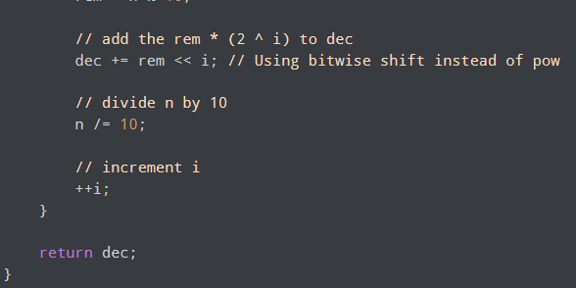
Output :
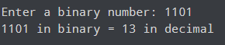

ASSIGNMENT 15
Problem Statement :
Write a program in C to generate pseudo random number.
Code :
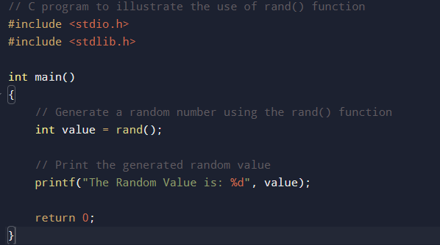
Output :


ASSIGNMENT 16
Problem Statement :
To accept a list of N integers and partition the list into two sublists containing even and odd numbers.
Code :
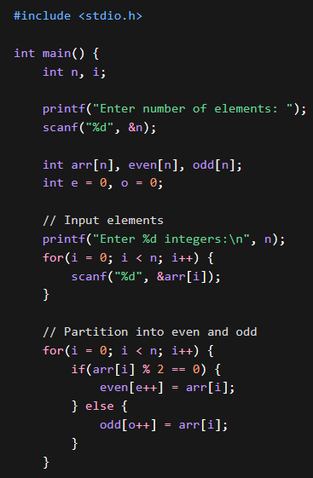

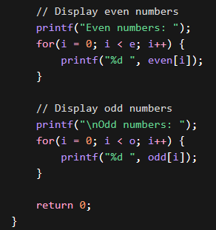
Output :
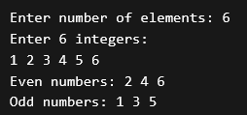

ASSIGNMENT 17
Problem Statement :
To accept the number of terms and find the sum of the sine series.
Code :
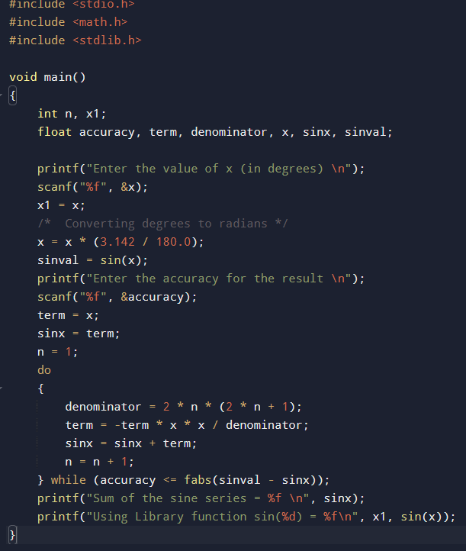
Output :
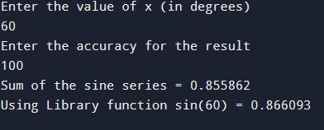

ASSIGNMENT 18
Problem Statement :
Write a C program that accepts a string from the user and performs the following string operations :
1) Calculate length of string
2) String reversal
3) Equality check of 2 strings
4) Check palindrome
5) Check substring
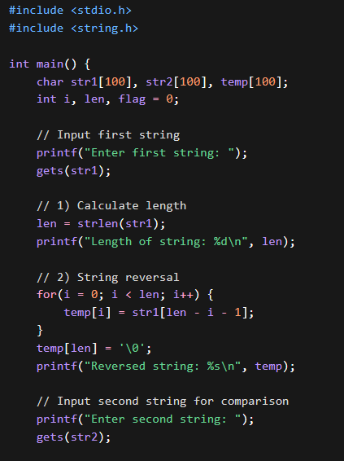
Code :
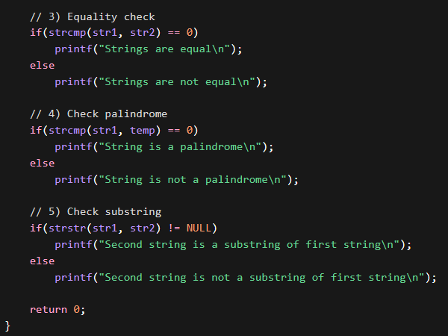
Output :
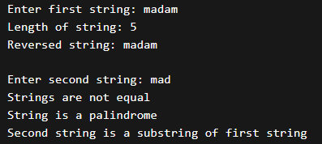

ASSIGNMENT 19
Problem Statement :
Create structure employee for string details (name, designation, gender, date of joining and salary). Define function members to compute :
1) Total number of employees in an organisation
2) Count of male and female employees
3) Employees with salary more than 10000
4) Employees with designation "Asst Manager"
Code :
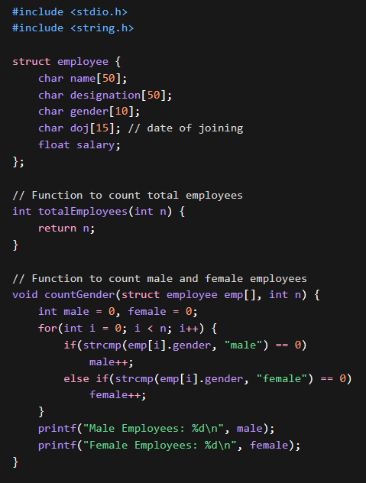
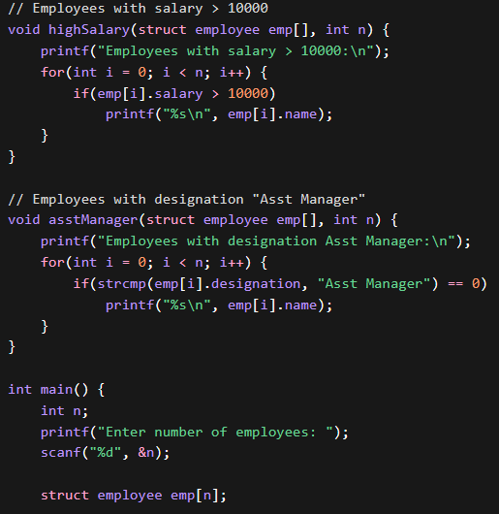
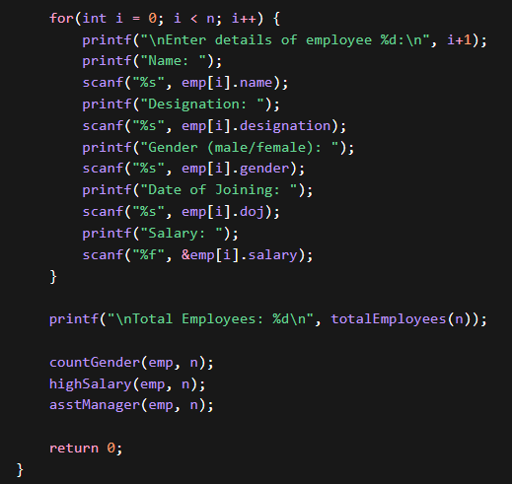

Output :
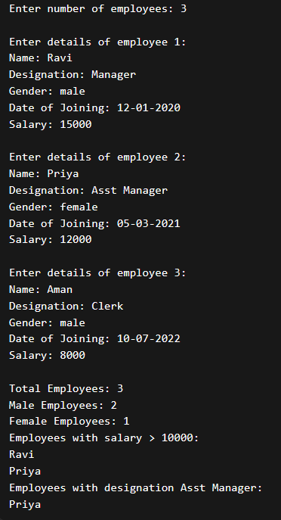

ASSIGNMENT 20
Problem Statement :
Write a C program to swap two numbers with and without using pointers.
Code :
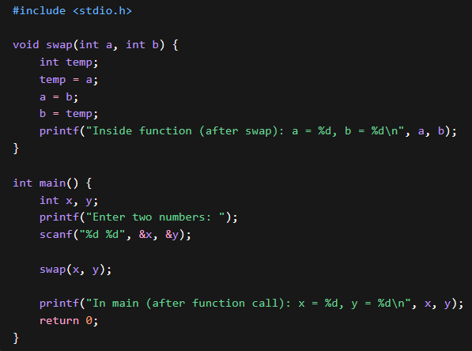
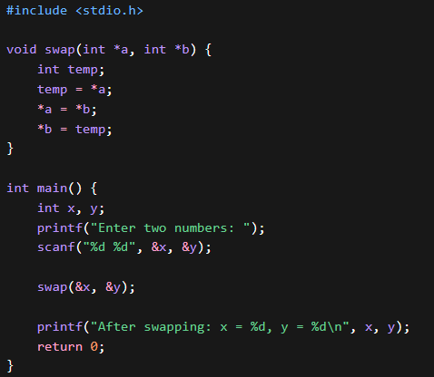
Output :
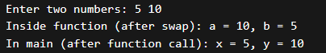
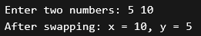

ASSIGNMENT 21
Problem Statement :
Write a c program to copy contents of one file to another using File handling.
Code :
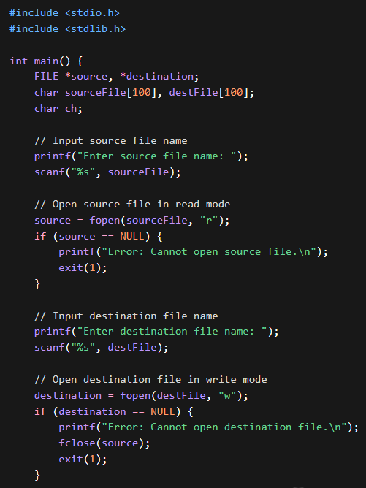
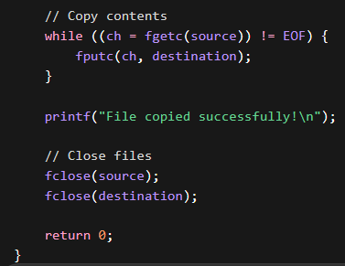
Output :
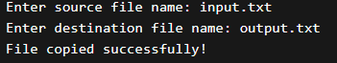

ASSIGNMENT 22
Problem Statement :
Write a menu driven program in C to perform various string operations using in-built function.
Code :
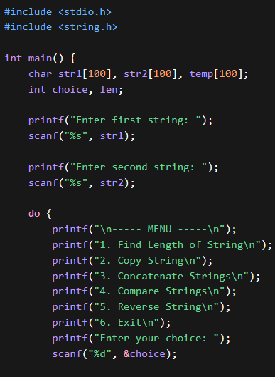

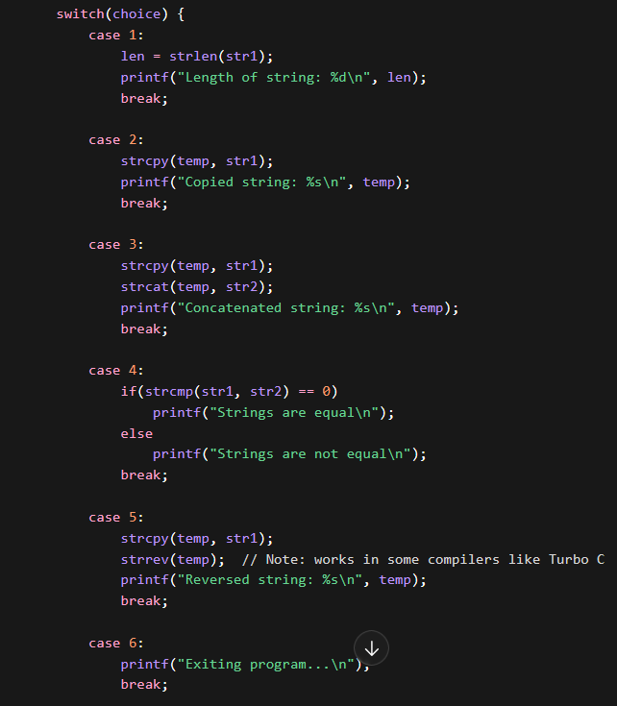
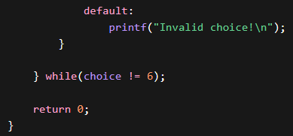
Output :
