**BLINKIT ANALYSIS**

* Import the data and see all the data items;

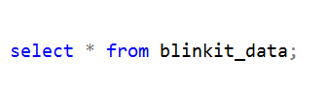

* Cleaning the Item_Fat_Content column helps ensure that the data is consistent and reliable for analysis. Variations like "LF", "low fat", and "Low Fat" may refer to the same category but appear as different values in the dataset. This inconsistency can lead to incorrect results when performing tasks like filtering, grouping, or visualizing the data. By standardizing these values into a uniform format, we reduce errors, simplify reporting, and make the dataset easier to work with for generating meaningful insights.

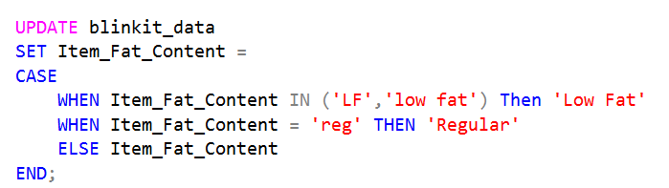

After executing this query check the data has been cleaned or not using below query



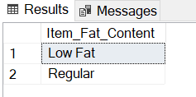

1. **KPI’S**
2. **TOTAL SALES:**

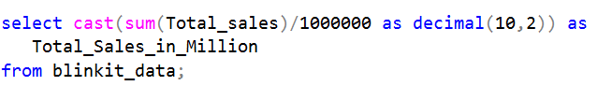

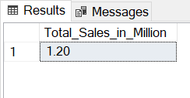

1. **AVERAGE SALES**

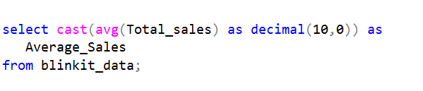

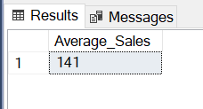

1. **NUMBER OF ITEMS**

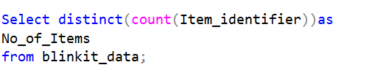

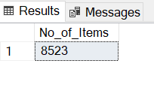

1. **AVERAGE RATING**

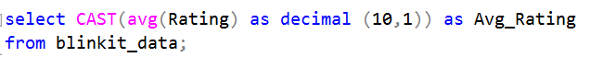

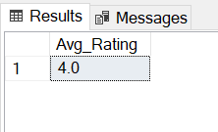

1. **Total Sales by Fat Content:**

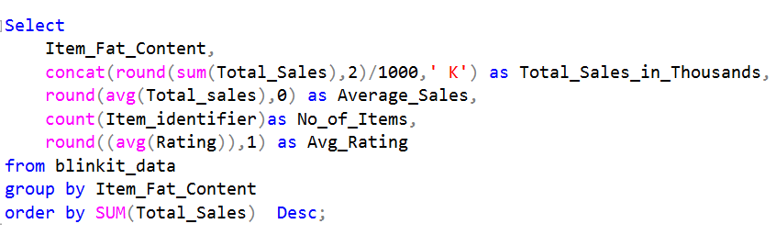

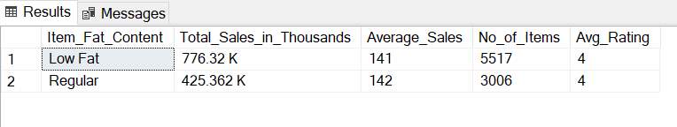

1. **Total Sales by Item Type:**

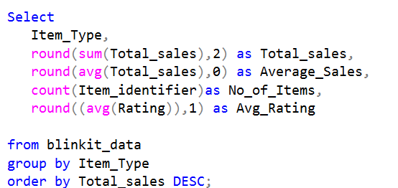

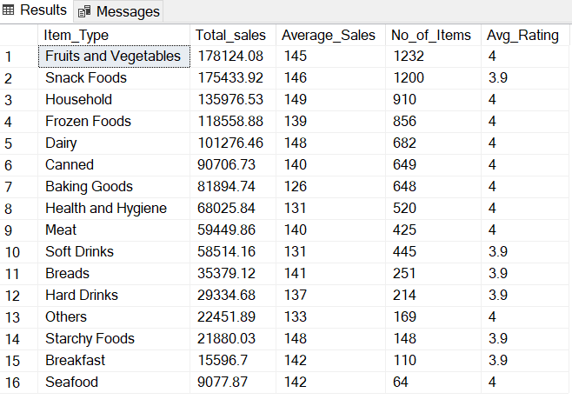

1. **Fat Content by Outlet for Total Sales**

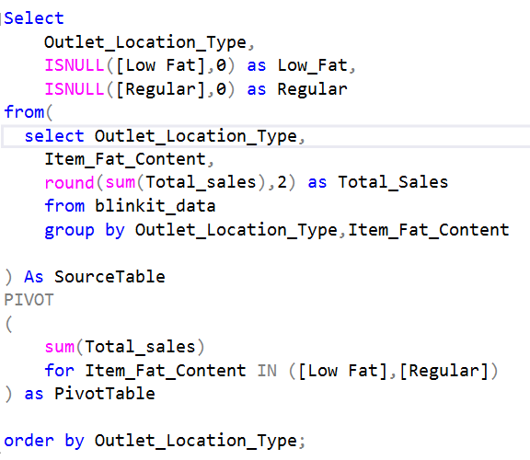

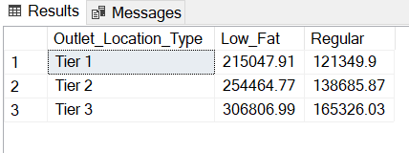

1. **Total Sales by Outlet Establishment**

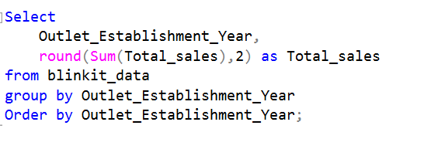

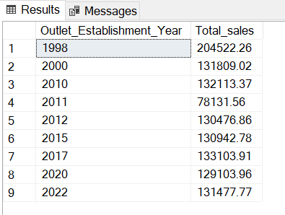

1. **Percentage of Sales by Outlet Size**

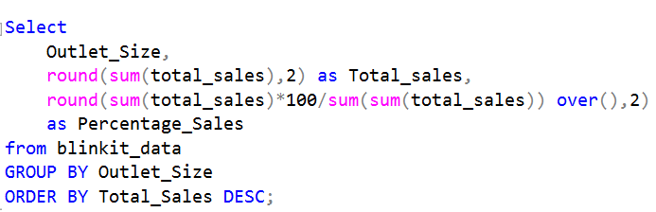

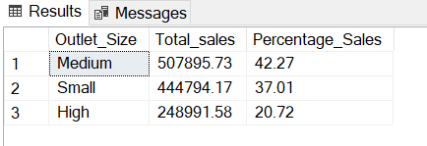

1. **Sales by Outlet Location**

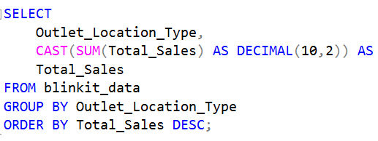

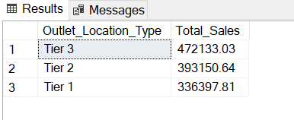

1. **All Metrics by Outlet Type:**

