**Insights – Business Analysis Report**

**Project Title:**

**PhonePe Pulse Data Analysis & Business Intelligence**

**Objective:**

To extract actionable insights from PhonePe’s transactional and insurance-related data across states and districts in India, aimed at guiding strategic decisions for business growth, product improvement, and market expansion.

**Business Test Cases and Insights**

**Transaction Analysis Across States and Districts**

**Purpose**:  
To identify high and low-performing states and districts based on transaction volume and amount.

**Insight**:  
States like **Maharashtra**, **Karnataka**, and **Tamil Nadu** exhibit the highest transaction amounts, indicating mature digital payment adoption. On the district level, metros such as **Mumbai**, **Bengaluru Urban**, and **Chennai** dominate due to dense urban populations and high merchant penetration.

**Business Impact**:  
Helps in **allocating budgets for regional marketing**, improving merchant onboarding in lagging districts, and tailoring state-specific campaigns.

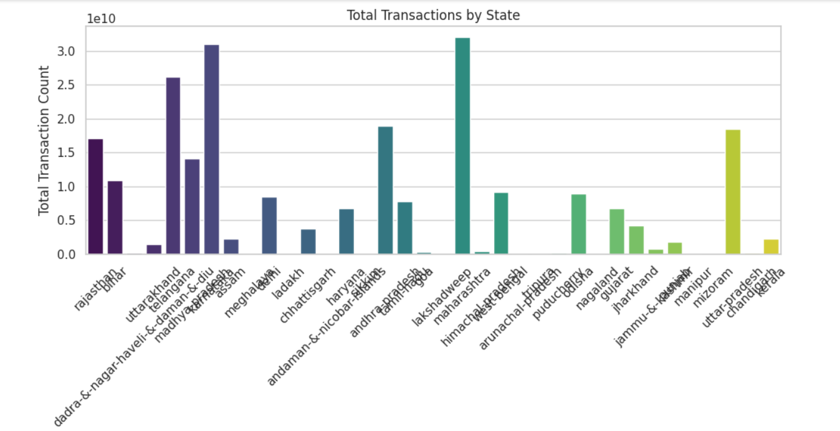

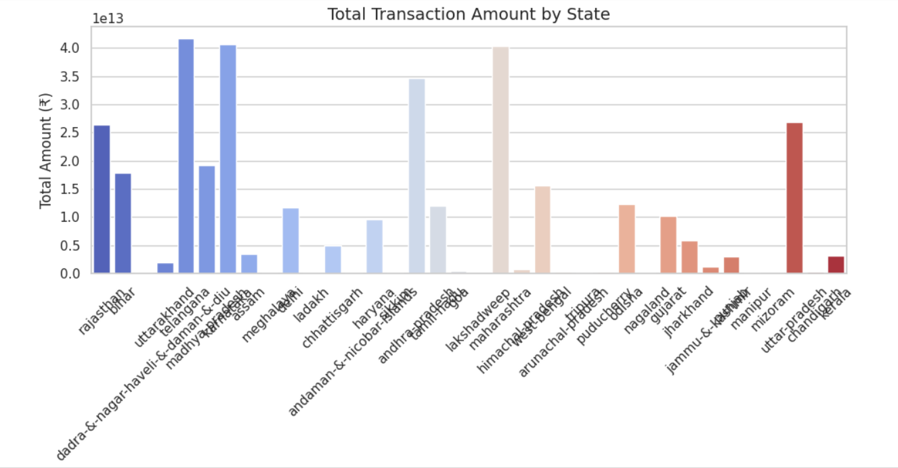

**Insurance Transactions Analysis**

**Purpose**:  
To evaluate the volume of insurance policies issued and claimed via PhonePe.

**Insight**:  
A significant growth trend in **insurance-related transactions** was observed in southern and western India. States like **Telangana** and **Kerala** show a high uptake in **microinsurance policies**, whereas metro districts show higher **claim amounts**, likely due to higher premium products.

**Business Impact**:  
Allows PhonePe to **expand insurance products** in tier-2 cities and offer more customized policies in metros. Can also guide tie-ups with regional insurance firms.

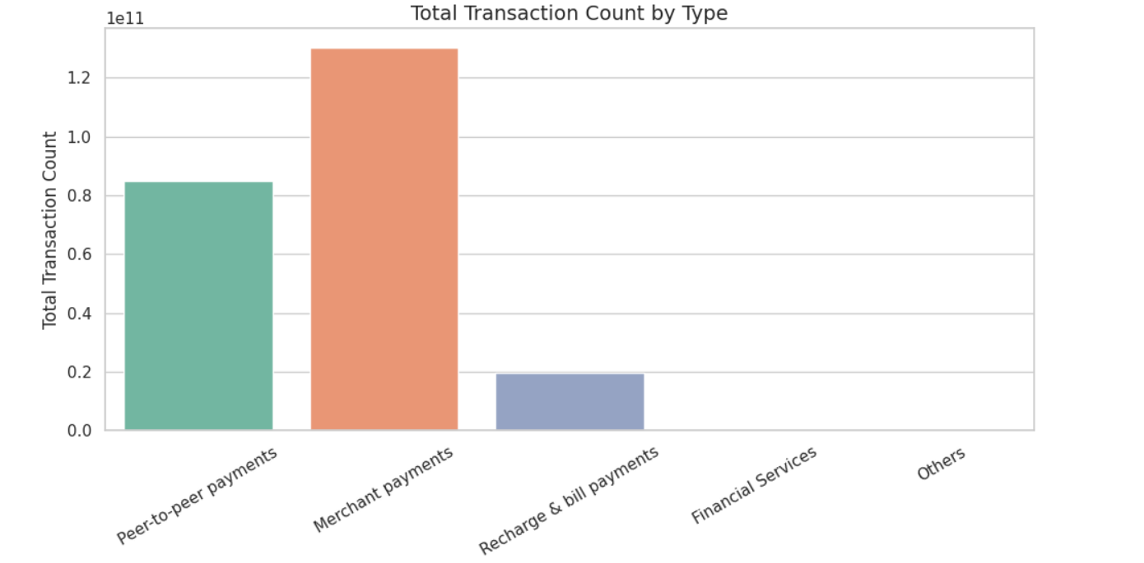

**Transaction Analysis for Market Expansion**

**Purpose**:  
To detect underperforming regions with potential for digital payment growth.

**Insight**:  
States in the **North-East** and certain rural districts in **Bihar** and **Uttar Pradesh** show low transaction counts but rising year-on-year growth. This signals **emerging digital adoption**.

**Business Impact**:  
These areas are strong candidates for **market expansion** through government collaboration, vernacular marketing, and UPI literacy programs.

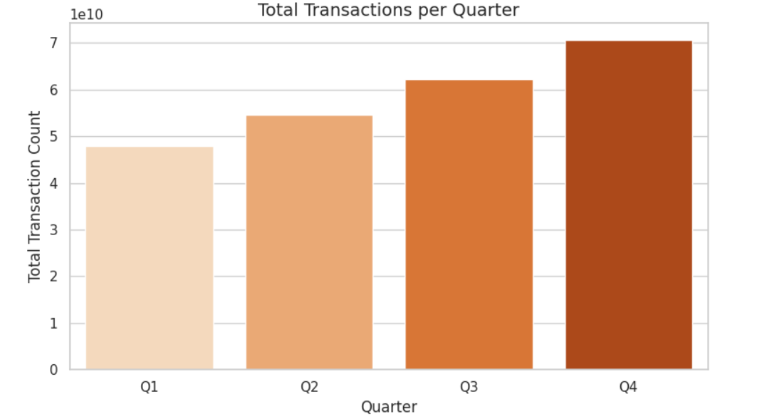

**Insurance Penetration and Growth Potential**

**Purpose**:  
To measure how well insurance products have penetrated across regions.

**Insight**:  
While states like **Maharashtra** and **Karnataka** lead in total policies, the **penetration rate per registered user** is higher in **Kerala** and **Goa**. This shows that some smaller states are more engaged with insurance products on a per capita basis.

**Business Impact**:  
PhonePe can replicate engagement strategies from these states in underperforming regions and increase cross-selling efforts where app activity is high but insurance uptake is low.

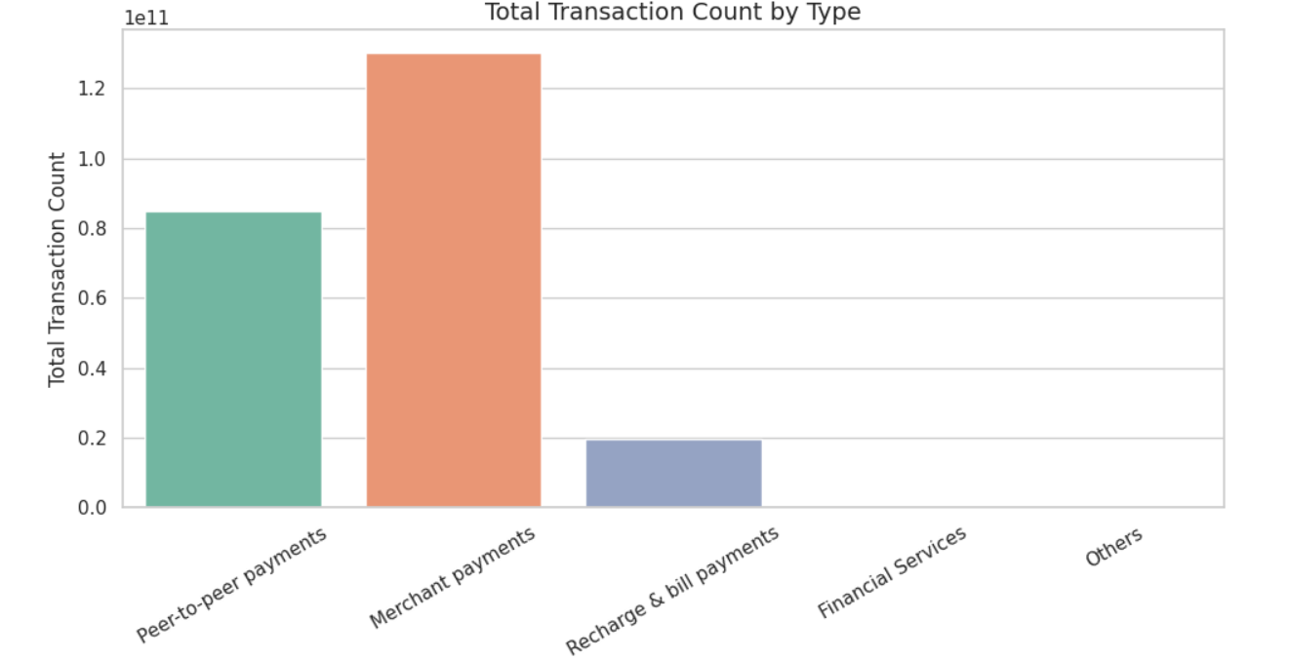

**Decoding Transaction Dynamics on PhonePe**

**Purpose**:  
To analyze usage patterns across various transaction types (P2P, merchant, recharge, bill payments).

**Insight**:  
Merchant and utility payments are growing steadily, especially in **urban and semi-urban belts**. P2P payments dominate in volume but not in value, while merchant payments dominate in total transaction value.

**Business Impact**:  
Helps refine UX around frequently used services and target high-value users for cashback offers, while improving merchant coverage in underserved areas.

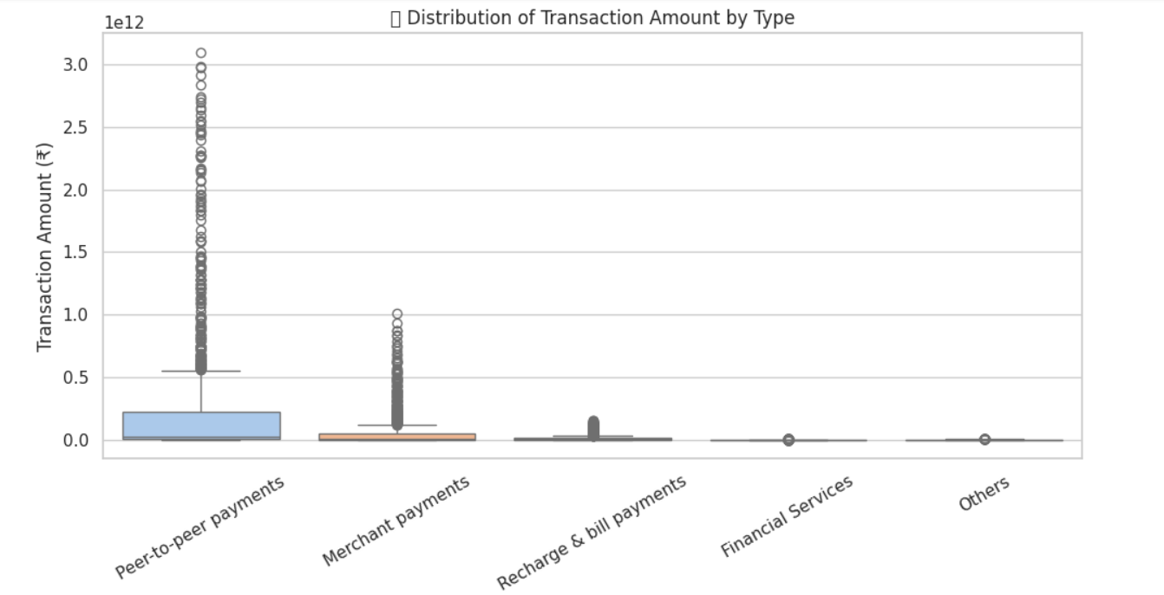

**Conclusion:**

The data-driven insights obtained from the PhonePe Pulse data provide a clear roadmap for business decisions across domains—marketing, product development, insurance distribution, and market expansion. Targeted strategies informed by state and district-level data can significantly improve user engagement, transaction value, and overall service penetration.

Project Title: PhonePe Pulse Data Analysis & Business Intelligence

Objective:

To extract actionable insights from PhonePe’s transactional and insurance-related data across states and districts in India, aimed at guiding strategic decisions for business growth, product improvement, and market expansion.

1. Transaction Analysis Across States and Districts

Insight: High transaction states include Maharashtra, Karnataka, Tamil Nadu. Helps identify top-performing regions and districts.

Impact: Enables targeted marketing and regional growth strategies.

2. Insurance Transactions Analysis

Insight: High microinsurance growth in Telangana and Kerala; high claim activity in metros.

Impact: Expand microinsurance in rural areas and refine high-premium offerings in cities.

3. Transaction Analysis for Market Expansion

Insight: Underperforming districts in North-East and UP show growth potential.

Impact: Focus market expansion campaigns and literacy efforts here.

4. Insurance Penetration and Growth Potential

Insight: Kerala and Goa show high per-user insurance uptake.

Impact: Use similar strategies to drive insurance in low-engagement states.

5. Decoding Transaction Dynamics on PhonePe

Insight: P2P is most frequent, but merchant payments contribute highest value.

Impact: Optimize user interface for frequent actions, expand merchant incentives.

Conclusion:

Insights guide decisions in regional marketing, product design, insurance engagement, and future growth. Data segmentation by geography and category offers powerful levers for PhonePe’s continued market leadership.