Neural Networks
-Shreya Sevelar
AI& DS – B, 21011101123

The Iris Flower Dataset:
Iris plants dataset
--------------------

**Data Set Characteristics:**

:Number of Instances: 150 (50 in each of three classes)
:Number of Attributes: 4 numeric, predictive attributes and the class
:Attribute Information:
- sepal length in cm
- sepal width in cm
- petal length in cm
- petal width in cm
- class:
- Iris-Setosa
- Iris-Versicolour
- Iris-Virginica

:Summary Statistics:

============== ==== ==== ======= ===== ====================
Min Max Mean SD Class Correlation
============== ==== ==== ======= ===== ====================
sepal length: 4.3 7.9 5.84 0.83 0.7826
sepal width: 2.0 4.4 3.05 0.43 -0.4194
petal length: 1.0 6.9 3.76 1.76 0.9490 (high!)
petal width: 0.1 2.5 1.20 0.76 0.9565 (high!)
============== ==== ==== ======= ===== ====================

:Missing Attribute Values: None
:Class Distribution: 33.3% for each of 3 classes.
:Creator: R.A. Fisher
:Donor: Michael Marshall (MARSHALL%PLU@io.arc.nasa.gov)
:Date: July, 1988

The famous Iris database, first used by Sir R.A. Fisher. The dataset is taken
from Fisher's paper. Note that it's the same as in R, but not as in the UCI
Machine Learning Repository, which has two wrong data points.

This is perhaps the best known database to be found in the
pattern recognition literature. Fisher's paper is a classic in the field and
is referenced frequently to this day. (See Duda & Hart, for example.) The
data set contains 3 classes of 50 instances each, where each class refers to a
type of iris plant. One class is linearly separable from the other 2; the
latter are NOT linearly separable from each other.

Library Based NN Design:

Model: "sequential_8"
_________________________________________________________________
Layer (type) Output Shape Param #
=================================================================
dense_18 (Dense) (None, 4) 20

dense_19 (Dense) (None, 5) 25

dense_20 (Dense) (None, 3) 18

=================================================================
Total params: 63
Trainable params: 63
Non-trainable params: 0
Library used – tensorflow (keras)
The model takes has an input layer which takes 4 inputs, a hidden layer with 5 neurons, and an output layer with 3 neurons.
The activation function for the first and second layers is the hyperbolic tangent function, whereas for the last layer it is a softmax function, since our problem is a multinomial classification problem.

Results:

This model has an accuracy of 100%, which is significantly higher than the whitebox version.
These improvements could be due to the better suited loss function used here- here, we've used a categorical cross entropy function which is better than mean squared error for a classification problem.
We've also used a softmax activation function in the output layer, which was not done for the whitebox implementation.

Here, we get 100% accuracy only because the dataset is very small- this would not be possible in real life applications

Whitebox Neural Networks

Percents : 93.33 % hits and 6.67 % faults
Total samples = 150
*Iris-Setosa: 14 samples
*Iris-Versicolour: 14 samples
*Iris-Virginica: 2 samples
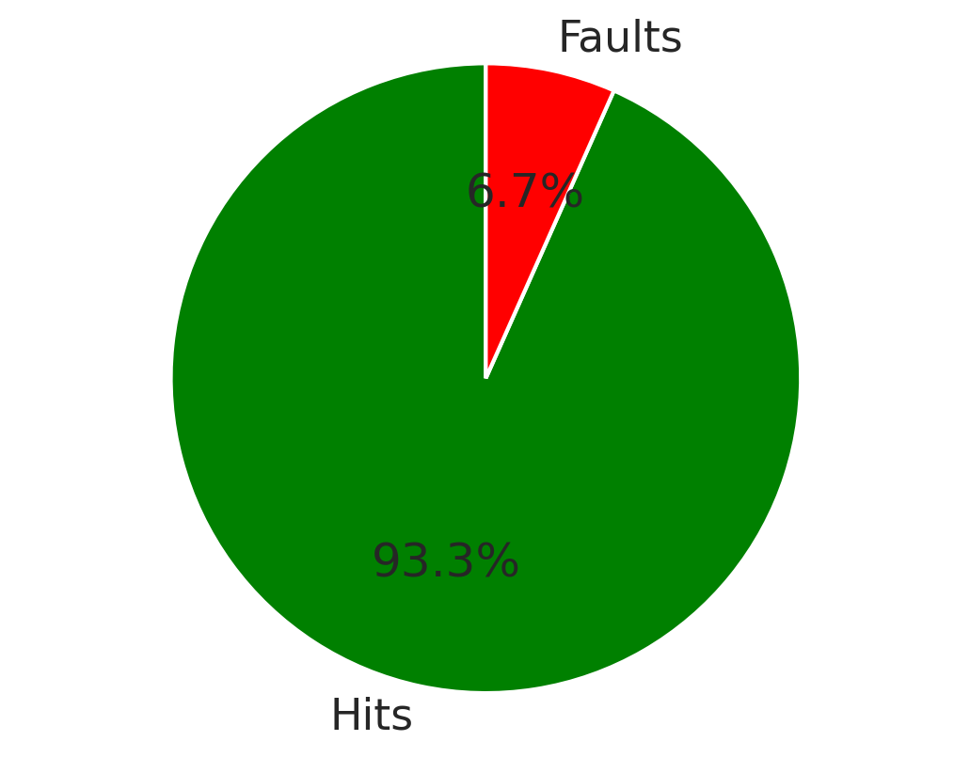

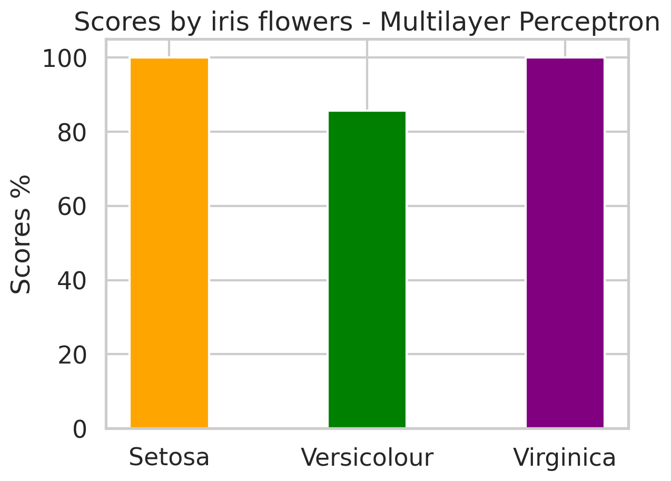

Activation Function:
I’ve chosen to use the hyperbolic tanh function.
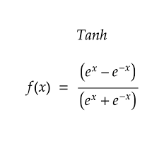

The derivative is 1-f(x)^2.

Advantages of the hyperbolic tangent over the sigmoid function:

The tanh function is a stretched and shifted version of the sigmoid. Therefore, there are a lot of similarities.
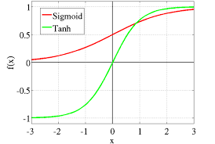
Both functions belong to the S-like functions that suppress the input value to a bounded range. This helps the network to keep its weights bounded and prevents the exploding gradient problem where the value of the gradients becomes very large.

An important difference between the two functions is the behavior of their gradient. Let’s compute the gradient of each activation function:
Below, we plot the gradient of the sigmoid (red) and the tanh (blue) activation function:
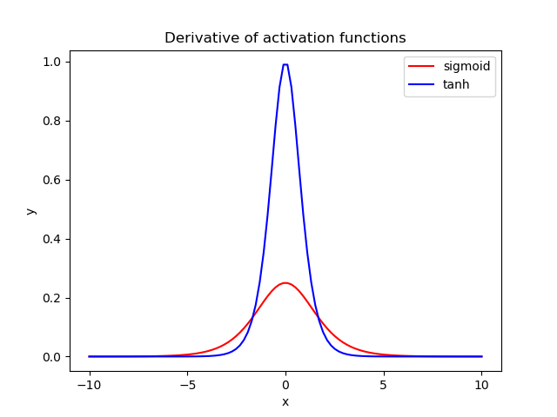
When we are using these activation functions in a neural network, our data are usually centered around zero. So, we should focus our attention on the behavior of each gradient in the region near zero.
We observe that the gradient of tanh is four times greater than the gradient of the sigmoid function. This means that using the tanh activation function results in higher values of gradient during training and higher updates in the weights of the network. So, if we want strong gradients and big learning steps, we should use the tanh activation function.
Another difference is that the output of tanh is symmetric around zero leading to faster convergence.
The sigmoid function is not centered around 0, which causes our weights to be either all positive or all negative which makes it harder to converge. Since the tanh function is centered around 0, convergence is faster.

This is still inferior to functions like relu and leaky relu, but i chose to use this for the sake of simplicity.

