PROJECT DOCUMENTATION
Responsive Personal Portfolio Website
MERN Stack Internship – Mini Project
Prepared by
Shreya Sharma
2026

1. Executive Summary
This project is a professional responsive personal portfolio website developed as part of the MERN Stack Internship mini project. The website presents the developer's profile, technical skills, services, selected projects, and contact information through a structured and accessible web interface.
The implementation uses semantic HTML5 for document structure, CSS3 for responsive layouts and visual presentation, and JavaScript for interactive functionality. The website is designed to operate across desktop, tablet, and mobile screen sizes and is suitable for deployment through GitHub Pages.

2. Project Objectives
- Develop a professional personal portfolio and business landing website.
- Implement a responsive interface for desktop, tablet, and mobile devices.
- Use semantic HTML5 elements to establish a meaningful document structure.
- Use CSS Flexbox and CSS Grid for modern responsive layouts.
- Implement JavaScript-based user interactions.
- Provide a dark and light theme selection.
- Follow fundamental accessibility practices.
- Optimize the website for strong Lighthouse performance.
- Maintain the project using Git and publish the source code on GitHub.
- Deploy the website publicly using GitHub Pages.

3. Project Scope
The scope of the project covers the design, development, testing, documentation, version control, and deployment of a static portfolio website. The website is focused on frontend implementation and does not require a backend server or database.

4. Technologies and Tools
Technology / Tool | Purpose | Implementation
HTML5 | Page structure and semantics | Semantic sections, navigation, forms and content hierarchy
CSS3 | Visual design and responsive layout | Flexbox, CSS Grid, media queries, transitions and theme variables
JavaScript | Client-side interaction | Navigation menu, theme toggle, form validation, active navigation and back-to-top control
Git | Version control | Meaningful incremental commits and source history
GitHub | Repository hosting | Source code repository and project collaboration
GitHub Pages | Public deployment | Static website hosting
Chrome Lighthouse | Quality and performance testing | Performance, accessibility, best-practices and SEO assessment

5. Functional and User Interface Features
Feature | Description
Home | Introduces the developer, professional role, primary call-to-action links and social profiles.
About | Provides a professional overview, development interests and key experience indicators.
Skills | Displays core technologies including HTML5, CSS3, JavaScript, React, Node.js, Express, MongoDB and Git/GitHub.
Services | Presents frontend development, backend development, full-stack development and performance optimization capabilities.
Projects | Showcases selected projects with descriptions and technology stacks.
Contact | Provides contact information and an interactive contact form.
Responsive Navigation | Provides a desktop navigation menu and a collapsible mobile menu.
Theme Switching | Allows users to switch between light and dark themes; the preference is retained with localStorage.
Smooth Navigation | Provides smooth movement between sections and a back-to-top control.
Scroll Interaction | Highlights the current navigation section and reveals selected content elements during scrolling.

6. Project Architecture
The project follows a simple static frontend architecture. HTML files define the content and structure, a centralized stylesheet controls presentation and responsive behavior, and a JavaScript file manages client-side interactions.

6.1 Directory Structure
Portfolio-Website/
├── assets/
│ ├── css/
│ │ └── style.css
│ ├── js/
│ │ └── script.js
│ ├── images/
│ └── fonts/
├── pages/
│ ├── about.html
│ ├── projects.html
│ └── contact.html
├── index.html
├── README.md
├── LICENSE
└── .gitignore

7. Implementation Details

7.1 Semantic HTML5
The website uses semantic elements including header, nav, main, section, article, footer, form, label, and button. This improves document structure, maintainability, accessibility, and search-engine interpretation.

7.2 Responsive CSS
The stylesheet uses CSS Grid and Flexbox for layout management. Media queries progressively adjust navigation, grids, typography, spacing, and content arrangement for smaller screens.

7.3 Theme Management
The light and dark themes are controlled through a CSS custom property system. JavaScript toggles the dark-mode class on the document body and stores the selected preference in localStorage.

7.4 JavaScript Interactions
- Mobile navigation menu open and close behavior.
- Theme switching with persistent user preference.
- Active navigation state based on the visible page section.
- Contact form validation and user feedback.
- Back-to-top button visibility and smooth scrolling.
- Intersection Observer-based reveal effects for selected cards.
- Automatic display of the current year in the footer.

8. Accessibility Considerations
- Semantic HTML elements are used to establish a logical content hierarchy.
- Form controls include descriptive labels.
- Interactive controls provide accessible labels through visible text or ARIA attributes.
- Keyboard focus states are clearly defined.
- Navigation state is communicated through active styling and ARIA-expanded behavior for the mobile menu.
- The page includes descriptive metadata and a meaningful heading hierarchy.
- A reduced-motion media query is included for users who prefer reduced animation.
- The design avoids unnecessary external dependencies that could introduce additional accessibility overhead.

9. Responsive Design
The website is designed using a mobile-first responsive approach in which layout dimensions, navigation behavior, grid structures, and typography adapt to available screen width.
Device Category | Primary Considerations | Expected Behavior
Desktop | Large content area | Multi-column layouts and full navigation
Tablet | Moderate content width | Reduced column counts and adjusted spacing
Mobile | Narrow viewport | Collapsible navigation and single-column content

10. Testing and Quality Assurance
The website should be tested before submission across multiple viewport sizes and in a modern browser. Testing should verify both functional behavior and visual responsiveness.
- Verify all navigation links and buttons.
- Verify mobile navigation open and close behavior.
- Verify light and dark theme switching.
- Verify the contact form required-field validation.
- Verify the back-to-top control.
- Verify responsive behavior at desktop, tablet, and mobile widths.
- Verify keyboard navigation and visible focus states.
- Verify there are no broken internal links or missing assets.
- Run Lighthouse and record the final scores.
- Confirm the deployed GitHub Pages version matches the submitted repository.

11. Lighthouse Performance and Quality Assessment
Google Chrome Lighthouse should be used to evaluate the final deployed website. The internship requirement specifies a Performance score above 90. Accessibility, Best Practices, and SEO should also be reviewed and improved before final submission.
Metric | Final Result
Performance | 100
Accessibility | 96
Best Practices | 100
SEO | 100
The final Lighthouse report should be placed in the internship-documentation/lighthouse-report directory and submitted with the project deliverables.

12. Version Control and GitHub
Git is used to maintain the project's development history. Commit messages should describe the actual change made so that the repository demonstrates a clear development process.
- Initial portfolio structure
- Add responsive navigation
- Add home and about sections
- Add skills and services sections
- Add projects section
- Implement dark and light theme
- Add contact form interaction
- Improve responsive layouts
- Improve accessibility
- Optimize Lighthouse performance
- Deploy portfolio to GitHub Pages

13. Deployment
The website is suitable for deployment using GitHub Pages because it is a static frontend application and does not require a server-side runtime.
- Create a public GitHub repository for the portfolio.
- Push the complete project source code to the main branch.
- Open the repository's Settings and navigate to Pages.
- Configure GitHub Pages to deploy from the main branch and the project root.
- Wait for the deployment process to complete.
- Open the generated public URL and verify the deployed website.
- Update README.md with the final repository and live website links.

14. Submission Deliverables
- Complete source code.
- Responsive portfolio website.
- GitHub repository.
- GitHub Pages live link.
- README.md.
- Desktop, tablet, and mobile screenshots.
- Lighthouse report.
- Project documentation.

15. Future Enhancements
- Connect the contact form to a backend or form-processing service.
- Add a downloadable resume.
- Add project filtering and search.
- Add a dedicated blog section.
- Integrate analytics.
- Introduce a content management workflow for project updates.
- Add automated testing and continuous deployment.

16. Conclusion
The Responsive Personal Portfolio Website demonstrates the practical application of HTML5, CSS3, JavaScript, responsive design, accessibility practices, Git version control, and GitHub Pages deployment. The project provides a professional platform for presenting technical skills and development work while meeting the specified internship requirements.

Appendix A: Screenshot Documentation
Insert the final screenshots in this section when preparing the submitted documentation. Recommended captures include:
- Desktop home page.
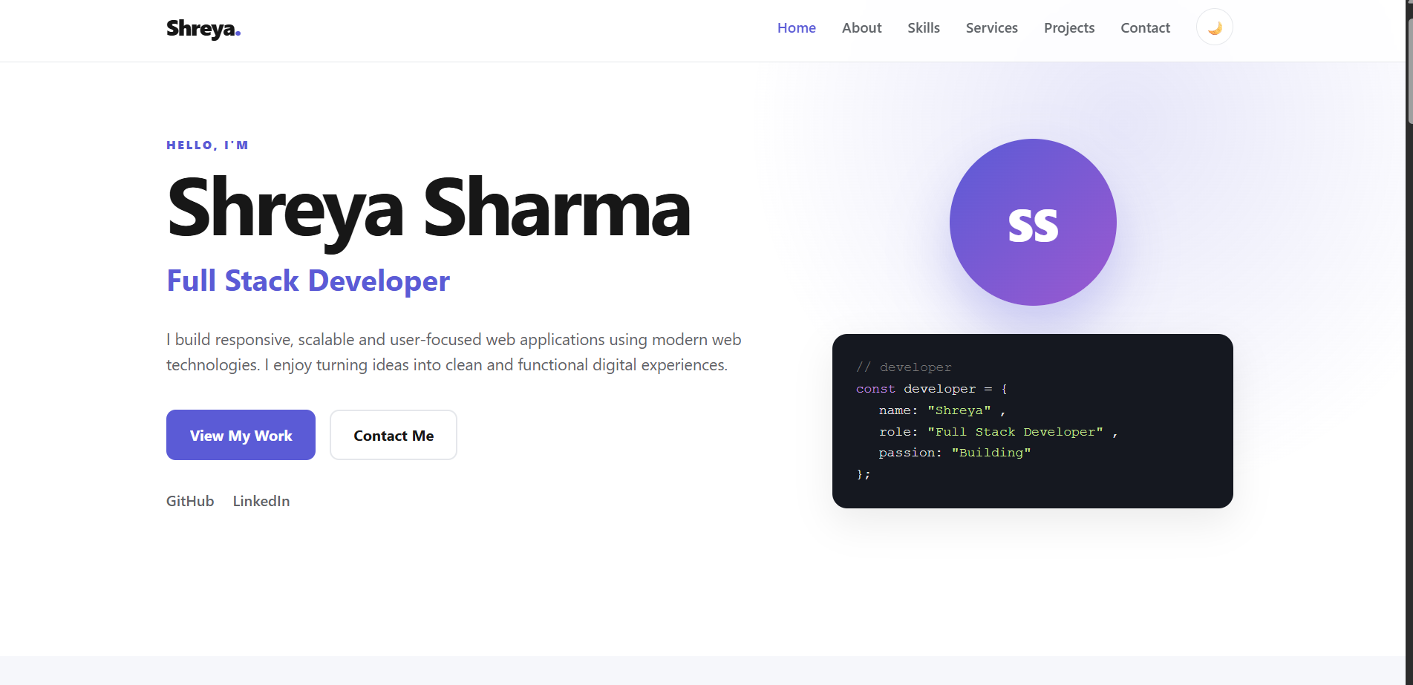

- Mobile responsive layout.
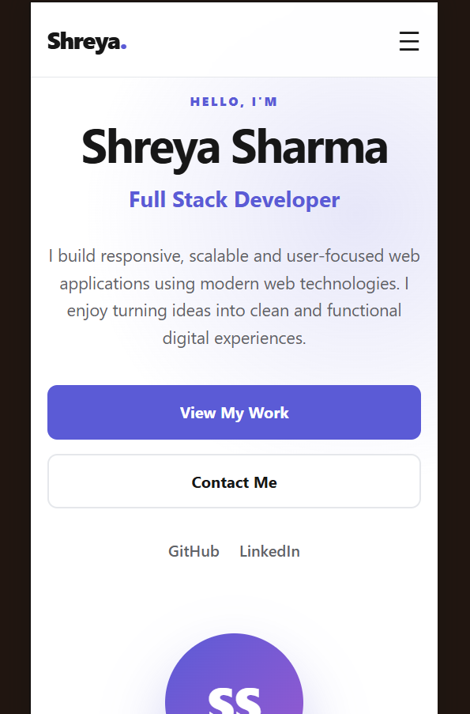

- Dark theme
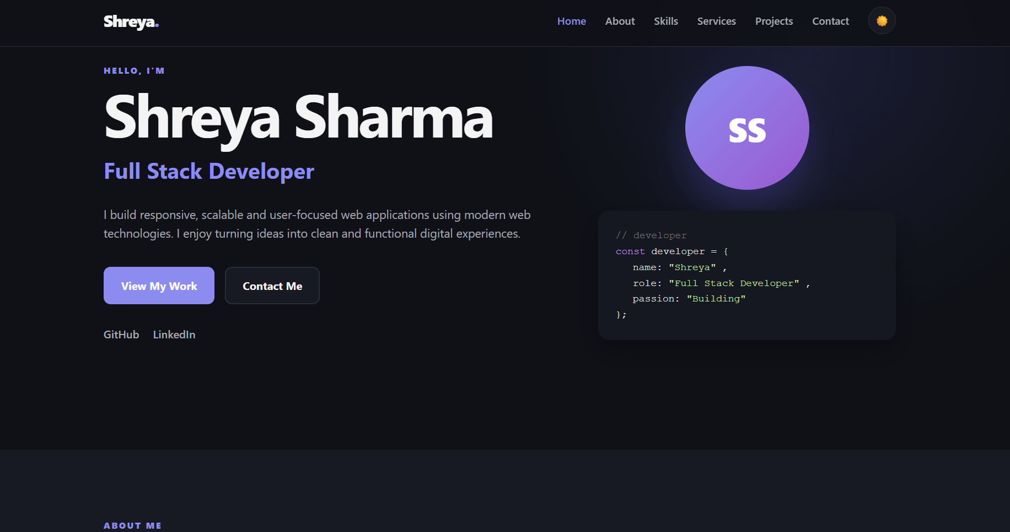

- Projects section.
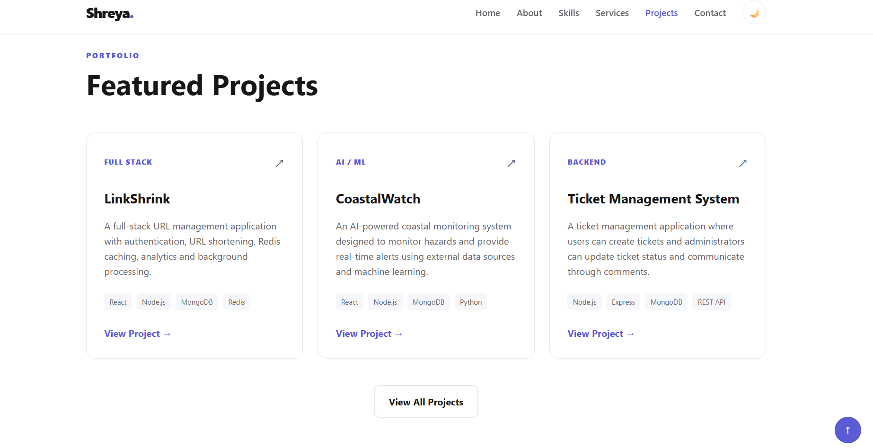

- Contact section.
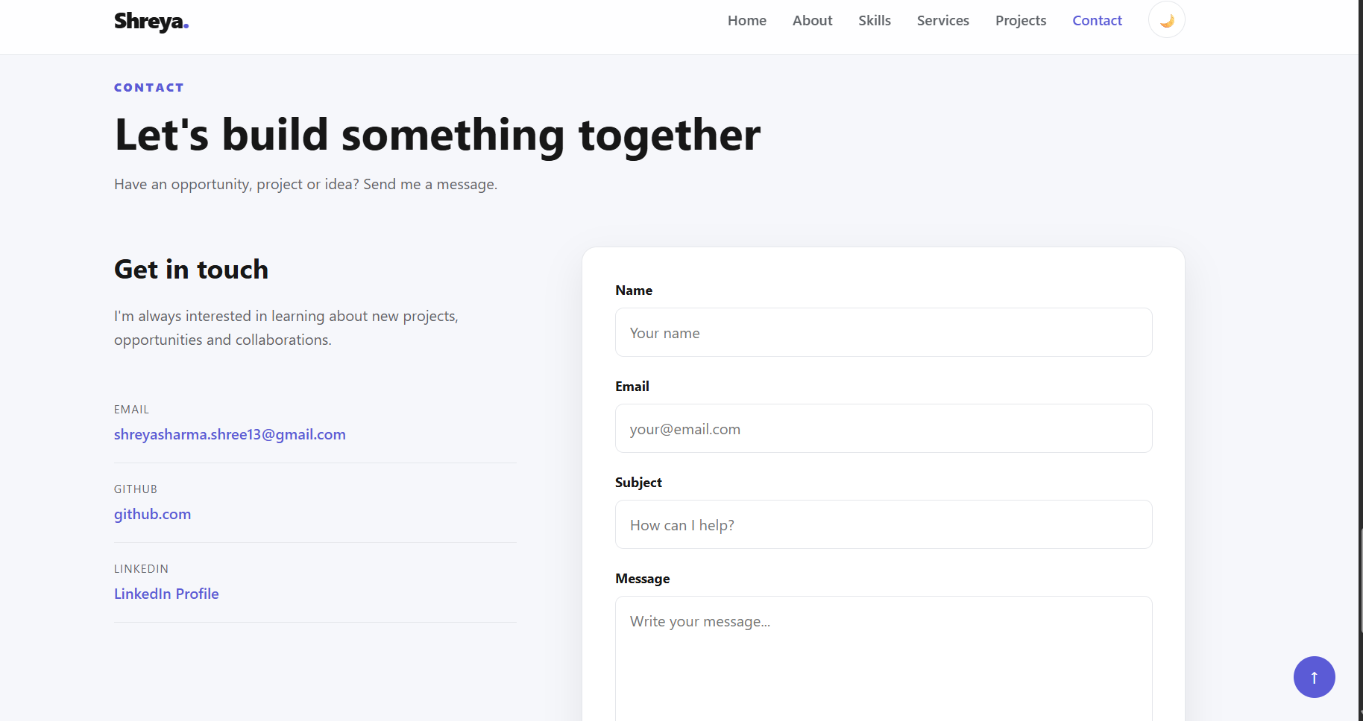

- Final Lighthouse report.

