Name: Sopariwala Shreya H.

Roll No.: 68

Course: M.Sc. (ICT)

Subject: 101(Frontend Development using ReactJs)

Practical Assignment: 3

Build a Small Task Management Website in React.js

Create a small website for managing tasks. The website should have the following features:

1. Class Components: Implement a class component called TaskManager that will serve as the main container for managing tasks. This component should have a state to store the list of tasks.

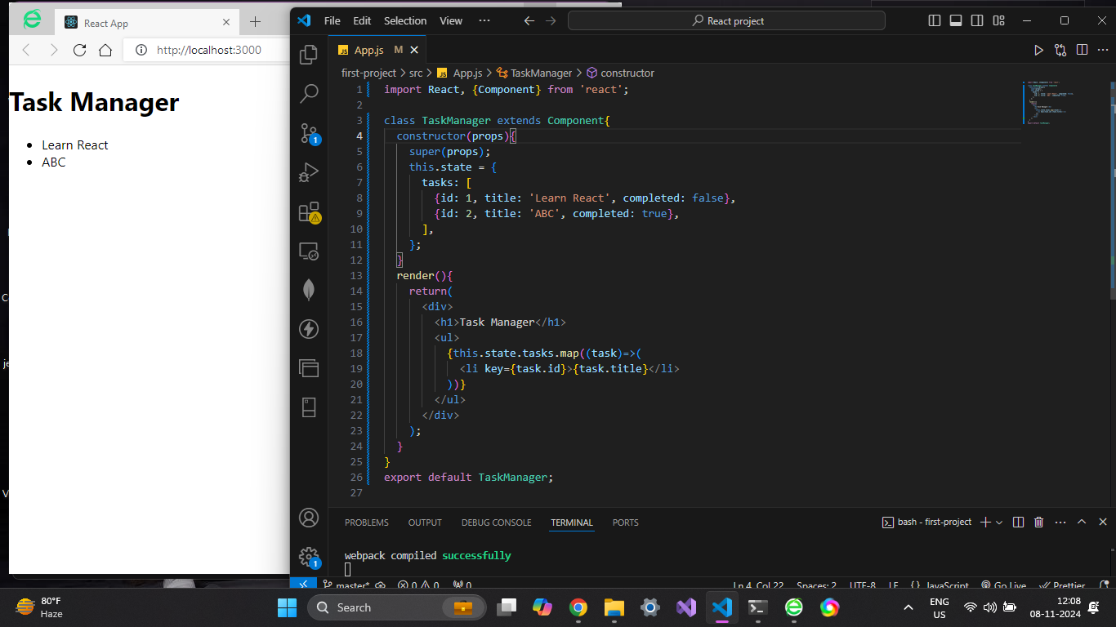

2. Functional Components: Create a functional component called TaskList responsible for displaying a list of tasks. It should receive the list of tasks as props from the TaskManager component.

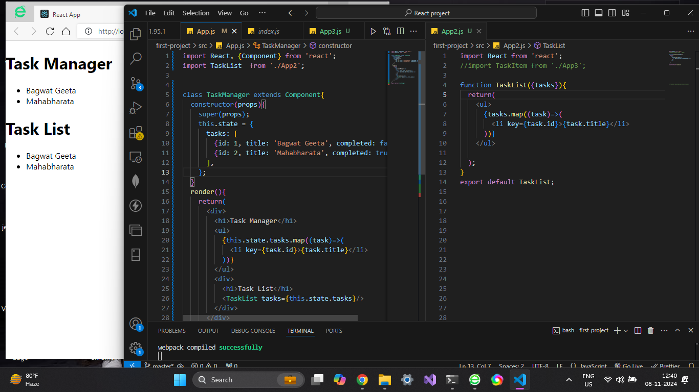

3. Nested Components: Inside the TaskList component, create a child component called TaskItem that represents an individual task.

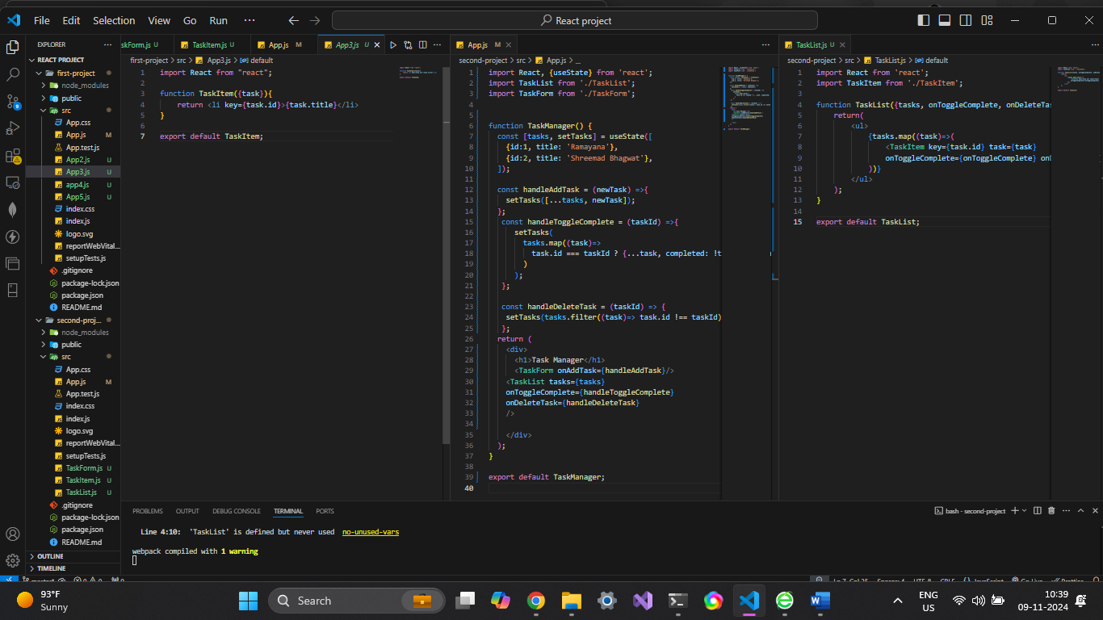

4. Conditional and Looping Constructs: Implement conditional rendering in the TaskList component. If there are no tasks, display a message like &quot;No tasks to display.&quot; Use a loop (e.g., map) to render each TaskItem.

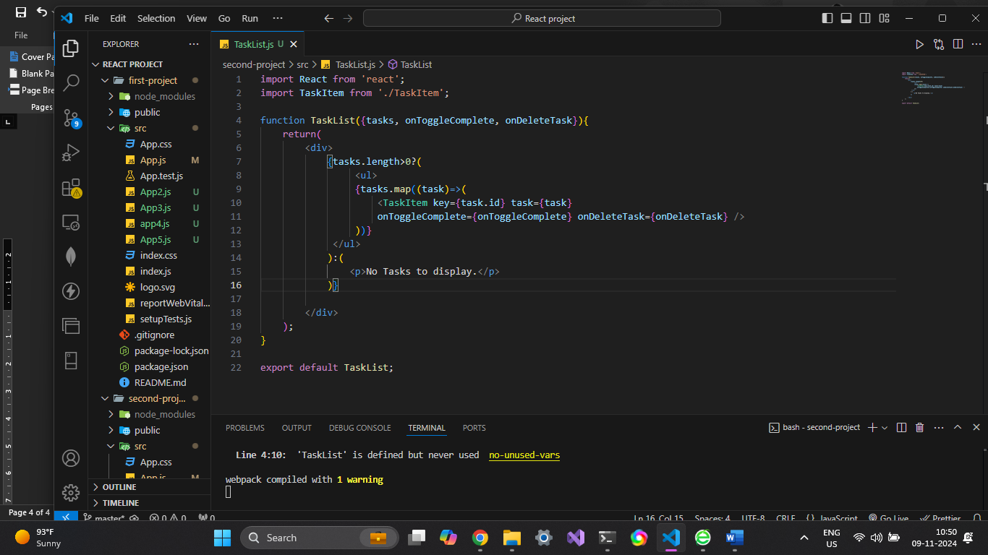

5. State: In the TaskManager component, manage the list of tasks using state. Initially, you can provide some sample tasks within the state.

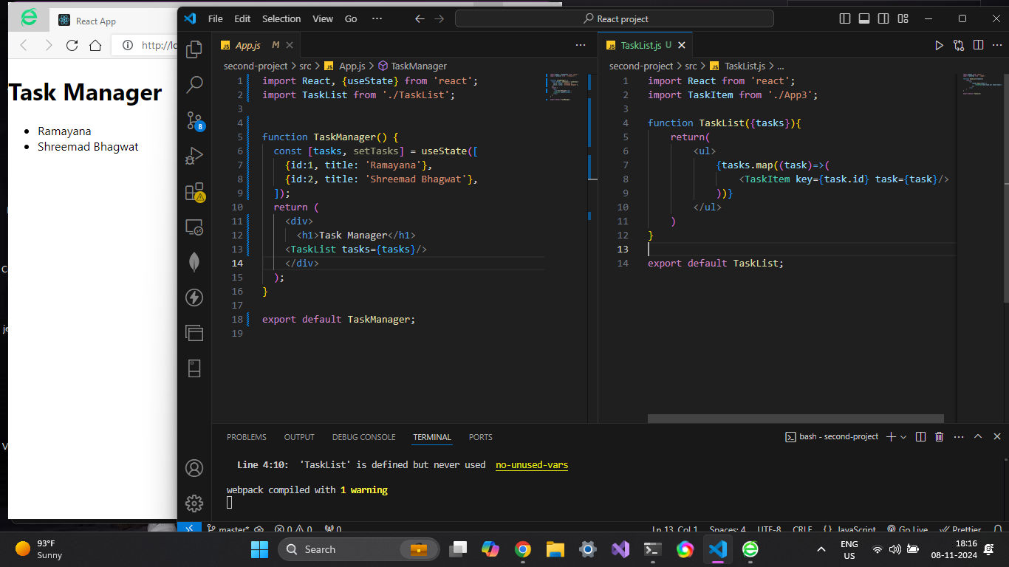

6. Props: Pass the list of tasks as props from the TaskManager component to the TaskList

component. Each TaskItem should receive a task object as a prop.

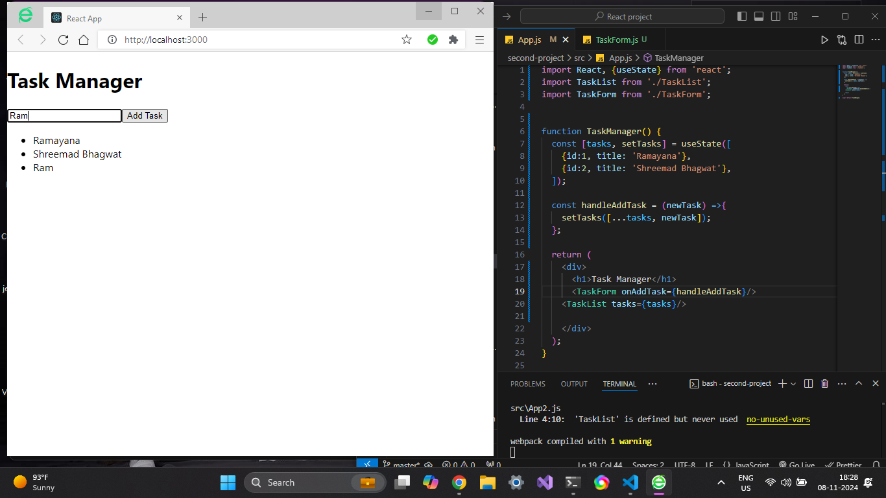

**7. Form (Controlled Component): Create a form component called TaskForm within the**

**TaskManager component. This form should allow users to add new tasks. Use controlled**

**components to manage form input values.**

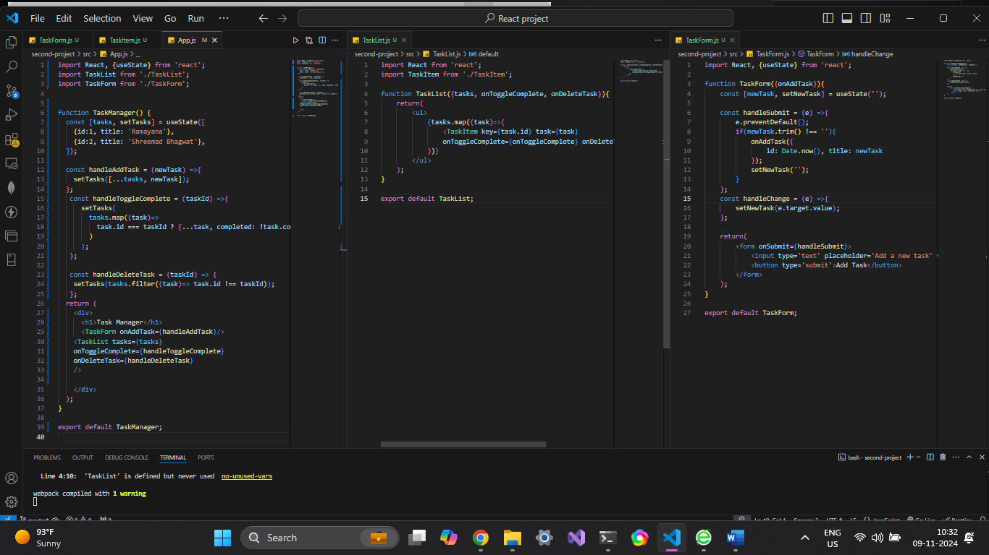

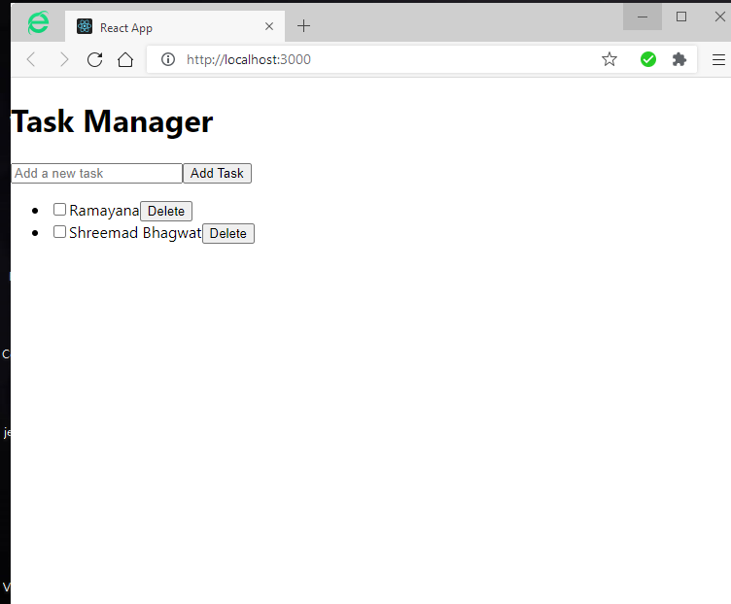

Github link: <https://github.com/ShreyaSopariwala1834/-Practical-Assignment>