**Xenon Stack- A Stack Innovator**

**Round -2**

**Technologies used:**

**Frontend:** HTML, CSS, Bootstrap, Javascript

**Backend:** Node.js

**Database:** MongoDB

Theme of the Project- **“DevStack.”(Developing User-Friendly Website)**

**Screenshots of Project:**

***HOME Page:***

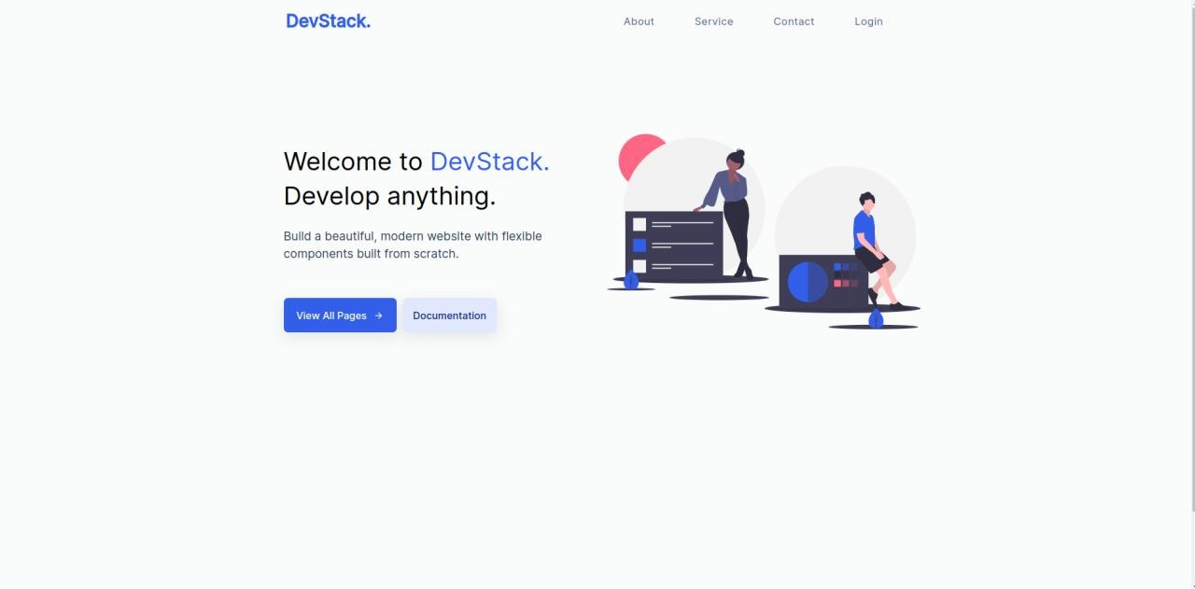

***SIGNUP Page:***

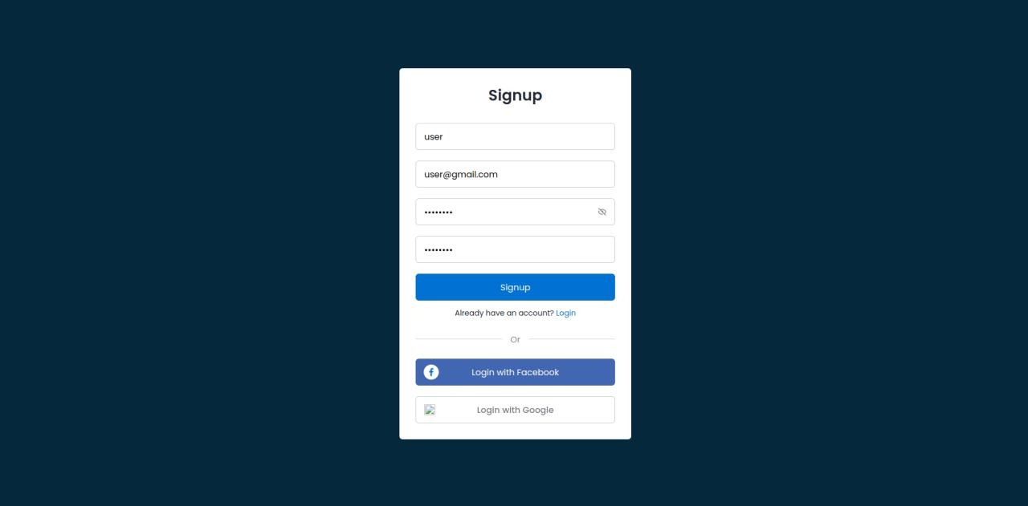

***LOGIN Page:***

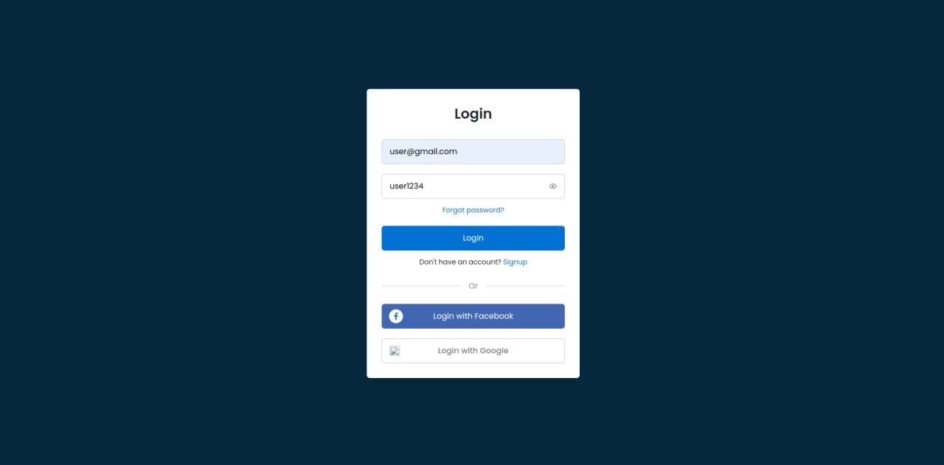

***LOGOUT Page:***

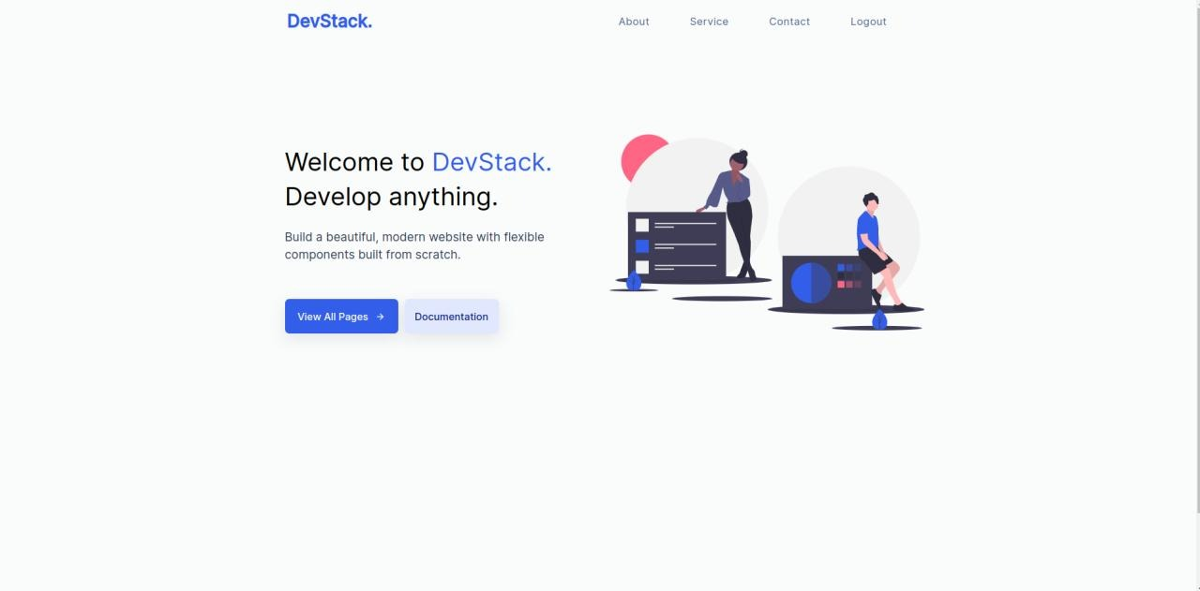

***CONTACT US Page:***

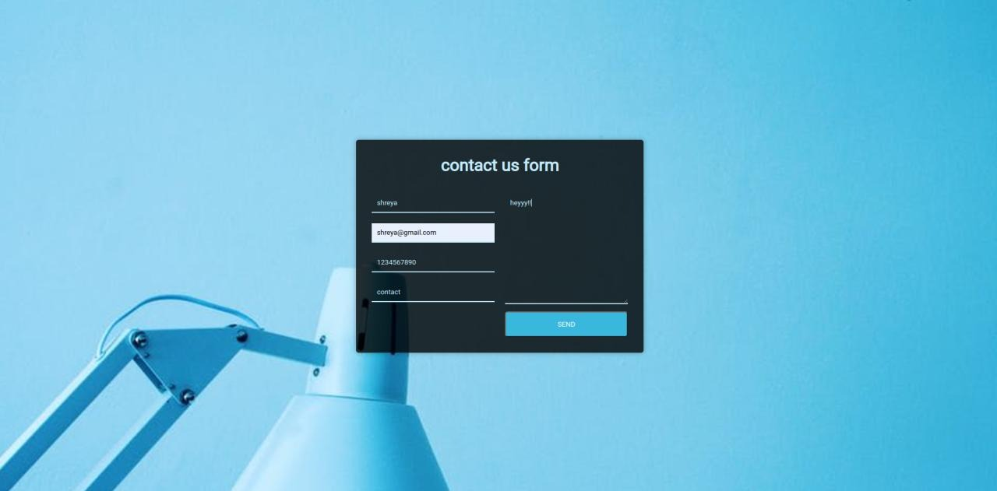

**Screenshots of Database:**

***Signup Page Data:***

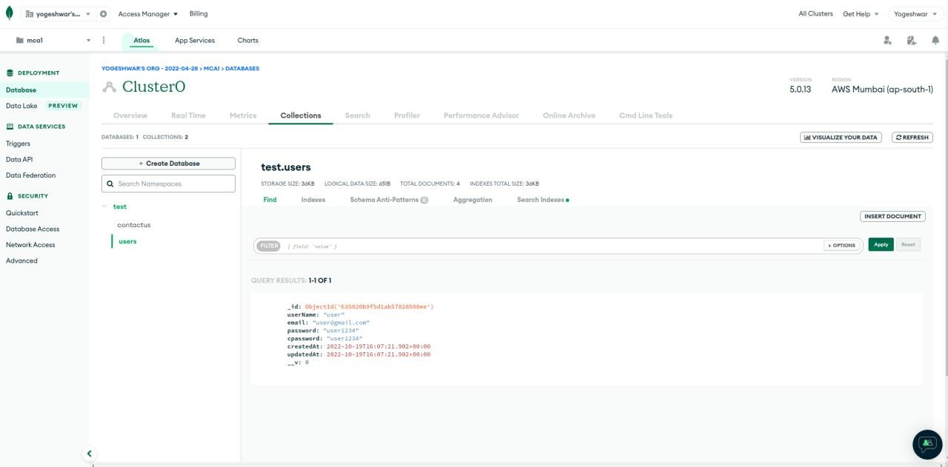

***Contact Us Page Data:***

