DBMS PROJECT
TOPIC : Movie Streaming & Ticket Booking

Implementation of streaming.sql
- Creating database
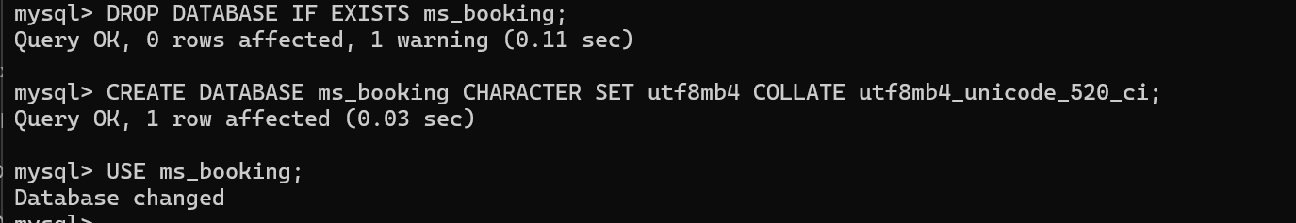
- Role(refence table )
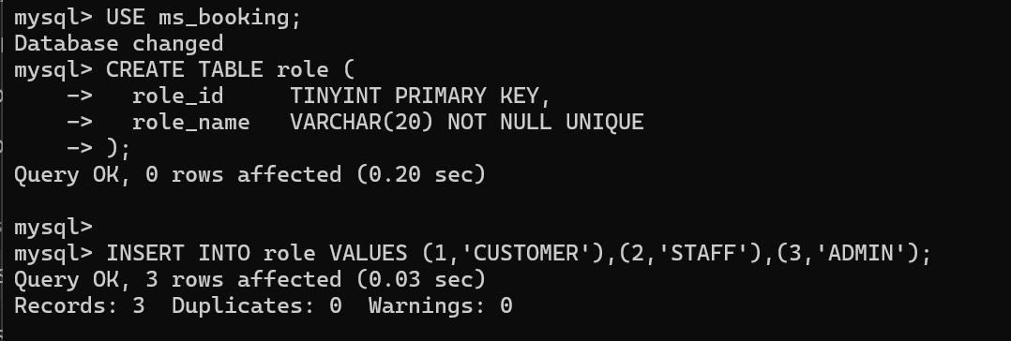
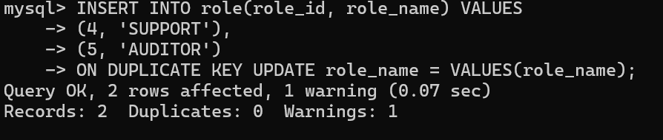
- City table
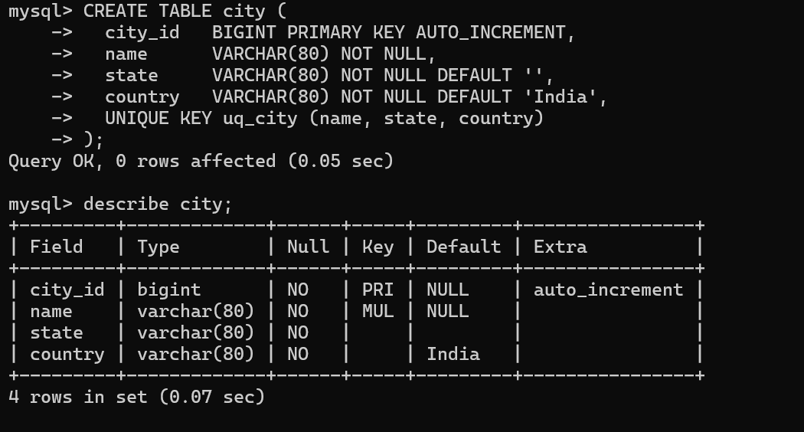
- User Account Table
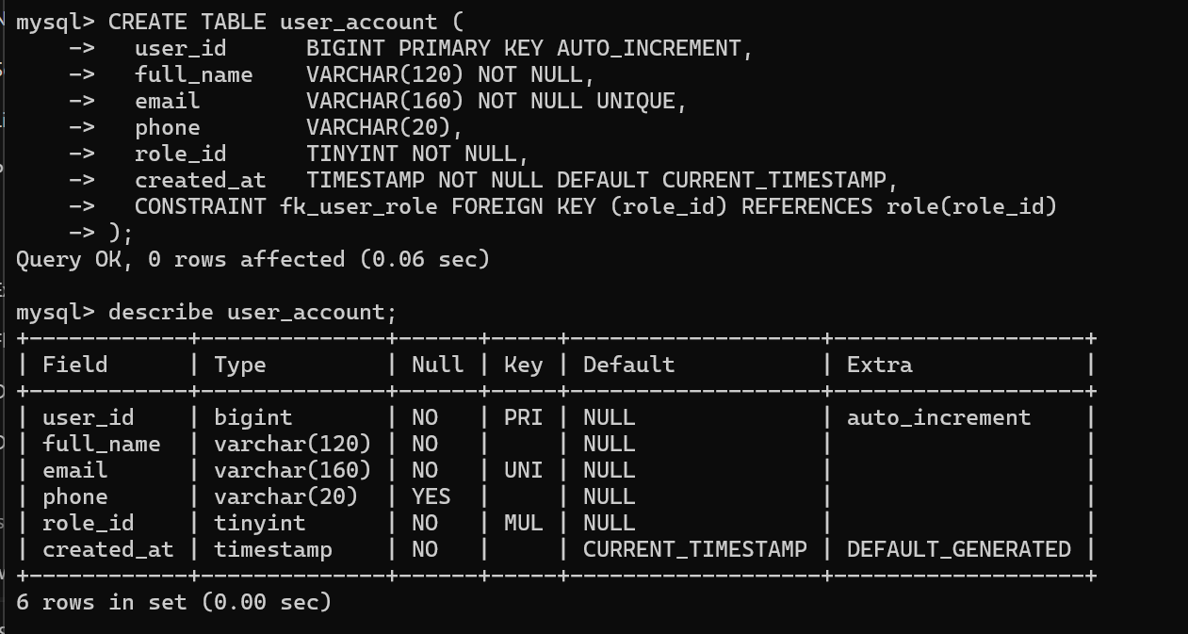
- Genre Table
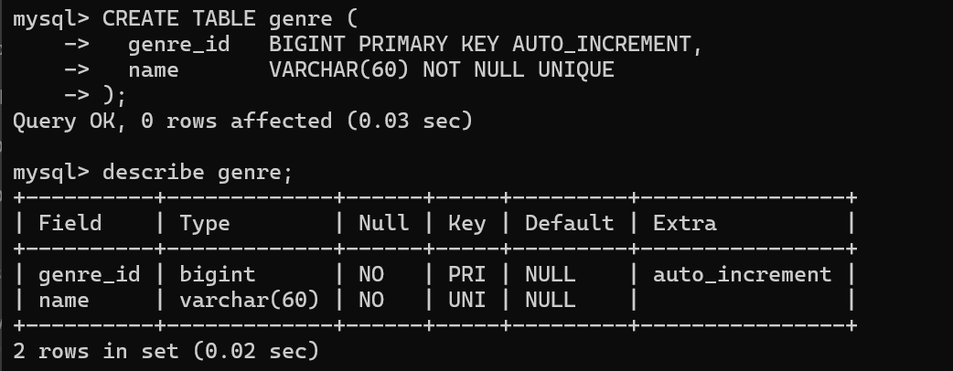
- Movie Table
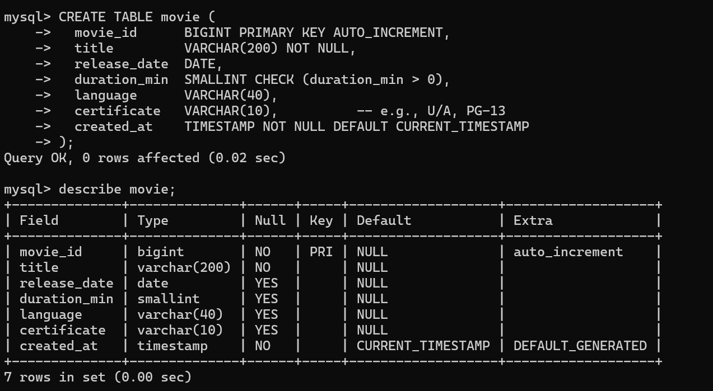
- Movie Genre Table
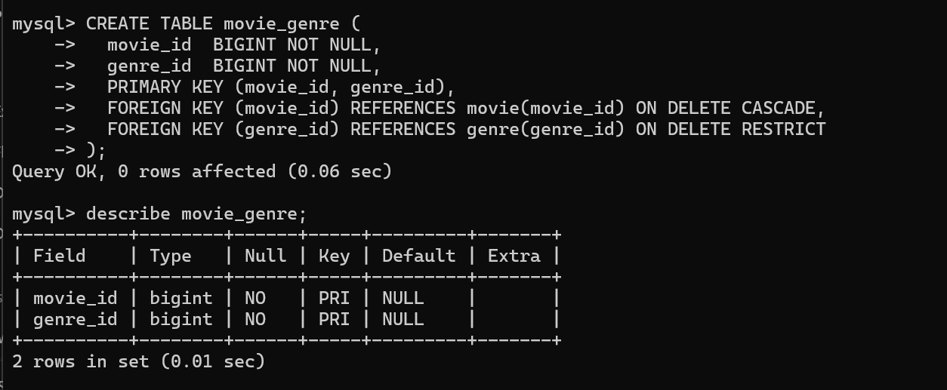
- Person Table
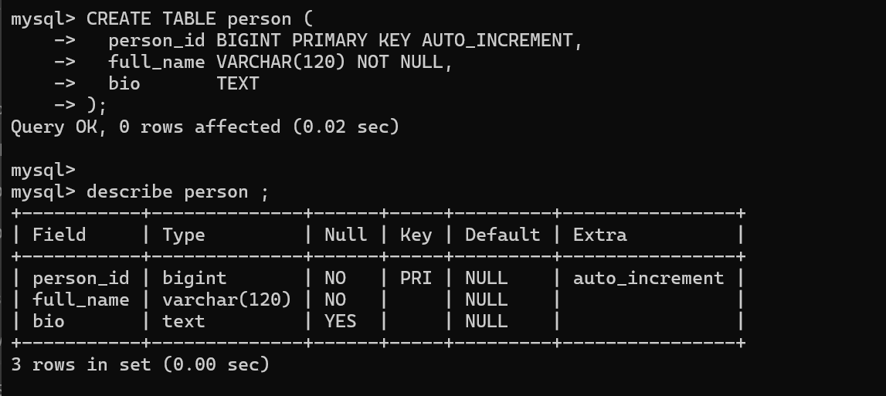
- Movie Cast Table
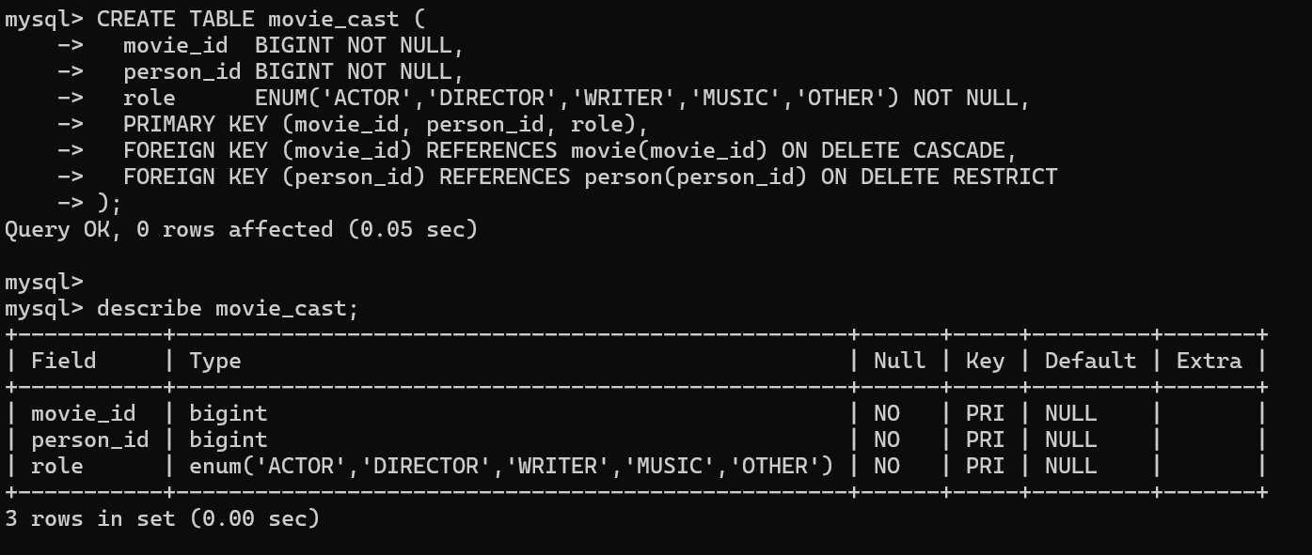
- Theatre Table
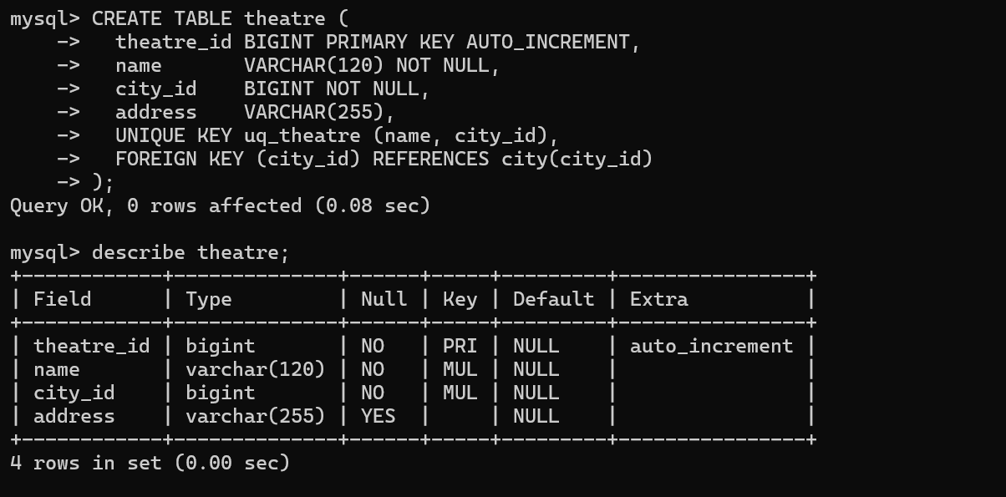
- Screen Table
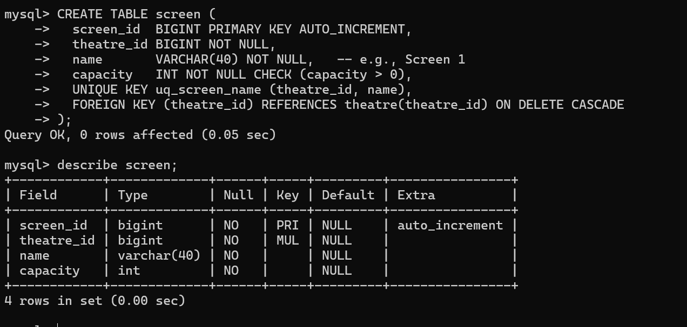
- Seat Table
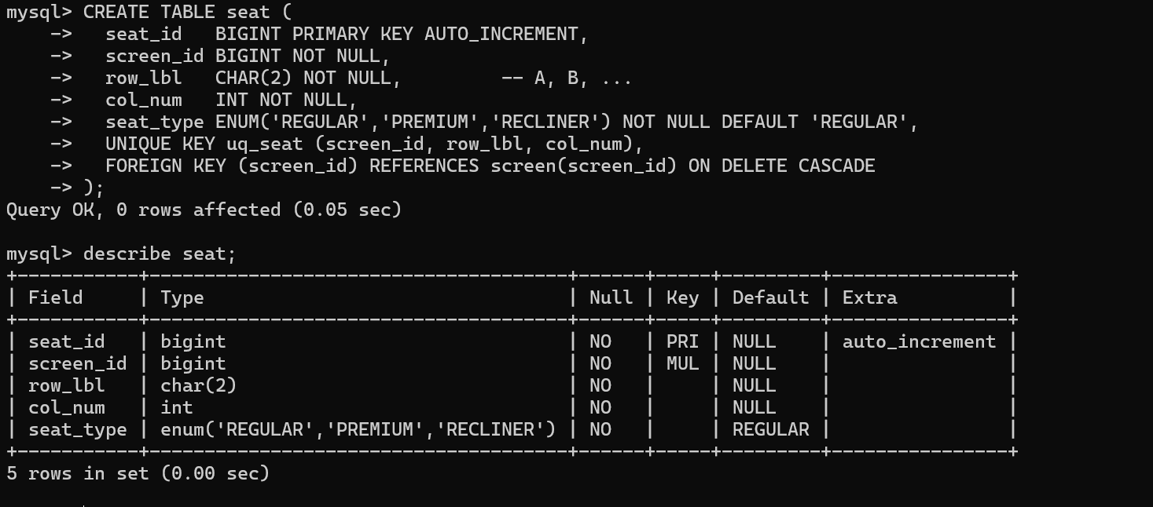
- Showtime Table
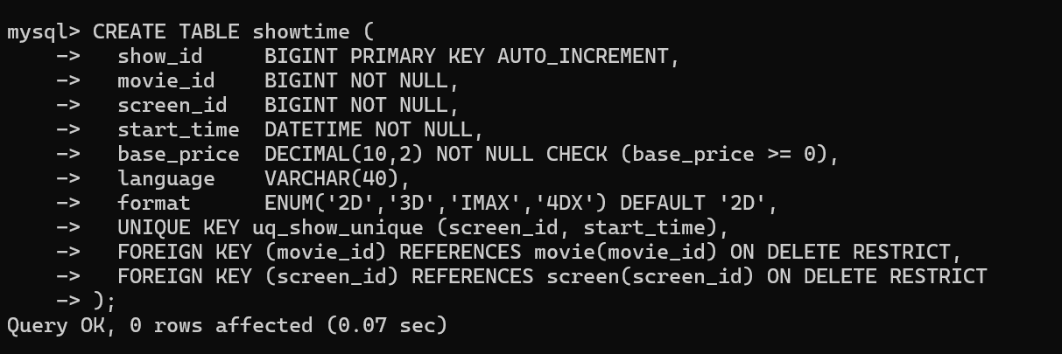
- Show Seat Table
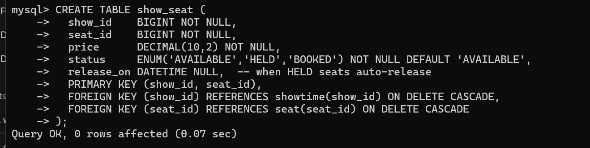
- Booking Table
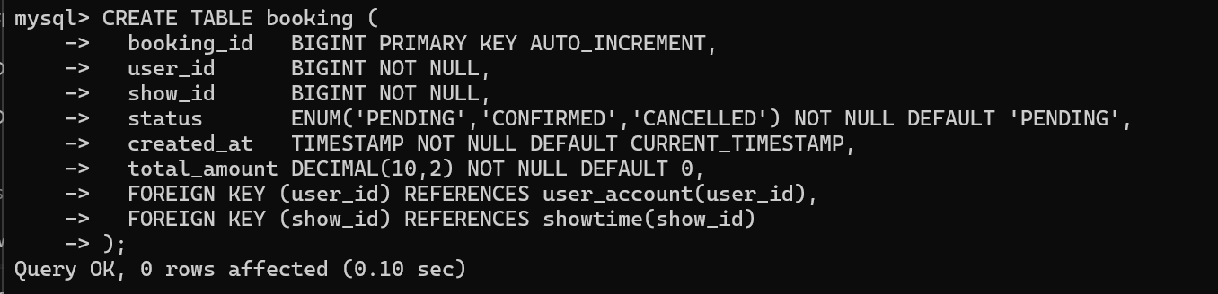
- Ticket Table
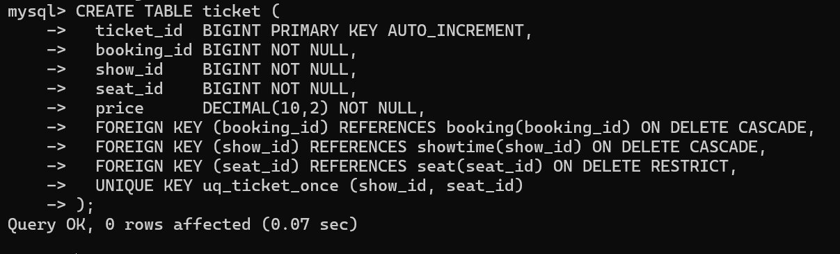
- Payment Table
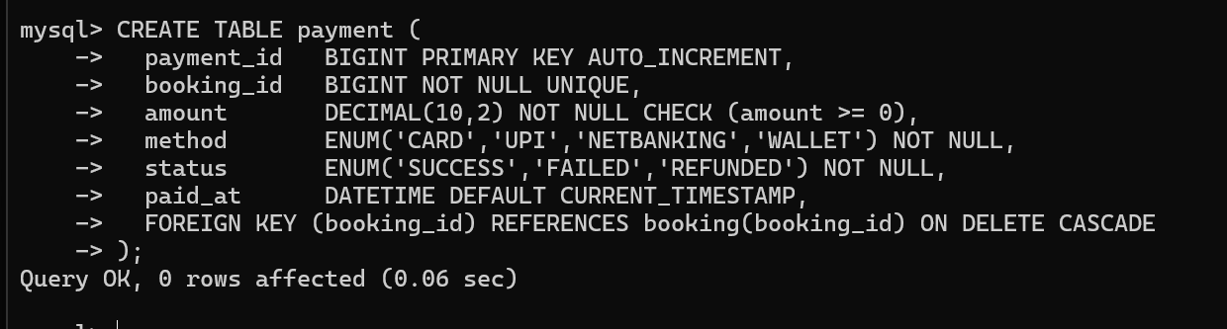
- Review Table
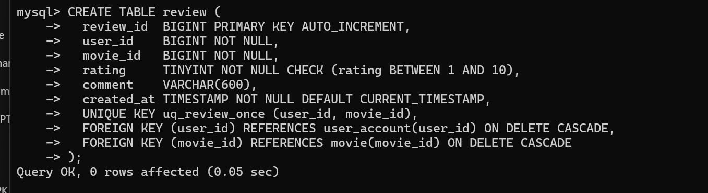
- Creation of Index
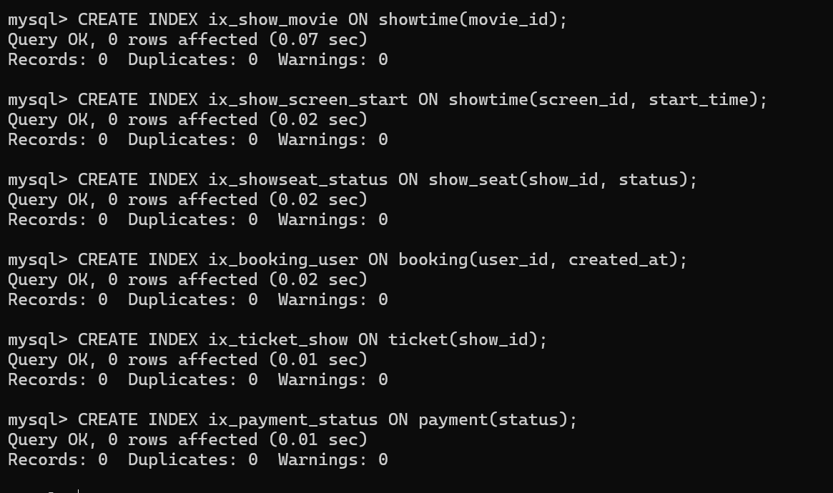
- Triggers
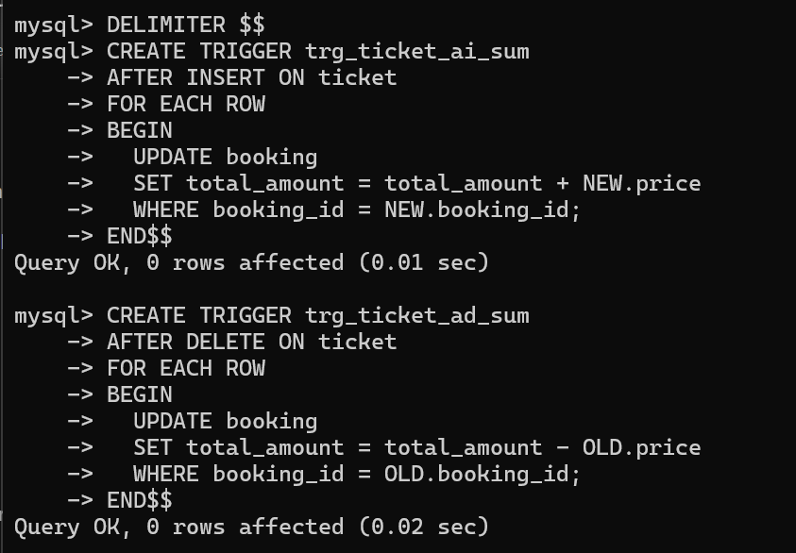
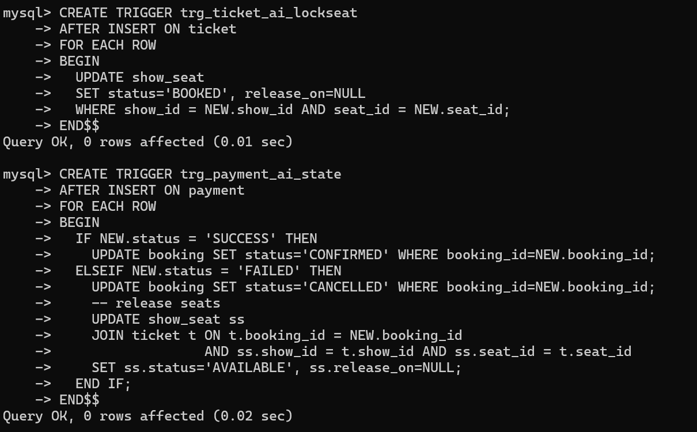
- Views
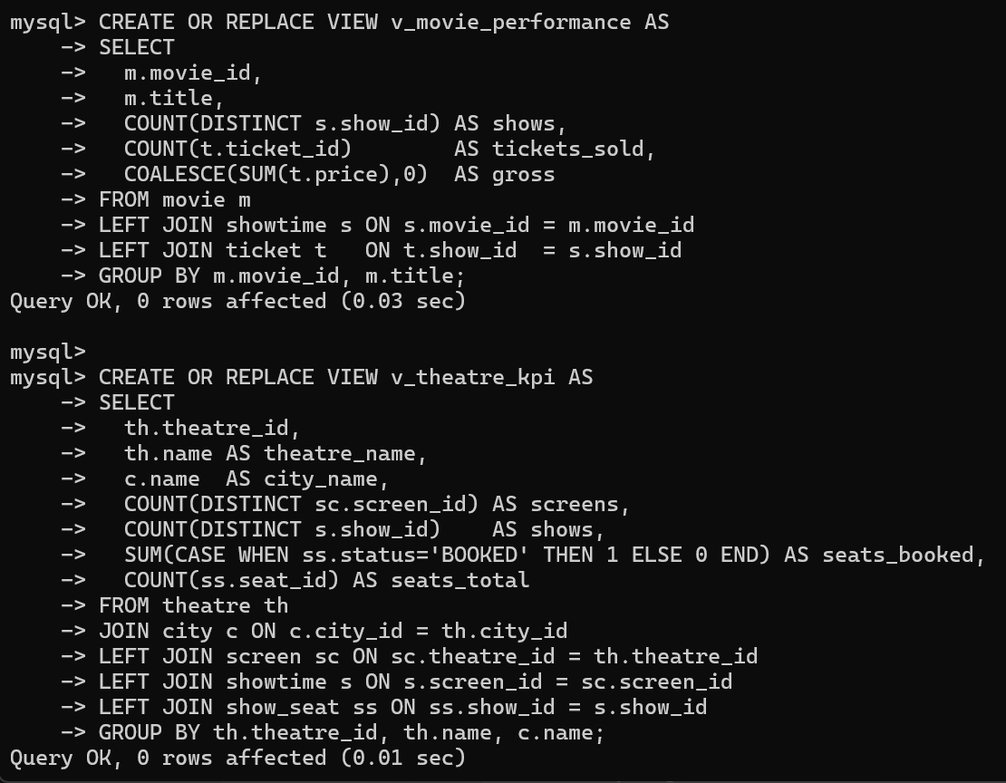
- Stored Function and Procedure ( Transaction booking demo)
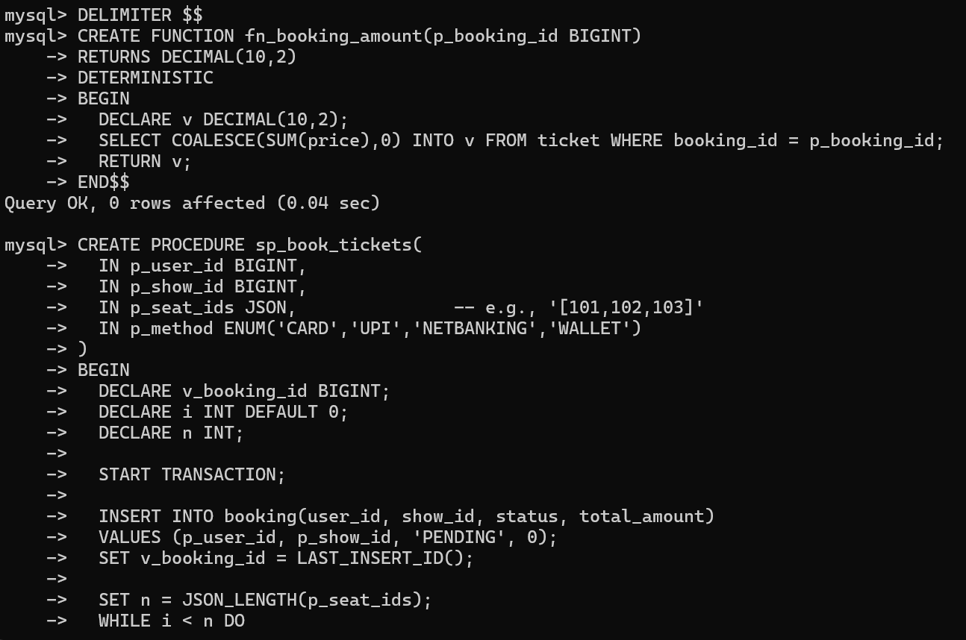
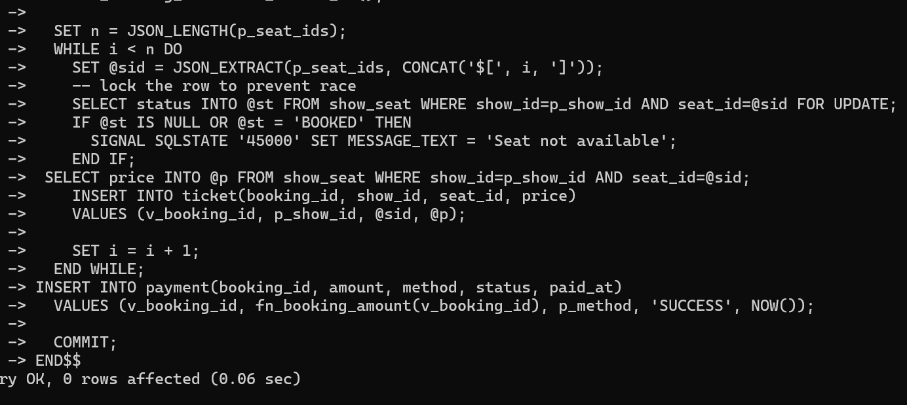
- Minimal Data input
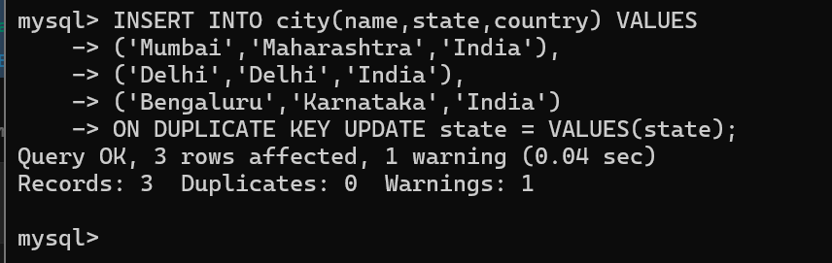
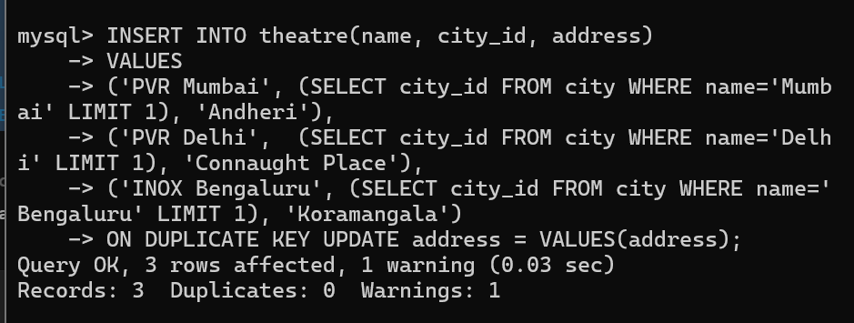
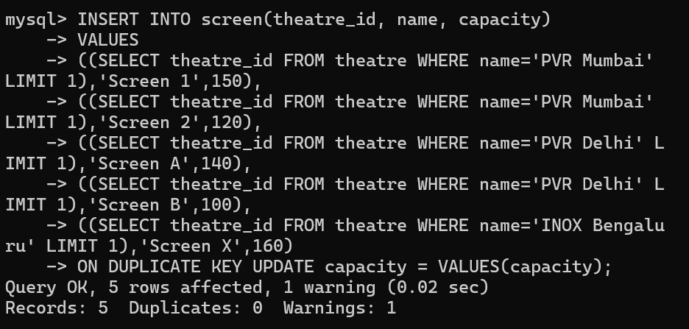
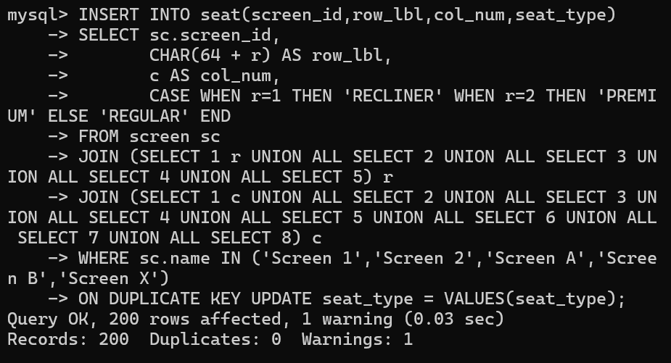
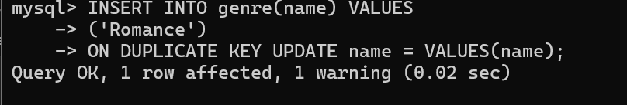
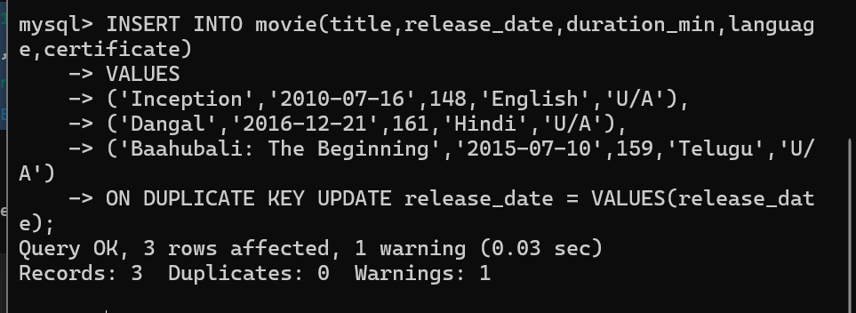
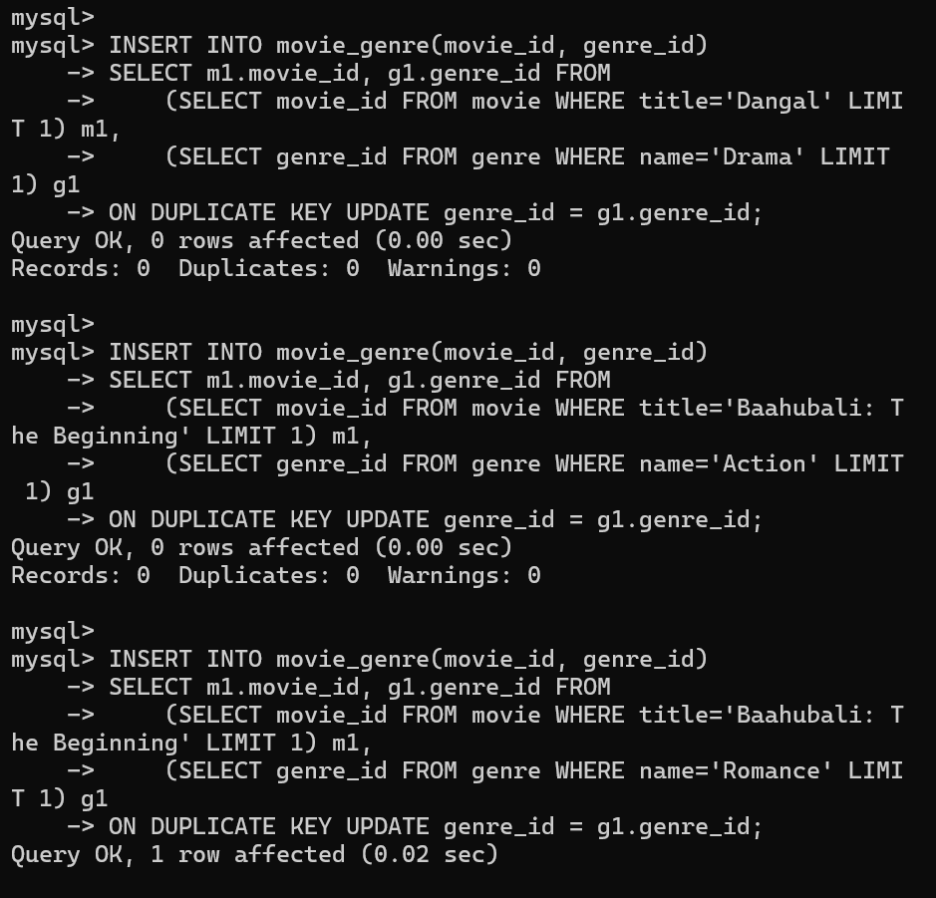
INSERT INTO person(full_name, bio) VALUES
('Tom Cruise','Actor'),
('Emily Blunt','Actor'),
('Rajkumar Hirani','Director'),
('Leonardo DiCaprio','Actor'),
('Aamir Khan','Actor & Producer')
ON DUPLICATE KEY UPDATE bio = VALUES(bio);

INSERT INTO movie_cast(movie_id, person_id, role)
SELECT m.movie_id, p.person_id, 'ACTOR'
FROM movie m, person p
WHERE m.title='Edge of Tomorrow' AND p.full_name='Tom Cruise'
ON DUPLICATE KEY UPDATE role = VALUES(role);

INSERT INTO movie_cast(movie_id, person_id, role)
SELECT m.movie_id, p.person_id, 'ACTOR'
FROM movie m, person p
WHERE m.title='Edge of Tomorrow' AND p.full_name='Emily Blunt'
ON DUPLICATE KEY UPDATE role = VALUES(role);

INSERT INTO movie_cast(movie_id, person_id, role)
SELECT m.movie_id, p.person_id, 'DIRECTOR'
FROM movie m, person p
WHERE m.title='3 Idiots' AND p.full_name='Rajkumar Hirani'
ON DUPLICATE KEY UPDATE role = VALUES(role);

INSERT INTO movie_cast(movie_id, person_id, role)
SELECT m.movie_id, p.person_id, 'ACTOR'
FROM movie m, person p
WHERE m.title='Inception' AND p.full_name='Leonardo DiCaprio'
ON DUPLICATE KEY UPDATE role = VALUES(role);

INSERT INTO movie_cast(movie_id, person_id, role)
SELECT m.movie_id, p.person_id, 'ACTOR'
FROM movie m, person p
WHERE m.title='Dangal' AND p.full_name='Aamir Khan'
ON DUPLICATE KEY UPDATE role = VALUES(role);

INSERT INTO user_account(full_name,email,phone,role_id)
VALUES
('Shreya Deshmukh','shreya@example.com','9999999999',1),
('Cinema Manager','manager@cinemax.com','8888888888',2),
('Rohan Sharma','rohan@example.com','7777777777',1),
('Priya Singh','priya@example.com','6666666666',1),
('Theatre Admin','admin@pvr.com','5555555555',2)
ON DUPLICATE KEY UPDATE phone = VALUES(phone), role_id = VALUES(role_id);

INSERT INTO showtime(movie_id, screen_id, start_time, base_price, language, format)
SELECT m.movie_id, sc.screen_id, DATE_ADD(CURDATE(), INTERVAL 18 HOUR), 250.00, 'English','2D'
FROM movie m JOIN screen sc ON sc.name='Screen 1'
WHERE m.title='Edge of Tomorrow'
ON DUPLICATE KEY UPDATE base_price = VALUES(base_price), start_time = VALUES(start_time);

INSERT INTO showtime(movie_id, screen_id, start_time, base_price, language, format)
SELECT m.movie_id, sc.screen_id, DATE_ADD(CURDATE(), INTERVAL 20 HOUR), 200.00, 'Hindi','2D'
FROM movie m JOIN screen sc ON sc.name='Screen 2'
WHERE m.title='3 Idiots'
ON DUPLICATE KEY UPDATE base_price = VALUES(base_price), start_time = VALUES(start_time);

INSERT INTO showtime(movie_id, screen_id, start_time, base_price, language, format)
SELECT m.movie_id, sc.screen_id, DATE_ADD(CURDATE(), INTERVAL 26 HOUR), 220.00, 'Hindi','3D'
FROM movie m JOIN screen sc ON sc.name='Screen A'
WHERE m.title='Dangal'
ON DUPLICATE KEY UPDATE base_price = VALUES(base_price), start_time = VALUES(start_time);

INSERT INTO showtime(movie_id, screen_id, start_time, base_price, language, format)
SELECT m.movie_id, sc.screen_id, DATE_ADD(CURDATE(), INTERVAL 30 HOUR), 300.00, 'English','IMAX'
FROM movie m JOIN screen sc ON sc.name='Screen 1'
WHERE m.title='Inception'
ON DUPLICATE KEY UPDATE base_price = VALUES(base_price), start_time = VALUES(start_time);

INSERT INTO showtime(movie_id, screen_id, start_time, base_price, language, format)
SELECT m.movie_id, sc.screen_id, DATE_ADD(CURDATE(), INTERVAL 36 HOUR), 280.00, 'Telugu','3D'
FROM movie m JOIN screen sc ON sc.name='Screen X'
WHERE m.title='Baahubali: The Beginning'
ON DUPLICATE KEY UPDATE base_price = VALUES(base_price), start_time = VALUES(start_time);

INSERT INTO show_seat(show_id, seat_id, price, status)
SELECT st.show_id, se.seat_id,
CASE se.seat_type WHEN 'RECLINER' THEN st.base_price*1.6
WHEN 'PREMIUM' THEN st.base_price*1.3
ELSE st.base_price END,
'AVAILABLE'
FROM showtime st
JOIN seat se ON se.screen_id = st.screen_id
ON DUPLICATE KEY UPDATE price = VALUES(price);

CALL sp_book_tickets(
(SELECT user_id FROM user_account WHERE email='rohan@example.com' LIMIT 1),
(SELECT st.show_id FROM showtime st JOIN movie m ON m.movie_id=st.movie_id WHERE m.title='Inception' LIMIT 1),
JSON_ARRAY(
(SELECT seat_id FROM seat WHERE screen_id=(SELECT screen_id FROM screen WHERE name='Screen 1' LIMIT 1) AND row_lbl='A' AND col_num=1),
(SELECT seat_id FROM seat WHERE screen_id=(SELECT screen_id FROM screen WHERE name='Screen 1' LIMIT 1) AND row_lbl='A' AND col_num=2)
),
'CARD'
);

CALL sp_book_tickets(
(SELECT user_id FROM user_account WHERE email='priya@example.com' LIMIT 1),
(SELECT st.show_id FROM showtime st JOIN movie m ON m.movie_id=st.movie_id WHERE m.title='Dangal' LIMIT 1),
JSON_ARRAY(
(SELECT seat_id FROM seat WHERE screen_id=(SELECT screen_id FROM screen WHERE name='Screen A' LIMIT 1) AND row_lbl='B' AND col_num=3)
),
'UPI'
);

CALL sp_book_tickets(
(SELECT user_id FROM user_account WHERE email='shreya@example.com' LIMIT 1),
(SELECT st.show_id FROM showtime st JOIN movie m ON m.movie_id=st.movie_id WHERE m.title='Baahubali: The Beginning' LIMIT 1),
JSON_ARRAY(
(SELECT seat_id FROM seat WHERE screen_id=(SELECT screen_id FROM screen WHERE name='Screen X' LIMIT 1) AND row_lbl='C' AND col_num=2)
),
'NETBANKING'
);

INSERT INTO review(user_id, movie_id, rating, comment)
VALUES
((SELECT user_id FROM user_account WHERE email='rohan@example.com'),
(SELECT movie_id FROM movie WHERE title='Inception'), 10, 'Mind-bending. Brilliant.'),
((SELECT user_id FROM user_account WHERE email='priya@example.com'),
(SELECT movie_id FROM movie WHERE title='Dangal'), 9, 'Inspiring and emotional.'),
((SELECT user_id FROM user_account WHERE email='shreya@example.com'),
(SELECT movie_id FROM movie WHERE title='3 Idiots'), 10, 'Classic favourite.'),
((SELECT user_id FROM user_account WHERE email='manager@cinemax.com'),
(SELECT movie_id FROM movie WHERE title='Edge of Tomorrow'), 8, 'Entertaining action.')
ON DUPLICATE KEY UPDATE rating = VALUES(rating), comment = VALUES(comment);

Implementation of queries.sql
- all movies with primary genres
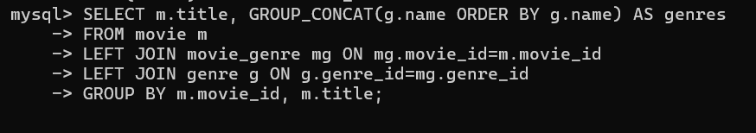
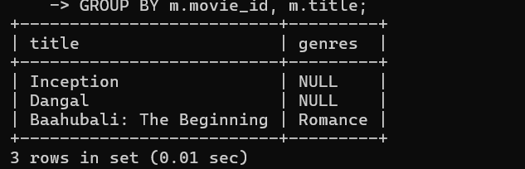
- Shows today by theatre & screen
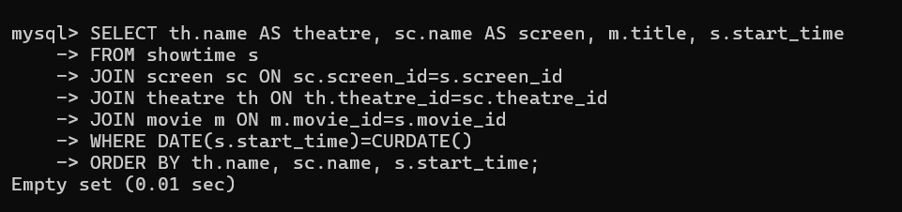
- Shows today by theatre & screen
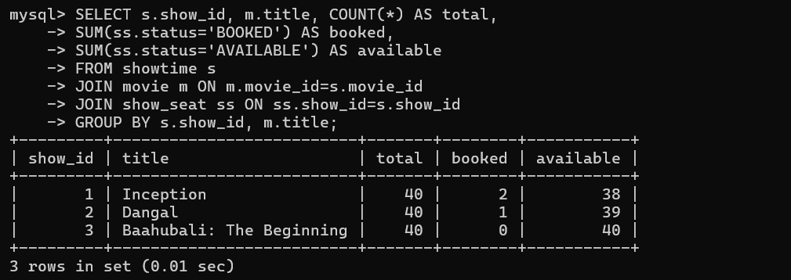
- Average ticket price per seat_type for a show
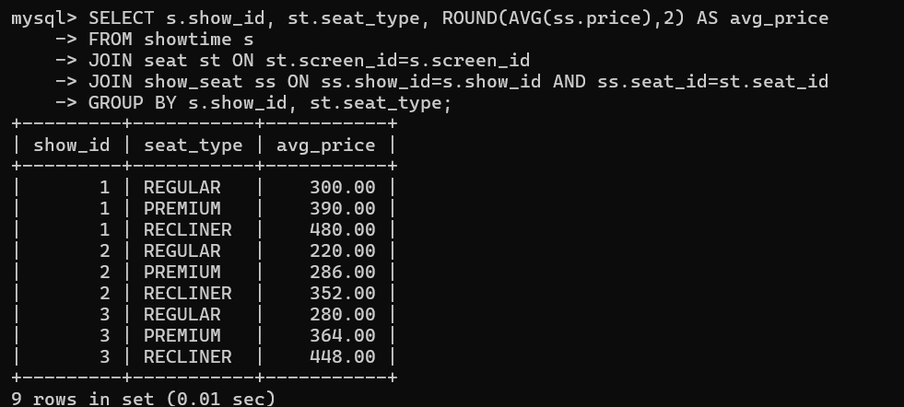
- Top movies by gross using view + window
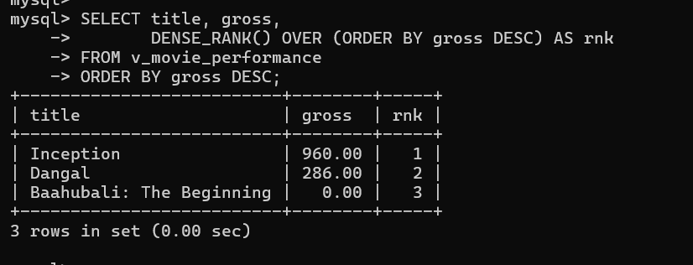
- Users with > 1 booking
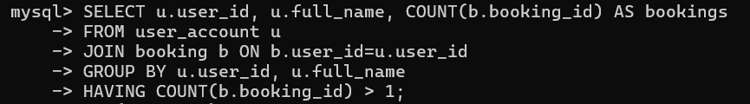
- Per-theatre KPI (view)
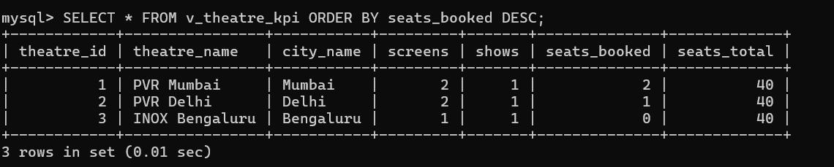
- Next 24h shows in a city with available seats
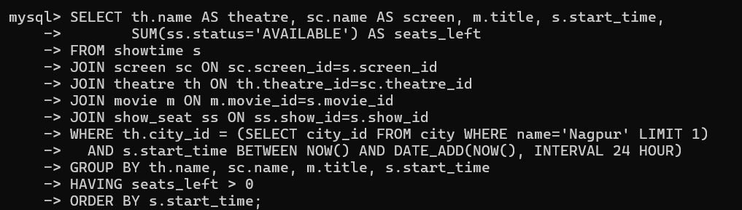
- Movie rating distribution (pivot-like)
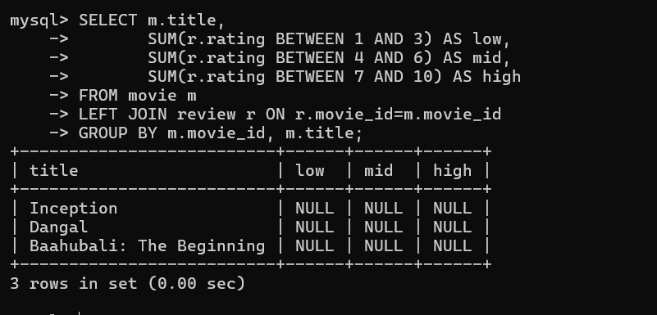
- Seats not sold for a given show (anti-join)
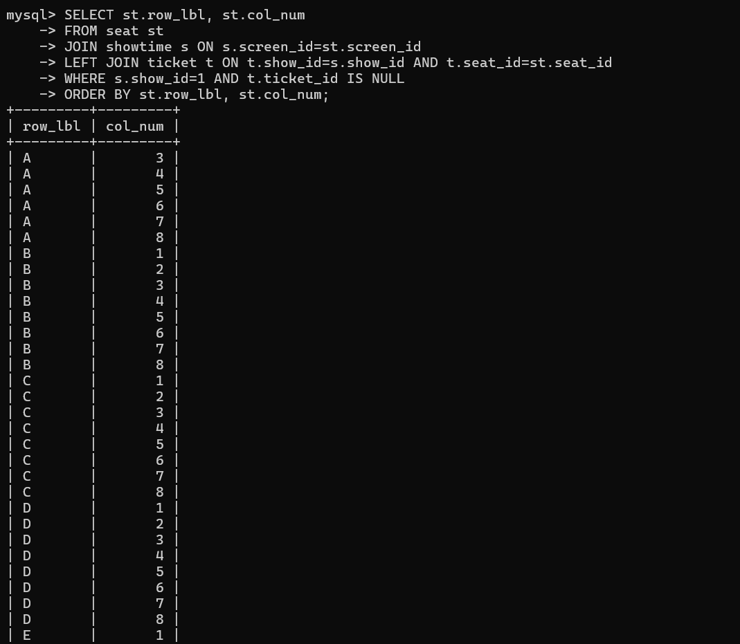
- Gross per movie per city (grouping sets style via rollup)
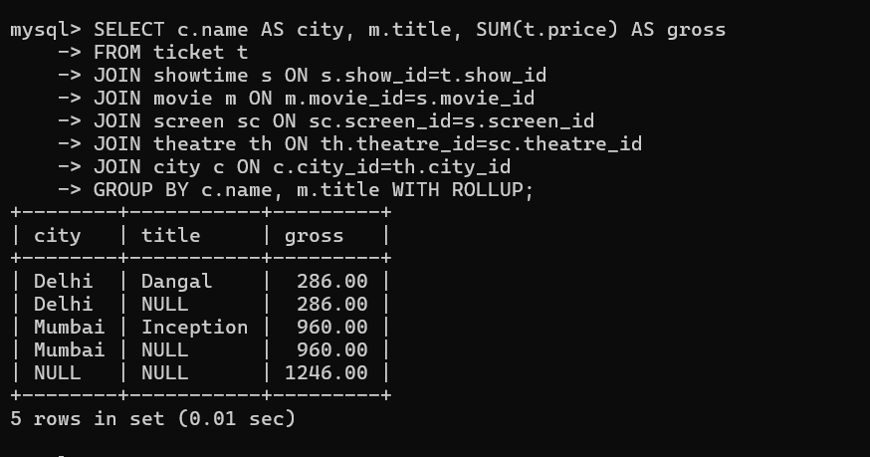
- Rank theatres by occupancy% over last 7 days
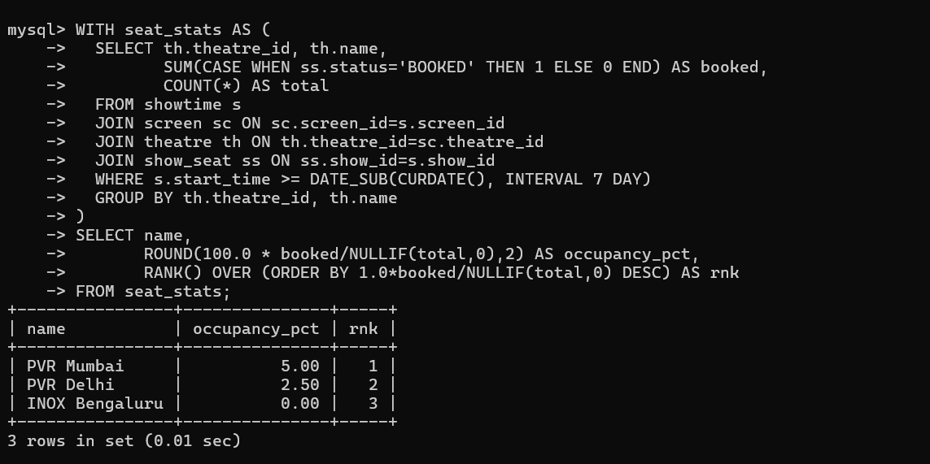
- Most frequent collaborators for each movie (actors/directors)
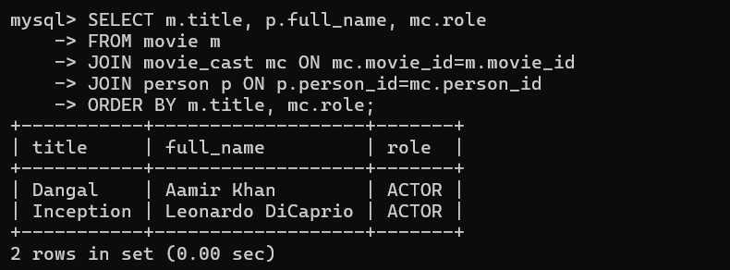
- Find shows overlapping on same screen (scheduling check)
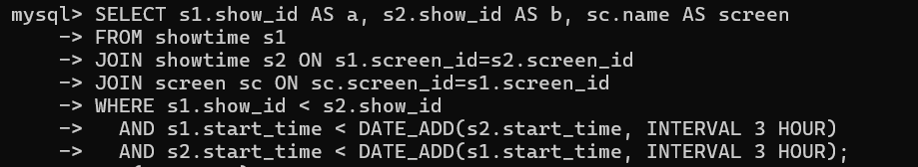
- Customers who booked all shows of a movie at a theatre (relational division style)
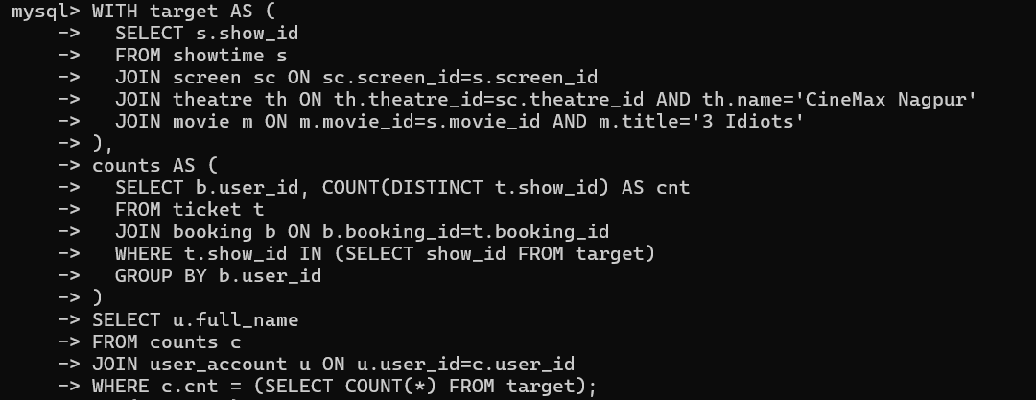
- Window: best seat types by revenue per theatre
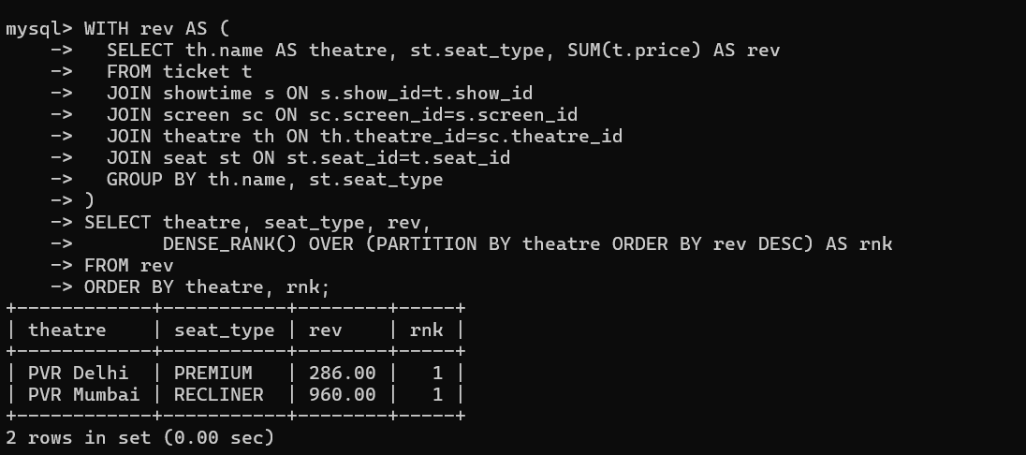
- Users who reviewed without booking (data quality check)
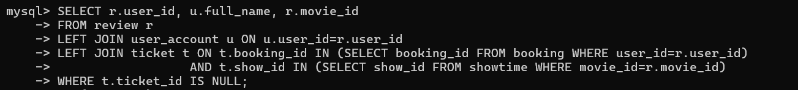
- Revenue per day for last 14 days (time series)
