Q. Write a program in python to demonstrate Gaussian Elimination Method.

Aim: To write a program in python to demonstrate Gaussian Elimination Method.

Program:
n = int(input("Enter number of equations: "))
a = []
for i in range(n):
row = list(map(float, input(f"Enter coefficients of equation {i+1} (including RHS): ").split()))
a.append(row)
def print_matrix(mat):
for r in mat:
print("\t".join(f"{val:8.3f}" for val in r))
print()
print("\nInitial Augmented Matrix:")
print_matrix(a)
for i in range(n):
if a[i][i] == 0:
print("Mathematical Error! Pivot element is zero.")
exit()
for j in range(i+1, n):
ratio = a[j][i] / a[i][i]
for k in range(n+1):
a[j][k] -= ratio * a[i][k]
print(f"After eliminating column {i+1}:")
print_matrix(a)
x = [0 for _ in range(n)]
for i in range(n-1, -1, -1):
x[i] = a[i][n]
for j in range(i+1, n):
x[i] -= a[i][j] * x[j]
x[i] /= a[i][i]
print("Final Upper Triangular Matrix:")
print_matrix(a)
print("Solution:")
for i in range(n):
print(f"x{i+1} = {x[i]:.4f}")

Output:
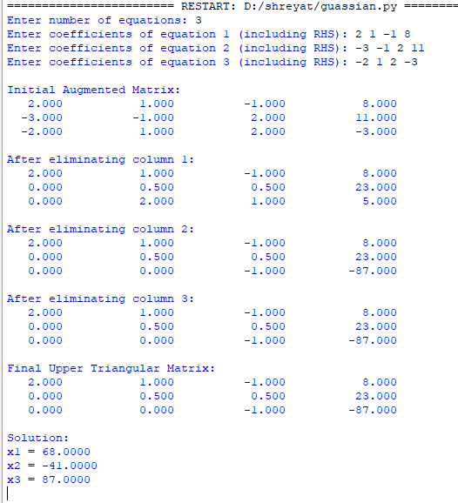
Conclusion: The above program has been executed successfully.

