Q. Write a program in python to demonstrate Taylor Series.

Aim: To write a program in python to demonstrate Taylor Series.

Program:
import math
def f(x, y):
return -y
x0 = 0
y0 = 1
h = 0.1
order = 5
derivs = [0]*order
derivs[0] = f(x0, y0)
for i in range(1, order):
derivs[i] = (-1)**i * y0
y1 = y0
for i in range(order):
y1 += (derivs[i] * (h**(i+1))) / math.factorial(i+1)
print("----------------------------------------------------")
print("Derivatives at x0 = %.1f, y0 = %.1f:" % (x0, y0))
print("----------------------------------------------------")
for i in range(order):
print(f"y^({i})(0) = {derivs[i]:.6f}")
print("\n----------------------------------------------------")
print(f"Taylor approximation up to order {order}:")
print(f"y({x0+h}) ≈ {y1:.10f}")
print(f"Rounded to 4 decimal places: {round(y1,4)}")
print("----------------------------------------------------")

Output:
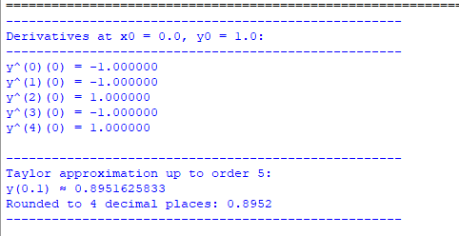
Conclusion: The above program has been executed successfully.

