Q. Write a program in python to demonstrate Trapezoidal rule.

Aim: To write a program in python to demonstrate Trapezoidal rule.

Program:
def f(x):
return x**2 + 1
a = 0
b = 1
n = 6
h = (b - a) / n
sum_val = f(a) + f(b)
print("------------------------------------------------------------")
print(" TRAPEZOIDAL RULE")
print("------------------------------------------------------------")
print(" i\t x\t\t f(x)")
print("------------------------------------------------------------")
for i in range(1, n):
x = a + i * h
fx = f(x)
print(f" {i:<2}\t {x:<10.6f}\t {fx:<10.6f}")
sum_val += 2 * fx
I = (h / 2) * sum_val
print("------------------------------------------------------------")
print(f" Approximate value of integral = {I:.6f}")
print(f" Rounded to 4 decimal places : {round(I,4)}")
print("------------------------------------------------------------")

Output:
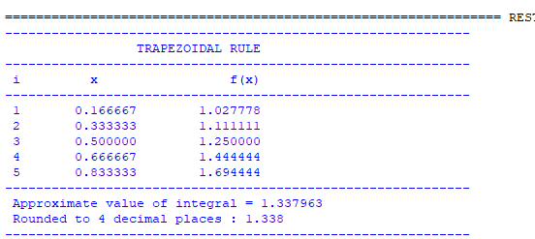

Conclusion: The above program has been executed successfully.

