Q. Write a program in python to demonstrate Bisection method.

Aim: To write a program in python to demonstrate Bisection method.

Program:
def f(x):
return x**3 - 4*x - 9
a = float(input("Enter a: "))
b = float(input("Enter b: "))
tolerance = float(input("Enter tolerance (e.g., 0.0001): "))
if f(a) * f(b) > 0:
print("No root found in this interval. Try different values of a and b.")
else:
print("\nIteration\t a\t\t b\t\t xr\t\t f(a)\t\t f(b)\t\t f(xr)")
iteration = 1
while True:
xr = (a + b) / 2
fa = f(a)
fb = f(b)
fxr = f(xr)
print(f"{iteration:>5}\t {a:.6f}\t {b:.6f}\t {xr:.6f}\t {fa:.6f}\t {fb:.6f}\t {fxr:.6f}")
if abs(fxr) < tolerance:
print("\nApproximate root:", xr)
break
if fa * fxr < 0:
b = xr
else:
a = xr
iteration += 1

Output:
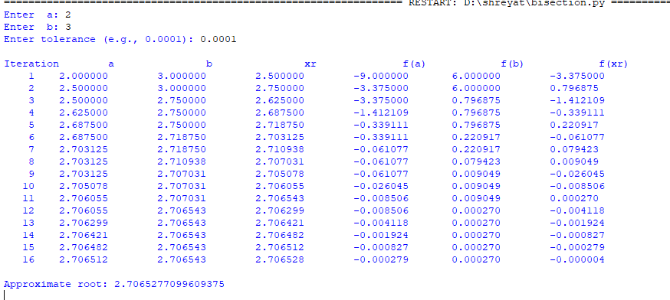

Conclusion: The above program has been executed successfully.

