Q. Write a program in python to demonstrate Northwest corner method.

Aim: To write a program in python to demonstrate Northwest corner method.

Program:
print("------------------------------------------------------------")
print(" NORTHWEST CORNER METHOD")
print("------------------------------------------------------------")
supply = [50, 60, 25]
demand = [30, 40, 20, 45]
m = len(supply)
n = len(demand)
cost = [
[2, 3, 1, 4],
[3, 2, 5, 9],
[8, 4, 3, 7]
]
allocation = [[0 for _ in range(n)] for _ in range(m)]
print(f" Supply : {supply}")
print(f" Demand : {demand}\n")
print(" Cost Matrix (C[i][j]) :")
for row in cost:
print(" ", row)
i, j = 0, 0
while i < m and j < n:
x = min(supply[i], demand[j])
allocation[i][j] = x
supply[i] -= x
demand[j] -= x
if supply[i] == 0 and i < m - 1:
i += 1
elif demand[j] == 0 and j < n - 1:
j += 1
else:
i += 1
j += 1
print("\n------------------------------------------------------------")
print(" Allocation Matrix (X[i][j]) :")
for row in allocation:
print(" ", row)
total_cost = 0
for i in range(m):
for j in range(n):
total_cost += allocation[i][j] * cost[i][j]
print("------------------------------------------------------------")
print(f" Total Transportation Cost = {total_cost}")
print("------------------------------------------------------------")

Output :
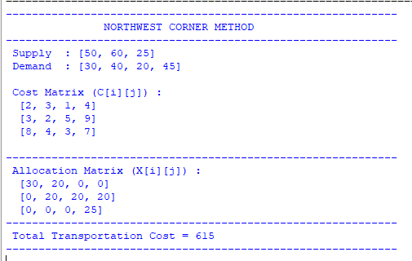

Conclusion: The above program has been executed successfully.

