Q. Write a program in python to demonstrate Runge-Kutta 2nd order method.

Aim: To write a program in python to demonstrate Runge-Kutta 2nd order method.

Program:
def f(x, y):
return x + y
x0 = 0
y0 = 1
h = 0.1
xn = 0.5
print("------------------------------------------------------------")
print(" RUNGE-KUTTA 2nd ORDER METHOD")
print("------------------------------------------------------------")
print(" x\t\t y\t\t k1\t\t k2\t\t y_new")
print("------------------------------------------------------------")
while x0 < xn:
k1 = f(x0, y0)
k2 = f(x0 + h, y0 + h * k1)
y1 = y0 + (h / 2) * (k1 + k2)
print(f" {x0:<8.2f}\t {y0:<10.6f}\t {k1:<10.6f}\t {k2:<10.6f}\t {y1:<10.6f}")
x0 += h
y0 = y1
print("------------------------------------------------------------")
print(f" Approximate value of y at x = {xn} is {y0:.6f}")
print(f" Rounded to 4 decimal places : {round(y0,4)}")
print("------------------------------------------------------------")

Output:
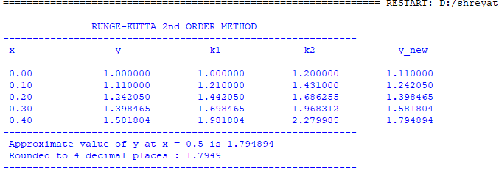

Conclusion: The above program has been executed successfully.

