Q. Demonstrate DHCP server in Packet Tracer.

Aim: To write code to demonstrate DHCP in packet tracer.

Steps:
- One router , switch and two PCs
- Connect both the 2 PCs to switch and connect switch to the router.
- Give router a IP address then PC0 and PC1 click the radio button of DHCP in the IP configuration panel,the values will be assigned automatically.

Topology:
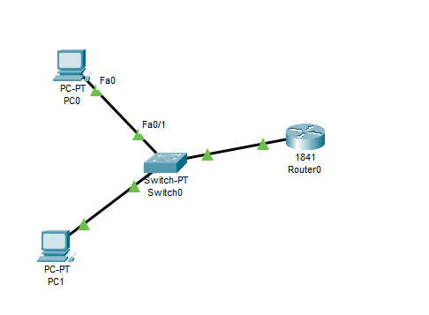
Code:
Router>enable
Router#configure terminal
Router(config)#interface FastEthernet0/0
Router(config-if)#ip address 192.168.1.1 255.255.255.0
Router(config-if)#no shutdown
Router(config-if)#exit
Router(config)#ip dhcp pool mypool
Router(dhcp-config)#network 192.163.1.0 255.255.255.0
Router(dhcp-config)#default-router 192.168.1.1
Router(dhcp-config)#exit

Output:
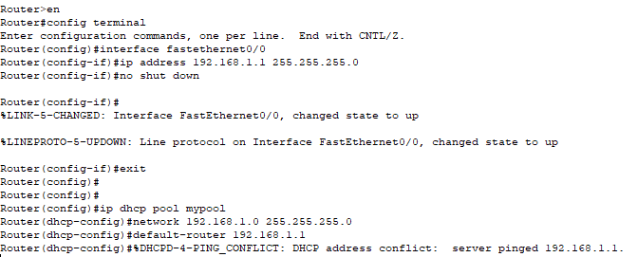
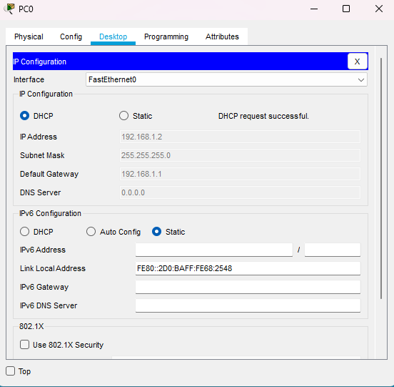
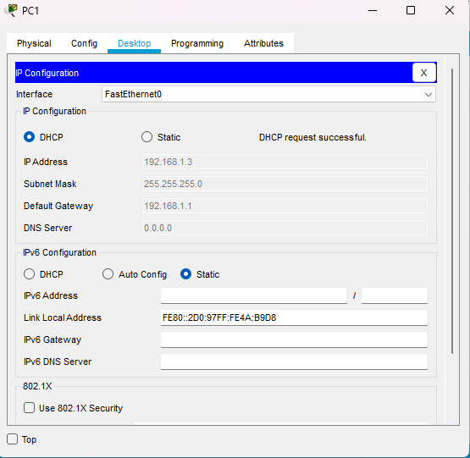
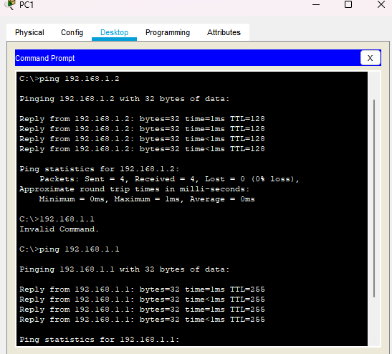
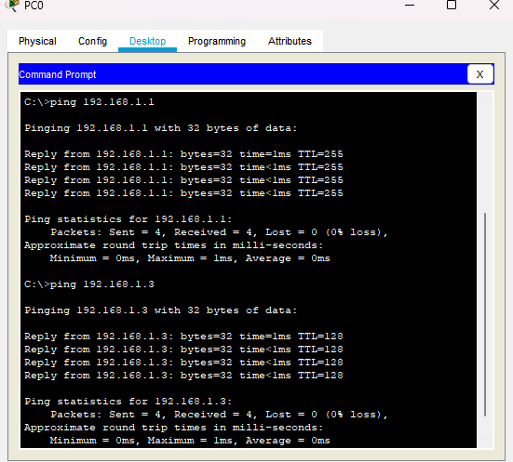

Conclusion: The above network topology has been executed successfully.

