Q. Demonstrate DNS server in Packet Tracer.

Aim: To write code to demonstrate DNS in packet tracer.

Steps:
- One server , switch and PC
- Connect PC to switch and connect switch to the server.
- Then in server on the DNS service
- Then assign IP address and DNS server
- For pc assign the ip address and DNS server IP address of Server.
Topology:
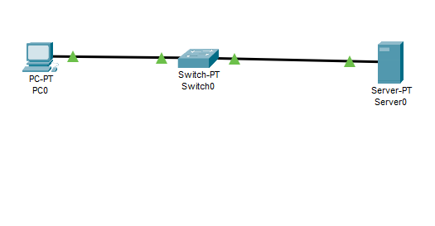
Code:
- Go to http in server
- There in file named index will appear,make some changes in that file and save it.
- In DNS service,add the name for website and the DNS server address and make the entry of this detail.
- Now, go to PC->Desktop->web browser.
- Put the name of the file in URL and click Go.
- If the topology works successfully then the website will be displayed

Output:
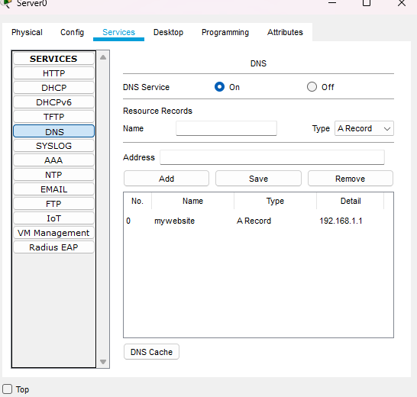
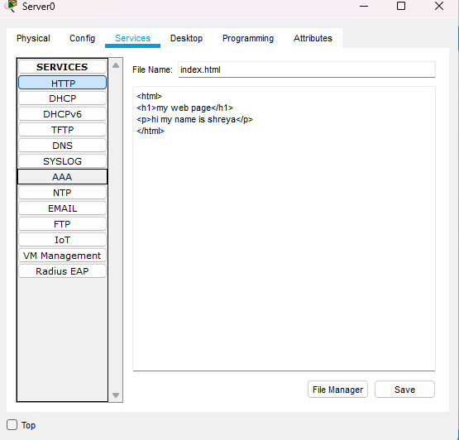
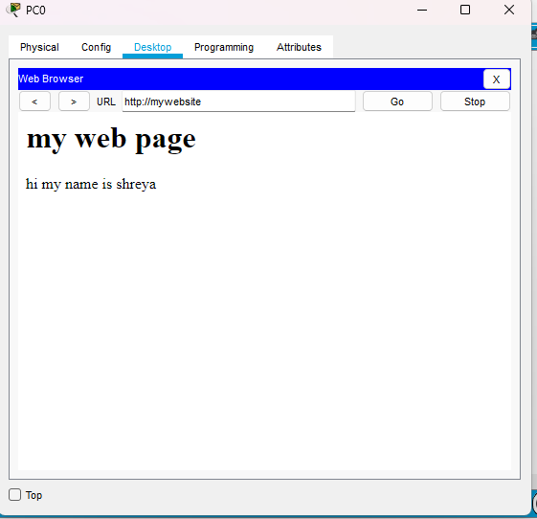
Conclusion: The above network topology has been executed successfully.

