Q. Demonstrate FTP server in Packet Tracer.

Aim: To write code to demonstrate FTP in packet tracer.

Steps:
- One server , switch and two PCs
- Connect both the PCs to switch and connect switch to the server.
Topology:
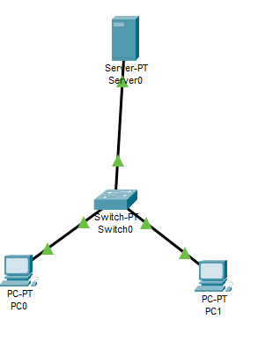
Code:
Server:
- Enable FTP option
- Create username and password
- Click all 5 tick boxes i.e write,read,delete,rename,list.
- Add it.
PC0:
Assign IP address:10.10.10.1 , Default gateway:10.10.10.0
PC1:
Assign IP address:10.10.10.2 , Default gateway:10.10.10.0

PC0:in cmd
C:\>ipconfig
C:\>ftp 10.10.10.0
C:\>username
Password
Logged in
In text editor
- Create a file and name it hi.html
- Save it
Again in cmd:
ftp>put hi.html
ftp>dir
If the file is there in the list the topology is successfully done.
Output:
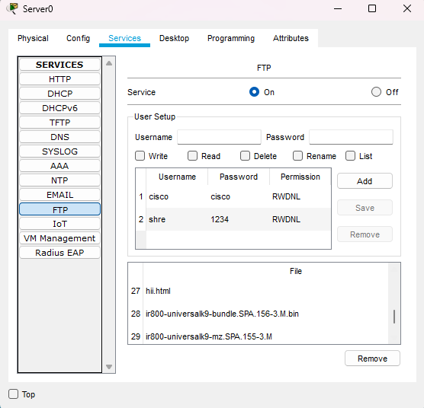
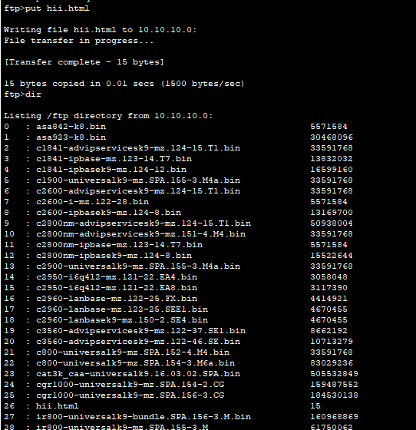

Conclusion: The above network topology has been executed successfully.

