Q. Demonstrate the RIP Routing in Packet tracer.

Aim: To write code to demonstrate rip routing in packet tracer.

Steps:
- In packet tracer place 2 PCs and 2 Routers.
- Connect Router0 with PC0 via fastethernet0/0 using cross-copper cord and Router1 with PC1 via fastethernet0/0 using cross-copper cord.
- Connect both router via fastethernet 0/1 using cross-copper cord.
- Set the IP address and default gatway of both the pcs in ip configuration of both the pcs respectively.

Topology: 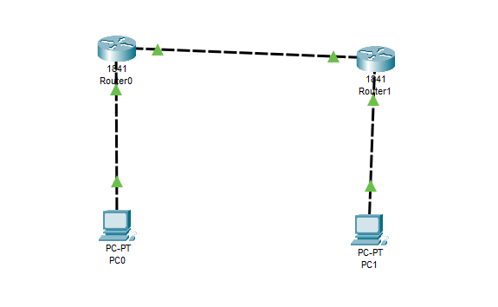
Code:
Router0:
Router>enable
Router#configure terminal
Router(config)#interface FastEthernet0/0
Router(config-if)#ip address 192.168.1.3 255.255.255.0
Router(config-if)#no shutdown
Router(config-if)#exit
Router(config)#interface FastEthernet0/1
Router(config-if)#ip address 192.168.3.2 255.255.255.0
Router(config-if)#no shutdown
Router(config-if)#exit
Router(config-router)#router rip
Router(config-router)#network 192.168.1.0
Router(config-router)#network 192.168.3.0
Router(config-router)#exit

Router 1:
Router>enable
Router#configure terminal
Router(config)#interface FastEthernet0/0
Router(config-if)#ip address 192.168.2.3 255.255.255.0
Router(config-if)#no shutdown
Router(config-if)#exit
Router(config)#interface FastEthernet0/1
Router(config-if)#ip address 192.168.3.3 255.255.255.0
Router(config-if)#no shutdown
Router(config-if)#exit
Router(config-router)#router rip
Router(config-router)#network 192.168.2.0
Router(config-router)#network 192.168.3.0
Router(config-router)#exit.

Verification: On Any One PC.
Router# show ip protocol
Router# show ip route
Router# show ip route rip

Output:
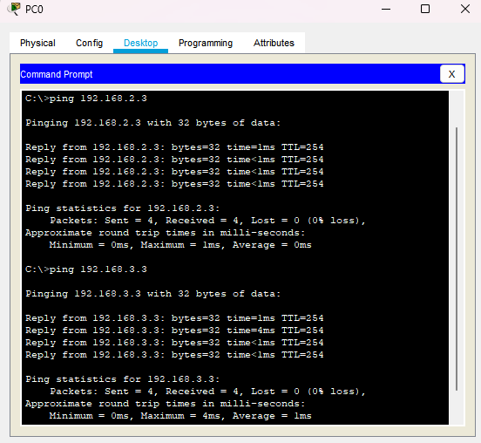
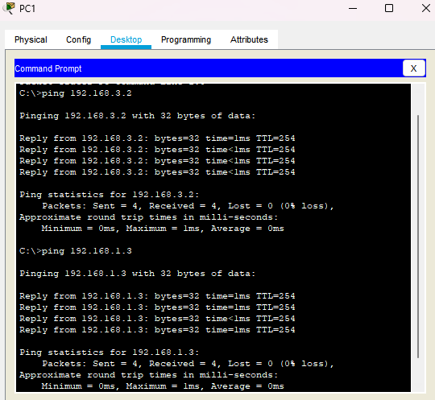
Conclusion: The above network topology has been executed successfully.

