Q. Demonstrate the Static Routing in Packet tracer.

Aim: To write code to demonstrate static routing in packet tracer.

Steps:
- In packet tracer place 2 PCs and 2 Routers.
- Connect Router0 with PC0 via fastethernet0/0 using cross-copper cord and Router1 with PC1 via fastethernet0/0 using cross-copper cord.
- Connect both router via fastethernet 0/1 using cross-copper cord.
- Set the IP address and default gatway of both the pcs in ip configuration of both the pcs respectively.

Topology: 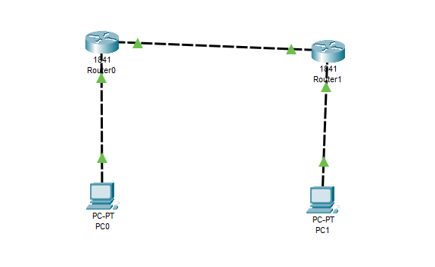
Code:
Router0:
Router>enable
Router#configure terminal
Router(config)#interface FastEthernet0/0
Router(config-if)#ip address 10.0.0.1 255.0.0.0
Router(config-if)#no shutdown
Router(config-if)#exit
Router(config)#interface FastEthernet0/1
Router(config-if)#ip address 20.0.0.1 255.0.0.0
Router(config-if)#no shutdown
Router(config-if)#exit
Router(config)#ip route 40.0.0.0 255.0.0.0 20.0.0.2
Router(config)#exit

Router 1:
Router>enable
Router#configure terminal
Router#configure terminal
Router(config)#interface FastEthernet0/0
Router(config-if)#ip address 20.0.0.2 255.0.0.0
Router(config-if)#no shutdown
Router(config-if)#exit
Router(config)#interface FastEthernet0/1
Router(config-if)#ip address 40.0.0.1 255.0.0.0
Router(config-if)#no shutdown
Router(config-if)#exit
Router(config)#ip route 10.0.0.0 255.0.0.0 20.0.0.1
Router(config)#exit.

Verification: In Both PCs Command Prompt

PC1:
C:\ipconfig
C:\ping 10.0.0.1
C:\ping 20.0.0.1
C:\ping 20.0.0.2
C:\ping 40.0.0.1
C:\ping 40.0.0.2

PC2:
C:\ipconfig
C:\ping 40.0.0.1
C:\ping 20.0.0.2
C:\ping 20.0.0.1
C:\ping 10.0.0.1
C:\ping 10.0.0.2

Output:
Pc0:
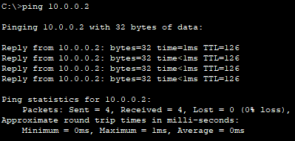
Pc1:
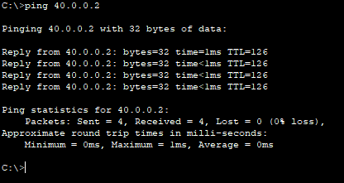

Conclusion: The above network topology has been executed successfully.

