Q. To create, Export and Validate a digital certificate

Aim: To write a code to create, Export & validate a digital certificate

Steps:
- Download and Install OpenSSL
- Add its bin path in “environment variable”
- Open command prompt

Program:

c:\Users\Shreya\Desktop>openssl req -x509 -days 365 -newkey rsa:2048
-keyout private-key.pem -out certificate.pem
Enter PEM Pass: 123456

Country Name (2 letter code) : IN
State or Province Name (full name) (some-state): Maharashtra
Locality Name (L): Mumbai
Organization Name : SIWS
Organization Unit Name: IT
Common Name : TMD
Email Address (E): shreyatiwari@gmail.com

c:\Users\Shreya\Desktop>openssl pkcs12 -export -in certificate.pem
-inkey private-key.pem -out TMD.pfx
Enter pass phrase for private-key.pem: 123456
Enter Export Password: 123456
Verifying - Enter Export Password: 123456

> openssl pkcs12 -in TMD.pfx -clcerts -nokeys -out public-key.pem
Enter Import Password: 123456
>
Import the certificate.

Output:
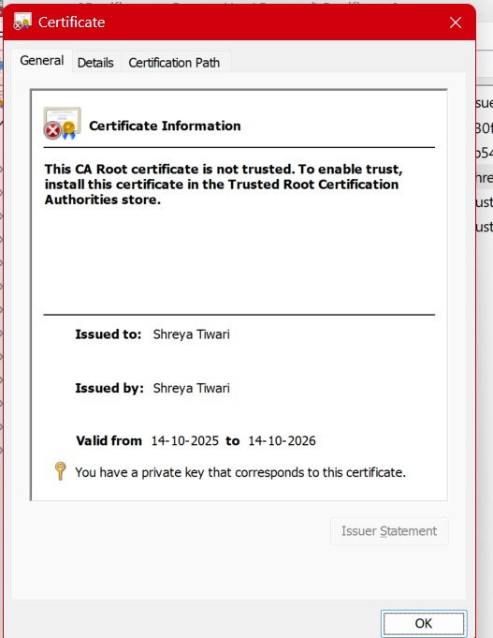
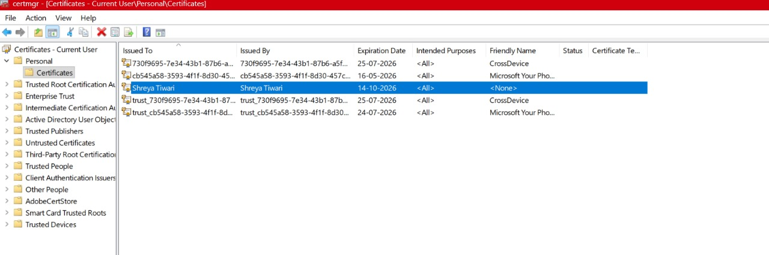
Conclusion: The above program has been executed successfully

