Q. Demonstrate the Static Routing in Packet tracer.

Aim: To write code to demonstrate static routing in packet tracer.

Steps:
- In packet tracer place 2 PCs and 2 Routers.
- Connect Router0 with PC0 via fastethernet0/0 using cross-copper cord and Router1 with PC1 via fastethernet0/0 using cross-copper cord.
- Connect both router via fastethernet 0/1 using cross-copper cord.
- Set the IP address and default gatway of both the pcs in ip configuration of both the pcs respectively.

Topology: 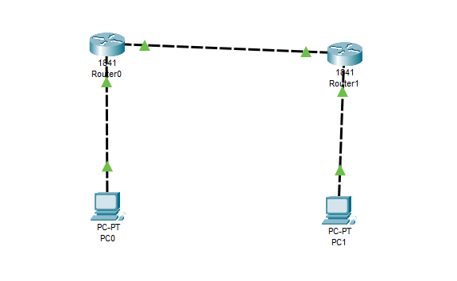
Code:
Router0:
Router>enable
Router#configure terminal
Router(config)#interface FastEthernet0/0
Router(config-if)#ip address 10.0.0.1 255.0.0.0
Router(config-if)#no shutdown
Router(config-if)#exit
Router(config)#interface FastEthernet0/1
Router(config-if)#ip address 20.0.0.1 255.0.0.0
Router(config-if)#no shutdown
Router(config-if)#exit
Router(config)#ip route 40.0.0.0 255.0.0.0 20.0.0.2
Router(config)#exit

Router 1:
Router>enable
Router#configure terminal
Router#configure terminal
Router(config)#interface FastEthernet0/0
Router(config-if)#ip address 20.0.0.2 255.0.0.0
Router(config-if)#no shutdown
Router(config-if)#exit
Router(config)#interface FastEthernet0/1
Router(config-if)#ip address 40.0.0.1 255.0.0.0
Router(config-if)#no shutdown
Router(config-if)#exit
Router(config)#ip route 10.0.0.0 255.0.0.0 20.0.0.1
Router(config)#exit.

Verification: In Both PCs Command Prompt

PC1:
C:\ipconfig
C:\ping 10.0.0.1
C:\ping 20.0.0.1
C:\ping 20.0.0.2
C:\ping 40.0.0.1
C:\ping 40.0.0.2

PC2:
C:\ipconfig
C:\ping 40.0.0.1
C:\ping 20.0.0.2
C:\ping 20.0.0.1
C:\ping 10.0.0.1
C:\ping 10.0.0.2

Output:
Pc0:
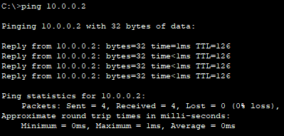
Pc1:
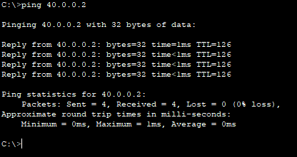

Conclusion: The above network topology has been executed successfully.

Q. Demonstrate the OSPF Routing in Packet tracer.

Aim: To write code to demonstrate ospf routing in packet tracer.

Steps:
- In packet tracer place 2 PCs and 2 Routers.
- Connect Router0 with PC0 via fastethernet0/0 using cross-copper cord and Router1 with PC1 via fastethernet0/0 using cross-copper cord.
- Connect both router via fastethernet 0/1 using cross-copper cord.
- Set the IP address and default gatway of both the pcs in ip configuration of both the pcs respectively.

Topology:
Code:
Router0:
Router>enable
Router#configure terminal
Router(config)#interface FastEthernet0/0
Router(config-if)#ip address 192.168.1.3 255.255.255.0
Router(config-if)#no shutdown
Router(config-if)#exit
Router(config)#interface FastEthernet0/1
Router(config-if)#ip address 192.168.3.2 255.255.255.0
Router(config-if)#no shutdown
Router(config-if)#exit
Router(config-router)#router ospf1
Router(config-router)#network 192.168.1.0 0.0.0.255 area 0
Router(config-router)#network 192.168.3.0 0.0.0.255 area 0
Router(config-router)#exit

Router 1:
Router>enable
Router#configure terminal
Router(config)#interface FastEthernet0/0
Router(config-if)#ip address 192.168.2.3 255.255.255.0
Router(config-if)#no shutdown
Router(config-if)#exit
Router(config)#interface FastEthernet0/1
Router(config-if)#ip address 192.168.3.3 255.255.255.0
Router(config-if)#no shutdown
Router(config-if)#exit
Router(config-router)#router ospf2
Router(config-router)#network 192.168.2.0 0.0.0.255 area 0
Router(config-router)#network 192.168.3.0 0.0.0.255 area 0
Router(config-router)#exit.

Verification: On Any One PC.
Router# show ip ospf neighbor
Router# show ip route ospf
Router# show ip protocol

Output:
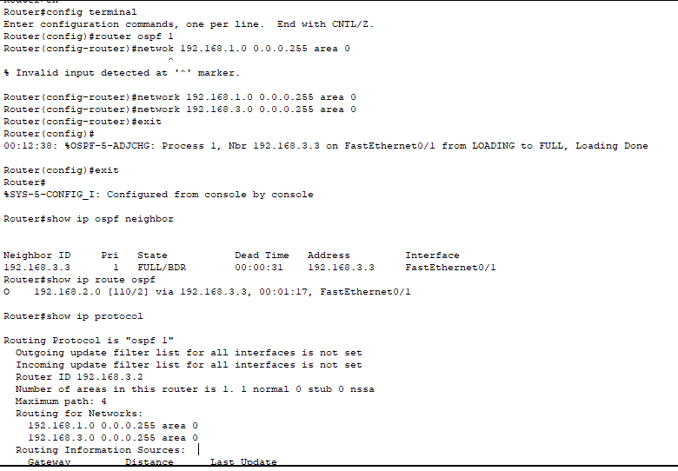

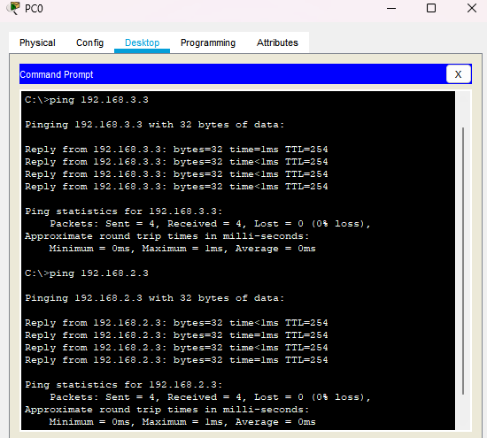
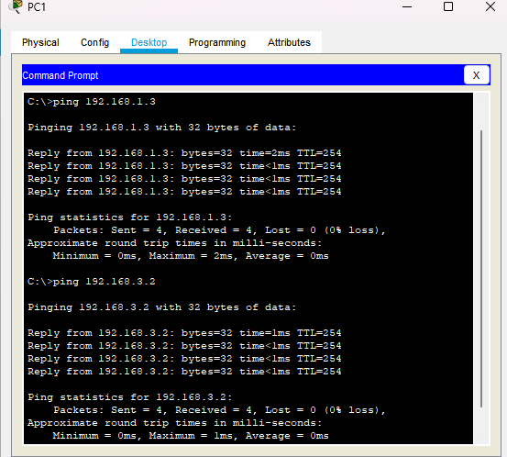

Conclusion: The above network topology has been executed successfully.

Q. Demonstrate the RIP Routing in Packet tracer.

Aim: To write code to demonstrate rip routing in packet tracer.

Steps:
- In packet tracer place 2 PCs and 2 Routers.
- Connect Router0 with PC0 via fastethernet0/0 using cross-copper cord and Router1 with PC1 via fastethernet0/0 using cross-copper cord.
- Connect both router via fastethernet 0/1 using cross-copper cord.
- Set the IP address and default gatway of both the pcs in ip configuration of both the pcs respectively.

Topology:
Code:
Router0:
Router>enable
Router#configure terminal
Router(config)#interface FastEthernet0/0
Router(config-if)#ip address 192.168.1.3 255.255.255.0
Router(config-if)#no shutdown
Router(config-if)#exit
Router(config)#interface FastEthernet0/1
Router(config-if)#ip address 192.168.3.2 255.255.255.0
Router(config-if)#no shutdown
Router(config-if)#exit
Router(config-router)#router rip
Router(config-router)#network 192.168.1.0
Router(config-router)#network 192.168.3.0
Router(config-router)#exit

Router 1:
Router>enable
Router#configure terminal
Router(config)#interface FastEthernet0/0
Router(config-if)#ip address 192.168.2.3 255.255.255.0
Router(config-if)#no shutdown
Router(config-if)#exit
Router(config)#interface FastEthernet0/1
Router(config-if)#ip address 192.168.3.3 255.255.255.0
Router(config-if)#no shutdown
Router(config-if)#exit
Router(config-router)#router rip
Router(config-router)#network 192.168.2.0
Router(config-router)#network 192.168.3.0
Router(config-router)#exit.

Verification: On Any One PC.
Router# show ip protocol
Router# show ip route
Router# show ip route rip

Output:
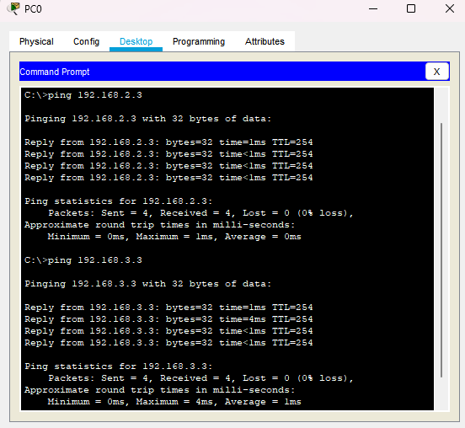
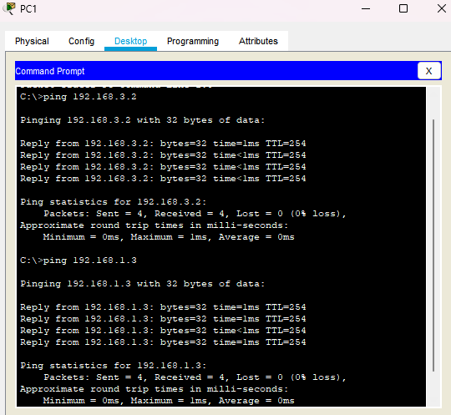
Conclusion: The above network topology has been executed successfully.
Q. Demonstrate DHCP server in Packet Tracer.

Aim: To write code to demonstrate DHCP in packet tracer.

Steps:
- One router , switch and two PCs
- Connect both the 2 PCs to switch and connect switch to the router.
- Give router a IP address then PC0 and PC1 click the radio button of DHCP in the IP configuration panel,the values will be assigned automatically.

Topology:
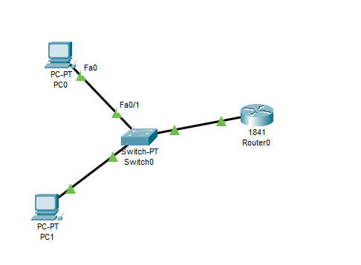
Code:
Router>enable
Router#configure terminal
Router(config)#interface FastEthernet0/0
Router(config-if)#ip address 192.168.1.1 255.255.255.0
Router(config-if)#no shutdown
Router(config-if)#exit
Router(config)#ip dhcp pool mypool
Router(dhcp-config)#network 192.163.1.0 255.255.255.0
Router(dhcp-config)#default-router 192.168.1.1
Router(dhcp-config)#exit

Output:
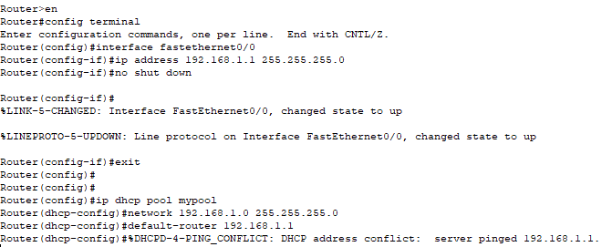
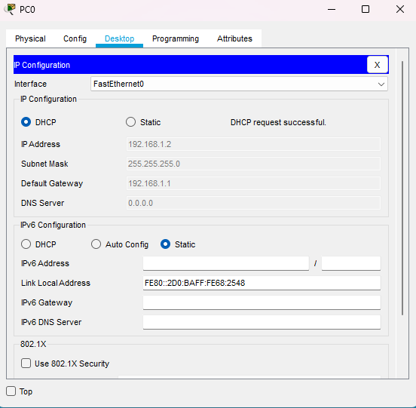
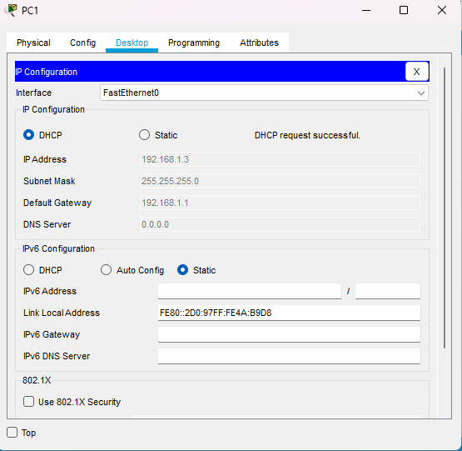
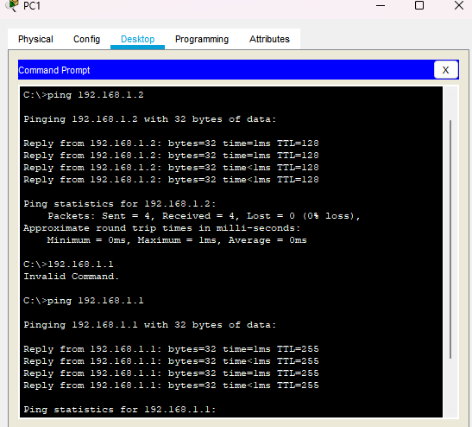
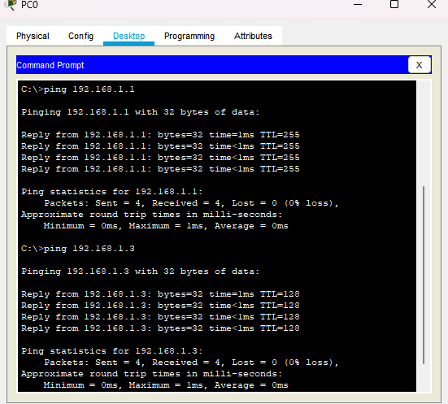

Conclusion: The above network topology has been executed successfully.

Q. Demonstrate DNS server in Packet Tracer.

Aim: To write code to demonstrate DNS in packet tracer.

Steps:
- One server , switch and PC
- Connect PC to switch and connect switch to the server.
- Then in server on the DNS service
- Then assign IP address and DNS server
- For pc assign the ip address and DNS server IP address of Server.
Topology:
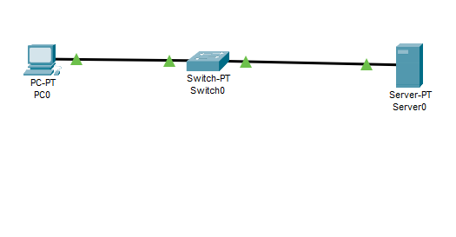
Code:
- Go to http in server
- There in file named index will appear,make some changes in that file and save it.
- In DNS service,add the name for website and the DNS server address and make the entry of this detail.
- Now, go to PC->Desktop->web browser.
- Put the name of the file in URL and click Go.
- If the topology works successfully then the website will be displayed

Output:
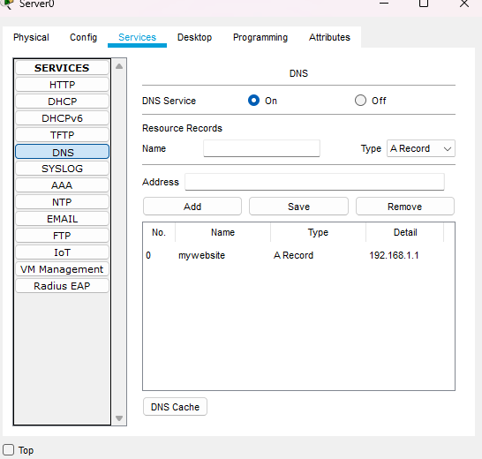
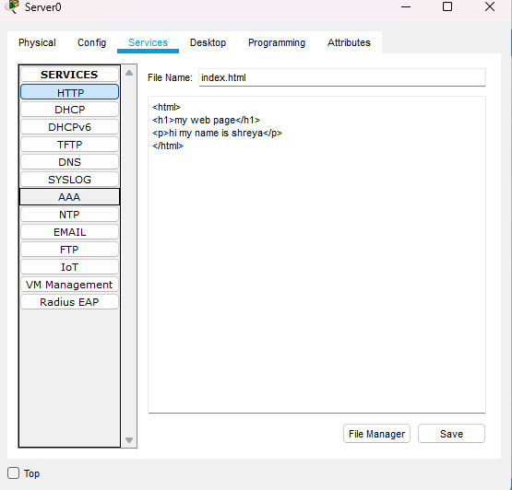
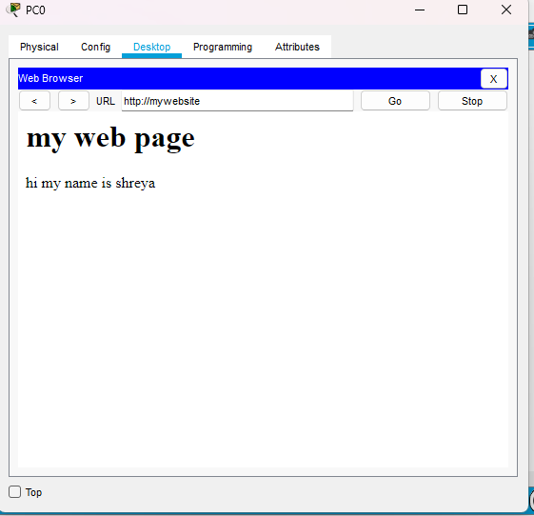
Conclusion: The above network topology has been executed successfully.
Q. Demonstrate HTTP server in Packet Tracer.

Aim: To write code to demonstrate HTTP in packet tracer.

Steps:
- Two server , one switch and PC
- Connect PC to switch and connect switch to both the server.
Topology:
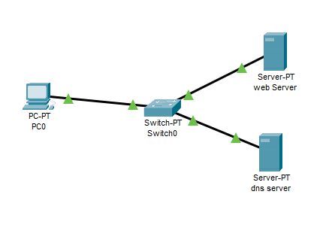
Code:
Server0(DNS server)
Assign IP address:192.168.1.1 , DNS server IP: 192.168.1.1
Server1(Web server)
Assign IP address:192.168.1.2 , DNS server IP: 192.168.1.1
DNS SERVER IP will be the same.
PC0:
Assign IP address:192.168.1.3 , DNS server IP: 192.168.1.1

- In DNS server, select and on DNS.
- Go to http in web server
- There in file named index will appear,make some changes in that file and save it.
- In DNS server,add the name for website and the DNS server address and make the entry of this detail in the DNS column.
- Now, go to PC->Desktop->web browser.
- Put the name of the file in URL and click Go.
- If the topology works successfully then the website will be displayed

Output:
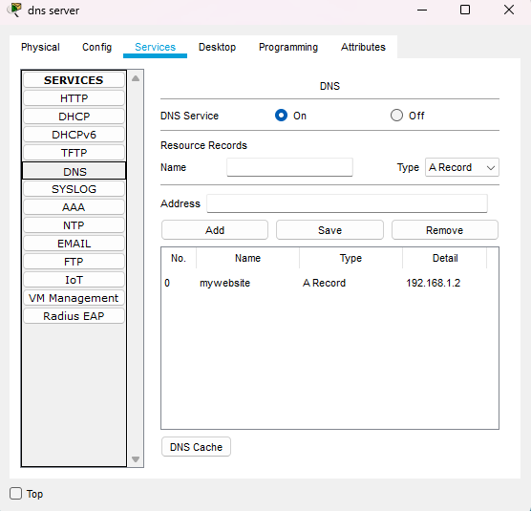

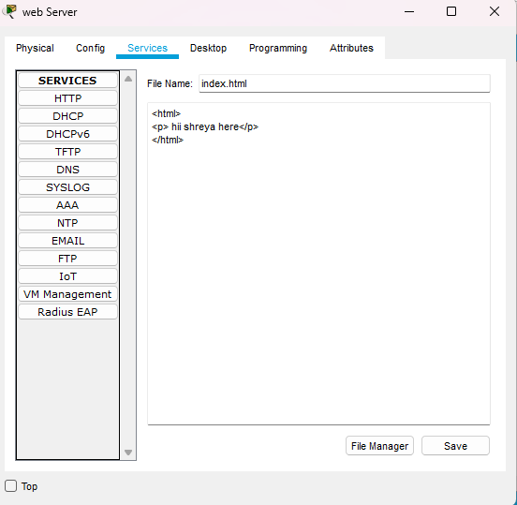
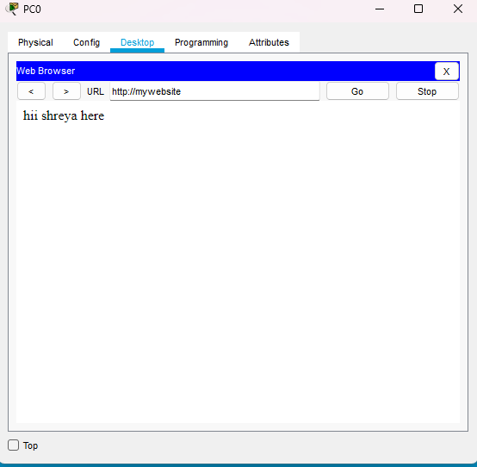
Conclusion: The above network topology has been executed successfully.

Q. Demonstrate FTP server in Packet Tracer.

Aim: To write code to demonstrate FTP in packet tracer.

Steps:
- One server , switch and two PCs
- Connect both the PCs to switch and connect switch to the server.
Topology:
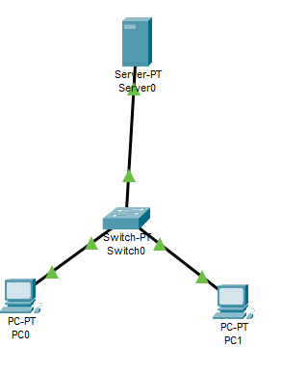
Code:
Server:
- Enable FTP option
- Create username and password
- Click all 5 tick boxes i.e write,read,delete,rename,list.
- Add it.
PC0:
Assign IP address:10.10.10.1 , Default gateway:10.10.10.0
PC1:
Assign IP address:10.10.10.2 , Default gateway:10.10.10.0

PC0:in cmd
C:\>ipconfig
C:\>ftp 10.10.10.0
C:\>username
Password
Logged in
In text editor
- Create a file and name it hi.html
- Save it
Again in cmd:
ftp>put hi.html
ftp>dir
If the file is there in the list the topology is successfully done.
Output:
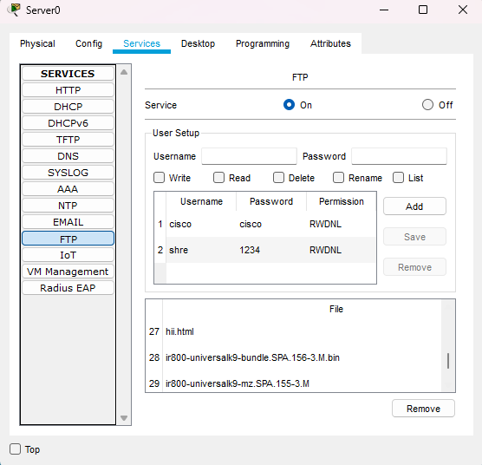
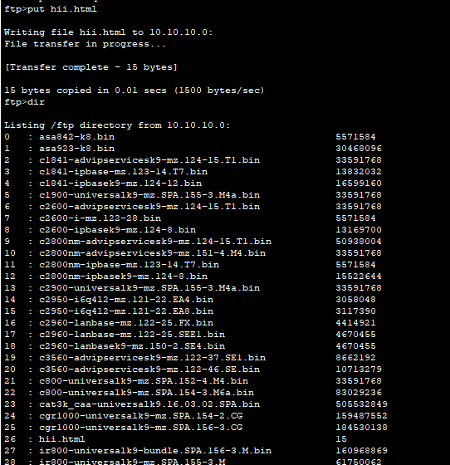

Conclusion: The above network topology has been executed successfully.

Q. Demonstrate substitution technique in C.

Aim: To write code to demonstrate substitution technique in C.

Description: A substitution technique in cryptography is a method where each element of the plain text is replaced with another symbol, letter or number to form the Cipher text, preserving the original message length but obscuring its content.

Program:
#include <stdio.h>
#include <conio.h>

void main()
{
char str[26];
int i;

clrscr();
printf("Enter plain text: ");
scanf("%s",str);
for(i=0, str[i]!='\0'; i++)
{
str[i] = str[i] + 4;
}

printf("Encrypted text : \n");
printf("Encrypted : %s\n",str);
for(i=0, str[i]!='\0'; i++)
{
str[i] = str[i] - 4;
}

printf("Decrypted text : \n");
printf("Decrypted : %s\n",str);
getch();
}
Output:
Enter plain text : shreya
Encrypted text : +4
Encrypted : wlviec
Decrypted text : -4
Decrypted : shreya

Conclusion: The above program has been executed successfully

Q. Demonstrate DES in python

Aim: To write code to demonstrate DES in python.

Program:
!pip install pycryptodome

from Crypto.Cipher import DES
from Crypto.Util.Padding import pad, unpad
text = "Hello from shreya!"
key_input = "mysecret"
key = key_input.encode()
data = text.encode()
cipher = DES.new(key, DES.MODE_ECB)
padded_data = pad(data, DES.block_size)
encrypted_data = cipher.encrypt(padded_data)
print(" Encrypted (DES):", encrypted_data)
decipher = DES.new(key, DES.MODE_ECB)
decrypted_data = unpad(decipher.decrypt(encrypted_data), DES.block_size)
print(" Decrypted (DES):", decrypted_data.decode())

Output:
Conclusion: The above program has been executed successfully

Q. Demonstrate AES in python

Aim: To write code to demonstrate AES in python.

Program:
!pip install pycryptodome

from Crypto.Cipher import AES
from Crypto.Util.Padding import pad
import binascii
sykey=bytes.fromhex('2b7e151628aeb2a6abf7158809cf4f3c')
originaltext=b"0123456789ABCDEF"
ciphertext=AES.new(sykey,AES.MODE_ECB)
cencrypt=ciphertext.encrypt(originaltext)
print(cencrypt.hex())
ciphertext1=cencrypt.hex()
ctext=AES.new(sykey,AES.MODE_ECB)
dtext=ctext.decrypt(cencrypt)
print(dtext)

Output:
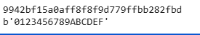
Conclusion: The above program has been executed successfully

Q. Demonstrate RSA in python

Aim: To write code to demonstrate RSA in python.

Program:
p=5
q=11
n=p*q
pn=(p-1)*(q-1)
e=3
d=27
m=9
c=pow(m,e,n)
print("Cipher Text",c)
decryption=pow(c,d,n)
print("decrypted",decryption)

Output:

Conclusion: The above program has been executed successfully

Q. Demonstrate MD5 algorithm in python

Aim: To write code to demonstrate MD5 algorithm in python.

Program:
import hashlib
str1 ="syit class"
md5hashvalue=hashlib.md5()
print(md5hashvalue)
md5hashvalue.update(str1.encode('utf-8'))
messagedigest=md5hashvalue.hexdigest()
messagedigest
print(messagedigest)

Output:

Conclusion: The above program has been executed successfully

Q. Demonstrate RSHash algorithm in python

Aim: To write code to demonstrate RSHash algorithm in python.

Program:
def rshashvalue(str2):
a=63689
b=378551
hashvalue=0
for ch in str2:
hashvalue=hashvalue*a+ord(ch)
a=a*b
return hashvalue & 0xFFFFFFFF
h1=rshashvalue('syit class')
print(h1)

Output:

Conclusion: The above program has been executed successfully

Q. To create, Export and Validate a digital certificate

Aim: To write a code to create, Export & validate a digital certificate

Steps:
- Download and Install OpenSSL
- Add its bin path in “environment variable”
- Open command prompt

Program:

c:\Users\Shreya\Desktop>openssl req -x509 -days 365 -newkey rsa:2048
-keyout private-key.pem -out certificate.pem
Enter PEM Pass: 123456

Country Name (2 letter code) : IN
State or Province Name (full name) (some-state): Maharashtra
Locality Name (L): Mumbai
Organization Name : SIWS
Organization Unit Name: IT
Common Name : TMD
Email Address (E): shreyatiwari@gmail.com

c:\Users\Shreya\Desktop>openssl pkcs12 -export -in certificate.pem
-inkey private-key.pem -out TMD.pfx
Enter pass phrase for private-key.pem: 123456
Enter Export Password: 123456
Verifying - Enter Export Password: 123456

> openssl pkcs12 -in TMD.pfx -clcerts -nokeys -out public-key.pem
Enter Import Password: 123456
>
Import the certificate.

Output:
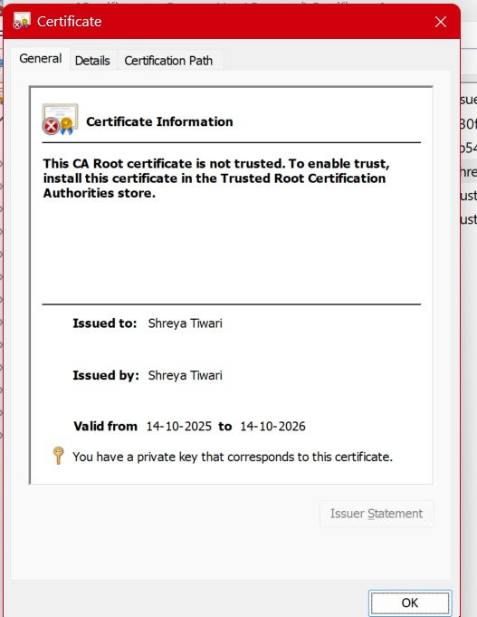
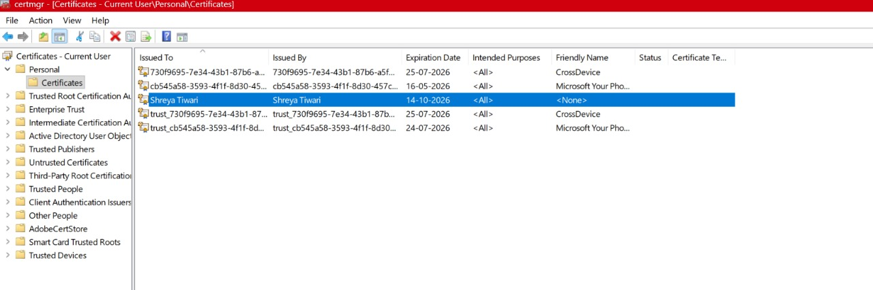
Conclusion: The above program has been executed successfully

