Q. Demonstrate HTTP server in Packet Tracer.

Aim: To write code to demonstrate HTTP in packet tracer.

Steps:
- Two server , one switch and PC
- Connect PC to switch and connect switch to both the server.
Topology:
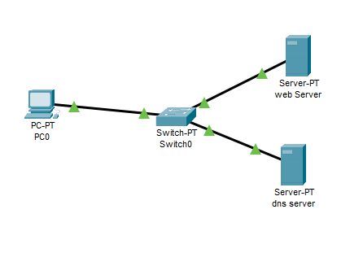
Code:
Server0(DNS server)
Assign IP address:192.168.1.1 , DNS server IP: 192.168.1.1
Server1(Web server)
Assign IP address:192.168.1.2 , DNS server IP: 192.168.1.1
DNS SERVER IP will be the same.
PC0:
Assign IP address:192.168.1.3 , DNS server IP: 192.168.1.1

- In DNS server, select and on DNS.
- Go to http in web server
- There in file named index will appear,make some changes in that file and save it.
- In DNS server,add the name for website and the DNS server address and make the entry of this detail in the DNS column.
- Now, go to PC->Desktop->web browser.
- Put the name of the file in URL and click Go.
- If the topology works successfully then the website will be displayed

Output:
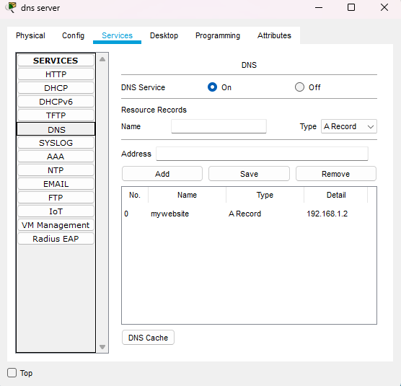

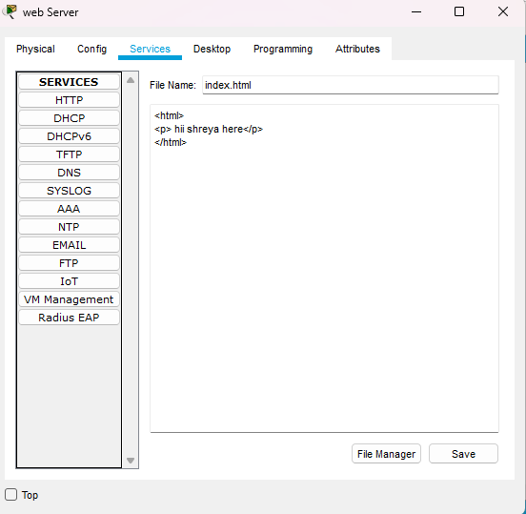
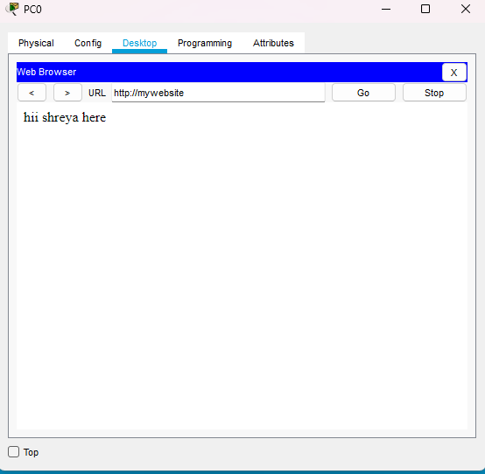
Conclusion: The above network topology has been executed successfully.

