Q. Demonstrate Telnet in Packet Tracer.

Aim: To write code to demonstrate Telnet in packet tracer.

Steps:
- One router , switch and PC
- Connect the PC to switch and connect switch to the router using copper straight-through cable.
- Do router,switch interface up.
Topology:
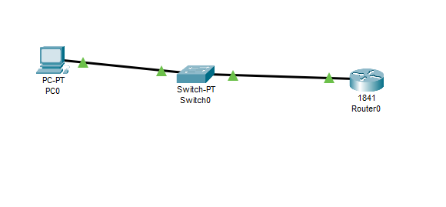
Code:
Switch:
Switch>enable
Switch# configure terminal
Switch(config)#interface fastethernet0/0
Switch(config-if)# ip address 192.168.1.2 255.255.255.0
Switch(config-if)#no shutdown
Switch(config-if)#exit
Switch(config)#line vty04
Switch(config-line)#password cisco
Switch(config-line)#login
Switch(config-line)#end
Switch#write memory
Router:
Router>enable
Router# configure terminal
Router(config)#interface fastethernet0/0
Router(config-if)# ip address 192.168.1.1 255.255.255.0
Router(config-if)#no shutdown
Router(config-if)#exit
Router(config)#line vty04
Router(config-line)#password cisco
Router(config-line)#login
Router(config-line)#end

Verification:
In cmd of pc:
>telnet 192.168.1.1
>telnet 192.168.1.2
Output:
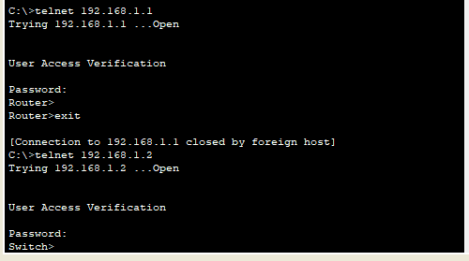

Conclusion: The above network topology has been executed successfully.

